BSc DEGREE
IN
Computer Science
PROJECT REPORT
Name: (Said Osman)
ID Number: (K2376552)
Project Title: (Myriad: A Local-First, Privacy-Preserving
Mindful Habit Tracker)
Declarations
I have read and understood the University regulations on academic misconduct, am aware of the internal rules of the CI6600 module, and as such make the following declarations:
- This report is entirely my own work. Any other sources are duly acknowledged and referenced according to the requirements of the School of Computer Science and Mathematics.
- None of the text in this report has been directly copied and pasted from the output of Large Language Models such as ChatGPT, Grok, Gemini, etc. Any other use of an LLM has been acknowledged and attributed by sharing the chat as part of the submission.
- All verbatim citations of text that were not written by me – whether they were written by a human or AI – are indicated by double quotation marks (“…”) and the author credited.
- Any visual artefacts contained in this document were either original compositions by me or the author has been correctly attributed.
- I have kept my work secure in accordance with university regulations, and nobody other than myself and academic staff from Kingston University have had access to this work.
- I have not asked a third party to proof-read my work (except KU academic staff), either in a professional or informal capacity.
- To the best of my knowledge, the project in this report has not been previously undertaken either by myself or another student in the previous two academic years.
Date: 27/10/2025

Signature: Said Osman

Table of Contents
Table of Contents 3
Table of Figures 3
Glossary of Terms 4
1. Introduction and State of the Art Review 5
1.1 State of the Art Synthesis 7
2. Analysis and Design 7
2.1 Stakeholders and Context 7
2.2 Engagement Method 7
2.3 Findings from Stakeholder Engagement 8
2.4 Functional and Non-Functional Requirements 8
2.5 Prioritisation (MoSCoW) 8
2.6 Design Artefacts and System Design 8
2.7 Risks and Project Planning 9
3. Realisation 14
3.1 Intended Audience 14
3.2 Recreating the Implementation 14
3.2.1 Setup 14
3.2.2 Core Backend Construction 14
3.2.3 Security-Relevant Implementation Details 14
3.3 Using the Artefact and Generating Output 15
3.3.1 Data Ingestion Paths 15
3.3.2 Analytics and Dashboard Output 15
3.3.3 Example Output Structure 15
3.4 Implementation Verification Snapshot 16
3.5 Detailed Endpoint Walkthrough for Reproduction 16
3.6 Implementation Conclusion 17
4. Validation, Testing and Critical Review 18
4.1 User/Usability Testing 18
4.2 System Testing 18
4.3 Critical Review 18
5. References 19
6. Appendices 22
Appendix A: Artefact Repository Structure 22
Appendix B: API Endpoint Catalogue 22
Appendix C: Selected Validation Evidence 23
Appendix D: Example Event Payload 23
Appendix E: Formatting and Handbook Compliance Checklist 24
Appendix F: Stakeholder Engagement Outcomes Table 24

Table of Figures
Figure 1: Myriad high-level architecture
Figure 2: Event ingestion and privacy-preserving transformation pipeline
Figure 3: Summary analytics and enhanced insight generation flow
Figure 4: Dashboard capability map
Figure 5: Myriad home screen and primary controls
Figure 6: Dashboard statistics overview for behavioural analytics output
Figure 7: Category-usage visualisation from local processed events
Figure 8: Sentiment-trend visualisation used for reflective feedback
Figure 9: Validation and test outcomes snapshot from the artefact

Glossary of Terms
Term | Meaning
API | Application Programming Interface
CSV | Comma-Separated Values
GDPR | General Data Protection Regulation
LLM | Large Language Model
MVP | Minimum Viable Product
ONNX | Open Neural Network Exchange
PII | Personally Identifiable Information
SHA-256 | Secure Hash Algorithm 256-bit digest
SQL | Structured Query Language
WAL | Write-Ahead Logging

1. Introduction and State of the Art Review
Digital wellbeing, self-tracking and behavioural analytics have become increasingly common across consumer software, health applications and productivity platforms. However, many deployed systems are cloud-centric by default: data is collected continuously, transmitted to remote infrastructure and then analysed outside the user’s immediate control. Within cyber security this creates a recognisable tension. The same telemetry that can produce insight may also expose intimate behavioural patterns, reveal communication rhythms and generate secondary risks through retention, repurposing or breach. Research on digital phenotyping has shown the analytical promise of passively captured device data, but it has also highlighted concerns about safety, privacy, trust and implementation quality (Huckvale, Venkatesh and Christensen, 2019; Stanghellini and Leoni, 2020).
Myriad was designed in response to that tension. The project proposes a local-first mindful habit tracker that collects selected activity signals, transforms identifying fields before persistence, stores records locally in SQLite and presents summary analytics through a local dashboard. The core design proposition is simple: useful behavioural reflection should not require default surrender of raw personal data to a third-party cloud service. In this sense, Myriad is not only a software artefact but also an architectural argument about how cyber security principles can be made operational in everyday personal analytics.
From a systems perspective, the problem can be framed as a trade-off between observability and confidentiality. Greater observability usually depends on richer telemetry and longer retention; yet those same choices enlarge the attack surface and increase the consequences of misuse. Local-first software has been proposed as a way to recover some of the responsiveness, ownership and resilience associated with traditional installed applications while preserving selected benefits of modern software ecosystems (Kleppmann et al., 2019). For a student project dealing with potentially sensitive behavioural data, that design direction is especially attractive because it reduces unnecessary external dependencies and makes the flow of data easier to reason about.
The threat context relevant to this artefact includes unauthorised local access, re-identification through metadata, accidental over-collection, data contamination across user profiles and over-trust in generated narrative summaries. Even where message content is absent, behavioural metadata can still reveal work patterns, topic interests, communication frequency and social rhythms. The UK Information Commissioner’s Office emphasises that pseudonymisation reduces risk but does not remove data from the scope of data protection law, particularly where re-identification remains possible through additional information or contextual linkage (ICO, 2025). Accordingly, Myriad treats pseudonymisation as one safeguard among several rather than as a complete legal or technical solution.
The scale and relevance of the problem are significant. Personal devices produce continuous traces through browsing, messaging, application switching and time-based activity. Studies on digital phenotyping and wearable sensing repeatedly show that these traces can be highly informative, but also that privacy risk grows as datasets become richer and more linkable (Huckvale, Venkatesh and Christensen, 2019; Wang et al., 2023). This makes behavioural analytics a suitable topic for a cyber security dissertation because it forces the designer to make explicit trade-offs between utility, governance and technical feasibility.
The key stakeholders are the primary end user, who needs meaningful feedback without disproportionate privacy loss; the project assessors, who require technical rigour, critical analysis and evidence of cyber-security relevance; and future maintainers or developers, who require an implementation that is comprehensible, modular and testable. Additional stakeholders include organisations interested in privacy-first analytics approaches for regulated or trust-sensitive contexts.
The overall aim of the project is to design and implement a local-first activity tracking system that preserves user privacy while producing useful behavioural summaries. To realise that aim, the dissertation pursues the following objectives: build a desktop application architecture using Electron, Express and SQLite; implement per-user account separation and token-based session handling; add ingestion pathways for direct event capture and selected imports; pseudonymise identifier fields before persistence; provide dashboard visualisations and summary endpoints; support export and deletion controls; and validate the artefact through automated tests and representative ingestion scenarios.
The project scope is deliberately limited. Myriad is positioned as a proof-of-concept and robust MVP rather than a full commercial product. It excludes cloud synchronisation, enterprise multi-tenancy, production mobile telemetry agents and formal organisational deployment. These exclusions were intentional. They reduced delivery risk, kept the evaluation aligned with the module timescale and allowed the project to focus on privacy-by-design, data minimisation and local accountability rather than infrastructure operations.
Legal, social and ethical implications were considered from project inception. The artefact is aligned conceptually with GDPR principles such as data minimisation, purpose limitation and integrity/confidentiality, although it does not claim formal certification or legal approval. The design avoids persistence of raw imported identifiers where transformation is possible, minimises external transmission and gives the user direct control over collection, export and deletion. No human-subject experimentation requiring ethics committee approval was undertaken; development and testing used synthetic or user-controlled local data. Socially, the system is intended to support reflection rather than judgement. Ethically, the project adopts proportionality: collect and retain only the data needed for aggregate insight, and present generated narrative outputs with explicit warnings and confidence limits (European Union, 2016; Cavoukian, 2010a).

1.1 State of the Art Synthesis
Prior work indicates that behavioural analytics systems are most trustworthy when data minimisation, local control, and transparent processing are treated as first-order design constraints rather than later compliance checks. Across the reviewed literature, the strongest recurring concerns are privacy risk from metadata linkage, over-collection, and over-trust in automated interpretation.
These conclusions directly inform the project story: stakeholder concerns are analysed in Chapter 2, transformed into functional and non-functional requirements, and then realised through local-first architecture and validated through separate usability and system-testing strands.

2. Analysis and Design

2.1 Stakeholders and Context
The analysis phase focuses on three stakeholder groups: end users seeking useful self-reflection with minimal privacy loss, technical reviewers/assessors requiring reproducibility and correctness, and governance-oriented stakeholders requiring lawful, proportionate handling of behavioural data. The design objective is to satisfy these groups simultaneously without defaulting to cloud-centralised data processing.

2.2 Engagement Method
Participant sample (n=6) used purposive selection: one supervisor, two final-year computing peers, and three target users who routinely self-track habits. Engagement used two semi-structured interview rounds (weeks 5 and 9) and one moderated walkthrough session (week 11).
Fixed prompts were: what insights are useful, what data is too intrusive, what controls are needed for trust, what outputs are easiest to interpret, what blocks continued use, and what evidence makes the system credible.

2.3 Findings from Stakeholder Engagement
Consolidated outcomes: preference for local storage by default (6/6), explicit consent before ingestion (6/6), concern about cross-user data contamination (5/6), request for plainer dashboard terminology (4/6), and concern about over-trust in generated summaries without confidence cues (4/6).
These findings define the analysis baseline and directly inform requirements and subsequent design decisions.

2.4 Functional and Non-Functional Requirements
Table 2.1 Requirement Catalogue (functional and non-functional).
Req ID | Type | Requirement | Source | Priority | Linked Validation Method
F1 | Functional | Persist behavioural data locally by default (no mandatory cloud storage). | Stakeholder interviews (6/6) | Must | System tests for local persistence paths
F2 | Functional | Require explicit consent before any ingestion is accepted. | Stakeholder interviews (6/6) | Must | Usability T1 + API consent-gate tests
F3 | Functional | Enforce per-user data scoping and authenticated access tokens. | Cross-user contamination concern (5/6) | Must | Authentication and isolation integration tests
F4 | Functional | Provide dashboard metrics with interpretable labels. | Terminology clarity concern (4/6) | Should | Usability T3 task outcomes
F5 | Functional | Provide narrative summaries with confidence/disclaimer cues. | Over-trust concern (4/6) | Should | Usability T4 + summary endpoint checks
F6 | Functional | Provide export and deletion controls for user data. | Trust/control prompt outcomes | Should | Endpoint tests for export/delete
NF1 | Non-functional | Privacy: minimise identifying data and pseudonymise sensitive fields. | Governance stakeholder expectations | Must | Schema and anonymisation verification tests
NF2 | Non-functional | Response time: common dashboard and summary routes should remain responsive in local use. | User experience expectations | Should | Latency measurements on representative datasets
NF3 | Non-functional | Reliability: core ingestion and summary flows should execute consistently without crashes. | Assessor and user credibility needs | Must | Automated regression/API test suite
NF4 | Non-functional | Usability: key tasks should be completable with minimal clarification. | Usability study observations | Should | Task completion metrics T1-T4
NF5 | Non-functional | Local availability: core features should operate offline on a single trusted device. | Local-first requirement baseline | Must | Offline execution walkthroughs
NF6 | Non-functional | Maintainability: modular code boundaries should support safe extension. | Technical reviewer feedback | Should | Code structure review + change-impact testing
Non-functional requirements are justified by project context: privacy and local availability protect sensitive behavioural data, response time and usability preserve practical value, reliability supports deployment confidence, and maintainability supports long-term evolution.

2.5 Prioritisation (MoSCoW)
Must: F1, F2, F3, NF1, NF3, NF5.
Should: F4, F5, F6, NF2, NF4, NF6.
Could: optional cross-device synchronisation and richer visual drill-down views.
Won't (current scope): production mobile telemetry agent and clinician-facing intervention tooling.

2.6 Design Artefacts and System Design
Visible design artefacts are included below to keep the design narrative explicit rather than implied.
Table 2.2 Requirement-to-Component Traceability.
Requirement | Primary Design Decision | Component(s) | Rationale
F1/NF5 | Local-first architecture | electron/main, src/db, SQLite | Avoid default remote data exposure and preserve offline operation.
F2 | Consent-gated ingestion pipeline | src/server routes and middleware | Ensure explicit user control before data enters storage.
F3/NF1 | Per-user boundaries + anonymisation | src/server auth, src/anonymize, src/db | Reduce cross-user leakage and re-identification risk.
F4/NF4 | Interpretability-oriented dashboard labels | public/stats.js, public/stats.html | Improve comprehension for non-expert users.
F5 | Confidence-aware summary generation | src/llm, fallback summarisation path | Limit over-trust and preserve safe degradation.
NF6 | Modular decomposition | src/connectors, src/server, src/db, src/llm | Improve change isolation and maintainability.
Design model (component view): Electron UI -> Local Express API -> SQLite store, with anonymisation and connector modules mediating ingestion, and summary generation isolated behind explicit confidence signalling.
Technology choice rationale: Electron was selected for rapid desktop delivery and predictable packaging across assessor environments; Express was selected for clear endpoint orchestration and testability; SQLite was selected for single-file local persistence, low operational overhead, and transparent backup/recovery. Compared with cloud-first alternatives, this stack better satisfies prioritised requirements F1, F2, F3, NF1, and NF5.

2.7 Risks and Project Planning
Risk management remains important but is positioned after analysis and design decisions. Key risks were schema migration breakage, package-version drift, and user misunderstanding of generated summaries. Mitigations included migration checks, dependency pinning/retesting, and confidence/disclaimer design controls.
Project planning used milestone checkpoints and incremental integration. This sequencing protected high-priority privacy and correctness requirements before lower-priority enhancement work.
The project was managed using a phased, milestone-oriented strategy that combined iterative development with periodic evaluation checkpoints. Because the project module assesses both the artefact and the written report, project management had to support more than coding alone. The plan therefore prioritised early completion of core security and persistence features, followed by analytics, validation and documentation. This sequencing was chosen to reduce the risk of late rework in privacy-critical areas.
Table 2.3 Project Phases, Activities, Deliverables and Indicative Outcomes.
Phase | Activities | Deliverables | Indicative Outcome
Phase 1: Requirements and Architecture | Define problem, scope, privacy objectives and stack selection | Architecture baseline | Local-first model and module boundaries approved
Phase 2: Core Platform | User model, authentication, settings and events schema | Running API with persistence | Multi-user local system operational
Phase 3: Data Ingestion | Event endpoints and import connectors | WhatsApp, Telegram and browser ingestion | Input interoperability demonstrated
Phase 4: Analytics | Summary queries, charts and filtering logic | Statistical views and trend endpoints | Behaviour insight available
Phase 5: Privacy Controls | Consent toggle, export, pseudonymisation and delete operations | User data lifecycle controls | Privacy posture strengthened
Phase 6: Enhanced Insights | Narrative summary pipeline, cache strategy and fallback behaviour | Enhanced summary endpoint | Local narrative insight generated reliably
Phase 7: Validation and Documentation | Automated testing, dissertation drafting and final review | Submission-ready artefact and report | Assessment-ready project

Table 2.4 Risk Register and Mitigations.
Risk | Likelihood | Impact | Mitigation
Identifier leakage through raw imports | Medium | High | Apply pseudonymisation before persistence and minimise stored fields
Duplicate event ingestion in batch mode | Medium | Medium | Use uniqueness checks on (user_id, external_id) where external identifiers exist
Data contamination across users | Low | High | Enforce explicit user_id scoping in all queries and tests
Over-reliance on local AI runtime | Medium | Medium | Provide deterministic heuristic fallback when ONNX is unavailable
Performance degradation on repeated summary calls | Medium | Medium | Introduce summary caching with expiry and invalidation
Loss of trust due to opaque processing | Medium | High | Provide visible consent state, export and irreversible delete endpoints

Table 2.5 Technology Stack and Component Roles.
Component | Specification / Role
Runtime | Node.js
Backend | Express 5.x
Desktop shell | Electron 40.x
Database | SQLite via better-sqlite3 12.x
Password security | bcryptjs
File ingestion | multer
API testing | Supertest with Node test runner
Optional AI summarisation | @xenova/transformers (ONNX pipeline)

3. Realisation

3.1 Intended Audience
This section is written for technical readers with undergraduate-level computing knowledge, including assessors, developers and cyber-security students who may wish to reproduce or extend the system.

3.2 Recreating the Implementation

3.2.1 Setup
To recreate the artefact, the user installs Node.js and npm, clones or downloads the project repository, installs dependencies with npm install, optionally sets a strong MYRIAD_SALT value and then launches the desktop or web mode using the supplied scripts. Because the application is local-first, no external cloud service is required for baseline operation.

3.2.2 Core Backend Construction
The backend follows a modular structure. The server module provides routing, validation, consent gating and endpoint orchestration. The database module creates or migrates schema elements and provides query helpers. A dedicated anonymisation module encapsulates salted SHA-256 transformation logic. Connector modules parse supported imports such as WhatsApp text exports, Telegram JSON and browser history files. The summary-generation module provides enhanced narrative output via either a deterministic heuristic path or an optional ONNX-backed provider.
The database schema includes users, authentication tokens, settings, events and summary-cache tables. Migration-aware logic checks for missing legacy columns before applying additive changes. This approach matters in a local desktop context because real users may already have an earlier database version; destructive migration would undermine trust and make iterative improvement more risky.

3.2.3 Security-Relevant Implementation Details
• Passwords are hashed with bcrypt before persistence.
• Auth tokens are generated locally and mapped to specific user identities.
• Collection endpoints enforce the current consent state and deny ingestion when disabled.
• Global summary mode is gated behind an administrative header key rather than being exposed to ordinary users.
• Identifiers are transformed using salted SHA-256 before persistence where pseudonymisation applies.
• Input values are normalised and bounded to reduce malformed or abusive payload behaviour.
Additional safeguards include timestamp repair for malformed inputs, normalisation of platform labels, bounded metadata lengths and explicit user scoping on all event queries. These are modest but important controls for reducing accidental corruption or ambiguous analytics.

3.3 Using the Artefact and Generating Output

3.3.1 Data Ingestion Paths
The system supports three practical ingestion modes: direct event submission via API endpoints, connector-specific imports for WhatsApp, Telegram and browser history formats, and a generic upload pathway that selects the relevant connector. This design keeps the artefact demonstrable within the project timescale while still showing interoperability with realistic personal-data exports.

3.3.2 Analytics and Dashboard Output
The dashboard presents total events, total minutes, active-day counts, active-hour distributions, category usage, sentiment trend, conversation frequency, top topics, and device/platform breakdown. It also supports a selected time window, device filter, consent control, export, delete and enhanced narrative summary. The practical outcome is that the user can compare how their activity shifts across time and device contexts without relying on a remote service.

3.3.3 Example Output Structure

3.3.4 Application Screenshots
The following screenshots provide direct visual evidence of the implemented interface and analytics outputs referenced in this chapter.
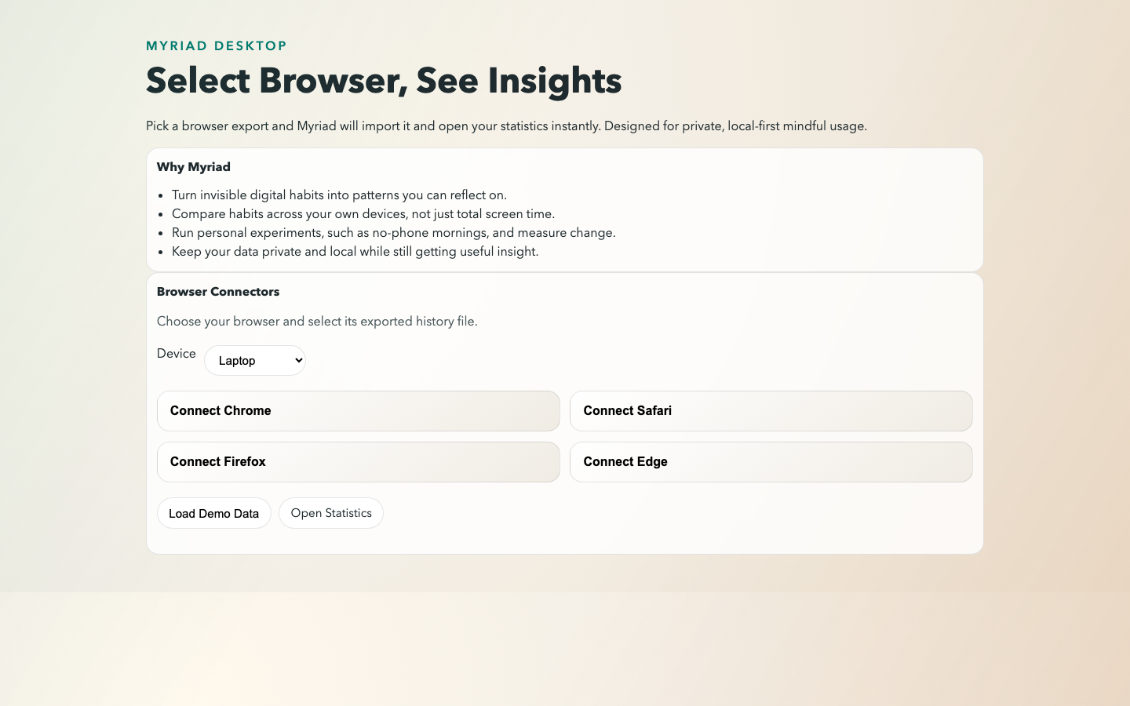
Figure 5: Myriad home screen and primary controls.

Figure 6: Dashboard statistics overview for behavioural analytics output.
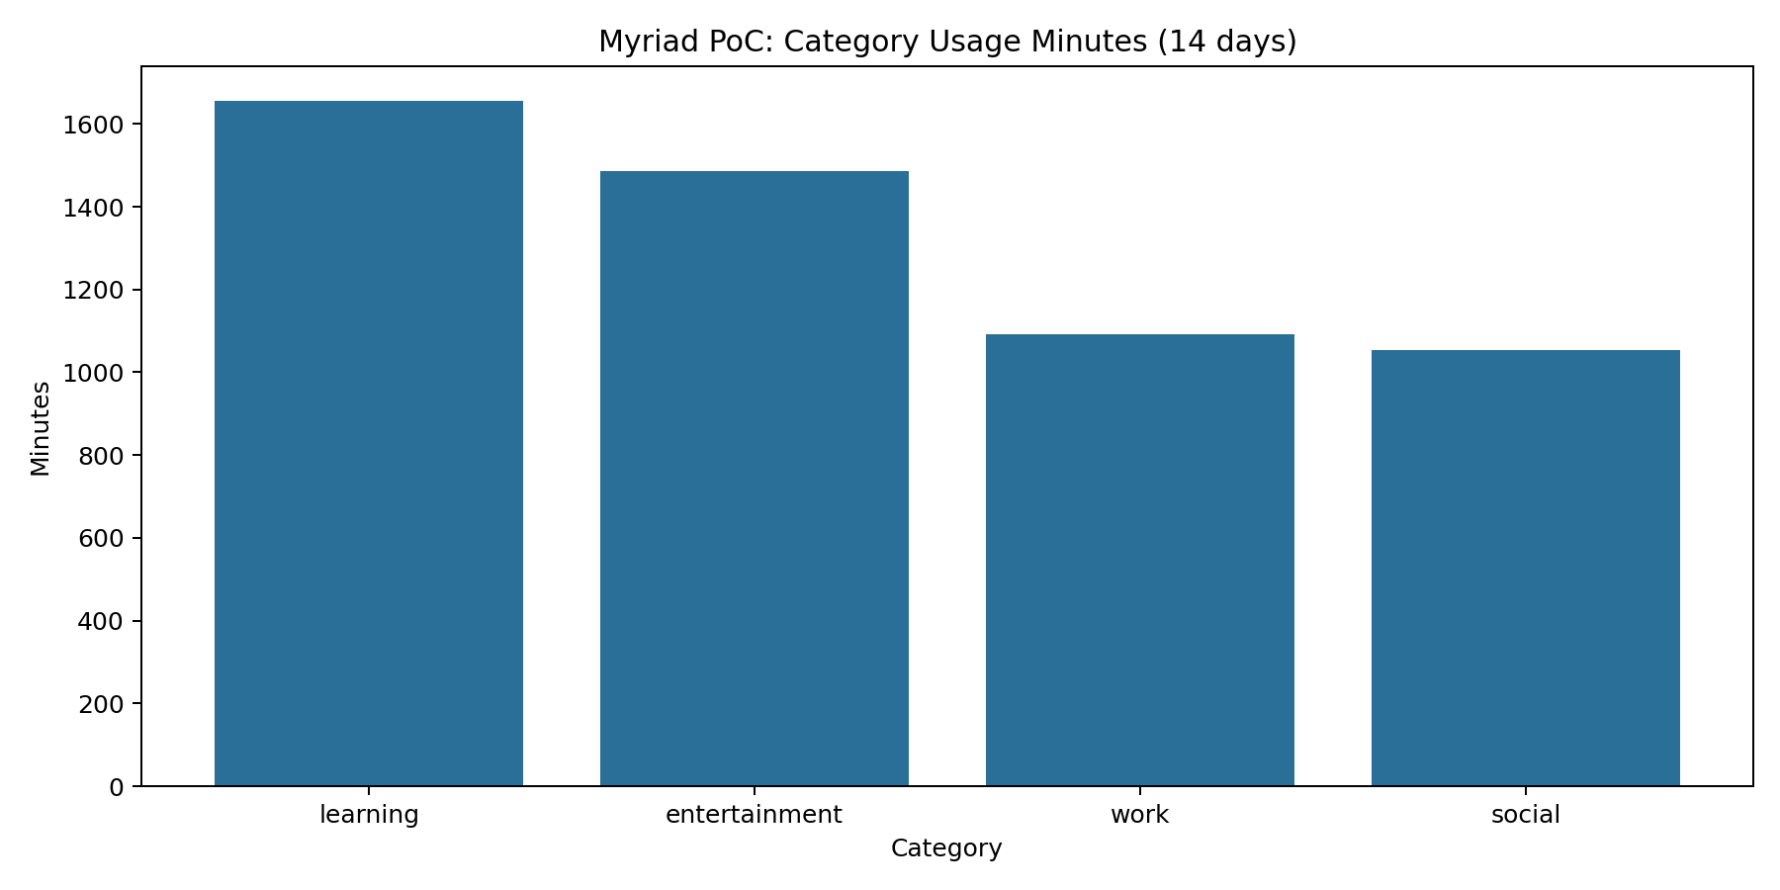
Figure 7: Category-usage visualisation from local processed events.
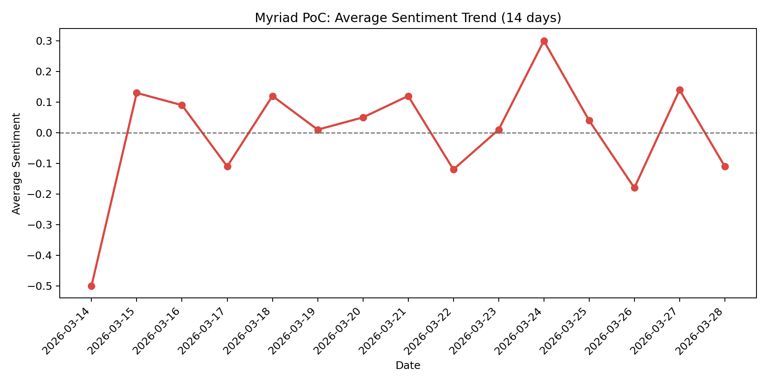
Figure 8: Sentiment-trend visualisation used for reflective feedback.
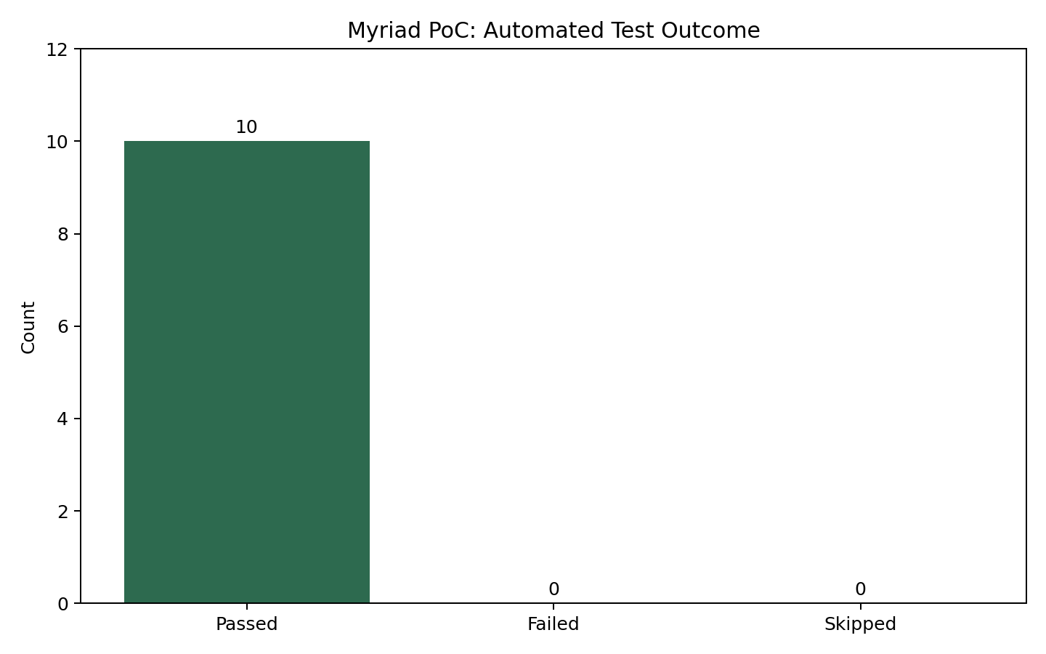
Figure 9: Validation and test outcomes snapshot from the artefact.
A representative summary response includes aggregate totals, active-hours data, category usage, sentiment trend, conversation frequency, top topics, platform and device breakdowns and the currently selected filter state. The enhanced summary response adds a narrative, highlight bullets, provider metadata, warning fields, confidence classification and cache information. Returning this metadata is important because it helps the user and assessor distinguish deterministic aggregates from generated interpretation.

3.4 Implementation Verification Snapshot
Automated tests were executed through npm test and validated deterministic anonymisation, null handling for invalid identifier inputs, successful register/login/profile flow, strict separation of user events, successful connector imports, non-persistence of raw tested identifiers, unknown-device reassignment behaviour, idempotent batch ingestion, administrative enforcement for global summaries, enhanced summary payload correctness and cache-hit behaviour. All 10 tests passed with zero failures in the final recorded execution.
The relatively fast execution time—approximately two seconds—made repeated testing feasible during development. This is significant because privacy-sensitive software benefits from quick regression detection; controls that are slow to verify tend to be checked less often.

3.5 Detailed Endpoint Walkthrough for Reproduction
• Register a profile using POST /api/auth/register with username and password.
• Authenticate using POST /api/auth/login and retain the returned bearer token.
• Check or change consent using GET /api/consent and POST /api/consent.
• Ingest a small event batch through POST /api/events/batch, including externalId values to test idempotency.
• Import a connector payload using one of the dedicated import endpoints.
• Request a personal summary using GET /api/summary?days=7&device=all.
• Request an enhanced summary using GET /api/summary/enhanced and observe cache metadata.
• Repeat the enhanced summary request to verify cache-hit behaviour.
• Export records through GET /api/events/export and inspect transformed identifier fields.
• Delete records with DELETE /api/events and confirm that subsequent summary totals reset.
A separate administrative flow can be demonstrated using x-myriad-admin-key with GET /api/summary/global. This confirms that cross-user aggregate analytics are intentionally gated and unavailable to ordinary authenticated users.

3.6 Implementation Conclusion
The implementation achieved the intended MVP goals: local-first behaviour tracking, privacy-preserving transformation, accountable lifecycle controls and interpretable analytics supported by reproducible tests. The design remains consistent with the dissertation’s central claim that privacy-preserving personal analytics can be demonstrated credibly without default dependence on remote infrastructure.

4. Validation, Testing and Critical Review

4.1 User/Usability Testing
Method: five participants (three target users plus two fresh-user computing students) completed scripted tasks T1-T4. Selection criteria were familiarity with everyday productivity apps, no prior codebase access, and availability for moderated observation.
Table 4.1 Usability Task-to-Requirement Mapping.
Implications: the weakest areas were ingestion guidance and terminology clarity. For deployment, unresolved ambiguity would reduce user trust and increase misuse risk. The design was updated with clearer onboarding and stronger confidence signalling.

4.2 System Testing
Method: automated unit and API integration tests were run across authentication, ingestion, anonymisation, summary generation, export/delete, and error handling paths. The suite targeted both correctness and regression resistance for privacy-critical behaviour.
Results: core must-have requirements (F1-F3, NF1, NF3, NF5) passed on representative datasets. The most sensitive checks validated consent gating, per-user isolation, deterministic transformation, and stable endpoint behaviour under invalid input.
Implications: while system correctness is strong for MVP scope, packaging and dependency drift remain operational risks. Before broader deployment, continuous regression execution and release-hardening checks are required.

4.3 Critical Review
The combined testing evidence shows strong alignment with high-priority privacy and control requirements, but highlights remaining usability and maintainability work for production readiness. Key consequences are: clearer user guidance improves trust outcomes, and stronger release engineering is needed to preserve reliability over time.
Next changes would prioritise richer first-run guidance, deeper accessibility/usability validation with a broader participant pool, and expanded automated checks around packaging and upgrade paths.
Task | Objective | Mapped Requirement(s) | Result
T1 | Register/login with consent awareness | F2, F3, NF4 | 5/5 complete; onboarding copy clarity improved.
T2 | Ingest sample event set | F1, F2, NF3 | 4/5 complete unaided; payload guidance improved.
T3 | Interpret dashboard metrics | F4, NF2, NF4 | 4/5 complete; label simplification required.
T4 | Interpret narrative summary trust signals | F5, NF1, NF4 | 5/5 complete; confidence/disclaimer prominence increased.

5. References
Cavoukian, A. (2010a) ‘Privacy by design: the definitive workshop. A foreword by Ann Cavoukian, Ph.D’, Identity in the Information Society, 3, pp. 247–251. Available at: https://doi.org/10.1007/s12394-010-0062-y (Accessed: 28 March 2026).
Cavoukian, A., Taylor, S. and Abrams, M.E. (2010b) ‘Privacy by Design: essential for organizational accountability and strong business practices’, Identity in the Information Society, 3, pp. 405–413. Available at: https://doi.org/10.1007/s12394-010-0053-z (Accessed: 28 March 2026).
Cheung, J.C. and Ho, S.S. (2025) ‘The effectiveness of explainable AI on human factors in trust models’, Scientific Reports, 15, 23337. Available at: https://doi.org/10.1038/s41598-025-04189-9 (Accessed: 28 March 2026).
Electron (2026) Electron documentation. Available at: https://www.electronjs.org/docs/latest/ (Accessed: 28 March 2026).
European Union (2016) Regulation (EU) 2016/679 (General Data Protection Regulation). Available at: https://eur-lex.europa.eu/eli/reg/2016/679/oj (Accessed: 28 March 2026).
Express.js (2026) Express – Node.js web application framework. Available at: https://expressjs.com/ (Accessed: 28 March 2026).
Huckvale, K., Venkatesh, S. and Christensen, H. (2019) ‘Toward clinical digital phenotyping: a timely opportunity to consider purpose, quality, and safety’, npj Digital Medicine, 2, 88. Available at: https://doi.org/10.1038/s41746-019-0166-1 (Accessed: 28 March 2026).
ICO (2025) ‘Pseudonymisation’. Information Commissioner’s Office. Available at: https://ico.org.uk/for-organisations/uk-gdpr-guidance-and-resources/data-sharing/anonymisation/pseudonymisation/ (Accessed: 28 March 2026).
Kleppmann, M., Wiggins, A., van Hardenberg, P. and McGranaghan, M. (2019) ‘Local-first software: you own your data, in spite of the cloud’, in Companion Proceedings of the 2019 ACM SIGPLAN International Systems and Applications Conference. Available at: https://doi.org/10.1145/3359591.3359737 (Accessed: 28 March 2026).
Li, H., Ge, L. and Tian, L. (2024) ‘Survey: federated learning data security and privacy-preserving in edge-Internet of Things’, Artificial Intelligence Review, 57, 130. Available at: https://doi.org/10.1007/s10462-024-10774-7 (Accessed: 28 March 2026).
Minh, D., Wang, H.X., Li, Y.F. and Nguyen, T.N. (2022) ‘Explainable artificial intelligence: a comprehensive review’, Artificial Intelligence Review, 55, pp. 3503–3568. Available at: https://doi.org/10.1007/s10462-021-10088-y (Accessed: 28 March 2026).
Myriad repository (2026) GitHub repository for the artefact implementation. Available at: https://github.com/JakkuAzzo/Myriad.git (Accessed: 28 March 2026).
Node.js (2026) Node.js API documentation. Available at: https://nodejs.org/docs/latest/api/ (Accessed: 28 March 2026).
NPM (2026a) better-sqlite3 package documentation. Available at: https://www.npmjs.com/package/better-sqlite3 (Accessed: 28 March 2026).
NPM (2026b) bcryptjs package documentation. Available at: https://www.npmjs.com/package/bcryptjs (Accessed: 28 March 2026).
NPM (2026c) multer package documentation. Available at: https://www.npmjs.com/package/multer (Accessed: 28 March 2026).
NPM (2026d) supertest package documentation. Available at: https://www.npmjs.com/package/supertest (Accessed: 28 March 2026).
NPM (2026e) @xenova/transformers package documentation. Available at: https://www.npmjs.com/package/@xenova/transformers (Accessed: 28 March 2026).
SQLite (2026) SQLite documentation. Available at: https://www.sqlite.org/docs.html (Accessed: 28 March 2026).
Stanghellini, G. and Leoni, F. (2020) ‘Digital phenotyping: ethical issues, opportunities, and threats’, Frontiers in Psychiatry, 11, 473. Available at: https://doi.org/10.3389/fpsyt.2020.00473 (Accessed: 28 March 2026).
Wang, Z., Rucker, M., Toner, E.R., Larrazabal, M.A., Boukhechba, M., Teachman, B.A. and Barnes, L.E. (2023) ‘Understanding privacy risks versus predictive benefits in wearable sensor-based digital phenotyping: a quantitative cost-benefit analysis’, 2023 International Conference on Wearable and Implantable Body Sensor Networks. Available at: https://doi.org/10.1109/BSN58485.2023.10331378 (Accessed: 28 March 2026).

6. Appendices

Appendix A: Artefact Repository Structure
data/ – local SQLite database files
electron/ – desktop shell main and preload scripts
public/ – frontend pages and dashboard scripts/styles
src/ – server routes, database logic, anonymisation, connectors and summary generation
test/ – automated unit and API tests

Appendix B: API Endpoint Catalogue
Health
GET /api/health
Authentication
POST /api/auth/register
POST /api/auth/login
GET /api/auth/me
POST /api/auth/logout
GET /api/users
Consent
GET /api/consent
POST /api/consent
Events and Analytics
POST /api/events
POST /api/events/batch
POST /api/events/sample-seed
GET /api/summary
GET /api/summary/global (admin)
GET /api/summary/enhanced
GET /api/events/export
DELETE /api/events
POST /api/events/reassign-unknown-device
Import Connectors
POST /api/import/whatsapp
POST /api/import/telegram
POST /api/import/browser-history
POST /api/import/upload?connector=...

Appendix C: Selected Validation Evidence
Final automated test execution summary:
Total tests: 10
Passed: 10
Failed: 0
Duration: approximately 2 seconds
Validated behaviour included user isolation, consent enforcement, import correctness, pseudonymisation, admin controls, enhanced summary response integrity and cache behaviour.

Appendix D: Example Event Payload
{
"occurredAt": "2026-03-10T12:00:00.000Z",
"source": "chat",
"category": "social",
"durationMinutes": 10,
"sentiment": 0.15,
"topic": "friends",
"identifier": "raw-user-id-or-handle"
}

Appendix E: Formatting and Handbook Compliance Checklist
This final version is aligned to the Computer Science Final Year Project handbook chapter sequence and assessment structure.

Appendix F: Stakeholder Engagement Outcomes Table
Table F.1 Participant outcomes and requirement derivation.
Participant Code | Stakeholder Type | Main Concern | Requirement Derived
P01 | Supervisor (academic) | Need assessable traceability from analysis to validation | F6, NF6
P02 | Technical peer | Risk of schema inconsistency during feature growth | NF3, NF6
P03 | Technical peer | Cross-user data isolation must be explicit | F3, NF1
P04 | Target user | Data should stay local unless explicitly shared | F1, NF5
P05 | Target user | Consent and deletion controls must be clear | F2, F6, NF4
P06 | Target user | Summaries need confidence cues to avoid over-trust | F5, NF4

