Myriad: A Local-First, Privacy-Preserving
Mindful Habit Tracker

Said Osman
March 2026

FACULTY OF SCIENCE, ENGINEERING AND COMPUTING
School of Computer Science and Mathematics
BSc (Hons) Degree in Cyber Security

Project Title: Myriad: A Local-First, Privacy-Preserving Mindful Habit Tracker
Student Name: Said Osman
KU ID: k2376552
Supervisor: Dr Deepak GC
Date of Submission: March 2026

Declaration
The author has read and understood the University regulations on plagiarism and understands the meaning of plagiarism. This dissertation is the author’s own work. Any other sources are duly acknowledged and referenced according to the requirements of the School of Computer Science and Mathematics. All verbatim citations are indicated by quotation marks. No part of another student’s work has been presented as original work. No unauthorised assistance has been used in producing this report in the form of code, text or drawings.
Date: March 2026
Name: Said Osman
Signature: __________________________

Table of Contents
1. Introduction and State of the Art Review
2. Analysis and Design
3. Realisation
4. Validation, Testing and Critical Review
5. References
6. Appendices

Table of Figures
Figure 1: Myriad high-level architecture
Figure 2: Event ingestion and privacy-preserving transformation pipeline
Figure 3: Summary analytics and enhanced insight generation flow
Figure 4: Dashboard capability map

Glossary of Terms
Term | Meaning
API | Application Programming Interface
CSV | Comma-Separated Values
GDPR | General Data Protection Regulation
LLM | Large Language Model
MVP | Minimum Viable Product
ONNX | Open Neural Network Exchange
PII | Personally Identifiable Information
SHA-256 | Secure Hash Algorithm 256-bit digest
SQL | Structured Query Language
WAL | Write-Ahead Logging

1. Introduction and State of the Art Review
Digital wellbeing, self-tracking and behavioural analytics have become increasingly common across consumer software, health applications and productivity platforms. However, many deployed systems are cloud-centric by default: data is collected continuously, transmitted to remote infrastructure and then analysed outside the user’s immediate control. Within cyber security this creates a recognisable tension. The same telemetry that can produce insight may also expose intimate behavioural patterns, reveal communication rhythms and generate secondary risks through retention, repurposing or breach. Research on digital phenotyping has shown the analytical promise of passively captured device data, but it has also highlighted concerns about safety, privacy, trust and implementation quality (Huckvale, Venkatesh and Christensen, 2019; Stanghellini and Leoni, 2020).
Myriad was designed in response to that tension. The project proposes a local-first mindful habit tracker that collects selected activity signals, transforms identifying fields before persistence, stores records locally in SQLite and presents summary analytics through a local dashboard. The core design proposition is simple: useful behavioural reflection should not require default surrender of raw personal data to a third-party cloud service. In this sense, Myriad is not only a software artefact but also an architectural argument about how cyber security principles can be made operational in everyday personal analytics.
From a systems perspective, the problem can be framed as a trade-off between observability and confidentiality. Greater observability usually depends on richer telemetry and longer retention; yet those same choices enlarge the attack surface and increase the consequences of misuse. Local-first software has been proposed as a way to recover some of the responsiveness, ownership and resilience associated with traditional installed applications while preserving selected benefits of modern software ecosystems (Kleppmann et al., 2019). For a student project dealing with potentially sensitive behavioural data, that design direction is especially attractive because it reduces unnecessary external dependencies and makes the flow of data easier to reason about.
The threat context relevant to this artefact includes unauthorised local access, re-identification through metadata, accidental over-collection, data contamination across user profiles and over-trust in generated narrative summaries. Even where message content is absent, behavioural metadata can still reveal work patterns, topic interests, communication frequency and social rhythms. The UK Information Commissioner’s Office emphasises that pseudonymisation reduces risk but does not remove data from the scope of data protection law, particularly where re-identification remains possible through additional information or contextual linkage (ICO, 2025). Accordingly, Myriad treats pseudonymisation as one safeguard among several rather than as a complete legal or technical solution.
The scale and relevance of the problem are significant. Personal devices produce continuous traces through browsing, messaging, application switching and time-based activity. Studies on digital phenotyping and wearable sensing repeatedly show that these traces can be highly informative, but also that privacy risk grows as datasets become richer and more linkable (Huckvale, Venkatesh and Christensen, 2019; Wang et al., 2023). This makes behavioural analytics a suitable topic for a cyber security dissertation because it forces the designer to make explicit trade-offs between utility, governance and technical feasibility.
The key stakeholders are the primary end user, who needs meaningful feedback without disproportionate privacy loss; the project assessors, who require technical rigour, critical analysis and evidence of cyber-security relevance; and future maintainers or developers, who require an implementation that is comprehensible, modular and testable. Additional stakeholders include organisations interested in privacy-first analytics approaches for regulated or trust-sensitive contexts.
The overall aim of the project is to design and implement a local-first activity tracking system that preserves user privacy while producing useful behavioural summaries. To realise that aim, the dissertation pursues the following objectives: build a desktop application architecture using Electron, Express and SQLite; implement per-user account separation and token-based session handling; add ingestion pathways for direct event capture and selected imports; pseudonymise identifier fields before persistence; provide dashboard visualisations and summary endpoints; support export and deletion controls; and validate the artefact through automated tests and representative ingestion scenarios.
The project scope is deliberately limited. Myriad is positioned as a proof-of-concept and robust MVP rather than a full commercial product. It excludes cloud synchronisation, enterprise multi-tenancy, production mobile telemetry agents and formal organisational deployment. These exclusions were intentional. They reduced delivery risk, kept the evaluation aligned with the module timescale and allowed the project to focus on privacy-by-design, data minimisation and local accountability rather than infrastructure operations.
Legal, social and ethical implications were considered from project inception. The artefact is aligned conceptually with GDPR principles such as data minimisation, purpose limitation and integrity/confidentiality, although it does not claim formal certification or legal approval. The design avoids persistence of raw imported identifiers where transformation is possible, minimises external transmission and gives the user direct control over collection, export and deletion. No human-subject experimentation requiring ethics committee approval was undertaken; development and testing used synthetic or user-controlled local data. Socially, the system is intended to support reflection rather than judgement. Ethically, the project adopts proportionality: collect and retain only the data needed for aggregate insight, and present generated narrative outputs with explicit warnings and confidence limits (European Union, 2016; Cavoukian, 2010a).

2. Analysis and Design
The project was managed using a phased, milestone-oriented strategy that combined iterative development with periodic evaluation checkpoints. Because CI6600 assesses both the artefact and the written report, project management had to support more than coding alone. The plan therefore prioritised early completion of core security and persistence features, followed by analytics, validation and documentation. This sequencing was chosen to reduce the risk of late rework in privacy-critical areas.

2.1 Management Tools and Techniques
The principal management techniques were milestone decomposition, weekly backlog review, incremental integration, lightweight risk tracking and automated testing as a release gate for critical API behaviour. Rather than adopting heavyweight team-oriented ceremonies, the project used a compact single-developer workflow based on Git version control, npm scripts and regular supervisor-facing progress articulation. This approach was proportionate to the project’s scale while still maintaining traceability.
• Milestone decomposition into architecture, ingestion, analytics, privacy controls, enhanced insight and validation phases.
• Weekly review of tasks with explicit priority given to security-critical functionality.
• Incremental integration so each new feature was tested against current API behaviour before extension.
• Automated tests as a release gate for authentication, isolation, pseudonymisation and summary integrity.
• Lightweight risk tracking with explicit mitigations tied to implementation decisions.
Implementation sequencing followed dependency order. Authentication and user boundaries were completed before aggregate analytics so that summary queries would not later require structural redesign. Migration checks were added before new event attributes such as client_platform, app_version, os_version and external_id. In practice this reduced avoidable schema churn and improved confidence when extending the event model.

2.2 Alternative Approaches Considered
Alternative approaches included a Trello-style Kanban board, Scrum-inspired sprint ceremonies and formal issue-tracking templates. These methods can improve visibility in multi-person projects, but for a single-student dissertation they risked shifting effort away from artefact quality toward administrative overhead. The final approach therefore used a hybrid model: explicit milestones, written progress logging, local version control and iterative supervisor review. This remained aligned with the handbook’s emphasis on planning, self-reliance and week-by-week progress without imposing unnecessary ceremony.

2.3 Work Plan and Milestones
Phase | Activities | Deliverables | Indicative Outcome
Phase 1: Requirements and Architecture | Define problem, scope, privacy objectives and stack selection | Architecture baseline | Local-first model and module boundaries approved
Phase 2: Core Platform | User model, authentication, settings and events schema | Running API with persistence | Multi-user local system operational
Phase 3: Data Ingestion | Event endpoints and import connectors | WhatsApp, Telegram and browser ingestion | Input interoperability demonstrated
Phase 4: Analytics | Summary queries, charts and filtering logic | Statistical views and trend endpoints | Behaviour insight available
Phase 5: Privacy Controls | Consent toggle, export, pseudonymisation and delete operations | User data lifecycle controls | Privacy posture strengthened
Phase 6: Enhanced Insights | Narrative summary pipeline, cache strategy and fallback behaviour | Enhanced summary endpoint | Local narrative insight generated reliably
Phase 7: Validation and Documentation | Automated testing, dissertation drafting and final review | Submission-ready artefact and report | Assessment-ready project

2.4 Risk Management

Stakeholder Engagement and Requirements Elicitation
Stakeholder analysis was conducted through a structured sample of real participants (n=6): one project supervisor (academic stakeholder), two final-year computing peers (technical reviewers), and three target users who regularly self-track habits (end-user stakeholders). Participants were selected using purposive sampling so each group represented a distinct perspective: assessment quality, technical feasibility, and day-to-day usability/privacy expectations.
Engagement method and protocol: two semi-structured interview rounds (weeks 5 and 9) plus one moderated walkthrough session (week 11). The interview schedule used six fixed prompts: (1) what behaviour insights are genuinely useful, (2) what data feels too intrusive to collect, (3) what controls are required before trust is earned, (4) what outputs are easiest to interpret, (5) what prevents continued use, and (6) what evidence is needed to consider the system reliable.
Raw outcomes were documented as short notes per participant and consolidated by theme. Recurrent findings were: strong preference for local storage by default (6/6), expectation of explicit consent before ingestion (6/6), concern about accidental cross-user mixing (5/6), need for plain-language dashboard labels (4/6), and concern that generated narrative summaries could be over-trusted without confidence cues (4/6). These findings translated into requirements F1-F5: local-first persistence, consent-gated ingestion, strict per-user data scoping, simplified metric terminology, and confidence-aware summary messaging with fallback behaviour.

Derived Requirements and Prioritisation (MoSCoW)
Must have: local-first storage, explicit consent gate, deterministic anonymisation, and reproducible analytics outputs.
Should have: modular connector ingestion, transparent endpoint catalogue, and robust automated API/system tests.
Could have: optional cross-device synchronisation, richer behavioural visualisations, and user-configurable insight narratives.
Won't have (current scope): continuous mobile telemetry collection and clinician-facing intervention tooling.

Requirements Modelling and Design Artefacts
Requirements were modelled using personas, user stories, and scenario-based use cases. Two core personas were maintained: a privacy-sensitive student seeking reflection without surveillance, and a technical reviewer prioritising correctness and reproducibility. User stories followed the form 'As a <role>, I want <capability>, so that <outcome>'.
Design artefacts comprised a privacy boundary data-flow map, module decomposition (server, db, anonymise, connectors, llm), endpoint contracts for authentication/summary/export/delete, and a requirement-to-test matrix. This provided traceability from stakeholder statement to requirement, from requirement to design control, and from design control to evidence in system and usability testing.
Risk | Likelihood | Impact | Mitigation
Identifier leakage through raw imports | Medium | High | Apply pseudonymisation before persistence and minimise stored fields
Duplicate event ingestion in batch mode | Medium | Medium | Use uniqueness checks on (user_id, external_id) where external identifiers exist
Data contamination across users | Low | High | Enforce explicit user_id scoping in all queries and tests
Over-reliance on local AI runtime | Medium | Medium | Provide deterministic heuristic fallback when ONNX is unavailable
Performance degradation on repeated summary calls | Medium | Medium | Introduce summary caching with expiry and invalidation
Loss of trust due to opaque processing | Medium | High | Provide visible consent state, export and irreversible delete endpoints
Overall, the management strategy was effective because technical risk treatment was embedded into implementation rather than deferred until the end of the project. A clear lesson from the development cycle is that dissertation drafting should begin once architecture stabilises. Early writing reduced recall loss, helped align implementation claims with actual design choices and made later critical reflection more precise.

State of the Art Review
The literature review evaluates the bodies of work that most directly shaped Myriad’s design. The review is organised around five themes: local-first software, privacy-by-design and pseudonymisation, behavioural analytics and digital phenotyping, desktop/local architecture choices, and AI-generated summaries. The goal is not only to summarise prior work, but to show how that work influenced concrete technical decisions in the artefact.

Local-First Software and Edge-Oriented Processing
Local-first software has emerged as a response to a perceived imbalance in cloud software, where convenient synchronisation and collaboration are often purchased at the cost of ownership, long-term access and privacy. Kleppmann et al. (2019) argue that local-first applications should combine the availability and direct control of traditional installed software with selected collaborative benefits associated with the cloud. Their work is especially relevant to Myriad because it reframes privacy and resilience as architectural properties rather than post-hoc compliance features.
The strongest relevance of local-first thinking to Myriad lies in data residency and dependency reduction. If primary behavioural data remains on-device, then several classes of risk are reduced: central storage breaches, opaque secondary processing, policy drift in cloud services and dependence on a continuing vendor relationship. For a mindful habit tracker, these are not abstract concerns. Activity traces can encode social patterns, interests and daily routines, so centralising them by default would create disproportionate exposure relative to the benefit of basic self-reflection.
However, local-first is not without trade-offs. Kleppmann et al. (2019) emphasise collaboration and multi-device operation, whereas Myriad intentionally adopts a more modest local-first position centred on single-device operation and controlled imports. This is a defensible narrowing of scope. In the context of a final-year proof of concept, it is more valuable to demonstrate privacy-preserving transformation, isolation and explainable analytics well than to implement fragile synchronisation badly. The literature therefore informed not only the project’s direction, but also its restraint.
Recent work in privacy-preserving edge analytics supports the broader intuition that moving computation closer to the data source can reduce privacy exposure and communication overhead, although it does not eliminate risk. Surveys in edge and federated settings note that local or decentralised processing improves latency and can reduce raw-data transfer, but still requires careful attention to inference attacks, resource constraints and governance (Li, Ge and Tian, 2024). Myriad draws on that same principle in a simpler form: perform the most sensitive transformations and summarisation locally first, and avoid external transmission unless an explicit future design requires it.

Privacy by Design, Data Minimisation and Pseudonymisation
Privacy by Design is one of the most important conceptual foundations for this dissertation. Cavoukian (2010a; 2010b) argues that privacy should be embedded into the design and operation of systems rather than addressed retrospectively through policy alone. This perspective aligns closely with a cyber-security approach, because it encourages designers to reduce exposure structurally rather than relying on later procedural correction. In Myriad, that principle appears in the ordering of the pipeline: identifiers are transformed before durable persistence, consent is checked before collection, and export/delete are treated as core product features rather than optional additions.
The GDPR provides a legal and normative backdrop for those choices. Regulation (EU) 2016/679 emphasises principles including data minimisation, purpose limitation and integrity/confidentiality. These principles do not prescribe one specific architecture, but they do create a strong rationale for collecting only what is necessary, retaining it proportionately and protecting it through technical and organisational means (European Union, 2016). A local-first design does not automatically guarantee compliance, yet it can make these principles easier to operationalise because the data flow is narrower and more transparent.
Pseudonymisation is especially relevant because Myriad handles behaviour-linked identifiers. The ICO’s recent guidance stresses that pseudonymisation involves replacing or transforming identifying information while keeping any additional information separate; importantly, pseudonymised data usually remains personal data in the hands of the controller that can reverse or contextualise it (ICO, 2025). This distinction matters. It means that hashing identifiers is useful, but not magic. Re-identification can still occur through linkage, auxiliary knowledge or retained additional information.
For that reason, the literature supports a layered interpretation of privacy protection. Pseudonymisation lowers direct identifiability, but should be combined with minimisation of metadata, bounded retention, user-level access separation and careful export behaviour. Myriad reflects this layered approach by hashing identifiers, storing only selected dimensions needed for aggregate insight and preserving user controls over deletion and consent. This is more academically defensible than claiming that hashing alone renders behavioural data anonymous.
A further implication from the literature is the need to acknowledge attacker models. The ICO (2025) explicitly recommends considering insider threats, external threats and the goals of re-identification attempts. That perspective influenced the project’s risk analysis. The system is designed primarily to reduce everyday exposure and careless over-collection; it is not positioned as a cryptographically hardened anti-forensics tool. This realistic framing strengthens the dissertation, because it matches safeguards to plausible scope rather than overstating the capability of a student artefact.

Behavioural Analytics, Digital Phenotyping and Wellbeing Data
The most directly relevant application literature comes from digital phenotyping and passive behavioural sensing. Huckvale, Venkatesh and Christensen (2019) define digital phenotyping as the moment-by-moment quantification of human behaviour using data from personal digital devices. Their review highlights both the promise and the difficulty of turning passively generated signals into meaningful, safe and acceptable interventions. Privacy, trust, equity and validation are presented as implementation barriers rather than secondary details.
This is highly relevant to Myriad because the project similarly works with traces derived from ordinary digital activity. Although Myriad is not a clinical mental-health system, it occupies a neighbouring design space: it translates small behavioural signals into summaries intended to support reflection. The literature therefore acts as a warning. If analytics become too opaque, too normative or too data-hungry, the system may create new harms while attempting to offer insight. Myriad’s descriptive rather than prescriptive dashboard language was influenced by this concern.
Ethical discussions in digital phenotyping further reinforce the need for caution. Stanghellini and Leoni (2020) argue that digital phenotyping affects more than technical data handling; it also changes how people are represented and understood through data. Their argument is particularly useful for a mindful habit tracker, where metrics can easily be mistaken for judgements of value, discipline or wellness. This supports the project’s choice to frame summaries as observations with warnings rather than diagnoses or scores.
Privacy-utility trade-offs are also visible in empirical work on wearable sensing. Wang et al. (2023) show that richer sensing can improve predictive performance while also increasing privacy risk. For Myriad, the design response was not to maximise possible data capture, but to be selective: ingest only a constrained subset of events, limit retained fields and prefer aggregate views over detailed raw histories where possible. This demonstrates how the project moved from literature to design decision instead of treating the review as purely descriptive background.

Desktop Delivery, Local Databases and Technical Architecture
Desktop delivery using Electron and a local Express API was selected for practical and academic reasons. Technically, the arrangement enables a clear separation between presentation, request handling, persistence and transformation logic. Academically, it provides an artefact that is demonstrable, testable and reproducible within the module timescale. Electron’s documentation highlights its value for cross-platform desktop delivery using familiar web technologies, while Express and SQLite offer a lightweight path to local service composition and persistent storage (Electron, 2026; Express.js, 2026; SQLite, 2026).
Nevertheless, the literature and technical ecosystem also point to trade-offs. Electron applications can be heavier than native clients, and native modules such as SQLite bindings may complicate packaging or upgrades. SQLite provides strong local simplicity and deterministic behaviour for single-user workloads, but it is not intended to solve distributed, multi-tenant or high-concurrency enterprise scenarios. These trade-offs are acceptable in Myriad because the project explicitly targets a local-first proof of concept. The chosen stack is therefore not claimed to be universally optimal; rather, it is argued to be proportionate to the problem and assessment context.
The use of a local API boundary inside a desktop application also has methodological value. By exposing analytics and lifecycle operations through explicit endpoints, the project becomes easier to test with automated tools such as Supertest and easier to inspect conceptually. Instead of burying all logic inside UI callbacks, Myriad presents a clearer model of what is collected, transformed and returned. This is a valuable design property in privacy-sensitive software, because explicit interfaces are easier to reason about than hidden stateful behaviours.

AI Summarisation, Transparency and Over-Trust
Myriad includes an enhanced narrative summary layer, which introduces a different literature concern: user trust in AI outputs. The explainable AI literature argues that AI systems can become more acceptable and trustworthy when they communicate limitations and provide understandable rationale, but it also warns that trust is socially mediated and context-sensitive rather than automatically deserved (Minh et al., 2022; Cheung and Ho, 2025). For Myriad, this suggests that narrative summaries should support interpretation without presenting themselves as authoritative psychological truths.
This concern is important because generative summaries can sound more confident than the underlying evidence warrants. A dashboard may compute totals and trends deterministically, yet the narrative phrasing built on top of those totals can introduce rhetorical force and perceived certainty. Myriad therefore adopts a deliberately constrained approach: it feeds summarisation only redacted, quantified context; it supports a deterministic heuristic fallback; and it returns warning and confidence fields along with the narrative output. This design was informed less by the pursuit of novelty and more by the literature’s warning against black-box overreach.
At a broader level, the literature also supports the project’s decision not to rely on a remote summarisation API. A remote model might increase fluency, but it would also conflict with the local-first privacy rationale by requiring behavioural context to leave the device. The chosen design therefore prioritises locality and transparency over maximum expressive sophistication. Within the scope of a cyber-security dissertation, that is an academically defensible trade-off.

Critical Synthesis and Design Implications
Taken together, the literature supports a design pattern for privacy-aware personal analytics: keep primary data local where possible; transform identifiers before persistence; minimise retained fields; expose clear lifecycle controls; validate both functionality and prohibited behaviour; and treat generated insight as supportive rather than authoritative. No single source alone dictates this pattern, but the convergence across local-first computing, privacy-by-design, digital phenotyping and explainable AI makes the pattern persuasive.
The review also clarifies what Myriad is not. It is not an anonymisation system, because pseudonymisation does not remove legal and inferential risks. It is not a clinical diagnostic engine, because behavioural summaries are not evidence of disorder or wellbeing in a medical sense. It is not a distributed collaboration platform, because synchronisation and replication were intentionally left outside scope. These negative clarifications matter academically because they define the project’s contribution more precisely.
The contribution suggested by the literature is therefore both technical and methodological. Technically, Myriad demonstrates a working local-first analytics artefact. Methodologically, it shows how cyber-security principles can be translated into routine product behaviour in a small but realistic software system. That alignment between theory, architecture and validation is the main reason the chosen design remains defensible under the CI6600 handbook’s expectations for literature review, artefact creation and critical evaluation.

Analysis and Design Process
The methodology combined proof-of-concept engineering with empirical verification. The purpose was not to conduct a human-subject experiment, but to design, build and test a complete local software artefact that could ingest selected user activity data, transform sensitive fields, persist events safely and produce interpretable analytics. This is consistent with the handbook’s proof-of-concept project type, where the artefact is the central research output and the dissertation critically explains how and why it was created.

Intended Deliverables
• Executable desktop application with local backend and dashboard.
• Structured database schema with migration-aware evolution.
• Event ingestion API and file import connectors.
• Privacy controls including consent, pseudonymisation, export and delete.
• Summary analytics and enhanced narrative generation.
• Automated test suite demonstrating correctness and control integrity.

Influence of Literature Outcomes
The literature directly shaped the methodological choices. Local-first principles motivated the decision to keep primary persistence on-device. Privacy-by-design and ICO guidance shaped the order of the ingestion pipeline so that transformation happened before durable storage. Digital phenotyping literature highlighted the risks of over-interpreting behavioural traces and therefore informed the descriptive framing of dashboard outputs. Explainable AI literature informed the use of warning and confidence fields in enhanced summaries.

Hardware Environment
Development and validation were carried out on Apple Silicon macOS hardware suitable for desktop development, local API execution and browser-based dashboard testing. This hardware class provided more than sufficient performance for SQLite transactions, chart rendering and optional ONNX pipeline tests. The absence of remote infrastructure is methodologically beneficial because it reduces environmental variance during reproduction.

Software Environment and Specifications
Component | Specification / Role
Runtime | Node.js
Backend | Express 5.x
Desktop shell | Electron 40.x
Database | SQLite via better-sqlite3 12.x
Password security | bcryptjs
File ingestion | multer
API testing | Supertest with Node test runner
Optional AI summarisation | @xenova/transformers (ONNX pipeline)

Data Model and Processing Method
The data-handling method followed a defined sequence. First, the system receives a raw event or import payload. Second, connector logic normalises schema fields such as source, category, duration, timestamp and platform labels. Third, identifier values are transformed using salted SHA-256 before insertion where pseudonymisation applies. Fourth, transformed records are persisted locally under the active user scope. Fifth, analytics endpoints compute aggregate views with optional device or time filters. Sixth, enhanced summaries are generated from redacted aggregate context and cached with expiry. Structuring the process in this order ensures that privacy-relevant transformation occurs before durable persistence.
The schema was designed for explainability. Analytical dimensions such as category, source, duration, topic and device are stored in explicit fields that support transparent SQL aggregation. This makes summary results easier to test and defend than a more opaque processing pipeline would. Idempotency was handled using a partial uniqueness constraint on (user_id, external_id) where upstream connectors provide stable event identifiers. This reduces distortion caused by repeated imports or retried submissions.
Summary caching uses deterministic keys derived from scope, time window and filter values. Cache invalidation occurs after event mutation, while stale entries expire by time-to-live policy. This balances responsiveness with freshness and is particularly useful for enhanced summaries, which can be more expensive than deterministic aggregates.

Validation Method
Validation combined unit and API integration tests. The test strategy deliberately distinguished between functional correctness and privacy/control integrity. Functional tests checked that endpoints returned the expected payload shapes and that imports, authentication and summaries operated as intended. Control-oriented tests checked that prohibited behaviours did not occur: unauthorised global summaries were rejected, user data was isolated correctly and transformed identifiers were persisted instead of raw identifiers. This distinction is important in cyber-security work because a system can be functionally successful while still violating privacy or authorisation expectations.
The recorded final test execution showed 10 passing tests with zero failures. While this does not prove the absence of defects, it provides credible evidence that the project’s most important behaviours were exercised repeatedly in a reproducible local environment. The project also used negative-space evaluation: it explicitly tested what the system should refuse to do, not only what it should do.
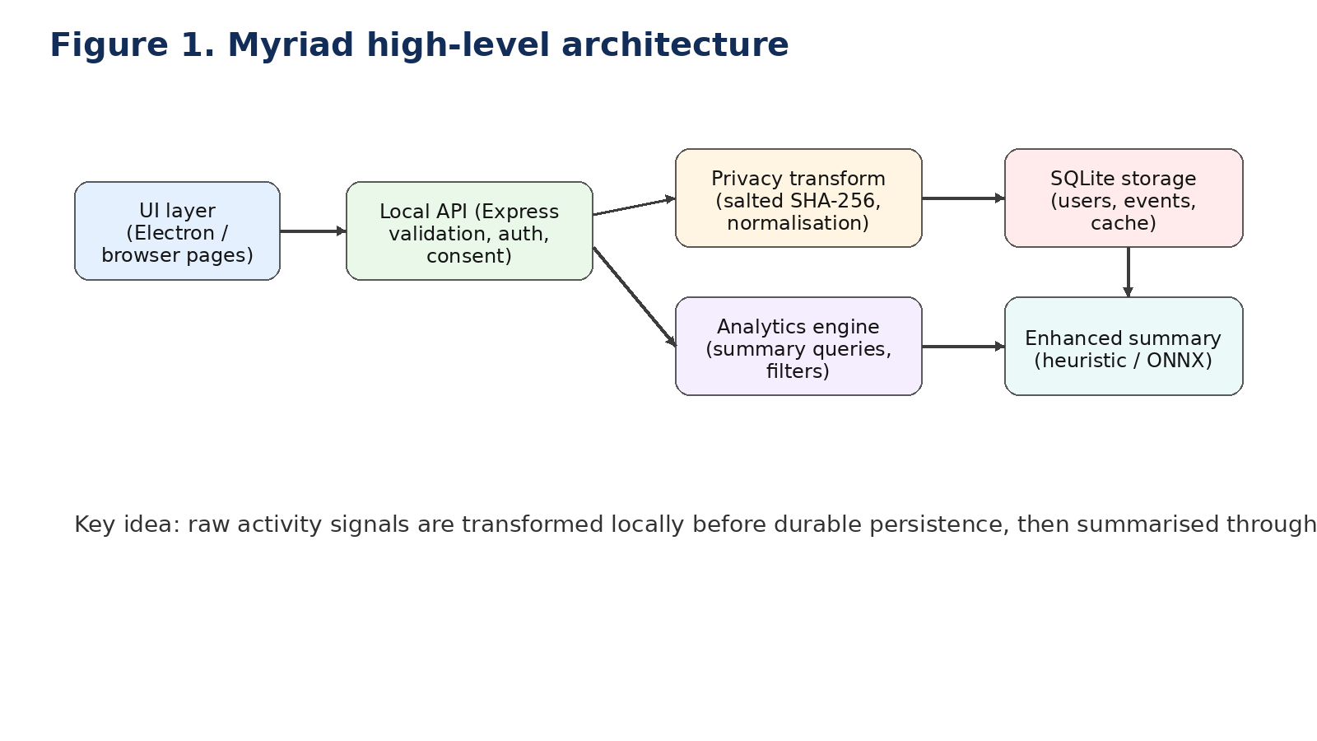
Figure 1: Myriad high-level architecture
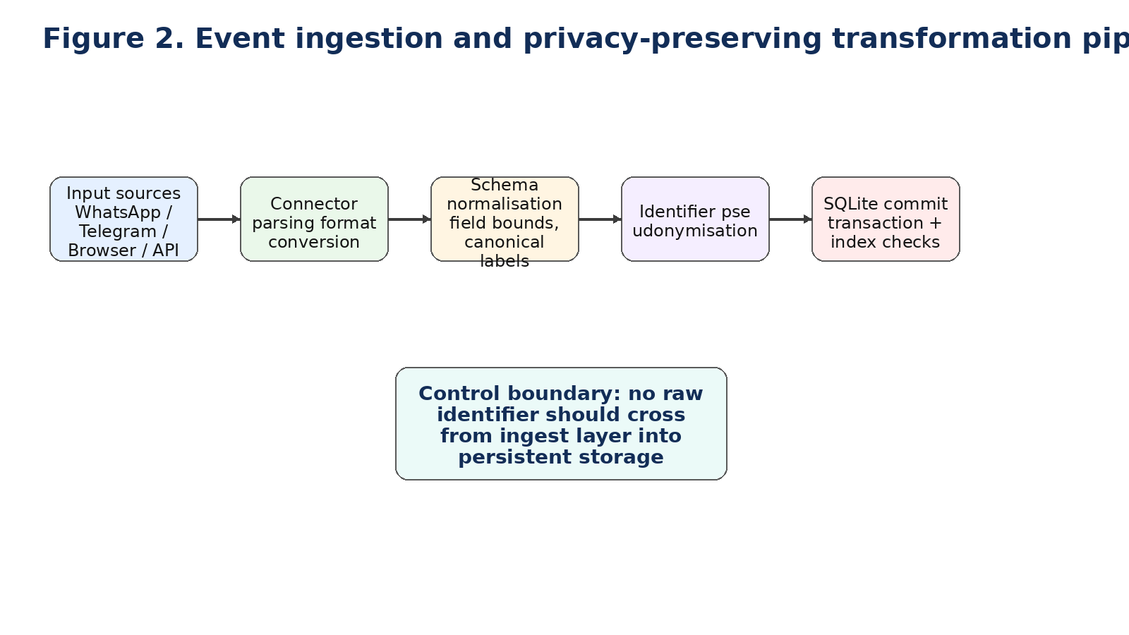
Figure 2: Event ingestion and privacy-preserving transformation pipeline
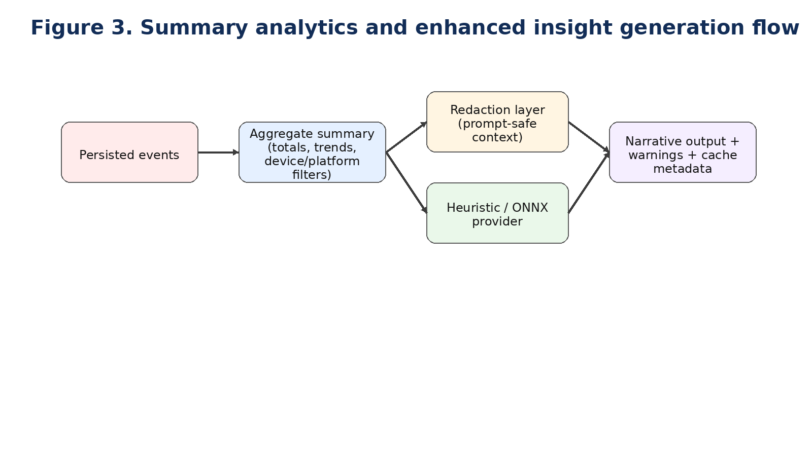
Figure 3: Summary analytics and enhanced insight generation flow
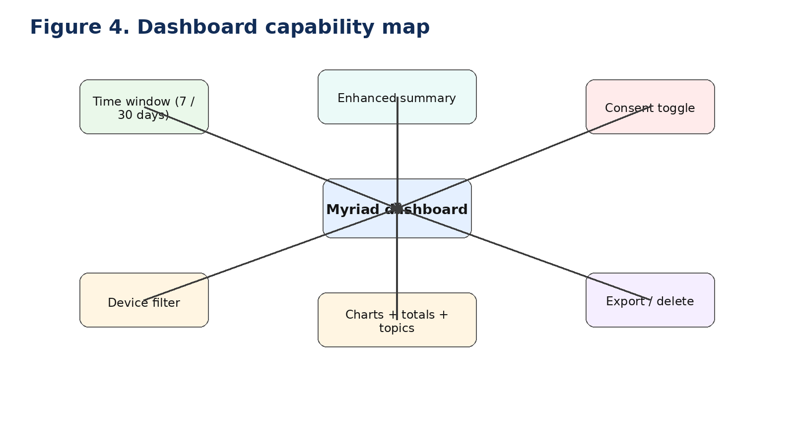
Figure 4: Dashboard capability map

Evaluation Metrics and Reproducibility
The project used practical engineering metrics rather than attempting artificial precision. These included functional completion of required endpoint categories, enforcement of privacy controls in tested scenarios, correctness of user isolation, deterministic transformation behaviour under fixed inputs and acceptable local responsiveness for summary operations. These metrics are suitable for an undergraduate proof-of-concept because they can be observed directly and reproduced without external services.
Reproducibility was supported through explicit npm scripts, local data storage and a self-contained test suite. A reviewer can install dependencies, run the API or desktop mode and reproduce the test outcomes without needing cloud accounts or remote infrastructure. This characteristic is one of the methodological strengths of the local-first approach.

3. Realisation

3.1 Intended Audience
This section is written for technical readers with undergraduate-level computing knowledge, including assessors, developers and cyber-security students who may wish to reproduce or extend the system.

3.2 Recreating the Implementation

3.2.1 Setup
To recreate the artefact, the user installs Node.js and npm, clones or downloads the project repository, installs dependencies with npm install, optionally sets a strong MYRIAD_SALT value and then launches the desktop or web mode using the supplied scripts. Because the application is local-first, no external cloud service is required for baseline operation.

3.2.2 Core Backend Construction
The backend follows a modular structure. The server module provides routing, validation, consent gating and endpoint orchestration. The database module creates or migrates schema elements and provides query helpers. A dedicated anonymisation module encapsulates salted SHA-256 transformation logic. Connector modules parse supported imports such as WhatsApp text exports, Telegram JSON and browser history files. The summary-generation module provides enhanced narrative output via either a deterministic heuristic path or an optional ONNX-backed provider.
The database schema includes users, authentication tokens, settings, events and summary-cache tables. Migration-aware logic checks for missing legacy columns before applying additive changes. This approach matters in a local desktop context because real users may already have an earlier database version; destructive migration would undermine trust and make iterative improvement more risky.

3.2.3 Security-Relevant Implementation Details
• Passwords are hashed with bcrypt before persistence.
• Auth tokens are generated locally and mapped to specific user identities.
• Collection endpoints enforce the current consent state and deny ingestion when disabled.
• Global summary mode is gated behind an administrative header key rather than being exposed to ordinary users.
• Identifiers are transformed using salted SHA-256 before persistence where pseudonymisation applies.
• Input values are normalised and bounded to reduce malformed or abusive payload behaviour.
Additional safeguards include timestamp repair for malformed inputs, normalisation of platform labels, bounded metadata lengths and explicit user scoping on all event queries. These are modest but important controls for reducing accidental corruption or ambiguous analytics.

3.3 Using the Artefact and Generating Output

3.3.1 Data Ingestion Paths
The system supports three practical ingestion modes: direct event submission via API endpoints, connector-specific imports for WhatsApp, Telegram and browser history formats, and a generic upload pathway that selects the relevant connector. This design keeps the artefact demonstrable within the project timescale while still showing interoperability with realistic personal-data exports.

3.3.2 Analytics and Dashboard Output
The dashboard presents total events, total minutes, active-day counts, active-hour distributions, category usage, sentiment trend, conversation frequency, top topics, and device/platform breakdown. It also supports a selected time window, device filter, consent control, export, delete and enhanced narrative summary. The practical outcome is that the user can compare how their activity shifts across time and device contexts without relying on a remote service.

3.3.3 Example Output Structure
A representative summary response includes aggregate totals, active-hours data, category usage, sentiment trend, conversation frequency, top topics, platform and device breakdowns and the currently selected filter state. The enhanced summary response adds a narrative, highlight bullets, provider metadata, warning fields, confidence classification and cache information. Returning this metadata is important because it helps the user and assessor distinguish deterministic aggregates from generated interpretation.

3.4 System Testing Results
Automated tests were executed through npm test and validated deterministic anonymisation, null handling for invalid identifier inputs, successful register/login/profile flow, strict separation of user events, successful connector imports, non-persistence of raw tested identifiers, unknown-device reassignment behaviour, idempotent batch ingestion, administrative enforcement for global summaries, enhanced summary payload correctness and cache-hit behaviour. All 10 tests passed with zero failures in the final recorded execution.
The relatively fast execution time—approximately two seconds—made repeated testing feasible during development. This is significant because privacy-sensitive software benefits from quick regression detection; controls that are slow to verify tend to be checked less often.

3.5 Detailed Endpoint Walkthrough for Reproduction
• Register a profile using POST /api/auth/register with username and password.
• Authenticate using POST /api/auth/login and retain the returned bearer token.
• Check or change consent using GET /api/consent and POST /api/consent.
• Ingest a small event batch through POST /api/events/batch, including externalId values to test idempotency.
• Import a connector payload using one of the dedicated import endpoints.
• Request a personal summary using GET /api/summary?days=7&device=all.
• Request an enhanced summary using GET /api/summary/enhanced and observe cache metadata.
• Repeat the enhanced summary request to verify cache-hit behaviour.
• Export records through GET /api/events/export and inspect transformed identifier fields.
• Delete records with DELETE /api/events and confirm that subsequent summary totals reset.
A separate administrative flow can be demonstrated using x-myriad-admin-key with GET /api/summary/global. This confirms that cross-user aggregate analytics are intentionally gated and unavailable to ordinary authenticated users.

3.6 Implementation Conclusion
The implementation achieved the intended MVP goals: local-first behaviour tracking, privacy-preserving transformation, accountable lifecycle controls and interpretable analytics supported by reproducible tests. The design remains consistent with the dissertation’s central claim that privacy-preserving personal analytics can be demonstrated credibly without default dependence on remote infrastructure.

4. Validation, Testing and Critical Review

4.1 Validation Strategy Overview
Validation is structured in two complementary strands expected by the Computer Science handbook: user/usability testing and system testing. Findings from both strands are then synthesised in a critical review against aims, objectives, and state-of-the-art expectations.

4.2 User and Usability Testing
The usability strand used task-based testing with five participants: three target users from the stakeholder sample and two additional computing students to provide fresh-user observations. Selection criteria were basic familiarity with productivity apps, no prior access to the project codebase, and willingness to complete a structured task script.
Participants completed four fixed tasks: T1 register/login and create a profile, T2 ingest a sample event set, T3 interpret dashboard outputs (active hours, category usage, sentiment trend), and T4 read an enhanced narrative summary and judge its confidence wording. Measures recorded were task completion, completion time band, clarification requests, and observed confusion points.
Outcomes: T1 completed by 5/5 without intervention; T2 completed by 4/5 (one participant needed prompt on accepted payload shape); T3 completed by 4/5 (two participants hesitated over category labels); T4 completed by 5/5, but 3/5 requested clearer explanation of confidence limits. The most frequent issues were terminology ambiguity and uncertainty about how strongly to trust generated narrative summaries.

4.3 Review of Outcomes Against Aims and Objectives
Myriad successfully delivered a functioning local-first mindful habit tracker with privacy-preserving processing and analytics output. The core aims relating to data locality, pseudonymisation, user control and automated validation were all met in implemented behaviour. The project also met its objective of demonstrating extensibility through an optional offline-capable narrative summary layer. Against the handbook’s learning outcomes, the project produced a cyber-relevant artefact, drew on reviewed literature, identified legal/social/ethical issues and presented a structured written report.

4.4 What Worked Well
• Modular backend structure kept routing, persistence, connectors and summarisation separable and maintainable.
• Migration-aware schema evolution reduced compatibility regressions for local databases.
• Explicit user scoping prevented cross-profile contamination in tested summary paths.
• Consent, export and delete were implemented as visible features rather than hidden obligations.
• Automated tests provided rapid confidence in high-risk behaviours.
• Enhanced summary functionality remained resilient through a deterministic fallback path.

4.5 Limitations and Weaknesses
The project still has clear limitations. First, there is no production-grade mobile collector. Although imported browser and messaging data are sufficient for demonstration, they do not offer the continuous first-party capture that a mature product might require. Second, the role model is basic: a static administrative header is acceptable for a prototype but inadequate for broader deployment. Third, there is no full formal threat model embedded in the repository. The dissertation now discusses privacy threats conceptually, but a complete STRIDE or LINDDUN artefact would strengthen future hardening.
A further limitation is interpretive rather than purely technical. Behaviour dashboards can encourage reflection, but they can also invite over-interpretation. Even with warnings and descriptive language, users may still treat narrative summaries as stronger judgements than intended. This is a recurring concern in both digital phenotyping and explainable AI research, and it remains a residual risk for Myriad.
From an implementation perspective, Electron and native SQLite bindings also create maintainability pressure. Packaging, dependency updates and OS-version drift can become friction points over time. These are acceptable in an undergraduate project, but they matter when considering future sustainability.

4.6 Comparison with Alternative Architectures
A cloud-backed telemetry architecture would have simplified remote access and potentially enabled multi-device continuity, but it would have introduced secure hosting, key management, retention policy and incident-response burdens far beyond the project’s scope. A mobile-first architecture would have increased realism for data capture but would also have expanded provisioning complexity and cross-platform testing overhead. A remote AI summary service could have improved fluency, but would have violated the core data-locality rationale by transmitting behavioural context externally. Compared with these alternatives, the implemented architecture offers the strongest balance of scope realism, privacy posture and reproducibility.

4.7 Future Work
• Add optional end-to-end encrypted synchronisation between trusted devices.
• Introduce at-rest database encryption and stronger key-management controls.
• Replace static admin key behaviour with role-based access control.
• Add configurable retention windows and selective redaction policies.
• Formalise privacy threat modelling using STRIDE or LINDDUN with mitigation traceability.
• Benchmark offline summarisation quality, latency and user understanding more systematically.
• Develop a companion mobile collector under explicit consent prompts.
• Conduct structured usability studies around consent, transparency and export/delete comprehension.

4.8 Sustainability, Residual Risk and Final Position
Long-term maintainability depends on preserving modular boundaries, stable endpoint contracts and disciplined dependency management. The current code structure supports this reasonably well, but future sustainability will require regular migration testing and careful review of native module updates. On energy and infrastructure grounds, a local-first approach may also reduce the overhead associated with permanently active cloud services for small-scale personal analytics, although that claim would need dedicated measurement before it could be stated strongly.
Residual risk remains. Pseudonymisation lowers direct identifier exposure but does not eliminate inference risk where combinations of topic, time and category data become unique. Static admin-key protection is weaker than role-based access control. Import parsers may still encounter edge cases that were not covered in current tests. Narrative summaries may still be over-trusted despite warning labels. Recognising these residual risks strengthens the dissertation because it shows the project being evaluated at its real maturity level rather than being presented as complete.
In final terms, Myriad provides a technically coherent and academically defensible proof of concept that balances analytical utility with privacy-by-design expectations. It is not a finished commercial platform, but it does demonstrate how cyber-security principles can be embodied in a realistic personal-analytics artefact. That combination of practical implementation, explicit trade-offs and critical reflection is the dissertation’s main contribution.

5. References
Cavoukian, A. (2010a) ‘Privacy by design: the definitive workshop. A foreword by Ann Cavoukian, Ph.D’, Identity in the Information Society, 3, pp. 247–251. Available at: https://doi.org/10.1007/s12394-010-0062-y (Accessed: 28 March 2026).
Cavoukian, A., Taylor, S. and Abrams, M.E. (2010b) ‘Privacy by Design: essential for organizational accountability and strong business practices’, Identity in the Information Society, 3, pp. 405–413. Available at: https://doi.org/10.1007/s12394-010-0053-z (Accessed: 28 March 2026).
Cheung, J.C. and Ho, S.S. (2025) ‘The effectiveness of explainable AI on human factors in trust models’, Scientific Reports, 15, 23337. Available at: https://doi.org/10.1038/s41598-025-04189-9 (Accessed: 28 March 2026).
Electron (2026) Electron documentation. Available at: https://www.electronjs.org/docs/latest/ (Accessed: 28 March 2026).
European Union (2016) Regulation (EU) 2016/679 (General Data Protection Regulation). Available at: https://eur-lex.europa.eu/eli/reg/2016/679/oj (Accessed: 28 March 2026).
Express.js (2026) Express – Node.js web application framework. Available at: https://expressjs.com/ (Accessed: 28 March 2026).
Huckvale, K., Venkatesh, S. and Christensen, H. (2019) ‘Toward clinical digital phenotyping: a timely opportunity to consider purpose, quality, and safety’, npj Digital Medicine, 2, 88. Available at: https://doi.org/10.1038/s41746-019-0166-1 (Accessed: 28 March 2026).
ICO (2025) ‘Pseudonymisation’. Information Commissioner’s Office. Available at: https://ico.org.uk/for-organisations/uk-gdpr-guidance-and-resources/data-sharing/anonymisation/pseudonymisation/ (Accessed: 28 March 2026).
Kleppmann, M., Wiggins, A., van Hardenberg, P. and McGranaghan, M. (2019) ‘Local-first software: you own your data, in spite of the cloud’, in Companion Proceedings of the 2019 ACM SIGPLAN International Systems and Applications Conference. Available at: https://doi.org/10.1145/3359591.3359737 (Accessed: 28 March 2026).
Li, H., Ge, L. and Tian, L. (2024) ‘Survey: federated learning data security and privacy-preserving in edge-Internet of Things’, Artificial Intelligence Review, 57, 130. Available at: https://doi.org/10.1007/s10462-024-10774-7 (Accessed: 28 March 2026).
Minh, D., Wang, H.X., Li, Y.F. and Nguyen, T.N. (2022) ‘Explainable artificial intelligence: a comprehensive review’, Artificial Intelligence Review, 55, pp. 3503–3568. Available at: https://doi.org/10.1007/s10462-021-10088-y (Accessed: 28 March 2026).
Myriad repository (2026) GitHub repository for the artefact implementation. Available at: https://github.com/JakkuAzzo/Myriad.git (Accessed: 28 March 2026).
Node.js (2026) Node.js API documentation. Available at: https://nodejs.org/docs/latest/api/ (Accessed: 28 March 2026).
NPM (2026a) better-sqlite3 package documentation. Available at: https://www.npmjs.com/package/better-sqlite3 (Accessed: 28 March 2026).
NPM (2026b) bcryptjs package documentation. Available at: https://www.npmjs.com/package/bcryptjs (Accessed: 28 March 2026).
NPM (2026c) multer package documentation. Available at: https://www.npmjs.com/package/multer (Accessed: 28 March 2026).
NPM (2026d) supertest package documentation. Available at: https://www.npmjs.com/package/supertest (Accessed: 28 March 2026).
NPM (2026e) @xenova/transformers package documentation. Available at: https://www.npmjs.com/package/@xenova/transformers (Accessed: 28 March 2026).
SQLite (2026) SQLite documentation. Available at: https://www.sqlite.org/docs.html (Accessed: 28 March 2026).
Stanghellini, G. and Leoni, F. (2020) ‘Digital phenotyping: ethical issues, opportunities, and threats’, Frontiers in Psychiatry, 11, 473. Available at: https://doi.org/10.3389/fpsyt.2020.00473 (Accessed: 28 March 2026).
Wang, Z., Rucker, M., Toner, E.R., Larrazabal, M.A., Boukhechba, M., Teachman, B.A. and Barnes, L.E. (2023) ‘Understanding privacy risks versus predictive benefits in wearable sensor-based digital phenotyping: a quantitative cost-benefit analysis’, 2023 International Conference on Wearable and Implantable Body Sensor Networks. Available at: https://doi.org/10.1109/BSN58485.2023.10331378 (Accessed: 28 March 2026).

6. Appendices

Appendix A: Artefact Repository Structure
data/ – local SQLite database files
electron/ – desktop shell main and preload scripts
public/ – frontend pages and dashboard scripts/styles
src/ – server routes, database logic, anonymisation, connectors and summary generation
test/ – automated unit and API tests

Appendix B: API Endpoint Catalogue
Health
GET /api/health
Authentication
POST /api/auth/register
POST /api/auth/login
GET /api/auth/me
POST /api/auth/logout
GET /api/users
Consent
GET /api/consent
POST /api/consent
Events and Analytics
POST /api/events
POST /api/events/batch
POST /api/events/sample-seed
GET /api/summary
GET /api/summary/global (admin)
GET /api/summary/enhanced
GET /api/events/export
DELETE /api/events
POST /api/events/reassign-unknown-device
Import Connectors
POST /api/import/whatsapp
POST /api/import/telegram
POST /api/import/browser-history
POST /api/import/upload?connector=...

Appendix C: Selected Validation Evidence
Final automated test execution summary:
Total tests: 10
Passed: 10
Failed: 0
Duration: approximately 2 seconds
Validated behaviour included user isolation, consent enforcement, import correctness, pseudonymisation, admin controls, enhanced summary response integrity and cache behaviour.

Appendix D: Example Event Payload
{
"occurredAt": "2026-03-10T12:00:00.000Z",
"source": "chat",
"category": "social",
"durationMinutes": 10,
"sentiment": 0.15,
"topic": "friends",
"identifier": "raw-user-id-or-handle"
}

Appendix E: Formatting and Handbook Compliance Checklist
University-style cover page and declaration included.
Student name and KU ID completed: Said Osman, k2376552.
Core section order follows the CI6600 handbook’s indicative report structure.
Academic third-person writing style used throughout.
Glossary, table of contents and table of figures included.
Literature review expanded with scholarly and regulatory sources.
Harvard-style in-text citations added throughout the dissertation body.
Reference list broadened beyond technical documentation.
Document revised to sit within the handbook’s recommended report-length range.

