Experiment 1: Installation of Hadoop
Student Name | Jakkubabitha | Date | June 2026

Aim
To install and configure Apache Hadoop 3.5.0 in Pseudo-Distributed Mode on macOS using Homebrew, and verify successful startup of all HDFS daemons (NameNode, DataNode, SecondaryNameNode).

Software Required
- macOS with Homebrew package manager
- OpenJDK 17 (Java runtime for Hadoop)
- Apache Hadoop 3.5.0
- Terminal with SSH enabled

Procedure
- Install Java (OpenJDK 17) using Homebrew and verify:
brew install openjdk@17
java -version
- Install Apache Hadoop 3.5.0:
brew install hadoop
hadoop version
- Set environment variables in ~/.zshrc:
export JAVA_HOME=$(/usr/libexec/java_home -v 17)
export HADOOP_HOME=/opt/homebrew/Cellar/hadoop/3.5.0/libexec
export PATH=$PATH:$HADOOP_HOME/bin:$HADOOP_HOME/sbin
source ~/.zshrc
- Configure Hadoop XML files in $HADOOP_HOME/etc/hadoop/:
core-site.xml → set fs.defaultFS = hdfs://localhost:9000
hdfs-site.xml → set dfs.replication = 1
- Enable passwordless SSH to localhost:
ssh-keygen -t rsa -P '' -f ~/.ssh/id_rsa
cat ~/.ssh/id_rsa.pub >> ~/.ssh/authorized_keys
- Format the HDFS NameNode (only once):
hdfs namenode -format
- Start all HDFS daemons:
start-dfs.sh
- Verify all running daemons using jps:
jps

Output
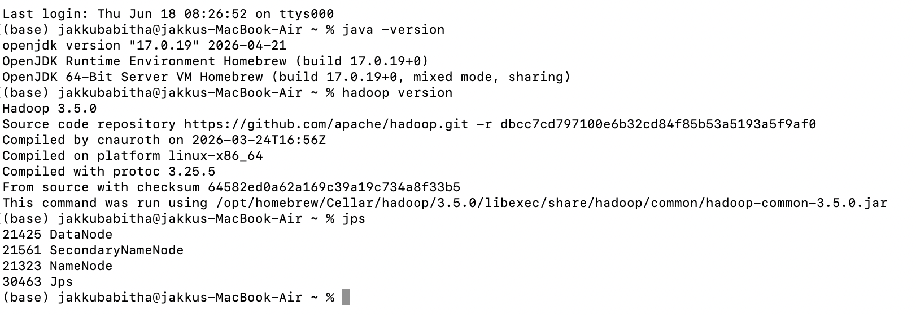
Fig 1: Terminal output showing Java 17.0.19, Hadoop 3.5.0, and jps confirming NameNode, DataNode, SecondaryNameNode running.

Result
Apache Hadoop 3.5.0 was successfully installed on macOS. The jps command confirmed that NameNode (PID 21323), DataNode (PID 21425), and SecondaryNameNode (PID 21561) are all running, indicating a successful Pseudo-Distributed Hadoop cluster setup.

Conclusion
Hadoop 3.5.0 was installed and configured in Pseudo-Distributed Mode using Homebrew on macOS with OpenJDK 17. All HDFS daemons started successfully, confirming the system is ready for HDFS operations and MapReduce experiments.

