Experiment 5: Sales Data Analysis using MapReduce
Experiment No. | 5 | Student | Jakkubabitha

Aim
To generate a large-scale sales dataset (50,000 records) using Python, upload it to HDFS, and perform city-wise total sales and transaction count analysis using a custom Hadoop MapReduce Streaming job with Python mapper and reducer scripts.

Software Required
- Apache Hadoop 3.5.0 (Pseudo-Distributed Mode)
- Python 3 with random and datetime modules
- Hadoop Streaming JAR (hadoop-streaming-3.5.0.jar)
- OpenJDK 17, macOS Terminal

Procedure
- Write a Python script to generate 50,000 synthetic sales records:
cat > generate_sales.py << 'EOF'
import random, datetime
products = ['Laptop','Mouse','Keyboard','Monitor','Headphones','Webcam','Printer','Scanner']
cities = ['Mumbai','Delhi','Bangalore','Chennai','Hyderabad','Pune','Kolkata','Ahmedabad']
customers = [f'CUST{str(i).zfill(5)}' for i in range(1, 1001)]
start_date = datetime.date(2024,1,1); end_date = datetime.date(2024,12,31)
date_range = (end_date - start_date).days
for i in range(50000):
date = start_date + datetime.timedelta(days=random.randint(0, date_range))
product = random.choice(products)
price = round(random.uniform(100, 5000), 2)
city = random.choice(cities)
customer = random.choice(customers)
quantity = random.randint(1, 5)
print(f"{date},{product},{price},{city},{customer},{quantity}")
EOF
- Generate the CSV file:
python3 generate_sales.py > sales_data.csv
ls -lh sales_data.csv # verify: 2.2M, 50000 lines
wc -l sales_data.csv
head -5 sales_data.csv
- Write the Mapper script (mapper_city_sales.py) — emits city, price*quantity:
cat > mapper_city_sales.py << 'EOF'
import sys
for line in sys.stdin:
parts = line.strip().split(',')
if len(parts) == 6:
city = parts[3]; price = float(parts[2]); qty = int(parts[5])
print(f'{city}\t{price * qty}')
EOF
- Write the Reducer script (reducer_city_sales.py) — aggregates total sales and count:
cat > reducer_city_sales.py << 'EOF'
import sys
current_city = None; total_sales = 0.0; count = 0
for line in sys.stdin:
city, amount = line.strip().split('\t')
amount = float(amount)
if city == current_city:
total_sales += amount; count += 1
else:
if current_city: print(f'{current_city}\t{total_sales:.2f}\t{count}')
current_city = city; total_sales = amount; count = 1
if current_city: print(f'{current_city}\t{total_sales:.2f}\t{count}')
EOF
- Test mapper + reducer locally on first 20 lines:
head -20 sales_data.csv | python3 mapper_city_sales.py | sort | python3 reducer_city_sales.py
- Upload sales_data.csv to HDFS:
hdfs dfs -mkdir -p /user/$USER/sales/input
hdfs dfs -put sales_data.csv /user/$USER/sales/input/
hdfs dfs -ls /user/$USER/sales/input/
- Run the Hadoop Streaming MapReduce job:
hadoop jar $HADOOP_HOME/share/hadoop/tools/lib/hadoop-streaming-3.5.0.jar \
-input /user/$USER/sales/input/sales_data.csv \
-output /user/$USER/sales/output \
-mapper mapper_city_sales.py \
-reducer reducer_city_sales.py \
-file mapper_city_sales.py \
-file reducer_city_sales.py
- Verify output files on HDFS:
hdfs dfs -ls /user/$USER/sales/output/
- View the final city-wise sales output:
hdfs dfs -cat /user/$USER/sales/output/part-00000 | head -20

Output / Screenshots
Fig 1: Python script (generate_sales.py) written and CSV generated
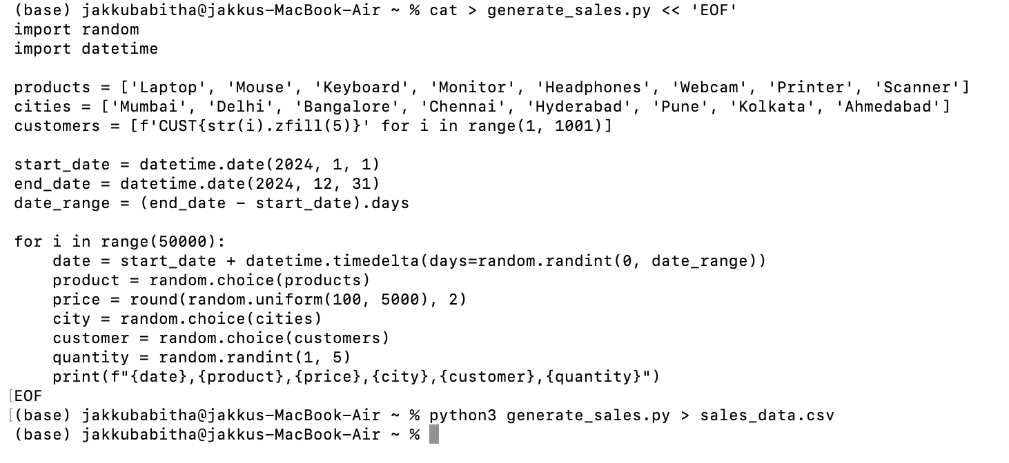
Fig 1: generate_sales.py script — 50,000 records with date, product, price, city, customer, quantity
Fig 2: File verification — 2.2M, 50,000 lines, sample rows
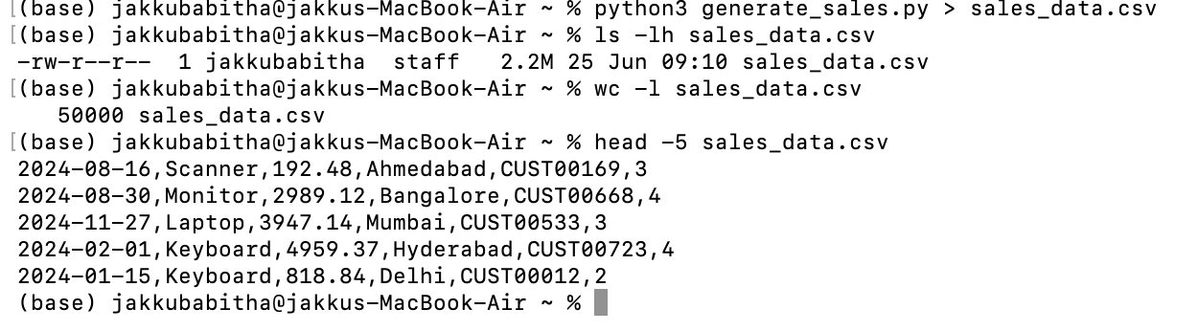
Fig 2: ls -lh (2.2M), wc -l (50000 lines), head -5 showing sample sales records
Fig 3: Local test of mapper + reducer pipeline on 20 rows
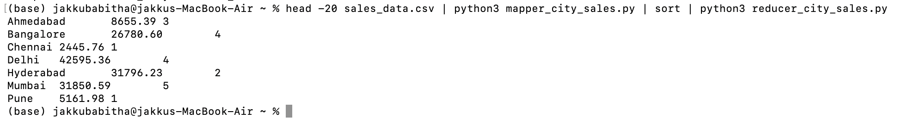
Fig 3: Local streaming test — city-wise sales totals from first 20 records
Fig 4: sales_data.csv uploaded and listed on HDFS
Fig 4: hdfs dfs -ls confirms sales_data.csv (2,335,572 bytes) in /user/jakkubabitha/sales/input/
Fig 5: HDFS output directory listing after MapReduce job
Fig 5: /user/jakkubabitha/sales/output/ contains _SUCCESS and part-00000 (200 bytes)
Fig 6: Final city-wise total sales and transaction count
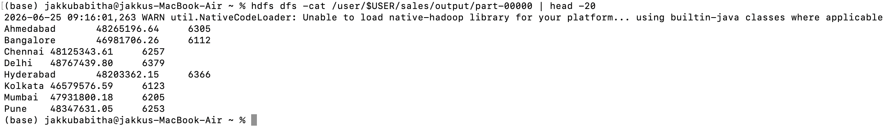
Fig 6: hdfs dfs -cat output — city-wise total revenue and number of transactions across all 50,000 records

Result
The Hadoop Streaming MapReduce job successfully processed all 50,000 sales records. The city-wise aggregated output (total revenue, transaction count) is shown below:

City | Total Sales (₹) | Transactions
Ahmedabad | 48,265,196.64 | 6305
Bangalore | 46,981,706.26 | 6112
Chennai | 48,125,343.61 | 6257
Delhi | 48,767,439.80 | 6379
Hyderabad | 48,203,362.15 | 6366
Kolkata | 46,579,576.59 | 6123
Mumbai | 47,931,800.18 | 6205
Pune | 48,347,631.05 | 6253

Conclusion
This experiment successfully demonstrated the use of Hadoop MapReduce Streaming with Python to analyse a large-scale sales dataset of 50,000 records. The mapper extracted city and revenue per transaction, while the reducer aggregated total sales and transaction counts per city. The full MapReduce pipeline — from data generation to HDFS upload to distributed processing — was executed end-to-end, confirming Hadoop's capability to handle big data analytics workloads efficiently.

