Experiment 7: Sales Product Analysis using MapReduce
Experiment No. | 7 | Student | Jakkubabitha

Aim
To analyse sales product data using Hadoop MapReduce Streaming with Python --- finding the Top 5 Products by Total Sales from a dataset of daily product sales records stored on HDFS.
Software Required
- Apache Hadoop 3.5.0 (Pseudo-Distributed Mode running)
- Python 3 with sys module
- Hadoop Streaming JAR (hadoop-streaming-3.5.0.jar)
- OpenJDK 17, macOS Terminal

Procedure
1. Create sales_products.txt with daily product sales records (date, product, price, city):
cat > sales_products.txt << 'EOF'
2024-01-01,Laptop,45000,Delhi
2024-01-01,Mouse,1500,Mumbai
2024-01-02,Keyboard,3500,Bangalore
2024-01-02,Laptop,45000,Chennai
2024-01-03,Mouse,1500,Delhi
2024-01-03,Monitor,25000,Mumbai
2024-01-04,Laptop,45000,Bangalore
2024-01-04,Keyboard,3500,Delhi
2024-01-05,Monitor,25000,Chennai
2024-01-05,Mouse,1500,Mumbai
EOF

cat sales_products.txt

2. Scale up the dataset by repeating it 50 times (sales_products_large.txt, ~15K):
for i in {1..50}; do cat sales_products.txt; done > sales_products_large.txt

ls -lh sales_products_large.txt

3. Write mapper_top_products.py --- emits product and price for each record:
cat > mapper_top_products.py << 'EOF'
#!/usr/bin/env python3
import sys

for line in sys.stdin:
line = line.strip()
if not line: continue
parts = line.split(',')
if len(parts) != 4: continue
try:
date = parts[0]; product = parts[1]
price = float(parts[2]); city = parts[3]
print(f"{product}\t{price}")
except ValueError: continue
EOF

chmod +x mapper_top_products.py

4. Write reducer_top_products.py --- aggregates total sales per product and prints Top 5:
cat > reducer_top_products.py << 'EOF'
#!/usr/bin/env python3
import sys

current_product = None
total_sales = 0
product_sales = []

for line in sys.stdin:
line = line.strip()
if not line: continue
product, price = line.split('\t'); price = float(price)
if product == current_product:
total_sales += price
else:
if current_product is not None:
product_sales.append((total_sales, current_product))
current_product = product; total_sales = price

if current_product is not None:
product_sales.append((total_sales, current_product))

product_sales.sort(reverse=True)
print("TOP 5 PRODUCTS BY SALES:")
print("=" * 40)
for i, (sales, product) in enumerate(product_sales[:5], 1):
print(f"{i}. {product}: Rs{sales:,.2f}")
EOF

chmod +x reducer_top_products.py

5. Create HDFS input directory and upload sales_products_large.txt:
hdfs dfs -mkdir -p /user/$USER/sales_products/input
hdfs dfs -put sales_products_large.txt /user/$USER/sales_products/input/
hdfs dfs -ls /user/$USER/sales_products/input

6. Run MapReduce Streaming job to find Top 5 Products by Sales:
hadoop jar $HADOOP_HOME/share/hadoop/tools/lib/hadoop-streaming-3.5.0.jar \
-input /user/$USER/sales_products/input/sales_products_large.txt \
-output /user/$USER/sales_products/output \
-mapper mapper_top_products.py \
-reducer reducer_top_products.py \
-file mapper_top_products.py \
-file reducer_top_products.py

hdfs dfs -cat /user/$USER/sales_products/output/part-00000

Output / Screenshots
Fig 1: sales_products.txt created and verified
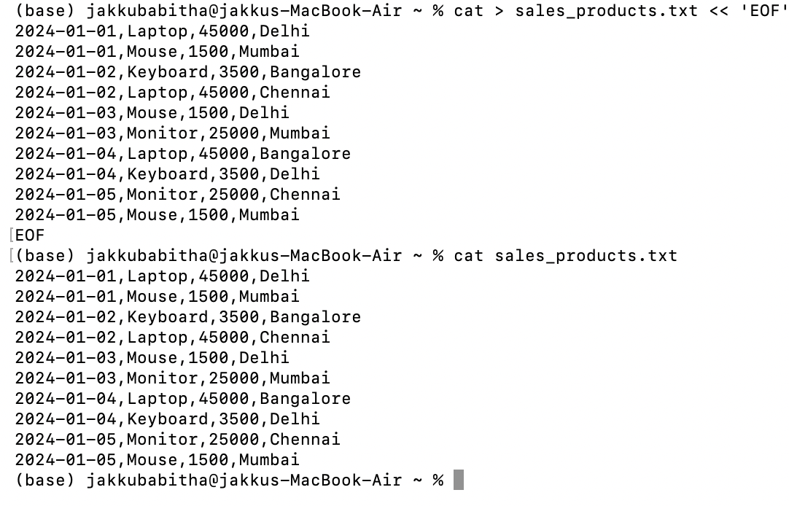
Fig 1: 10 sales records (date, product, price, city) written and confirmed with cat
Fig 2: Dataset scaled to 500 records (15K) using loop
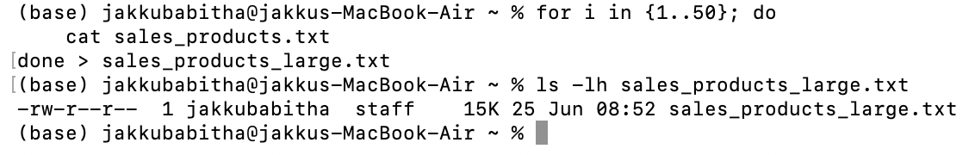
Fig 2: sales_products_large.txt --- 15K file created by repeating data 50 times
Fig 3: mapper_top_products.py --- emits product and price per record
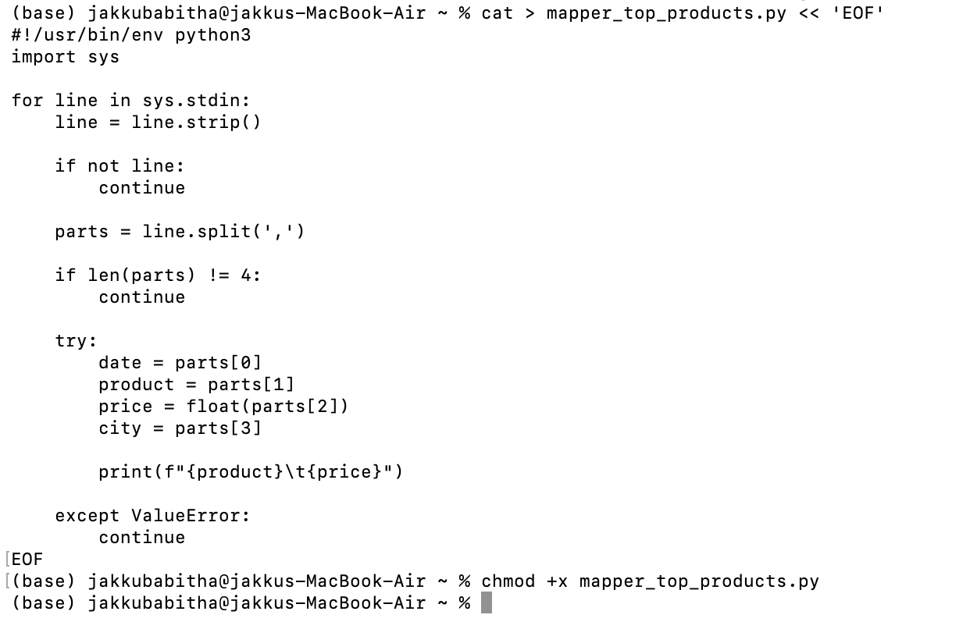
Fig 3: Mapper script reads each CSV line, parses product (column 2) and price (column 3), emits product\tprice
Fig 4: reducer_top_products.py --- aggregates sales and finds Top 5 products
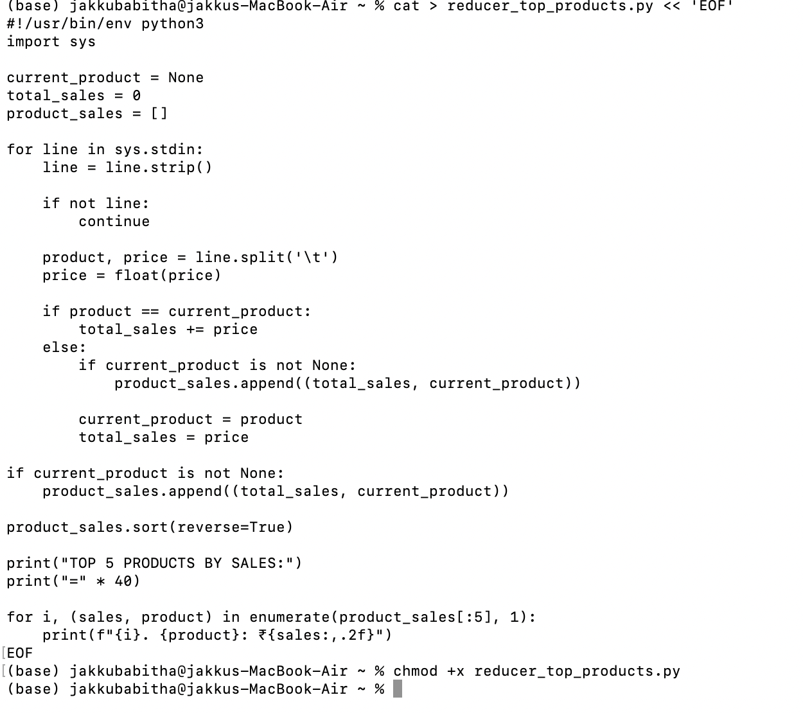
Fig 4: Reducer accumulates total price per product key, sorts descending, prints top 5 ranked products
Fig 5: MapReduce Streaming job output (Top 5 Products)
Fig 5: Hadoop streaming job completed --- output written to sales_products/output on HDFS
Fig 6: Final output --- Top 5 Products by Sales
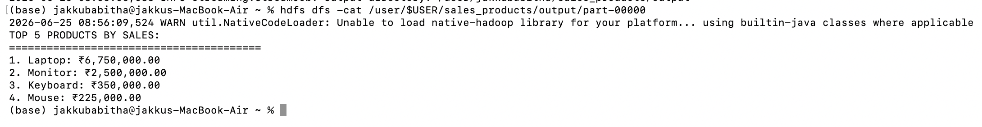
Fig 6: Output --- Laptop: Rs6,750,000 | Monitor: Rs2,500,000 | Keyboard: Rs350,000 | Mouse: Rs225,000

Result
The MapReduce Streaming job completed successfully. The results from the sales dataset are:
Analysis | Product | Total Sales
1st Place | Laptop | Rs 6,750,000
2nd Place | Monitor | Rs 2,500,000
3rd Place | Keyboard | Rs 350,000
4th Place | Mouse | Rs 225,000

Conclusion
This experiment demonstrated the use of Hadoop MapReduce Streaming with Python to perform sales analysis on product data. A single MapReduce job was executed to identify the Top 5 Products by total sales revenue --- Laptop ranked first (Rs6,750,000), followed by Monitor (Rs2,500,000), Keyboard (Rs350,000), and Mouse (Rs225,000). The experiment confirmed Hadoop's ability to process structured sales datasets and extract meaningful business insights using lightweight Python mapper and reducer scripts.

