Exercise 9: Cassandra Data Modeling

1. Objective / Scenario
Acting as the data engineer for "Sparkify", a fictional music-streaming service, the goal was to design a Cassandra data model capable of answering three specific analytics queries efficiently. Since Cassandra does not support JOINs, the standard approach designing one denormalized table per query pattern was followed.
- Query 1: Get all songs played in a specific session, in play order.
- Query 2: Get all songs a specific user played during a specific session, most recent first.
- Query 3: Find all users who listened to a specific song.
This exercise builds directly on the Cassandra environment set up in Exercise 8 (Docker container, connected via cqlsh).

2. Data Model

2.1 Keyspace
CREATE KEYSPACE IF NOT EXISTS sparkify
WITH REPLICATION = {
'class': 'SimpleStrategy',
'replication_factor': '1'
};
USE sparkify;

2.2 Table 1 — song_info_by_session (answers Query 1)
CREATE TABLE IF NOT EXISTS song_info_by_session (
artist TEXT,
song TEXT,
length DECIMAL,
session_id INT,
item_in_session INT,
PRIMARY KEY (session_id, item_in_session)
) WITH CLUSTERING ORDER BY (item_in_session ASC);
Partition key: session_id — all songs from one session live together. Clustering column item_in_session (ASC) keeps rows sorted in play order on disk.

2.3 Table 2 — song_playing_history_by_user (answers Query 2)
CREATE TABLE IF NOT EXISTS song_playing_history_by_user (
artist TEXT,
song TEXT,
first_name TEXT,
last_name TEXT,
session_id INT,
item_in_session INT,
user_id INT,
PRIMARY KEY ((user_id, session_id), item_in_session)
) WITH CLUSTERING ORDER BY (item_in_session DESC);
Composite partition key (user_id, session_id) keeps each user's session bounded to its own partition instead of growing unbounded per user. Clustering DESC returns the most recently played song first.

2.4 Table 3 — who_listened_to_song (answers Query 3)
CREATE TABLE IF NOT EXISTS who_listened_to_song (
user_id INT,
first_name TEXT,
last_name TEXT,
song TEXT,
PRIMARY KEY (song, user_id)
);
Partition key: song — every listener of a given song is grouped together, making the lookup a single-partition read.
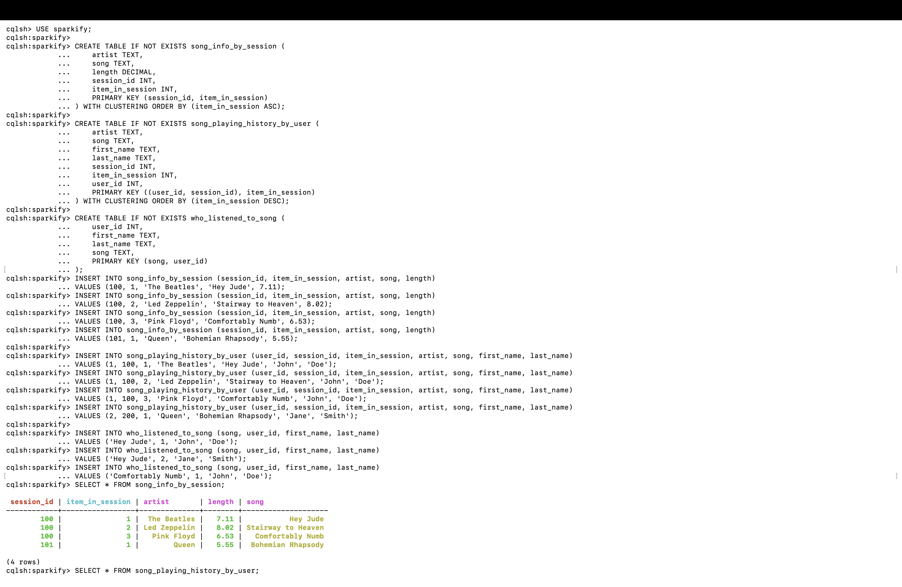
Figure 1: All three CREATE TABLE statements executed successfully in cqlsh, followed by sample INSERT statements and the first SELECT on song_info_by_session.

3. Sample Data Insertion & Verification
Sample rows (The Beatles, Led Zeppelin, Pink Floyd, Queen) were inserted into all three tables to represent listening activity across two sessions and two users, then each table was queried in full to confirm the data landed as expected.
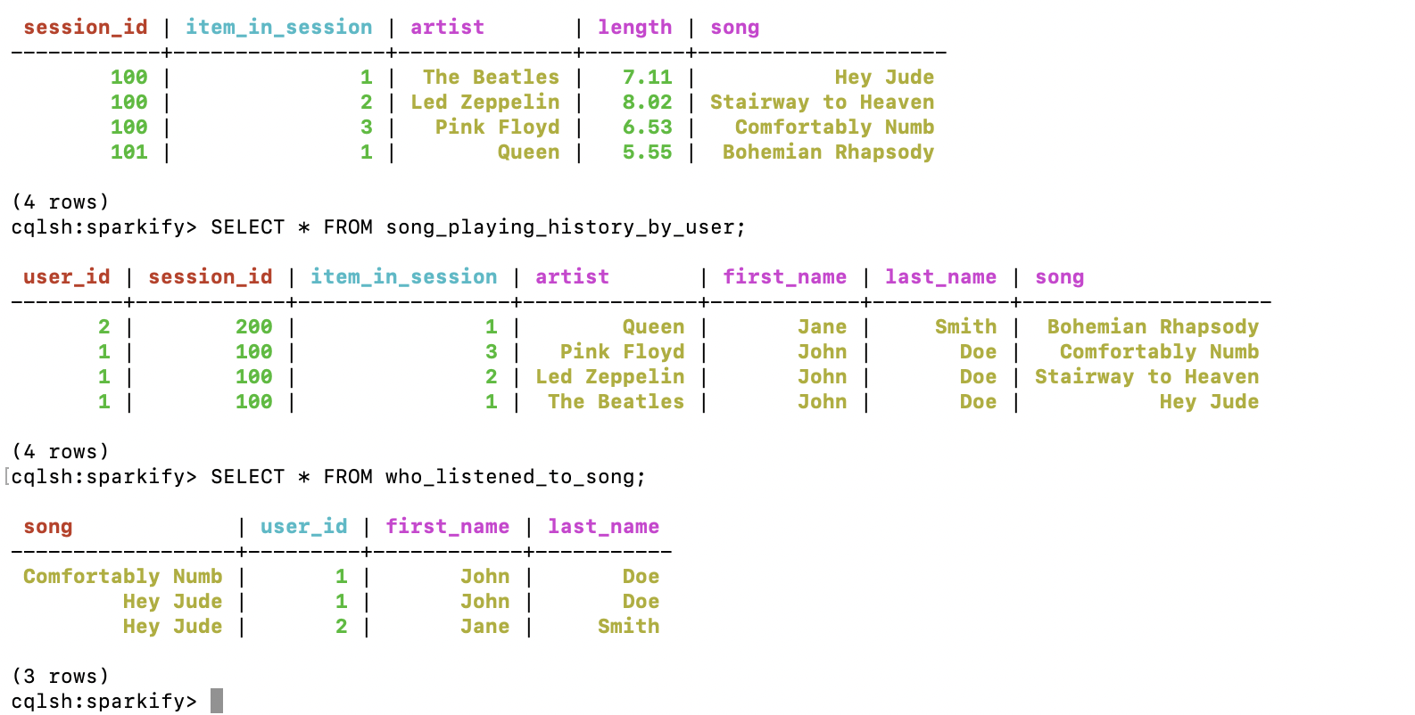
Figure 2: Full contents of all three tables — song_info_by_session, song_playing_history_by_user, and who_listened_to_song — confirming data was inserted correctly.

4. Query Execution & Results

4.1 Query 1 — Songs played in session 100, in play order
SELECT * FROM song_info_by_session WHERE session_id = 100;
Result: Hey Jude → Stairway to Heaven → Comfortably Numb, correctly ordered by item_in_session ascending.
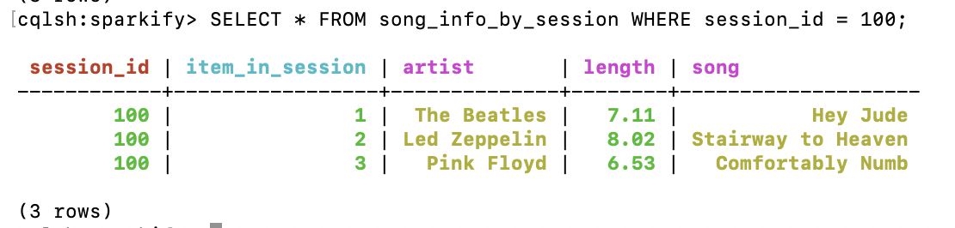
Figure 3: Query 1 result — 3 rows returned in ascending play order.

4.2 Query 2 — User 1's songs in session 100, most recent first
SELECT * FROM song_playing_history_by_user WHERE user_id = 1 AND session_id = 100;
Result: Comfortably Numb → Stairway to Heaven → Hey Jude, correctly reversed due to the DESC clustering order.
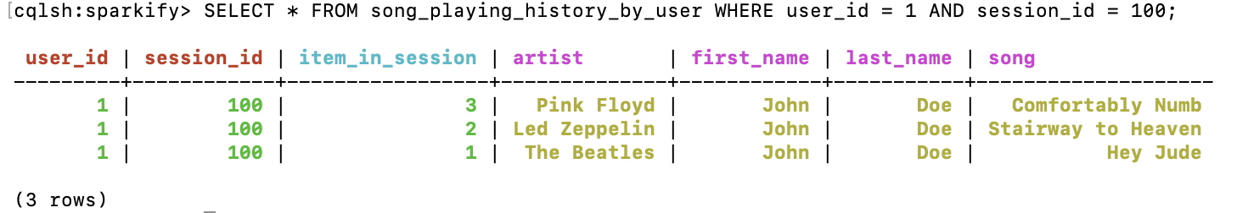
Figure 4: Query 2 result — 3 rows returned in descending (most-recent-first) order.

4.3 Query 3 — Users who listened to 'Hey Jude'
SELECT * FROM who_listened_to_song WHERE song = 'Hey Jude';
Result: both John Doe and Jane Smith returned, confirming the song-partitioned table correctly aggregates all listeners.
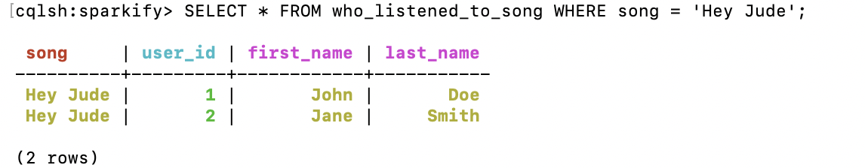
Figure 5: Query 3 result — 2 rows returned, both listeners of "Hey Jude".

5. UPSERT Behavior
Cassandra does not distinguish between INSERT and UPDATE at the storage level — both are writes with a timestamp. To demonstrate this, a new row was inserted using the same primary key (session_id=100, item_in_session=1) as the existing "Hey Jude" row, but with different column values.
INSERT INTO song_info_by_session (session_id, item_in_session, artist, song, length)
VALUES (100, 1, 'The Beatles', 'Let It Be', 4.03);

SELECT * FROM song_info_by_session WHERE session_id = 100;
As expected, the row at (100, 1) was silently overwritten — "Hey Jude" (length 7.11) became "Let It Be" (length 4.03), with no error or duplicate row created. This confirms Cassandra's "last write wins" upsert semantics.
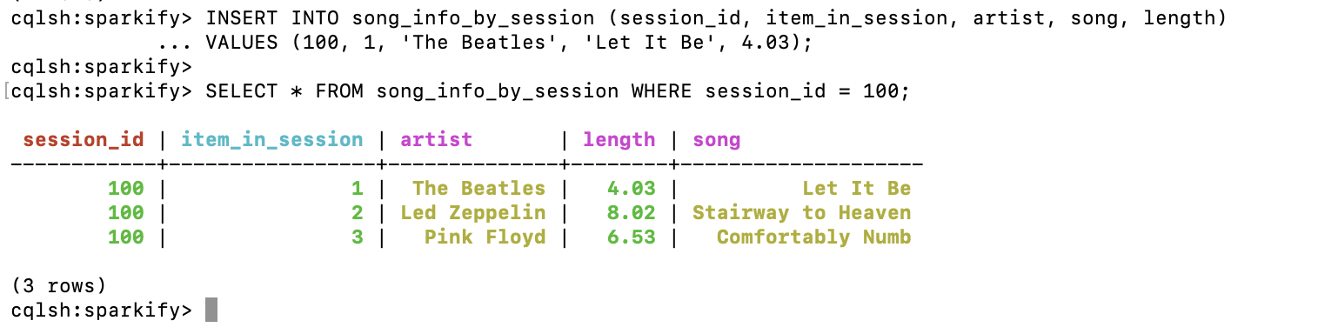
Figure 6: UPSERT in action — the row at (session_id=100, item_in_session=1) now shows "Let It Be" instead of "Hey Jude."

6. Consistency Level
The current read/write consistency level was checked and then explicitly set to ONE, meaning only a single replica must acknowledge a read or write for it to be considered successful.
CONSISTENCY;
CONSISTENCY ONE;
SELECT * FROM song_info_by_session WHERE session_id = 100;
The default consistency level was confirmed as ONE. Because this cluster uses replication_factor = 1 (a single node, single replica), CONSISTENCY ONE and CONSISTENCY ALL behave identically here — the distinction only becomes meaningful in a multi-node cluster with replication_factor > 1.
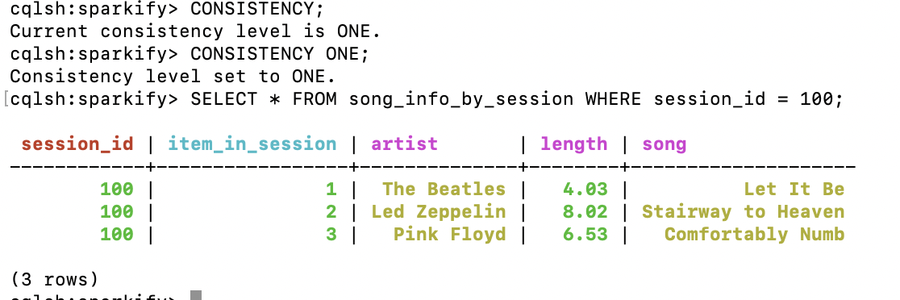
Figure 7: CONSISTENCY check confirming level ONE, followed by a successful read at that consistency level.

Conclusion
The Sparkify data model was successfully implemented in Cassandra using three query-optimized, denormalized tables. All three target queries returned correct results, and the exercise additionally demonstrated two core Cassandra behaviors — upsert-on-conflict semantics and tunable read/write consistency — that distinguish it from traditional relational databases.

