Name: J.NIKHILA
Roll no: 2420030387
Section - 1

Experiment-6: Docker
Step 1: Installation
Download and install Docker Desktop on the system.
Open Docker Desktop after installation and make sure Docker Desktop is running.
Step 2: Build a Hello World Image in Docker Desktop
Open Docker Desktop and use the Docker environment to build a simple Hello World image.
Create a Dockerfile for the Hello World image:
FROM ubuntu:latest
CMD ["echo", "Hello World"]
Build the image using the Docker build command:
docker build -t hello-world-image .
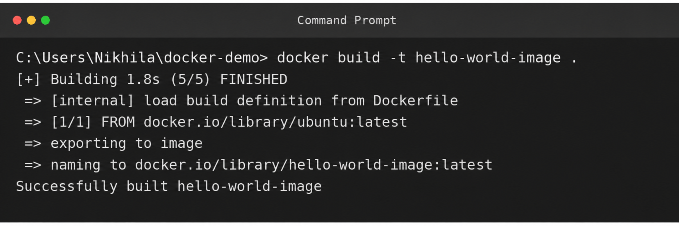
The image is created and can be viewed in Docker Desktop under Images.
Step 3: Docker Container
A Docker container is a running instance of a Docker image.
Run the Ubuntu image interactively using:
docker run -it ubuntu
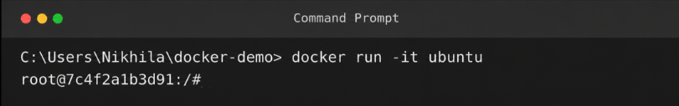

This creates and starts an Ubuntu container in interactive terminal mode.
Step 4: Check Images and Containers in Docker Desktop Website
Open Docker Desktop and check the Images section to view the available Docker images.
Open the Containers section to view the containers that are running or have been created.
The Docker Desktop interface can be used to view the image and container details.
Step 5: Check Containers Using Command
To display all containers, including stopped containers, use:
docker ps -a
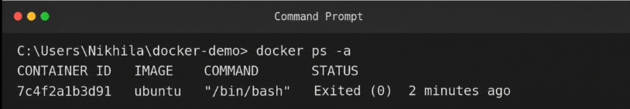

Step 6: Check Docker Images
To display the Docker images available on the system, use:
docker images
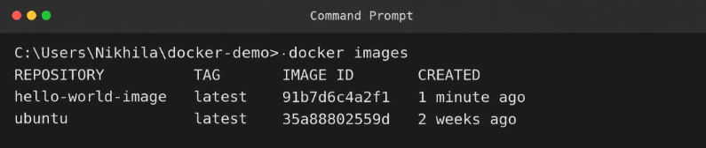

Step 7: Remove a Docker Container
To remove a container using its container ID, use:
docker rm <container_Id>
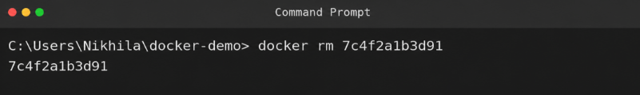

Step 8: Remove a Docker Image
To remove an image using its image ID, use:
docker rmi <Image_Id>
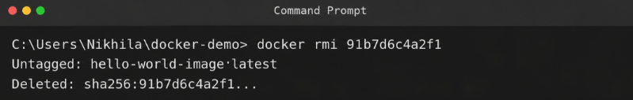
Step 9: Run Ubuntu Container
Run an Ubuntu container in interactive terminal mode:
docker run -it ubuntu
The -it options allow interactive access to the Ubuntu container through the terminal.
Basic Docker Workflow
Docker Desktop Installation
↓
Build Hello World Image
↓
Check Images
↓
Run Docker Container
↓
Check Containers
↓
Remove Container / Image

