Adaptive Software Engineering
Name: J.Nikhila
Roll no: 2420030387
Section - 1

Experiment-9: Static Code Analysis using SonarQube

Objective
To perform static code analysis of a Java program using SonarQube, identify duplicate code and maintainability issues, and verify the analysis event before and after improving the code.
Step 1: Create the Project Structure
Create the following project structure for the Java project.
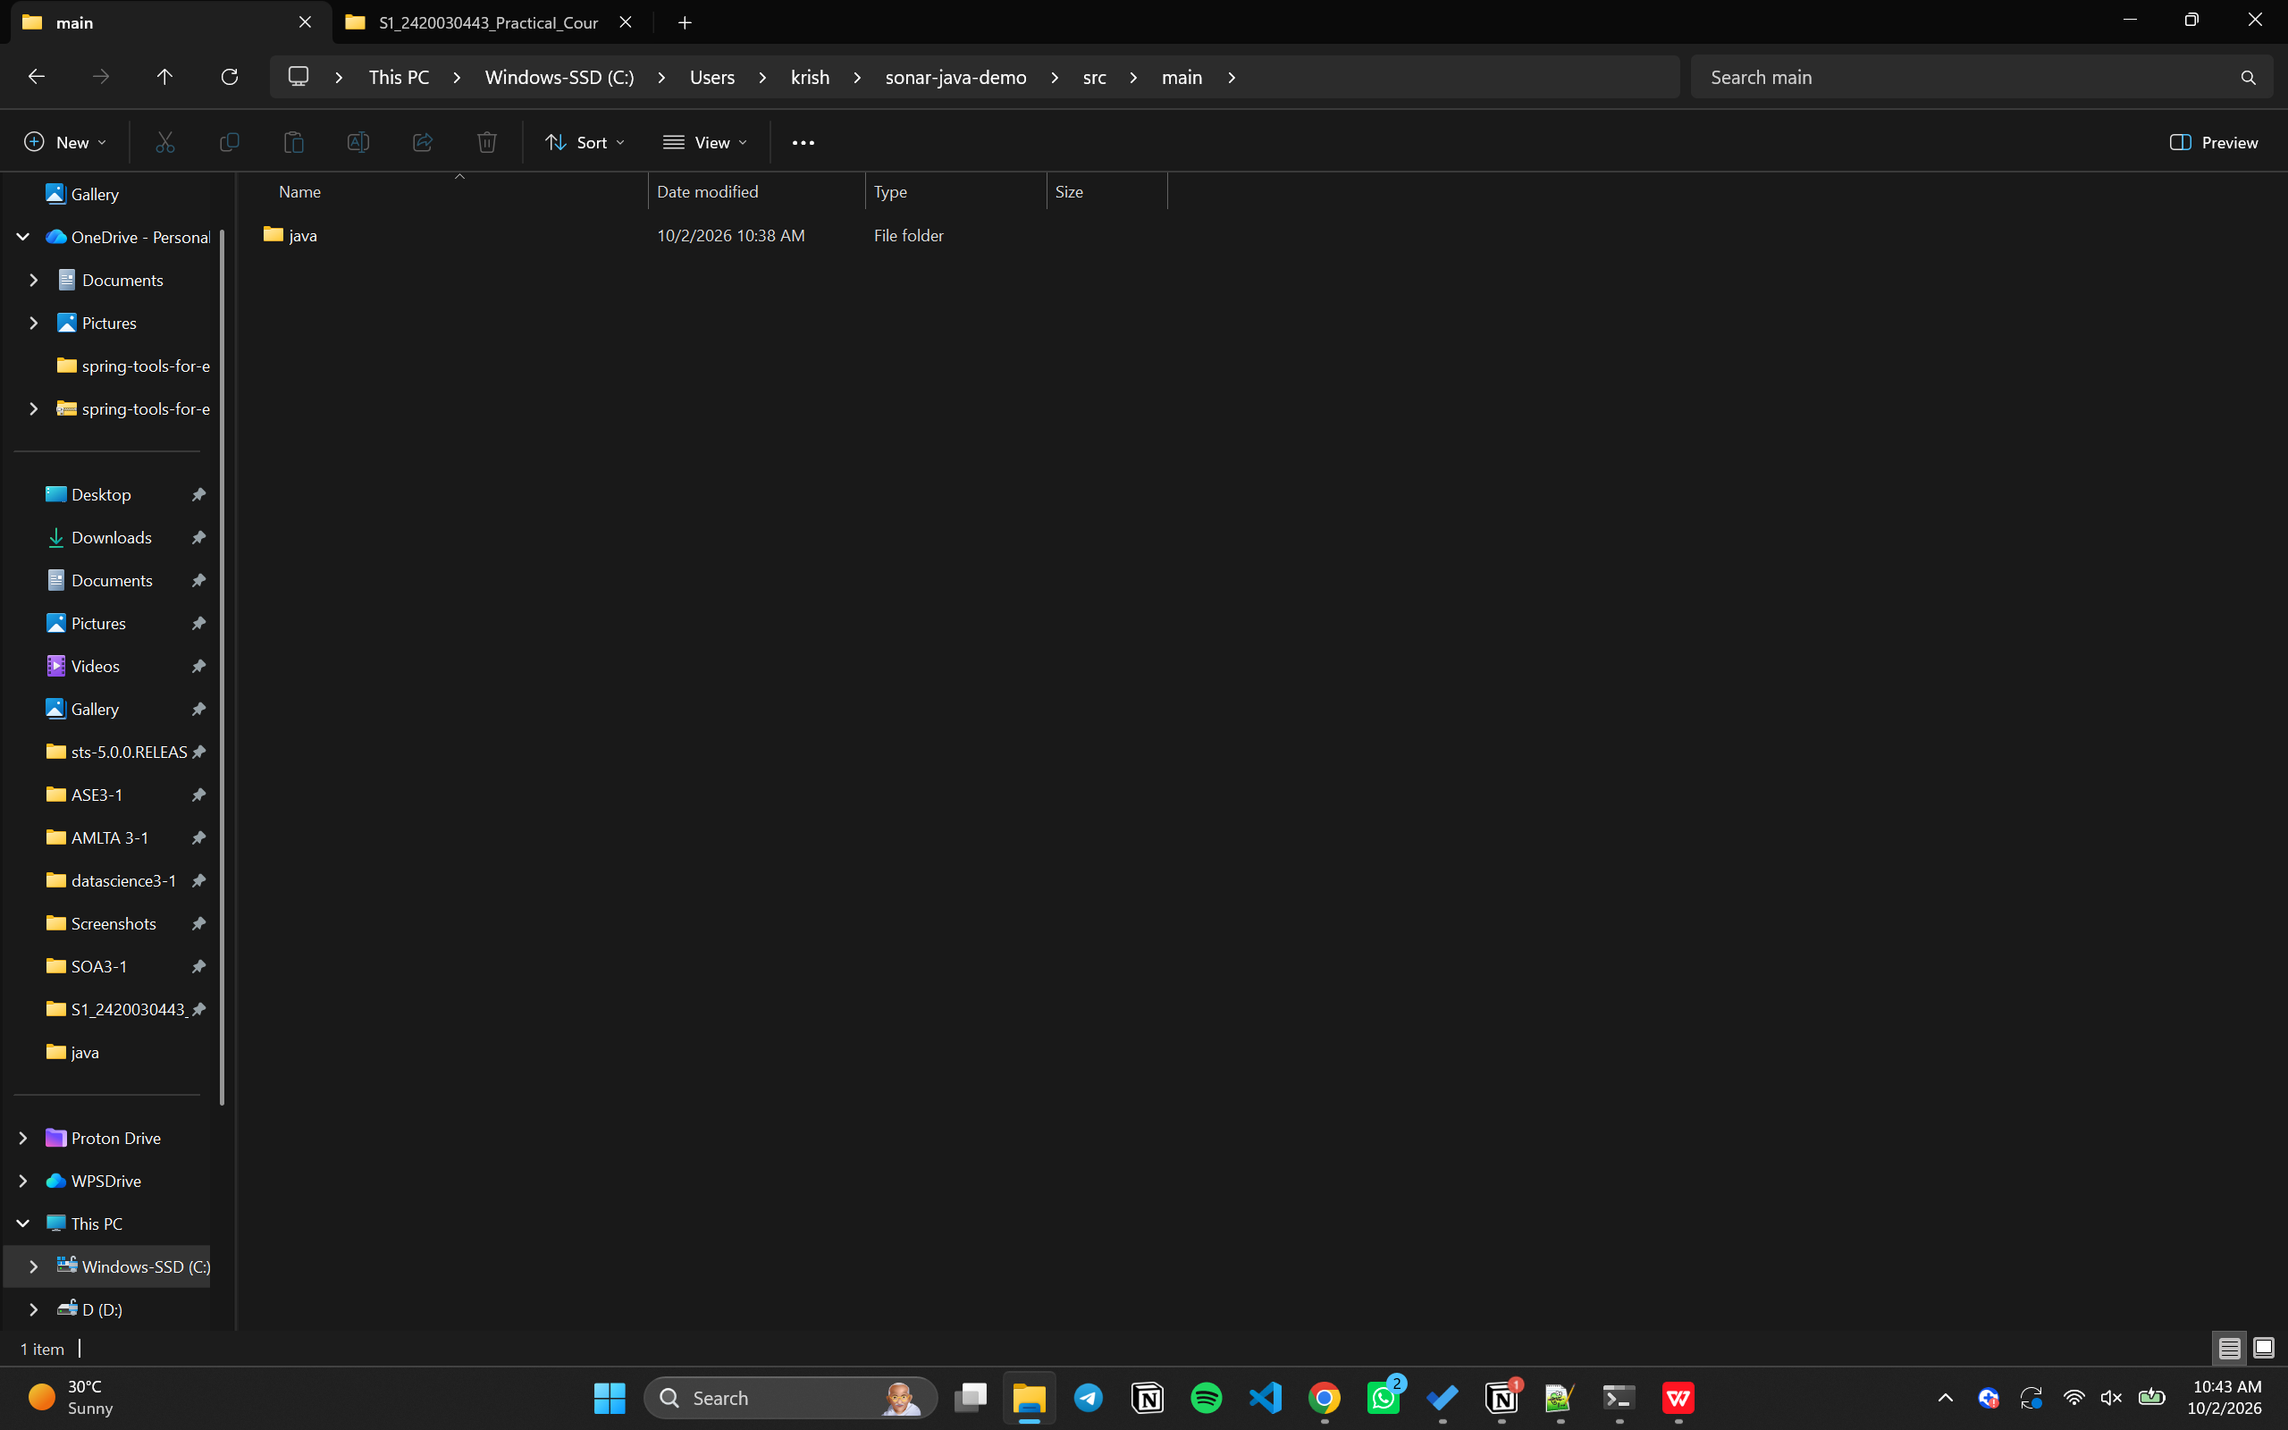
Step 2: Create the Java File
Create a file named DuplicateCode.java and add the required Java code.
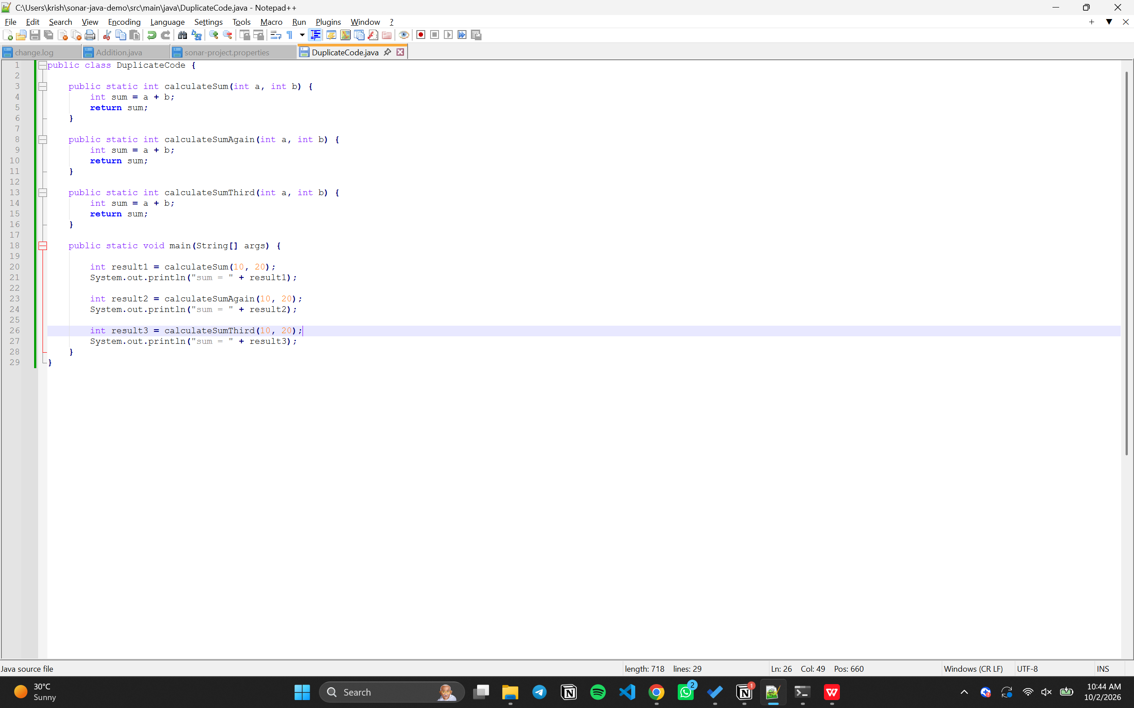

Step 3: Run the Java Program
Open Command Prompt and execute the following commands:
cd C:\Users\DELL\sonar-java-demo
javac src\main\java\DuplicateCode.java
java -cp src\main\java DuplicateCode

Output
sum = 30
sum = 30
sum = 30
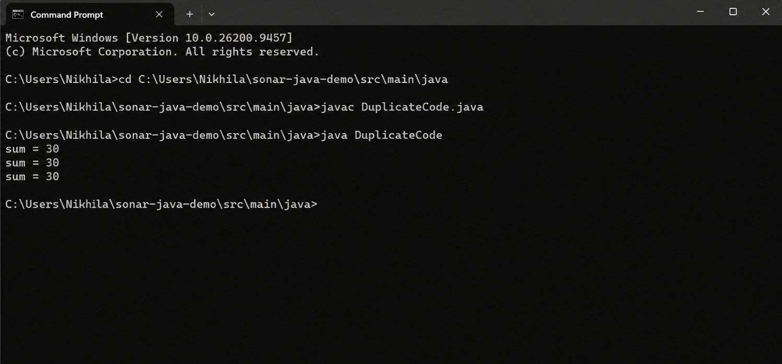

SonarQube Server Setup
Step 4: Start SonarQube Server
Open Command Prompt and navigate to the SonarQube installation folder. Start the SonarQube server and wait until the server is operational.
cd /d C:\Users\DELL\sonarQube\sonarqube-25.9.0.112764\bin\windows-x86-64
StartSonar
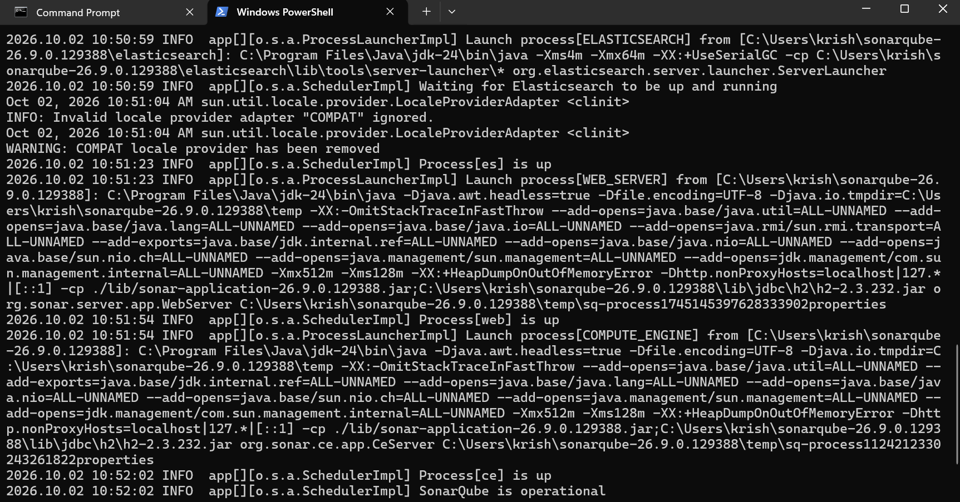
Open the SonarQube web interface in the browser:
http://localhost:9000

Login
Open the SonarQube login page and sign in with the configured credentials.
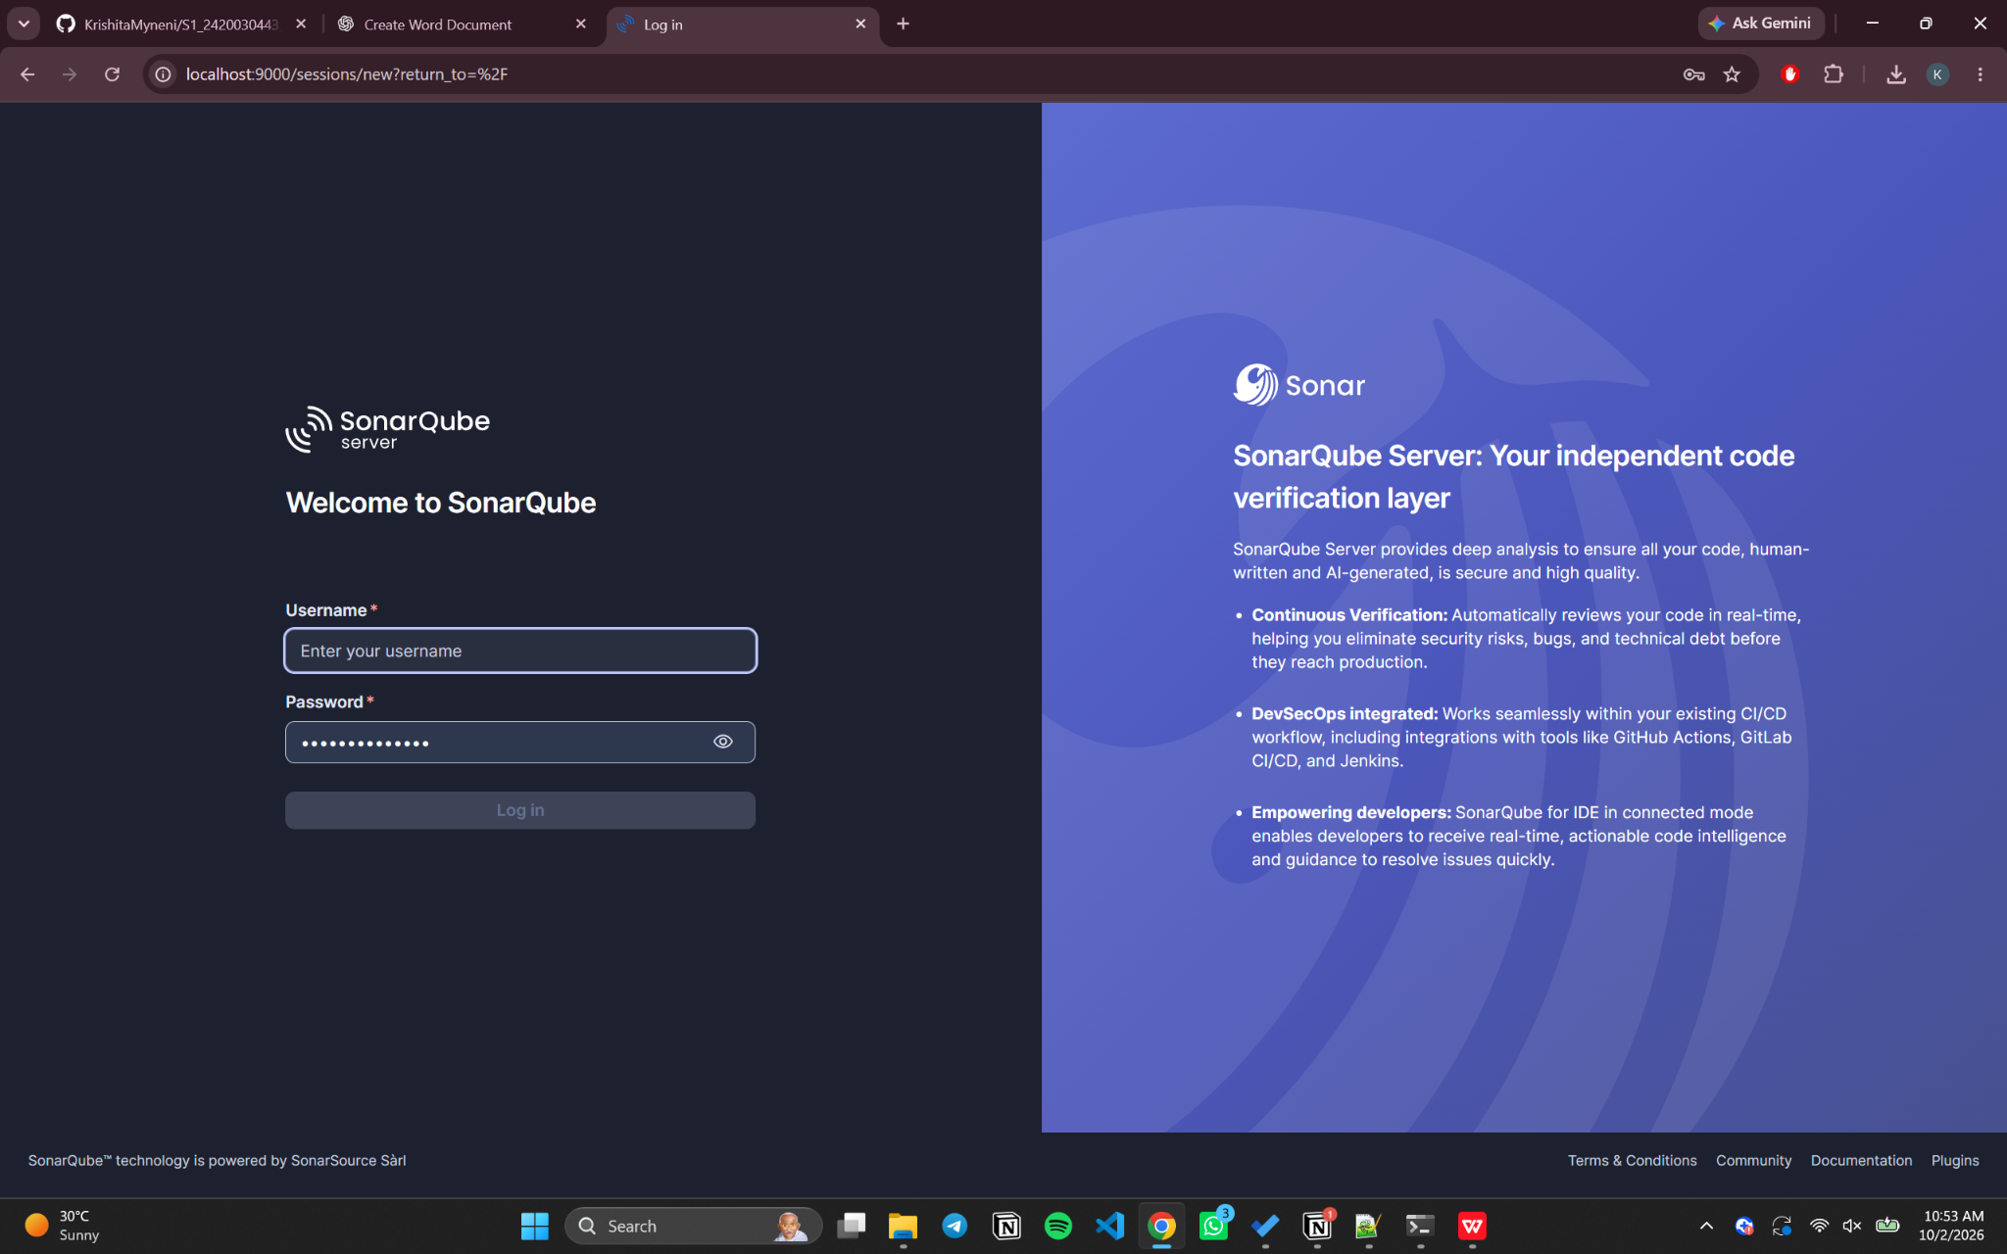

Create the SonarQube Project
Create a new project using the following project details:
Project Name: Java Duplicate Code Analysis
Project Key: Java-Duplicate-Code-Analysis
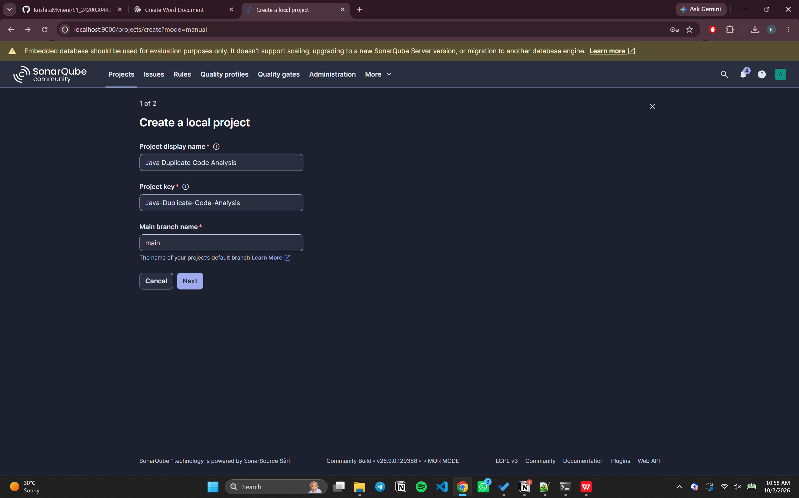
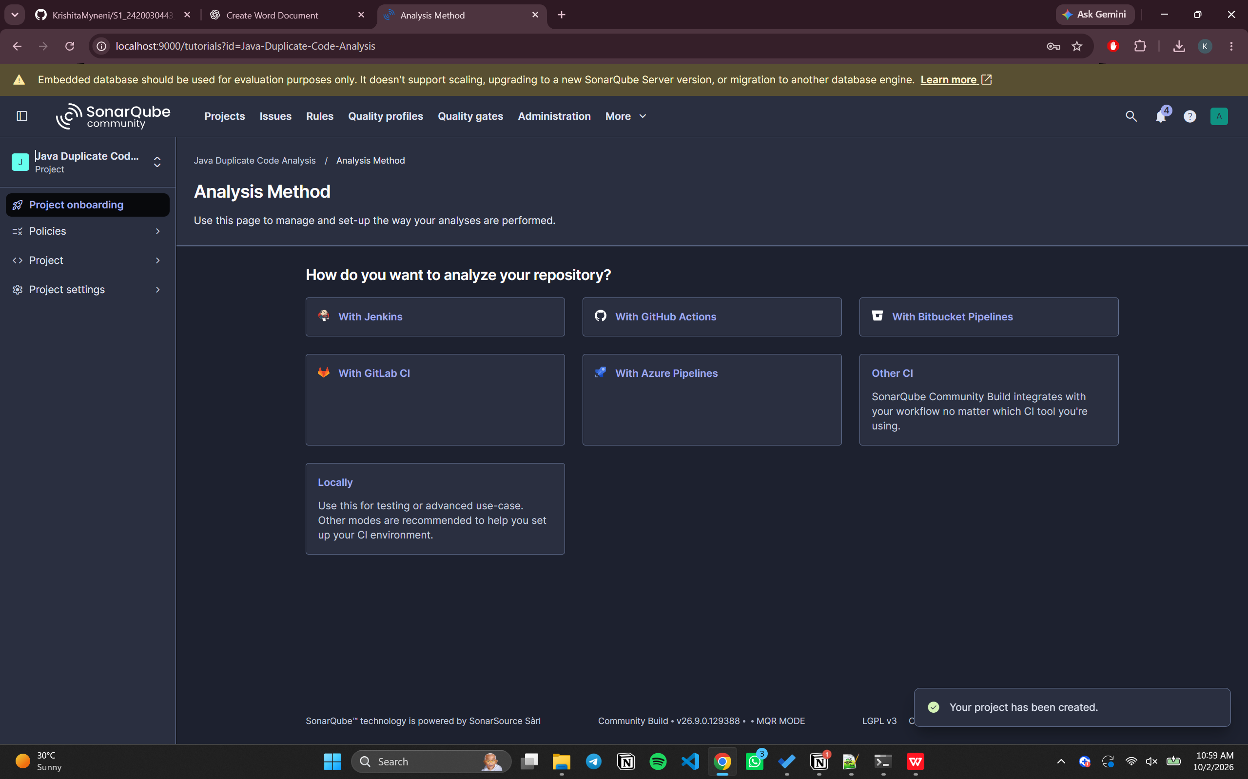

Project Token
Generate an analysis token for the project and copy it safely. The token is required to authenticate the SonarScanner analysis.
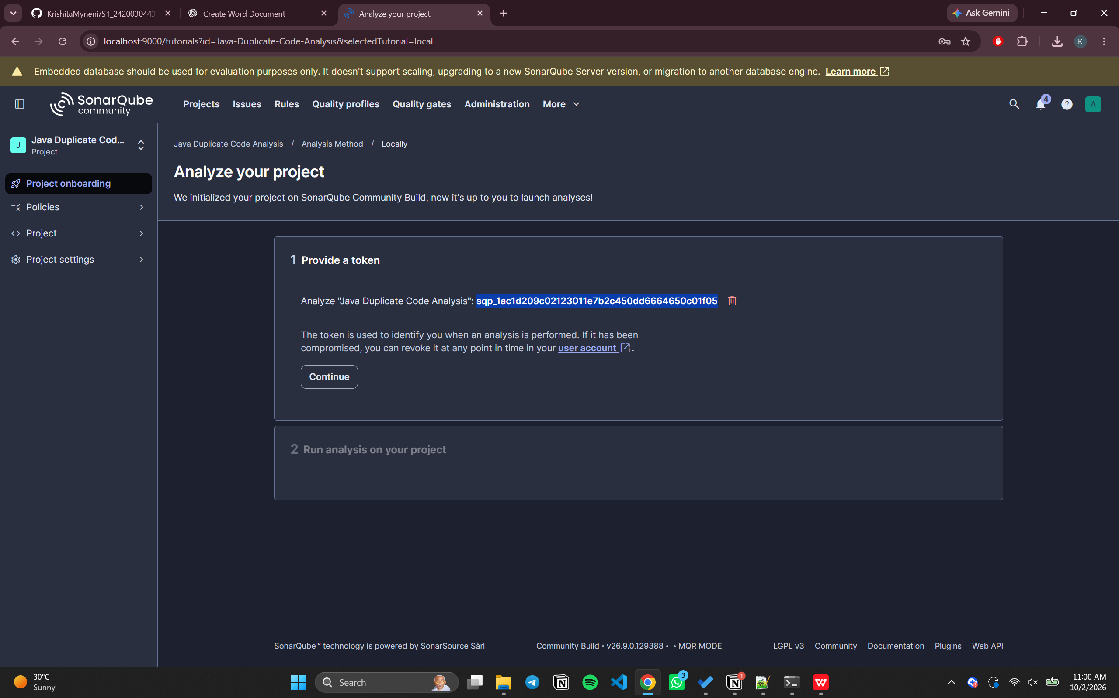

Generate and Run the SonarQube Analysis
Step 5: Generate an Analysis Token
Generate an analysis token in SonarQube according to the selected CI version and operating system information.
Step 6: Run SonarScanner
Open Command Prompt in the Java project directory and execute:
cd C:\Users\DELL\sonar-java-demo
sonar-scanner -Dsonar.projectKey=Java-Duplicate-Code-Analysis -Dsonar.sources=src\main\java -Dsonar.host.url=http://localhost:9000 -Dsonar.token=YOUR_NAME_TOKEN
Wait for the scanner to complete successfully. The analysis results are then uploaded to the SonarQube server.
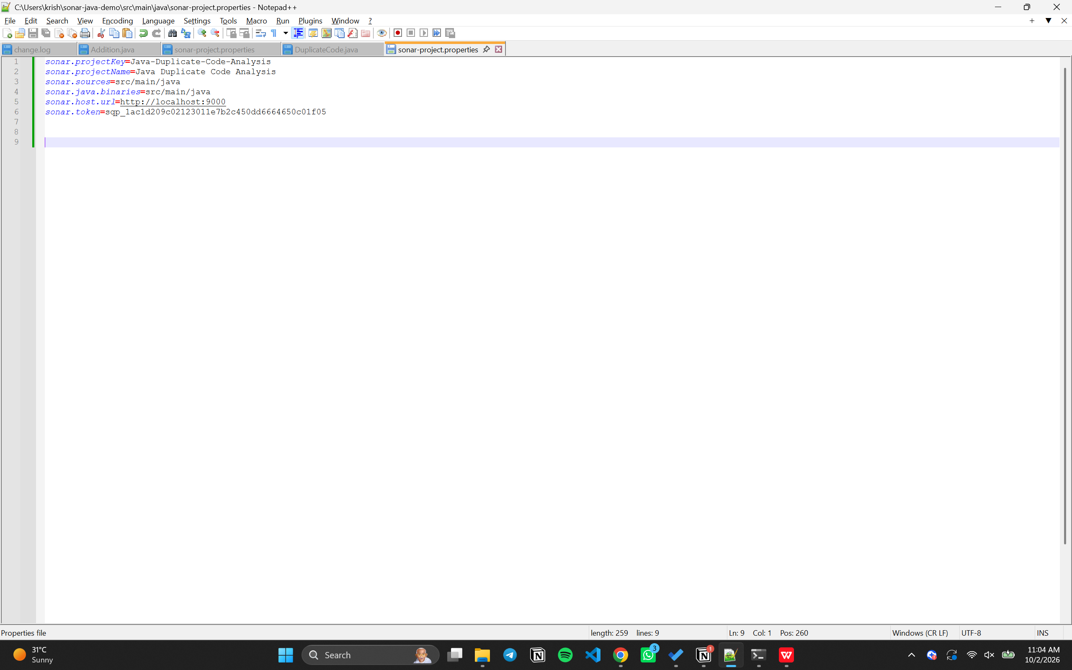
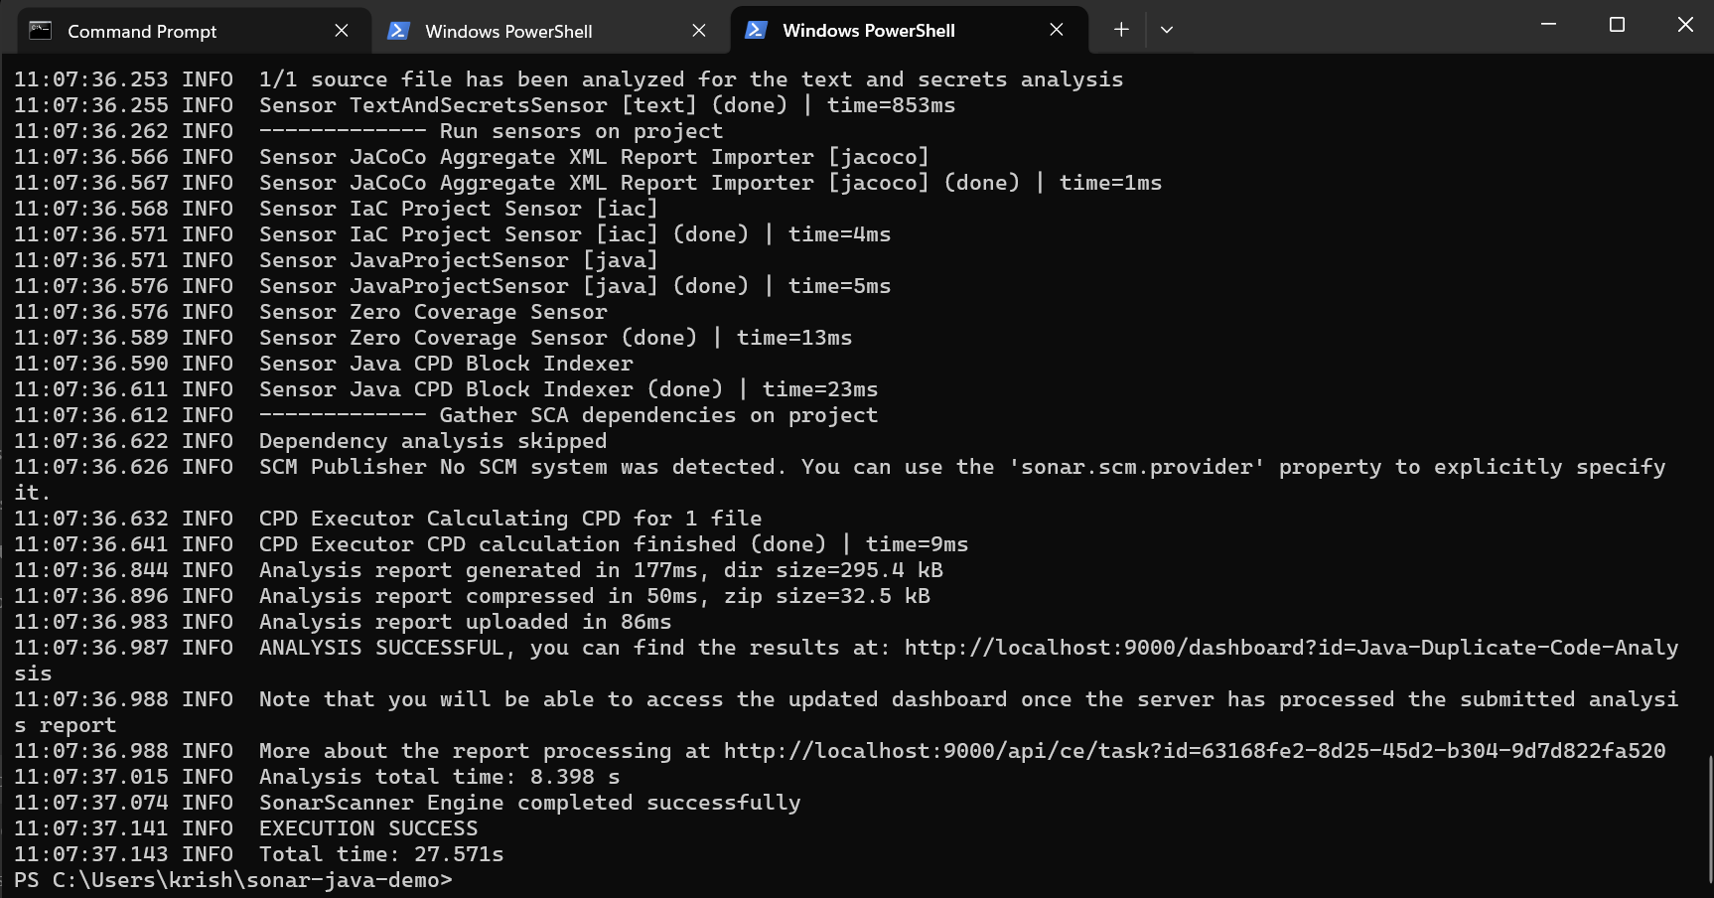

Project Dashboard
Open the project dashboard in SonarQube to view the analysis results.
http://localhost:9000/project/dashboard/branch/main/?id=Java-Duplicate-Code-Analysis
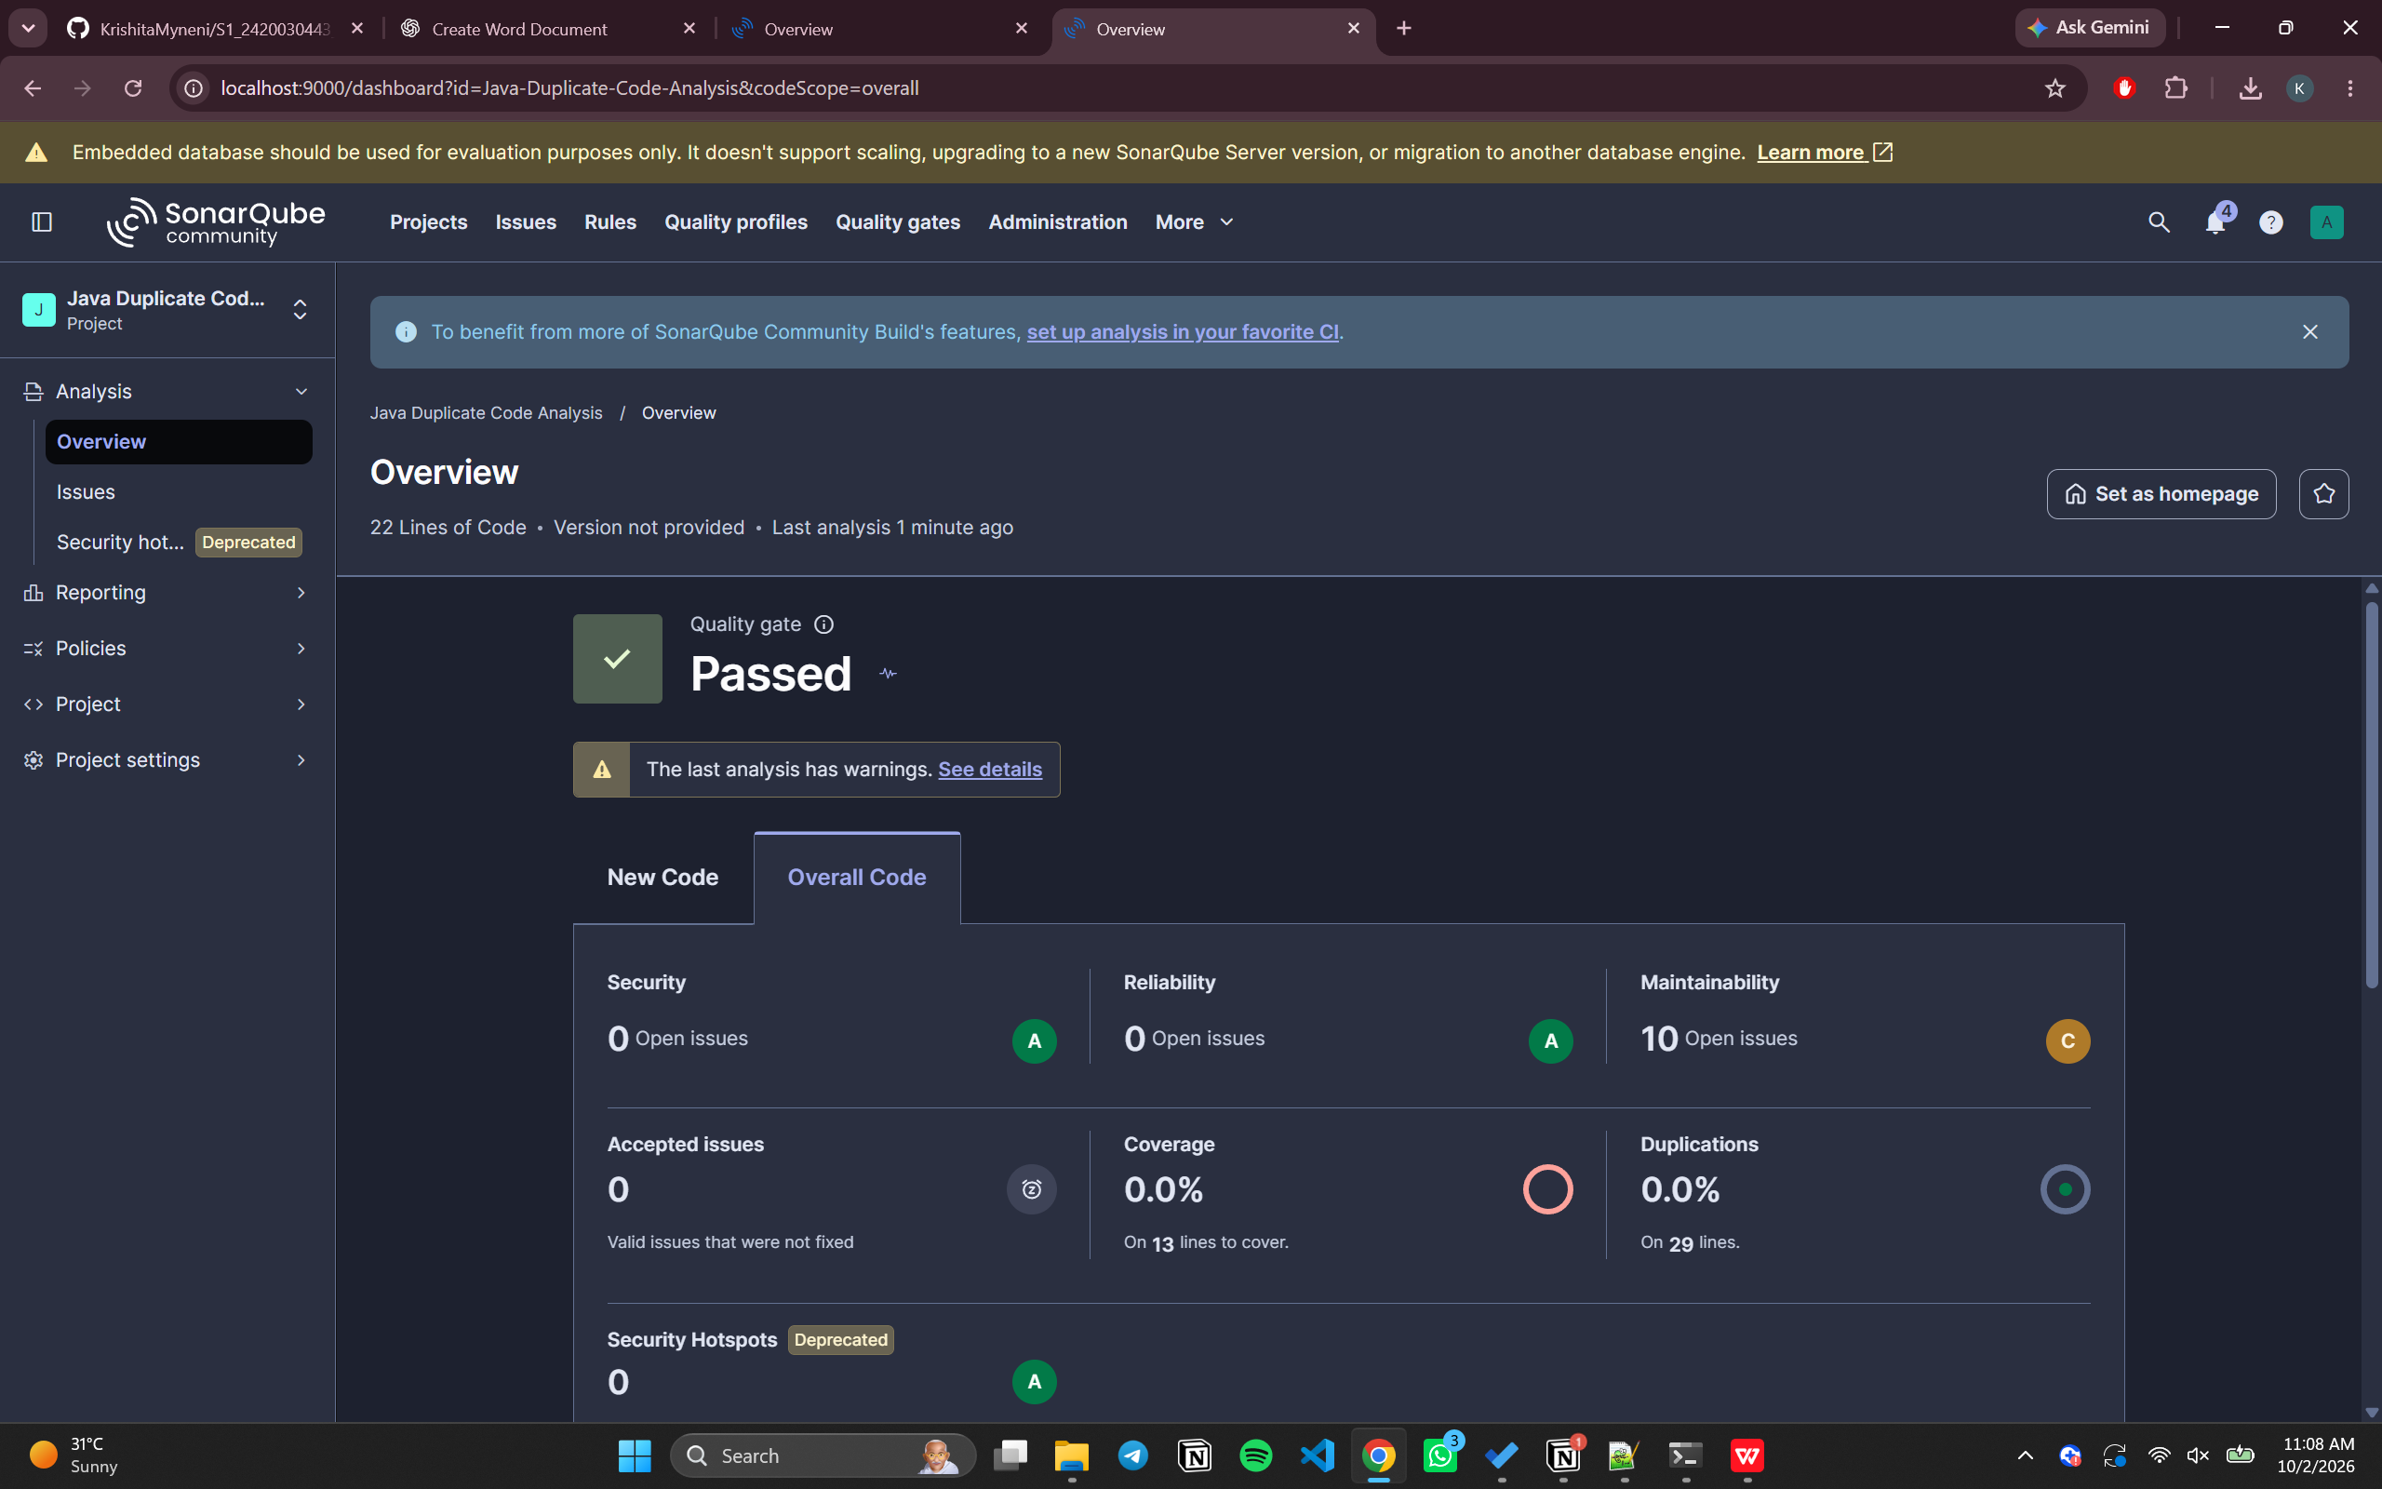

Static Code Analysis Results

Analysis
SonarQube analyzes the Java source code and reports issues related to code quality, duplicate code, maintainability, and other static-analysis metrics.

Duplicate Code
The initial Java program contains repeated code. SonarQube can identify the duplicated sections during the analysis.

Maintainability Issues
The SonarQube dashboard can be used to inspect maintainability-related issues reported for the project.

Before and After Improvement
Run the analysis on the original program, improve the duplicated or maintainability-related code, and run SonarScanner again. Compare the analysis events in SonarQube to verify the change in reported issues.

Analysis Event
The project dashboard displays the analysis event and the resulting quality information after the scan is completed.

Basic SonarQube Workflow
Create Java Project
↓
Create DuplicateCode.java
↓
Compile Java Program
↓
Start SonarQube Server
↓
Create SonarQube Project
↓
Generate Analysis Token
↓
Run SonarScanner
↓
View Analysis Results
↓
Improve the Code
↓
Run SonarScanner Again
↓
Compare the Analysis Events

Result
The Java program was analyzed successfully using SonarQube. Duplicate code and maintainability issues can be identified from the SonarQube dashboard, and the analysis can be repeated after improving the code to verify the changes.

