Ozone Levels in Various Botanical Gardens

It is well known to the public that part of Earth’s atmosphere is made up of the elemental compound ozone. Ozone is primarily contained in the outer layer of the atmosphere to protect the surface from excessive ultraviolet exposure but also acts as a primary pollutant linked to human respiratory diseases like asthma. Surface-level ozone is primarily classified as dangerous and harmful to plants. The main reason behind this conclusion is that ozone will enter the plants’ cellular layers via the stomata and leave behind long-lasting damage to the internal tissue and negatively affect plants’ immunity, which makes them more vulnerable to pests and drought. Other processes that will be negatively affected by ozone layers include photosynthesis, food storage, and overall growth for the plant. Some of the most common symptoms of prolonged ozone exposure in plants include distinct black, brown, or yellow spots on leaves, particularly older leaves. The major discovery that was found during this study is that the gardens on the east side exude more presence of ozone than the west side gardens measured in this study. This is most likely due to east side gardens being in areas of higher ozone content, such as urban or suburban regions with dense populations.

The data shows that twenty gardens from various locations exhibited different ozone levels due to the ozone content of the area they’re occupied in. A two-sample t-test was conducted to determine the likelihood that there is a more specific correlation between ozone levels and the different gardens that were studied.
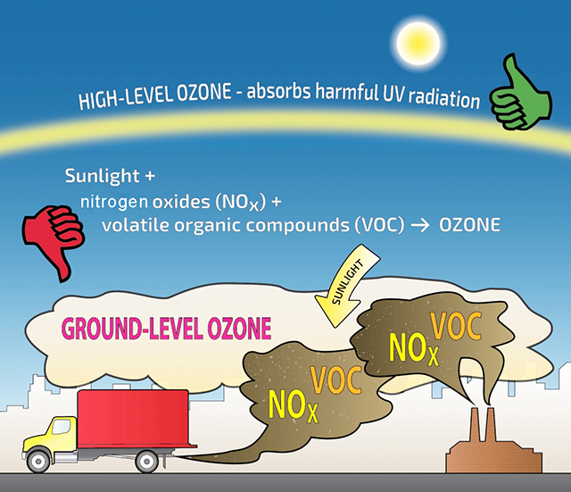
Credit: State of Washington Department of Ecology

