Ozone Levels in Various Botanical Gardens

It is well known to the public that part of Earth’s atmosphere is made up of the elemental compound “ozone”. Ozone is primarily contained within the outer layer of the atmosphere to protect the surface from excessive ultraviolet exposure from the Sun but also acts as a primary pollutant linked to human respiratory diseases such as asthma. Surface-dwelling ozone is primarily classified as harmful to plants. The primary reason behind this conclusion is that ozone element will enter the plants’ cellular layers via the stomata and leave behind long-lasting damage to the internal tissue and negatively affect plants’ immunity, which makes them more vulnerable to pests and environmental hazards. Other processes that will be negatively affected by extensive ozone exposure include photosynthesis, food storage, and overall metabolism for the plants. Some of the most common symptoms of prolonged ozone exposure in plants include the formation of distinct black, brown, or yellow spots on leaves, particularly of older age. The major discovery that was found during this study is that the gardens on the east side of a city exude a more intense presence of ozone than the west side gardens measured in this study. This is most likely due to east side gardens being in areas of higher ozone content, such as residential, commercial, or industrial areas with dense populations.

The data shows that twenty gardens from various locations exhibited different ozone levels due to the ozone content of the area they’re occupied in. A two-sample t-test was conducted to determine the likelihood that there is a more specific correlation between ozone levels and the different gardens that were studied.
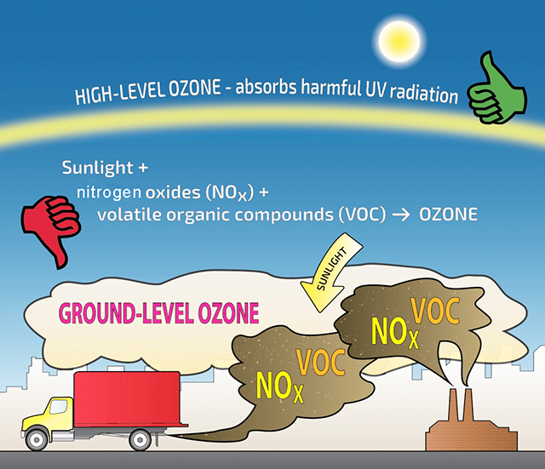
Credit: State of Washington Department of Ecology

