ENTERPRISE REFERENCE ARCHITECTURE BLUEPRINT
Agentic AI & Semantic Knowledge Fabric for Telecom Operations
A 5-Layer Architecture Combining Thin-Client MCP Orchestration, SOP-Compiled Worker Agents, Dual-Slice Semantic Knowledge Graphs (Stardog EKG & Open-Source W3C), and a Dedicated Runtime CQRS Action Plane

Document Attribute | Specification | Architectural Governance | Standard / Baseline
Document ID | ARCH-TELCO-AGENT-EKG-2026-V2 | Industry Alignment | TM Forum ODA, SID (GB922), eTOM (GB921), Open APIs
Target Domain | Telecom OSS/BSS Operations (Assurance, Fulfillment, Inventory) | Semantic Standards | W3C OWL 2, RDF-star, SPARQL 1.1, R2RML, SHACL, SKOS, QUDT
Agent Protocol | Model Context Protocol (MCP) + OAuth2 OBO Token Exchange | Reference Stacks | Commercial: Stardog EKG + Voicebox | OSS: Ontop + Fuseki + Qdrant

Architectural Blueprint Structure (Table of Contents)
Part / Plane | Section | Core Architectural Focus & Deliverables
Part I: Agentic Control Plane | Section 1 | Executive Summary & End-to-End 5-Layer Reference Architecture (Build Plane, Read Plane & CQRS Action Plane)
Part I: Agentic Control Plane | Section 2 | Layer 1: Platform-Agnostic Thin-Client Orchestration, MCP Topology & Proactive Event Reflex Arc
Part I: Agentic Control Plane | Section 3 | Layer 2: Worker Agents ('Agent-as-a-Tool') & The SOP-to-Skill / Guardrail HITL Pipeline
Part II: Creating the Knowledge Graph | Section 4 | Telecom Domain Ontology (TM Forum SID / eTOM TBox) & Dual-Slice Schema Separation
Part II: Creating the Knowledge Graph | Section 5 | Three-Pronged Knowledge Ingestion Architecture (SQL Virtual, Excel Materialized, PDF/PPTX BITES)
Part III: Using the Knowledge Graph | Section 6 | Runtime Read Plane: Layer 3 (NL2Semantics) & Layer 4 (Deterministic Semantic Compiler & Federation)
Part III: Using the Knowledge Graph | Section 7 | Runtime CQRS Action Plane: Read-Only EKG Boundaries, Singleton Check MCP Server & Transactional Write MCP Server
Part III: Using the Knowledge Graph | Section 8 | End-to-End Sequence Walkthrough, OBO Security, AgentOps Observability & Stack Comparison

1. Executive Summary & The 5-Layer Reference Architecture
1.1 Operational Challenges in Telecom OSS/BSS Environments
Modern Telecommunications Service Providers operate across deeply fragmented Operational Support Systems (OSS) and Business Support Systems (BSS). Executing routine operational workflows—such as Layer-2/Layer-3 enterprise fiber assurance, SLA degradation triage, complex B2B service fulfillment, and installed-base reconciliation—requires correlating live network state across relational Configuration Management Databases (CMDBs), semi-structured commercial product spreadsheets, and thousands of unstructured engineering PDFs and customer contract decks.
Deploying first-generation Large Language Model (LLM) agents directly over these raw telecom silos fails in production due to three systemic engineering failure modes:
- 1. Procedural Improvisation Risk: Free-form autonomous ReAct agents improvise troubleshooting steps, violating strict telecom Standard Operating Procedures (SOPs), bypassing pre-flight safety checks, and risking cascading network outages.
- 2. Semantic & Join Hallucinations: When LLMs are asked to write raw SQL or API queries against hundreds of normalized OSS/BSS tables with cryptic column names, volatile natural keys, and unaligned units (e.g., dBm, Mbps vs. Gbps), they hallucinate join paths and produce inaccurate SLA calculations.
- 3. Uncontrolled State Mutation: Granting probabilistic AI models direct write access to network provisioning APIs or knowledge repositories without deterministic schema validation (SHACL), singleton state verification, and blast-radius circuit breakers introduces unacceptable operational risk.
1.2 The 5-Layer Architectural Paradigm Across Three Functional Planes
To eliminate these failure modes while achieving high operational automation, this Reference Architecture enforces a strict separation of concerns across three distinct vertical planes: (1) the Design-Time / Build Plane, (2) the Runtime Operational Read Plane structured into five vertical layers (Layers 1–5), and (3) the parallel Runtime CQRS Action Plane (housing the Singleton Check MCP Server and Transactional Write MCP Server):
Layer / Plane | Architectural Component | Engine Type | Primary Operational Responsibility
Layer 1 (Read Plane) | Platform-Agnostic Orchestration Agent | Probabilistic AI (Thin Client) | Hosts user/ticket interaction on any agent platform (Vertex AI, Copilot Studio, Bedrock, LangGraph) and handles proactive event awakening via northbound MCP.
Layer 2 (Read Plane) | Procedural Worker Agents ('Agent-as-a-Tool') | Deterministic State Machine + Bounded LLM | Encapsulates domain workflows as MCP tools. Executes strict state machines and safety guardrails compiled from human-reviewed Telecom SOPs.
Layer 3 (Read Plane) | Semantic Intent Translation (NL2Semantics) | Probabilistic AI (Conceptual Slice) | Reads ONLY the business-facing TM Forum SID/eTOM Conceptual Ontology (TBox) to translate worker intent into safe, canonical SPARQL AST queries.
Layer 4 (Read Plane) | Deterministic Semantic Compiler & Federation | 100% Deterministic Engine (Physical Slice) | Compiles canonical SPARQL AST queries via R2RML/SMS2 into federated SQL pushdown and RDF reads across virtualized and materialized stores.
Layer 5 (Read Plane) | Heterogeneous Telecom Data & Network Sources | Storage & Live Network Endpoints | Houses live SQL Installed Base databases (CMDB), Excel service catalogs, unstructured PDF/PPTX documents, and live OSS/NMS APIs.
Runtime CQRS Action Plane | Singleton Check & Transactional Write MCP Servers | 100% Deterministic Action & Verification Engines | Invoked directly by Layer 2 Worker Agents to perform real-time pre-flight device state checks (Singleton Check MCP Server) and governed mutations (Transactional Write MCP Server).

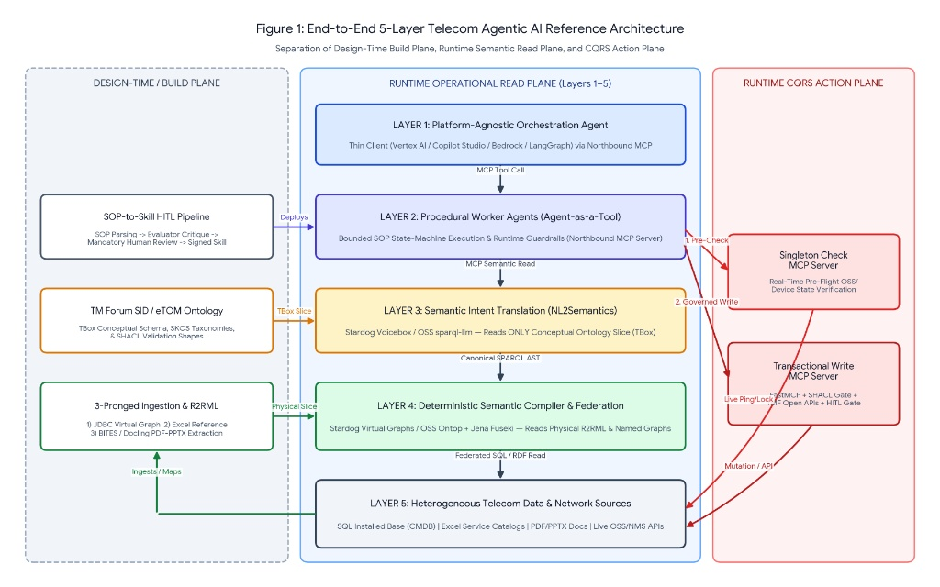
Figure 1: End-to-End 5-Layer Telecom Agentic AI Reference Architecture showing the separation of the Design-Time Build Plane (left), Runtime Operational Read Plane across Layers 1–5 (center), and Runtime CQRS Action Plane (right).
2. Layer 1: Platform-Agnostic Orchestration & Thin-Client MCP Topology
2.1 Bring-Your-Own-Orchestrator (BYOO) & Thin-Client Design Principles
Large telecommunications enterprises rarely standardize on a single AI interface. Customer service desks may use Microsoft Copilot Studio or ServiceNow Now Assist, network operations centers (NOCs) may deploy Google Cloud Vertex AI Agent Builder, and network engineering teams may run custom Python LangGraph pipelines. Layer 1 is architected as a strictly decoupled 'Thin-Client Orchestration Layer' governed by three engineering invariants:
- Zero Embedded Domain Logic: The Layer 1 Orchestrator contains zero telecom troubleshooting trees, zero OSS database credentials, and zero knowledge of underlying SQL table schemas or network element APIs.
- Dynamic Capability Discovery via MCP: At session initialization, the Layer 1 Orchestrator connects as an MCP Client to the Layer 2 Enterprise MCP Gateway, invoking tools/list to dynamically discover bounded Worker Agents exposed as discrete MCP tools.
- Context Window Minimization: Instead of stuffing 50-page network engineering SOPs or massive database DDL schemas into the Layer 1 system prompt, Layer 1 only sees concise MCP tool signatures (e.g., diagnose_l2_fiber_circuit, verify_b2b_upgrade_eligibility) and receives synthesized, decision-ready JSON payloads back from Layer 2.
2.2 Proactive Event-Driven Awakening (Southbound Telemetry to Northbound Reflex Arc)
While conversational chat and ITSM ticket creation represent top-down ('pull') triggers, over 70% of telecom assurance operations (eTOM Assurance) originate as bottom-up ('push') network events. To support Zero-Touch NOC operations without flooding Layer 1 LLMs with raw syslog or SNMP storms, the architecture implements a deterministic Event Reflex Arc:
- 1. Telemetry Ingestion & Windowed Deduplication: High-velocity network alarms (gNMI telemetry, syslog bursts, SNMP traps, and TMF642 Alarm Management payloads) land in an Apache Kafka / Google Cloud Pub/Sub event bus. A deterministic stream processor suppresses flapping alarms and correlates child symptoms to root transport failures.
- 2. Asynchronous MCP Awakening: When a correlated threshold breach occurs (e.g., Optical Rx Power drops below -27 dBm on a trunk serving VIP enterprise circuits), the event gateway emits an asynchronous webhook / MCP notification that instantiates a headless Layer 1 Orchestrator session pre-populated with the TMF642 alarm payload and invokes the appropriate Layer 2 Worker Agent.
2.3 Zero-Trust Identity Propagation (OAuth2 On-Behalf-Of Flow)
To prevent privilege escalation across virtualized data sources, Layer 1 enforces strict identity propagation. When a human NOC engineer or automated service principal initiates a task, an OIDC/OAuth2 JWT containing their organizational roles, tenant clearances (e.g., Retail vs. Wholesale vs. Government Defense circuits), and blast-radius scopes is attached to the MCP _meta request header. This cryptographic token is exchanged via OAuth2 On-Behalf-Of (OBO) delegation across Layer 2, Layer 3, Layer 4, and the Runtime CQRS Action Plane, ensuring downstream queries and mutations respect row-level and Named-Graph-level RBAC.
3. Layer 2: Worker Agents ('Agent-as-a-Tool') & The SOP-to-Skill HITL Pipeline
3.1 The 'Agent-as-a-Tool' Encapsulation Pattern
In Layer 2, each Worker Agent is packaged as a self-contained, bounded microservice exposed northbound to Layer 1 as a standard MCP Tool, while acting southbound as an MCP Client that consumes Layer 3/4 semantic read tools and the Runtime CQRS Action Plane tools (Singleton Check MCP Server and Transactional Write MCP Server). Unlike unconstrained autonomous agents, a Layer 2 Worker Agent operates as a deterministic finite state machine (implemented via LangGraph StateGraph or semantic workflow runners) where an LLM is used strictly for structured parameter extraction and step-level summarization—never to invent new operational steps.
3.2 The SOP-to-Skill & Guardrail Transformation Pipeline with Human-in-the-Loop (HITL)
Telecom operators maintain thousands of formal Standard Operating Procedures (SOPs) authored in Word, PDF, or Confluence. Manually coding state machines for every SOP creates a massive engineering bottleneck, whereas letting an LLM interpret raw SOP prose at runtime leads to non-deterministic execution. This architecture introduces a governed Design-Time CI/CD Pipeline with mandatory Human-in-the-Loop (HITL) engineering sign-off that compiles unstructured SOPs into versioned Worker Skills and runtime Guardrails:
Pipeline Stage | Execution Component | Architectural Transformation & Governance Function
Stage 1: Document Normalization | Docling / Unstructured.io | Parses Word/PDF SOPs into structured Markdown ASTs, preserving decision tables, threshold matrices, CLI command blocks, and escalation flowcharts.
Stage 2: AI Skill & Guardrail Extraction | LLM Compiler Agent (Constrained Schema) | Decomposes the SOP into two formal artifacts: (a) a state-machine workflow (skill.md / StateGraph YAML) and (b) a declarative Guardrail Specification (JSON Schema + SHACL pre/post-conditions).
Stage 3: Evaluator-Optimizer Critique | Automated Verification Agent | Cross-examines the compiled skill against the raw SOP text to flag missing fallback branches, unmapped southbound MCP tools, or ambiguous numeric thresholds.
Stage 4: Mandatory HITL Review Gate | Lead Network Architect / Process Owner (Git PR + Visual Diff UI) | Presents a side-by-side visual state-graph and diff mapping every compiled node and guardrail back to the exact source SOP paragraph. Requires cryptographic approval before merge.
Stage 5: Sandbox Simulation & Promotion | CI/CD Runner + MCP Registry | Executes synthetic replay tests (happy path, boundary failure, permission denial) against mock MCP endpoints, signs the skill bundle, and publishes it to the Layer 2 runtime.

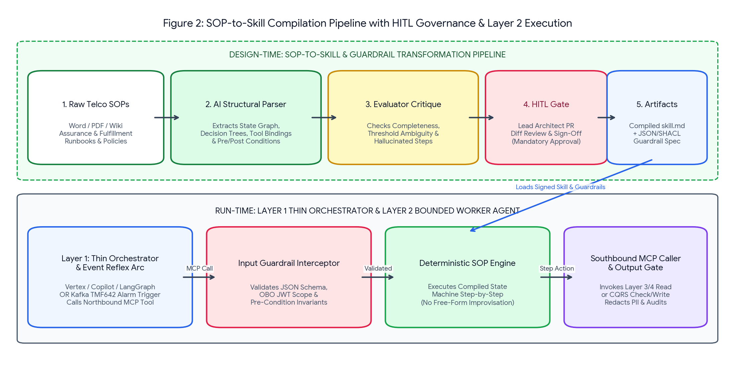
Figure 2: Functional Breakdown of the Design-Time SOP-to-Skill HITL Compilation Pipeline (top) and the Layer 1 to Layer 2 Runtime Guardrail Execution Engine (bottom).
3.3 Concrete Telecom Example: Compiling SOP-ASSUR-402 ('Enterprise L2 Fiber Degradation')
To illustrate how prose SOP rules become deterministic runtime behavior, consider a standard NOC procedure: 'When an Enterprise Ethernet circuit reports packet loss > 0.5%, first verify customer SLA tier and historical contract commitments in the Knowledge Graph. Next, perform a live singleton optical power check on the terminating CPE port. If Rx power is between -25 dBm and -28 dBm and no maintenance window is active, trigger a non-intrusive DDM recalibration; if Rx power is below -28 dBm, abort remote action and dispatch field fiber repair.'
Compiled Artifact A & B: Worker Skill State-Machine & Guardrail Spec (Approved via HITL Gate #PR-884)
# FILE: skills/l2_fiber_assurance_v2.yaml (Compiled from SOP-ASSUR-402 Rev 4.1)
skill_id: "telco.assurance.l2_fiber_degradation"
approved_by: "j.vandijk@telco-arch.nl (Lead Transport Architect)"
mcp_input_schema:
required: ["circuit_id", "reported_packet_loss_pct", "obo_jwt_token"]
guardrails:
pre_conditions:
- id: "GR-PRE-01"
rule: "reported_packet_loss_pct >= 0.5"
on_fail: "ABORT_NO_ACTION_REQUIRED"
execution_invariants:
- id: "GR-INV-01"
rule: "NEVER invoke write_cpe_recalibration unless singleton_check.maintenance_lock == false"
- id: "GR-INV-02"
rule: "IF singleton_check.optical_rx_dbm < -28.0 THEN FORBID all remote write tools; FORCE transition -> STEP_4_DISPATCH"
workflow_states:
STEP_1_SEMANTIC_CONTEXT:
tool: "mcp://stardog-ekg/query_semantic_context"
intent: "Fetch Customer SLA Tier, CFS/RFS topology, and BITES contract penalty clauses for {circuit_id}"
next: "STEP_2_SINGLETON_OPTICAL_PROBE"
STEP_2_SINGLETON_OPTICAL_PROBE:
tool: "mcp://singleton-check-server/probe_live_optical_port"
params: { "rfs_port_iri": "{STEP_1.terminating_port_iri}", "bypass_cache": true }
branching:
- condition: "rx_dbm < -28.0" -> "STEP_4_FIELD_DISPATCH"
- condition: "rx_dbm >= -28.0 AND rx_dbm <= -25.0 AND maintenance_lock == false" -> "STEP_3_REMOTE_RECALIBRATE"
STEP_3_REMOTE_RECALIBRATE:
tool: "mcp://transactional-write-server/execute_tmf640_recalibration"
requires_shacl_validation: true

4. Part II (Build Plane): Telecom Domain Ontology & Dual-Slice Schema Design
4.1 Accelerating the Semantic Layer with Generic Telecom Knowledge (TM Forum SID & eTOM)
Building an enterprise ontology from scratch ('greenfield modeling') typically stalls in multi-month taxonomy debates. In the telecommunications domain, this architecture accelerates ontology creation and drastically improves LLM grounding accuracy by anchoring the core TBox (Terminological Box) directly to two industry-standard TM Forum frameworks:
- 1. TM Forum SID (Shared Information and Data Model / GB922) as the Structural Backbone: Instead of inventing custom classes, the ontology imports a pruned subset of the SID class hierarchy across the Customer, Product, Service, and Resource domains. Specifically, it establishes the canonical multi-hop traversal spine: tmf:Customer -> tmf:Product -> tmf:CustomerFacingService (CFS) -> tmf:ResourceFacingService (RFS) -> tmf:PhysicalResource (OLT, Router, Fiber Span, CPE). Every relational table, Excel row, and unstructured PDF entity maps into this standardized spine.
- 2. TM Forum eTOM (Business Process Framework / GB921) as a Controlled SKOS Taxonomy: A critical design pattern proven in enterprise Voicebox deployments is avoiding the bulk ingestion of raw, unstructured eTOM guidebook prose into the vector store—which pollutes retrieval with generic definitions. Instead, eTOM Level 1–3 process identifiers (e.g., 1.3.7 Problem Handling, 1.4.5 Resource Trouble Management) are modeled as a lightweight, structured SKOS taxonomy (skos:ConceptScheme) linked directly to SID entities and Worker Agent skills via tmf:governedByProcess.
4.2 The Two-Slice Semantic Model Split (Conceptual TBox vs. Physical Mappings)
To ensure that Layer 3 (NL2Semantics) never hallucinates physical SQL join paths while Layer 4 (Deterministic Compiler & Federation) executes exact federated queries, the semantic model repository is partitioned at build time into two strictly decoupled metadata slices:
- Slice A — The Conceptual Ontology Slice (TBox / SKOS / SHACL): Exposed exclusively to Layer 3 (NL2Semantics). Contains human-readable OWL classes, object/datatype properties, natural language descriptions (rdfs:comment), domain synonyms (skos:altLabel—e.g., mapping 'NTU', 'Optical Demarc', and 'Customer Modem' to tmf:CPE), and parameterized Stored SPARQL Query templates. Contains ZERO physical table names, column names, or database coordinates.
- Slice B — The Physical Mapping & Federation Slice (R2RML / SMS2 / Crosswalks): Exposed exclusively to Layer 4 (Deterministic Semantic Compiler & Federation). Contains W3C R2RML or Stardog SMS2 virtual graph bindings linking SID classes to physical SQL queries, surrogate-to-Golden-IRI crosswalk tables, SCD Type 2 temporal window filters, and QUDT unit conversion formulas.
4.3 Parallel Tooling Comparison: Commercial (Stardog) vs. Open-Source W3C Modeling
Modeling Capability | Commercial Approach (Stardog EKG) | Open-Source W3C Approach
Visual Ontology Authoring (TBox) | Stardog Designer & Stardog Studio (No-code visual OWL/SKOS canvas with Git sync) | Stanford Protégé + OntoMaven / ROBOT CLI for automated OWL 2 & SKOS CI/CD builds
Constraint & Data Hygiene Rules | Stardog Integrity Constraint Validation (ICV) using native SHACL & OWL axioms | Apache Jena SHACL / pySHACL validation shapes integrated into pre-ingestion pipelines
Virtual Graph Mapping Authoring | Stardog SMS2 (Stardog Mapping Syntax 2) with auto-schema discovery wizard | W3C R2RML / RML mappings authored via Ontop Protégé Plugin or YARRRML declarative YAML
Semantic Metadata Catalog | Stardog Voicebox Ontology Metadata & Stored Query Registry | Open-source Qdrant vector index storing embedded OWL class definitions & Golden SPARQL pairs

5. Part II (Build Plane): The Three-Pronged Knowledge Ingestion Architecture
Operational telecom knowledge resides across three fundamentally different storage paradigms: high-velocity relational databases (SQL Installed Base), semi-structured commercial spreadsheets (Excel Service Options), and unstructured technical/commercial documents (PDFs and PowerPoint decks). Rather than forcing all three into a monolithic ETL data lake—which destroys real-time accuracy for operational data—this architecture implements Stardog's three-pronged hybrid virtualization-and-materialization pattern (alongside its exact Open-Source W3C equivalent).
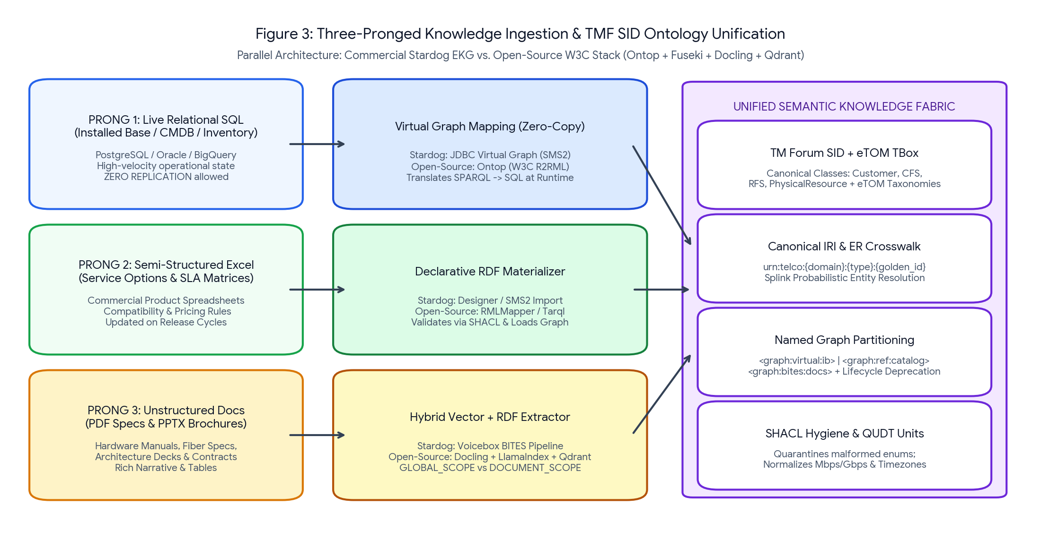
Figure 3: Functional Breakdown of the Three-Pronged Ingestion Architecture unifying live SQL Virtual Graphs, materialized Excel Reference Graphs, and unstructured PDF/PPTX BITES extractions under a single TM Forum SID Ontology.
5.1 Flow 1: Live Relational Data (SQL Installed Base) via Zero-Copy Virtual Graphs
The SQL Installed Base (CMDB, network inventory, active circuit tables in PostgreSQL, Oracle, Snowflake, or BigQuery) changes continuously as circuits are provisioned or modified. Replicating this data into a graph database introduces fatal state synchronization lag.
- Ingestion & Mapping Mechanics: Zero data rows are copied during ingestion. Instead, architects register a JDBC Virtual Graph mapping (Stardog SMS2 or Open-Source Ontop R2RML) that binds SQL views/tables to TM Forum SID classes (e.g., mapping CMDB_ACTIVE_CIRCUITS to tmf:CustomerFacingService) and defines deterministic URI templates.
- Stardog vs. Open Source: Stardog uses its native JDBC Virtual Graph engine with cost-based SQL pushdown optimization. The Open-Source stack uses Ontop (an OBDA—Ontology-Based Data Access—engine compliant with W3C R2RML) exposed as a virtual SPARQL endpoint federated into Apache Jena Fuseki.
5.2 Flow 2: Semi-Structured Spreadsheets (Excel Service Options) via Materialized Reference Graphs
Product managers and commercial engineering teams frequently maintain service option matrices, CPE hardware compatibility tables, SLA tier definitions, and regional bandwidth upgrade rules in complex Excel workbooks (.xlsx). Unlike the live CMDB, these spreadsheets change on controlled product release cycles but suffer from irregular formatting and shadow enums.
- Ingestion & Mapping Mechanics: When an updated Excel workbook is committed to the product repository, an automated ingestion pipeline converts the worksheets into RDF triples mapped to the SID Product/ServiceSpecification classes, validates every cell against SHACL shapes (catching invalid bandwidth enums or missing SLA codes), and materializes the clean triples into a dedicated Reference Named Graph (<urn:telco:graph:ref:service-options>).
- Stardog vs. Open Source: Stardog Designer imports CSV/Excel files directly via declarative SMS2 mappings into a materialized Named Graph. In the Open-Source stack, a Python pre-processor normalizes merged Excel headers and executes RMLMapper (or Chowlk/Tarql), validates the output via pySHACL, and performs an atomic SPARQL Graph Store HTTP PUT into Apache Jena Fuseki.
5.3 Flow 3: Unstructured Documents (PDFs & PPTX Decks) via Voicebox BITES / Hybrid Extraction
Critical operational context—such as optical transceiver thermal tolerances in vendor PDF manuals, bespoke SLA penalty clauses in enterprise contract PDFs, and target network topologies in customer solution PowerPoint (.pptx) decks—exists only in unstructured files. Because SQL/SPARQL cannot be pushed down into a raw PDF at query time, extracted facts must be physically materialized into the Knowledge Graph.
- Stardog Voicebox BITES Pipeline: Stardog's BITES (Blob Indexing, Text Extraction, and Semantics) pipeline ingests PDFs and PPTX files into three synchronized artifacts inside Stardog: (1) Content-aware document chunks stored in the internal document store, (2) Dense vector embeddings for semantic similarity retrieval, and (3) Ontology-constrained RDF entity and relationship triples extracted by an LLM guided by the active TBox schema.
- Entity Scoping (GLOBAL_SCOPE vs. DOCUMENT_SCOPE): To prevent cross-document entity pollution, BITES applies two scoping modes: GLOBAL_SCOPE entities (such as canonical Product SKUs, CPE Models like 'Nokia-7210-SAS', or Enterprise Customer IDs) resolve directly to the shared Golden IRIs used by the SQL and Excel graphs. DOCUMENT_SCOPE entities (such as local clauses, slide-specific architecture assumptions, or temporary project milestones) are minted with document-scoped IRIs anchored to a tmf:DocumentMetadata provenance node.
- Document Update & Deprecation Lifecycle: Each ingested PDF/PPTX is isolated inside a versioned Named Graph (<urn:telco:graph:bites:doc-{uuid}-v{n}>) linked to a metadata management graph tracking dcterms:issued, dcterms:replaces, and telco:lifecycleStatus ('ACTIVE', 'SUPERSEDED', 'DEPRECATED'). When a new contract revision or hardware manual is uploaded, the pipeline atomically flips the old Named Graph status to 'SUPERSEDED' and excludes it from active Layer 3/4 runtime queries.
- Open-Source Equivalent Pipeline: Uses IBM Docling (or Unstructured.io) for layout-aware PDF table/text and PPTX slide parsing -> LlamaIndex SchemaLLMPathExtractor constrained by the Protégé OWL ontology to emit RDF triples -> pySHACL validation -> triples loaded into Jena Fuseki Named Graphs while text chunks + canonical IRI metadata pointers are indexed in Qdrant.
5.4 Unifying the Three Prongs: Canonical IRI Templates & Entity Resolution
The architectural glue that allows a single runtime SPARQL query to seamlessly join a live SQL Installed Base row with an Excel Service Option rule and a PDF hardware manual is the Canonical Golden IRI Template combined with an Entity Resolution (ER) Crosswalk:
Cross-Source Unification via Canonical IRI Templates & Named Graph Federation
# Canonical IRI Pattern: urn:telco:{domain}:{entity_type}:{canonical_id}
# 1. Generated virtually from SQL Installed Base (Prong 1 - Graph <urn:telco:graph:virtual:ib>):
<urn:telco:service:cfs:CIR-994821> a tmf:CustomerFacingService ;
tmf:hasServiceSpec <urn:telco:catalog:spec:ETH-10G-GOLD> ;
tmf:usesPhysicalResource <urn:telco:resource:cpe:NOK-7210-SAS-Mxp> .
# 2. Materialized from Excel Service Options Matrix (Prong 2 - Graph <urn:telco:graph:ref:catalog>):
<urn:telco:catalog:spec:ETH-10G-GOLD> a tmf:ServiceSpecification ;
telco:maxPacketLossThresholdPct "0.1"^^xsd:decimal ;
telco:eligibleUpgradeSpec <urn:telco:catalog:spec:ETH-100G-PLATINUM> .
# 3. Extracted from Vendor PDF Manual via BITES (Prong 3 - Graph <urn:telco:graph:bites:doc-882-v2>):
<urn:telco:resource:cpe:NOK-7210-SAS-Mxp> a tmf:PhysicalResourceSpec ;
telco:minOpticalRxPowerDbm "-27.5"^^xsd:decimal ;
prov:wasDerivedFrom <urn:telco:doc:pdf:nokia-7210-optical-guide-p42> .

When natural keys differ across systems (e.g., 'KPN-ENT-00492' in Billing SQL vs. 'KPN Corporate NL' in a PPTX deck), an upstream probabilistic record linkage pipeline (using Splink on BigQuery/Spark or Stardog native Entity Resolution) materializes owl:sameAs / telco:hasGoldenIRI crosswalk triples into an Identity Bridge Named Graph.
6. Part III (Runtime Read Plane): Layer 3 (NL2Semantics) & Layer 4 (Deterministic Compiler)
6.1 Runtime Separation of Duties Across the Dual-Slice Semantic Model
When a Layer 2 Worker Agent executes a diagnostic or verification step, it invokes the Semantic Knowledge Layer via MCP ('MCP Semantic Read' in Figure 1). Rather than letting an LLM generate raw SQL against physical databases, runtime read execution splits cleanly across Layer 3 (Probabilistic Intent Translation) and Layer 4 (Deterministic Semantic Compiler & Federation).
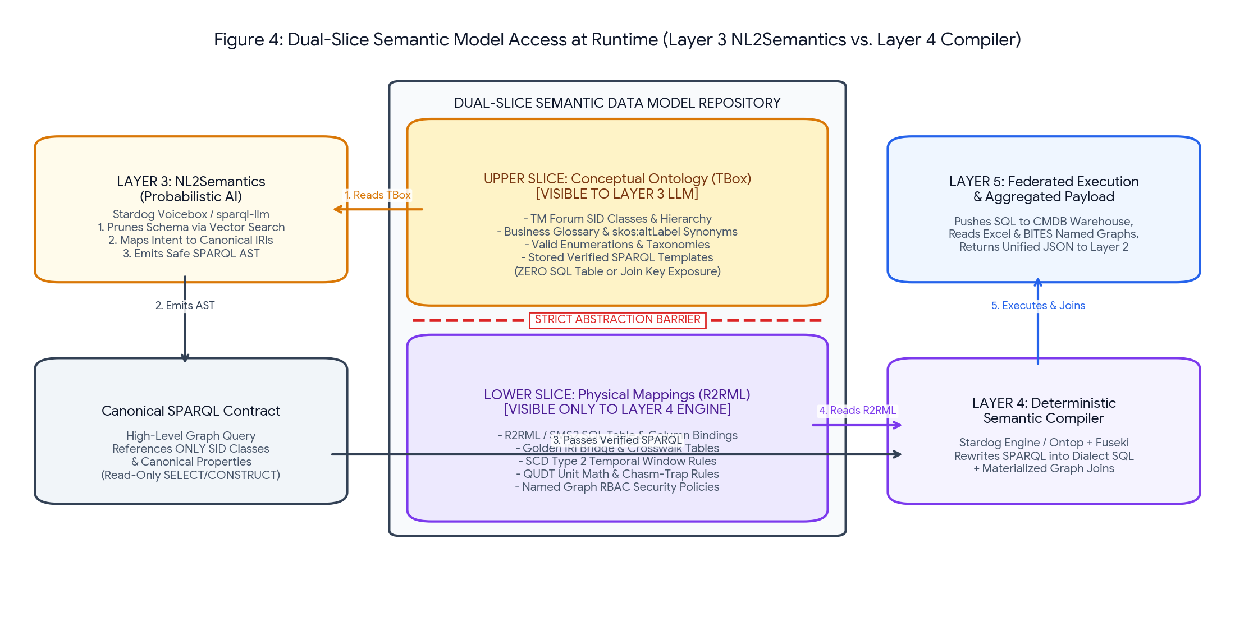
Figure 4: Functional Breakdown of Runtime Query Execution showing Layer 3 (NL2Semantics) reading the Conceptual Ontology Slice (TBox) and Layer 4 (Deterministic Compiler) reading the Physical R2RML Mapping Slice.
6.2 Layer 3 (NL2Semantics) Execution Mechanics
Layer 3 receives a natural language or structured semantic request from the Layer 2 Worker Agent (e.g., 'Retrieve the active CFS topology, allowed optical Rx range from hardware specs, and upgrade options for circuit CIR-994821'). Layer 3 executes four sequential sub-functions:
- 1. Context-Window Schema Pruning: Enterprise telecom ontologies contain thousands of classes and properties. Layer 3 first embeds the incoming request and searches its vectorized TBox catalog (Voicebox internal index or Qdrant in Open Source) to retrieve only the top-K relevant SID classes, properties, and verified Stored SPARQL Query templates.
- 2. Lexical & Synonym Disambiguation: Using skos:altLabel and owl:equivalentClass axioms in the Conceptual Slice, Layer 3 resolves domain jargon ('demarcation box', 'optical handoff') to exact canonical ontology IRIs (tmf:PhysicalResourceSpec, telco:minOpticalRxPowerDbm).
- 3. Constrained SPARQL AST Generation: The fine-tuned NL2Semantics model (Stardog Voicebox or Open-Source sparql-llm with grammar-constrained decoding) emits a read-only SPARQL 1.1 SELECT/CONSTRUCT query ('Canonical SPARQL AST') referencing ONLY canonical TBox classes and properties.
- 4. Pre-Execution Static Analysis: A deterministic parser verifies that all predicates in the generated SPARQL AST exist in the Conceptual TBox and rejects any query containing mutation keywords (INSERT, DELETE, LOAD, CLEAR, DROP).
6.3 Layer 4 (Deterministic Semantic Compiler & Federation) & Resolving the 5 Integration Challenges
Once Layer 3 passes the verified Canonical SPARQL AST across the abstraction boundary, Layer 4's Deterministic Semantic Compiler reads the Physical Mapping Slice (R2RML/SMS2, Golden IRI crosswalks, and Named Graph policies) to rewrite the abstract graph pattern into a Federated SQL / RDF Read against Layer 5. The table below details how Layer 3 and Layer 4 jointly solve the five core enterprise data integration challenges:
Integration Challenge | How Layer 3 (NL2Semantics) & Layer 4 (Deterministic Compiler) Resolve It | Stardog vs. Open-Source Implementation
1. Semantic Gap (Homonyms, Synonyms, Unit & Granularity Mismatch) | Layer 3 separates homonyms via distinct RDF namespaces (billing:Account vs iam:Account) and resolves synonyms via skos:altLabel. Layer 4 applies QUDT unit conversion math (normalizing Kbps/Mbps/Gbps and mW/dBm) and symmetric aggregation rules. | Stardog OWL/SWRL reasoning + QUDT rules vs. Apache Jena OWL reasoner + Ontop SQL expression macros.
2. Unstable Universal Keys (Surrogate Fragmentation, Volatile Keys, Hidden M:N) | Layer 4 replaces fragmented SQL primary keys with canonical IRIs bridged via the Golden ID Crosswalk Named Graph. Hidden M:N relationships are modeled natively as multi-edge RDF graph patterns without row fan-out. | Stardog native ER + Virtual Graph joins vs. Splink crosswalk tables mapped into Ontop R2RML bridge joins.
3. Structural Heterogeneity (3NF vs. Wide Tables, Hierarchies, Nullable Refs) | Both 3NF SQL tables and nested JSON/document hierarchies project into uniform Subject-Predicate-Object triples. Missing foreign keys rely on RDF Open-World Assumption (OPTIONAL patterns) rather than dropping inner-joined SQL rows. | Stardog SMS2 virtual projection vs. Ontop R2RML SQL pushdown + RMLMapper nested JSON/Excel unwinding.
4. Temporal Drift & State Desync (SCD Type 1/2 Mismatch, Latency, Timezones) | Layer 4 attaches bitemporal metadata (RDF-star << ?s ?p ?o >> telco:validFrom ?t1) and injects point-in-time SQL window predicates (BETWEEN valid_from AND valid_to) while normalizing timestamps to xsd:dateTimeStamp (UTC). | Stardog RDF-star (Edge Properties) + temporal named graphs vs. Jena Fuseki RDF-star + Ontop temporal SQL views.
5. Data Hygiene & Free-Form Inputs (Unconstrained Text, Shadow Enums) | Build-time SHACL shapes quarantine non-compliant rows. Shadow enums (e.g., legacy status='99') are translated via R2RML CASE WHEN / SKOS rules into canonical states before Layer 3 ever queries them. | Stardog ICV SHACL + BITES NLP extraction vs. pySHACL gatekeeper + Docling/LlamaIndex structured extraction.

7. Part III (Runtime CQRS Action Plane): Read-Only Boundaries, Singleton Checks & Writes
7.1 Architectural Rationale: Why the Semantic Read Plane (Layers 3 & 4) is Strictly Read-Only
A fundamental architectural rule of this blueprint—visually enforced by the separation between the center Runtime Operational Read Plane and the right-hand Runtime CQRS Action Plane in Figure 1—is that the Semantic Knowledge Layer (Layers 3 and 4) is strictly limited to read-only operations (SPARQL SELECT, ASK, DESCRIBE, and CONSTRUCT). SPARQL Update operations (INSERT DATA, DELETE WHERE) are blocked at the semantic MCP gateway for four engineering reasons:
- 1. Non-Invertibility of Virtual Graph Mappings: R2RML and SMS2 virtual mappings often project multi-table SQL joins, aggregations, and CASE WHEN expressions into virtual RDF triples. Writing a triple back through a non-invertible virtual view into normalized 3NF OSS/BSS tables is mathematically ambiguous and breaks transactional referential integrity.
- 2. Bypass of OSS/BSS Domain State Machines: Updating a circuit state or service bandwidth in a telecom operator cannot be done via a raw database INSERT; it must traverse TM Forum Open APIs (e.g., TMF640 Service Activation, TMF641 Service Ordering) to trigger downstream billing, inventory lock, and network element provisioning workflows.
- 3. Prevention of Unvalidated LLM Graph Poisoning: Allowing an LLM in Layer 3 to emit raw SPARQL INSERT queries risks injecting malformed predicates, orphaned blank nodes, or hallucinated facts that violate ontology constraints.
- 4. Caching & Virtualization Latency: Layer 4 semantic query engines utilize query plan caches, materialized reference snapshots, and connection pooling optimized for multi-hop analytical reads, making them unsuitable for sub-second hardware mutex locks.
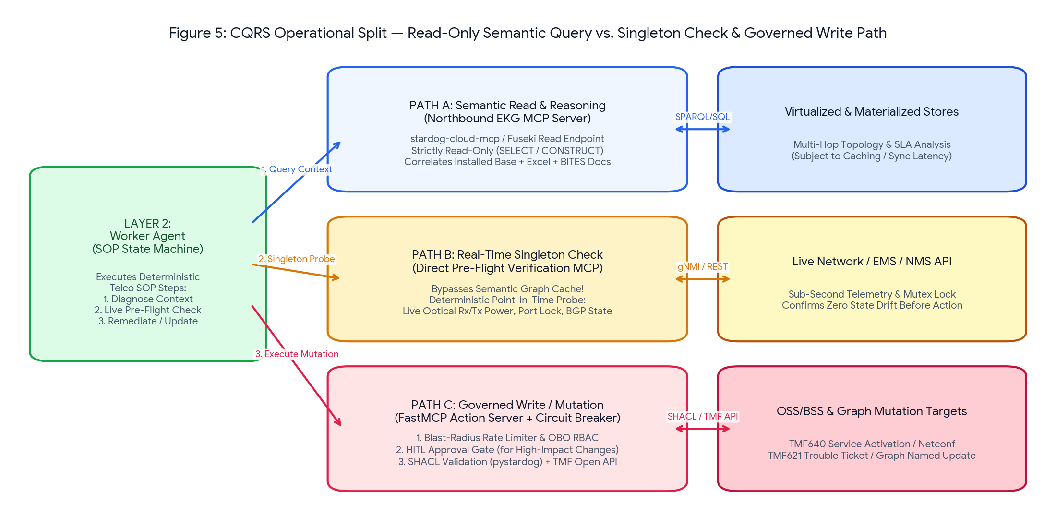
Figure 5: CQRS Runtime Architecture showing how the Layer 2 Worker Agent separates Semantic Read Queries (Path A via Layers 3 & 4) from Real-Time Singleton Pre-Flight Checks (Path B) and SHACL-Validated Transactional Writes (Path C) in the Runtime CQRS Action Plane.
7.2 Supporting Real-Time Singleton State Checks (Singleton Check MCP Server)
Before a Layer 2 Worker Agent executes any remediation or configuration change (such as resetting an optical port, shifting BGP traffic, or upgrading a QoS profile), it must verify the exact, sub-second physical state of that specific target resource. Relying on the Layer 3/4 Semantic Knowledge Graph is insufficient because virtualized CMDB tables or cached graph projections may lag live hardware state by seconds or minutes.
To solve this, the Runtime CQRS Action Plane provides a dedicated Singleton Check MCP Server ('1. Pre-Check' -> 'Live Ping/Lock' in Figure 1) that the Layer 2 Worker Agent invokes immediately prior to any mutation step:
- Deterministic Point-in-Time Probing: The Singleton Check MCP Server takes a single canonical resource IRI resolved from the Semantic Read Plane (e.g., <urn:telco:resource:port:OLT04-P12>) and executes a direct, non-cached, synchronous call against the live Layer 5 OSS/NMS API (via gNMI, NETCONF, or REST) with Cache-Control: no-store.
- Pre-Flight Safety Verification: The Singleton Check verifies three mandatory safety gates in real time: (1) Live telemetry metric confirmation (e.g., instantaneous optical Rx/Tx power or interface error counter), (2) Absence of an active maintenance lock or human CLI session on the network element, and (3) Acquisition of a short-lived distributed mutex lock (Redis/etcd lock) so no concurrent agent or engineer modifies the same port simultaneously.
7.3 Supporting Write, Update, and Delete Operations (Transactional Write MCP Server)
Following the Command Query Responsibility Segregation (CQRS) pattern, all state mutations—whether updating the operational OSS/BSS systems or appending curated knowledge triples to a materialized Named Graph—are routed from Layer 2 directly to the Transactional Write MCP Server ('2. Governed Write' -> 'Mutation / API' in Figure 1) built with FastMCP:
- 1. Mutating Operational OSS/BSS & Network State: The Transactional Write MCP Server exposes strongly typed, deterministic domain tools (e.g., create_tmf621_trouble_ticket, execute_tmf640_service_recalibration, update_cmdb_circuit_status). These tools never use an LLM to generate payloads; they map validated JSON parameters directly into Layer 5 TMF Open APIs or NETCONF/YANG RPCs. Once the underlying SQL CMDB commits the transaction, the change is immediately visible to subsequent Layer 4 Virtual Graph reads.
- 2. Mutating Materialized Knowledge Graph Triples (Curated Graph Writeback): When an agent workflow needs to write, update, or delete triples inside a materialized Named Graph (e.g., recording a verified root-cause incident post-mortem or deprecating an outdated document node), the Transactional Write MCP Server uses a custom Python wrapper around pystardog (or SPARQL Update against Jena Fuseki) that enforces strict programmatic SHACL validation inside a transactional rollback block before committing.
- 3. Blast-Radius Circuit Breakers & HITL Approval Gates: Every write tool is wrapped by a deterministic Policy Enforcement Point (OPA / Cedar). Low-risk actions (e.g., appending diagnostic notes to a TMF621 ticket) execute autonomously under the OBO JWT scope. High-impact mutations (e.g., port reset, bandwidth modification, or service deletion) trigger an asynchronous MCP Human-in-the-Loop approval request, pausing the Layer 2 state machine until an authorized NOC engineer cryptographically signs off. Furthermore, a token-bucket circuit breaker caps maximum write velocity (e.g., max 3 CPE resets per 5-minute window) to prevent runaway agent loops.
Reference Implementation: Transactional Write MCP Server with Pre-Commit SHACL Gate & Blast-Radius Control
from fastmcp import FastMCP
import pystardog
from pyshacl import validate
from rdflib import Graph
mcp_action = FastMCP("telco-transactional-write-mcp-server")
@mcp_action.tool()
def record_verified_incident_resolution(
incident_iri: str, root_cause_iri: str, resolution_summary: str,
singleton_lock_token: str, obo_jwt: str
) -> dict:
# 1. Verify OBO RBAC clearance & active Singleton Pre-Flight Lock
verify_obo_permission(obo_jwt, required_scope="telco:assurance:write")
verify_active_singleton_lock(incident_iri, singleton_lock_token)
check_blast_radius_circuit_breaker(caller_jwt=obo_jwt, action="graph_write")
# 2. Construct candidate RDF triples in memory (Zero LLM generation)
candidate_ttl = f"""
@prefix tmf: <http://tmforum.org/sid/> .
@prefix xsd: <http://www.w3.org/2001/XMLSchema#> .
<{incident_iri}> a tmf:TroubleTicket ;
tmf:hasRootCause <{root_cause_iri}> ;
tmf:resolutionNote """{resolution_summary}"""^^xsd:string ;
tmf:status "RESOLVED" .
"""
data_graph = Graph().parse(data=candidate_ttl, format="turtle")
# 3. Deterministic Pre-Commit SHACL Shape Validation
conforms, _, results_text = validate(
data_graph, shacl_graph=LOAD_SHACL_SHAPES("trouble_ticket_shape.ttl"),
inference="rdfs", abort_on_first=True
)
if not conforms:
raise ValueError(f"SHACL Guardrail Violation - Write Rejected: {results_text}")
# 4. Atomic Transaction Commit to Materialized Named Graph via pystardog
with pystardog.Connection("telco_ekg", **STARDOG_CREDS) as conn:
conn.begin()
conn.add(pystardog.content.Raw(candidate_ttl, "text/turtle"),
graph_uri="urn:telco:graph:assurance:resolutions")
conn.commit()
return {"status": "COMMITTED", "target_graph": "urn:telco:graph:assurance:resolutions"}

8. End-to-End Operational Walkthrough, AgentOps Observability & Stack Comparison
8.1 Step-by-Step Runtime Sequence Walkthrough: Enterprise Fiber Assurance & Upgrade Check
The sequence table below traces a complete operational execution across the five layers of the Runtime Operational Read Plane and the parallel Runtime CQRS Action Plane when a VIP enterprise circuit experiences degraded performance:
Step | Active Layer / Plane Component | Action Executed & Protocol Payload | Data / Governance Artifact Used
1. Trigger | Layer 5 -> Layer 1 (Event Reflex Arc) | Kafka ingests a TMF642 optical degradation alarm on circuit CIR-994821. Deduplicator wakes up a headless Layer 1 Orchestrator session with an OBO service token. | TMF642 Alarm JSON + OAuth2 OBO JWT
2. Tool Call | Layer 1 -> Layer 2 (Northbound MCP) | Layer 1 discovers MCP tools and invokes telco.assurance.l2_fiber_degradation(circuit_id='CIR-994821', loss_pct=1.2). | MCP tools/call over HTTP/SSE
3. Guardrail & Step 1 | Layer 2 (Worker Agent State Machine) | Input Guardrail GR-PRE-01 verifies loss_pct >= 0.5. State machine enters STEP_1_SEMANTIC_CONTEXT and sends an MCP Semantic Read to Layer 3. | Compiled SOP Skill v2.1 (HITL signed)
4. NL2Semantics | Layer 3 (Voicebox / sparql-llm) | Reads Conceptual TBox Slice; maps intent to SID classes (tmf:CFS, tmf:PhysicalResourceSpec) and emits a verified Canonical SPARQL AST. | Conceptual TBox Slice + Stored Queries
5. Federated Compile | Layer 4 -> Layer 5 (Deterministic Compiler) | Rewrites SPARQL via R2RML into SQL pushdown against live CMDB (Prong 1), joins Excel SLA matrix (Prong 2) and Nokia PDF optical guide via BITES (Prong 3). | Physical R2RML Slice + Golden IRI Crosswalk
6. Singleton Pre-Check | Layer 2 -> CQRS Singleton Check MCP Server | Worker receives min Rx threshold (-27.5 dBm). Executes STEP_2 ('1. Pre-Check'): calls probe_live_optical_port(bypass_cache=True). Live Layer 5 EMS returns -26.4 dBm and acquires port lock. | Direct gNMI/REST Probe + Redis Port Mutex
7. Governed Write | Layer 2 -> CQRS Transactional Write MCP Server | Since Rx (-26.4 dBm) is within recalibration bounds (-25 to -28 dBm) and lock=false, STEP_3 ('2. Governed Write') calls execute_tmf640_recalibration and logs SHACL-validated resolution. | FastMCP + pySHACL + TMF640 Open API

8.2 AgentOps: End-to-End Observability, Distributed Tracing & Semantic Drift Governance
Operating a multi-layer agentic architecture in production requires continuous observability and automated drift detection across both probabilistic and deterministic components:
- Unified OpenTelemetry (OTel) Trace Propagation: Every request carries a W3C traceparent ID injected into MCP _meta headers. A single distributed trace in Grafana Tempo / Cloud Trace links: (1) Layer 1 Orchestrator reasoning tokens, (2) Layer 2 SOP state transitions and guardrail checks, (3) Layer 3 generated SPARQL text, (4) Layer 4 compiled SQL pushdown queries and execution latency, and (5) Runtime CQRS Action Plane Singleton Check and Transactional Write API status codes.
- Empty-Result vs. Schema-Drift Disambiguation: If an upstream OSS SQL table renames a column or introduces a new unmapped status code, a virtualized SPARQL query might silently return 0 bindings—which an LLM could misinterpret as 'Customer has no active circuits.' Layer 4 runs automated canary health probes against every Virtual Graph mapping and returns explicit SEMANTIC_MAPPING_DEGRADED error codes rather than empty arrays when source schemas drift.
- Continuous Golden Evaluation Suite: Prior to promoting any TBox ontology update, R2RML mapping change, or compiled SOP skill, the CI/CD pipeline runs an automated regression benchmark of 200+ curated telecom incident scenarios, verifying 100% SPARQL syntactic validity, precision/recall of BITES document retrieval, and zero guardrail violations.
8.3 Master Architectural Comparison: Commercial (Stardog) vs. Open-Source W3C Stack
Architectural Layer / Plane Function | Commercial Enterprise Stack (Stardog + Ecosystem) | 100% Open-Source W3C Stack
Layer 1: Thin-Client Orchestrator | Google Vertex AI Agent Builder / MS Copilot Studio / Bedrock | LangGraph / CrewAI / Open-Source MCP Client Host
Layer 2: Worker Agent & SOP Pipeline | LangGraph Platform + Enterprise Git PR HITL UI + FastMCP | LangGraph + Docling + pySHACL + GitHub Actions HITL Gate
Layer 3: NL2Semantics (Conceptual) | Stardog Voicebox (Hallucination-free NL-to-SPARQL engine) | sparql-llm + Qdrant Vector Store (Ontology + Golden Queries) + vLLM
Layer 4: Deterministic Compiler & Federation | Stardog Enterprise Knowledge Graph (Virtual Graphs + SMS2) | Ontop (W3C R2RML SQL Pushdown) + Apache Jena Fuseki (Federation)
Prong 1: SQL Installed Base Ingestion | Stardog JDBC Virtual Graph + Native Entity Resolution | Ontop OBDA Virtual Endpoint + Splink (Probabilistic ER Crosswalk)
Prong 2: Excel Service Options Ingestion | Stardog Designer / SMS2 Materialized Named Graph + ICV | RMLMapper / Tarql + pySHACL -> Jena Fuseki Named Graph
Prong 3: PDF/PPTX Unstructured Ingestion | Stardog Voicebox BITES (Chunks + Vectors + Scoped RDF) | Docling + LlamaIndex RDF Extractor + Qdrant + Jena Fuseki
CQRS Action Plane (Singleton & Write MCP) | stardog-cloud-mcp (Read) + Custom FastMCP + pystardog (Write) | Custom FastMCP Read Wrapper (Fuseki) + FastMCP + pySHACL (Write)

