ENTERPRISE IMPLEMENTATION & READINESS PLAN (REVISION V2)
First Use-Case Pre-Implementation Plan & Component Design Decisions
A Consolidated 4-Stage Execution Blueprint Incorporating Stage 0 Completion, Dual-HITL Semantic Governance, Generic CQRS Primitives, and the Full Activity 0.3 Component Architecture Decision Specification

Plan Attribute | Specification | Governance Alignment | Target Baseline
Document ID | PLAN-TELCO-AGENT-UC1-2026-V2 | Companion Blueprint | ARCH-TELCO-AGENT-EKG-2026-V3 (5-Layer Reference Architecture)
Execution Strategy | Thin Vertical 'Steel-Thread' Slice (UC-001) | Stage 0 Status | Activities 0.1 & 0.2 Verified; Activity 0.3 Stack Decisions Locked
Target Duration | 5 Weeks (Pre-Implementation Foundation) | Exit Criterion | 30 Golden Eval Scenarios + Glass-Box Flight Recorder Audit
Demo Scenarios & State | Section 8 | Master Demo Scenarios (DT-00..03, RT-01..06), Golden Snapshot & Live State Inspector (SYS-01)
Incremental Co-Execution | Section 9 | 11-Step Incremental Development Plan Mapped 1-to-1 to Demo Scenarios & State Checks

Implementation Plan Structure (Table of Contents)
Execution Stage / Track | Section | Core Pre-Implementation Deliverables & V2 Updates
Executive Strategy | Section 1 | The 'Steel-Thread' Principle & Dual-Track Execution (Track A Plumbing vs. Track B Semantics)
Stage 0 (Days 1–5) | Section 2 | Anchor Domain Lock (UC-001), Negative-Test Artifact Seeding (Act 0.2) & 3-Tier Stack Selection (Act 0.3)
Stage 1 / Track A (Weeks 1–3) | Section 3 | Domain-Agnostic Platform, Autonomous SOP Compiler with MCP Primitive Gap Analysis & Generic CQRS Primitives
Stage 2 / Track B (Weeks 2–4) | Section 4 | Domain-Scoped Semantic TBox, 3-Pronged Ingestion & Mandatory HITL Validation Gates 1 & 2
Stage 3 (Week 5) | Section 5 | End-to-End Integration, SOP Skill Promotion, CQRS Payload Binding & 30-Scenario Readiness Gate
Governance & Risk | Section 6 | Master Deliverables Checklist (incl. UCDIL), RACI Matrix & Pre-Implementation Risk Mitigation
Component Decisions (Act 0.3) | Section 7 | Complete Component Design Decisions Specification (Options, Pros/Cons & Rationale for Decisions 1–7)

1. Executive Strategy: The 'Steel-Thread' Foundation Approach
1.1 Avoiding the Enterprise Modeling Boil-the-Ocean Trap
Implementing the first operational use case on the 5-Layer Telecom Agentic AI Reference Architecture requires standing up capabilities across the Design-Time Build Plane, the Runtime Operational Read Plane (Layers 1–5), and the Runtime CQRS Action Plane. Attempting to model the entire telecom enterprise before locking down a concrete use case causes three systemic bottlenecks: (1) TM Forum SID Scope Creep across 1,500+ classes, (2) Firewall and InfoSec approval paralysis for whole-database virtualization, and (3) Unbounded Entity Resolution (ER) rules.
1.2 Dual-Track Execution & Living UCDIL Governance (OBS-00)
This plan structures pre-implementation into four stages with two parallel tracks—separating Track A (Domain-Agnostic Platform Plumbing) from Track B (Domain-Scoped Semantic & Procedural Content)—while maintaining two living governance artifacts across all stages: (1) the Observation Notepad and (2) the Use Case Design & Implementation Log (UCDIL) so the final Use Case Design Document can be generated automatically upon completion.
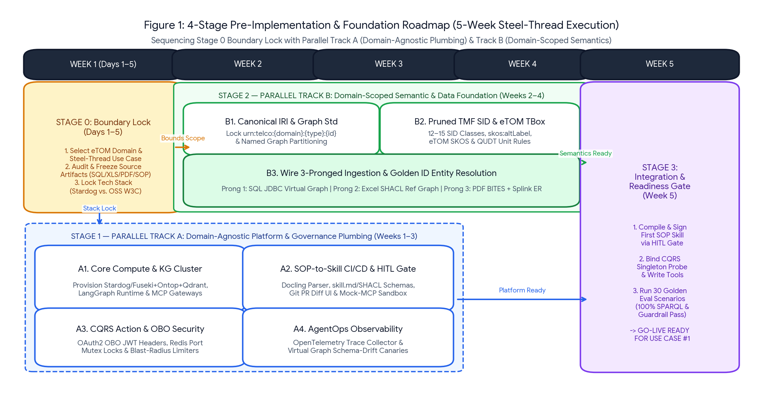
Figure 1: Consolidated 4-Stage Pre-Implementation Roadmap illustrating how Stage 0 bounds Parallel Track B (Domain-Scoped Semantics) while Parallel Track A (Domain-Agnostic Platform Plumbing) executes concurrently from Day 1.
2. Stage 0: Anchor Domain, Negative-Test Seeding & Stack Lock (Days 1–5)
2.1 Activity 0.1: Anchor Domain & 'Steel-Thread' Use Case Lock (COMPLETED)
Locked Use Case UC-001 (Enterprise L2 Fiber Packet-Loss Triage & Automated Optical DDM Recalibration) for customer 'A Corporate Enterprise' (CUST-ENT-409 in SQL CMDB / 'A Corporate Enterprise B.V.' in MSA PDF), circuit CIR-994821 (ETH-10G-GOLD), port OLT04-P12, and CPE NOK-7210-SAS-Mxp.
2.2 Activity 0.2: Audit, Freeze & Seed Raw Source Artifacts with Negative-Test Traps (COMPLETED — OBS-02 & OBS-03)
Rather than using toy data files containing only happy-path fields, Activity 0.2 requires freezing wide, noise-rich enterprise artifacts that explicitly embed negative-path test seeds to verify runtime temporal filtering and build-time SHACL quarantine:
- Prong 1 Wide SQLite CMDB (cmdb_installed_base.db): 4 tables, 104 rows, unrelated billing audit table (T_BILLING_AUDIT_NOISE), shadow enums ('10','20','99'), mixed bandwidth units, and an explicit SCD Type 2 historical expired row (CFS_ROW_ID=2000, ETH-1G-SILVER) alongside the active row (CFS_ROW_ID=2001, ETH-10G-GOLD) for circuit CIR-994821.
- Prong 2 Multi-Tab Excel Workbook (Telco_Master_Product_SLA_Catalog_2026.xlsx): 3 tabs, merged banners, 50 SKUs, plus 2 deliberate dirty rows in Tab 2 (negative packet loss -0.5% and invalid lifecycle flag '99_INVALID') to verify row-level pySHACL quarantine.
- Prong 3 Multi-Page PDFs & Master SOP Runbook: 5-page Hardware Manual PDF, 4-page MSA Contract PDF, and 6-section Master NOC Runbook containing target Section 5 (SOP-ASSUR-402) amidst 4 distractor procedures (BGP, 5G RAN, GPON, DWDM).
2.3 Activity 0.3: Commit to the Reference Technology Stack Across Three Tiers (OBS-04)
In addition to the Commercial Stack (Stardog) and Open-Source Cluster Stack (Ontop + Fuseki + Qdrant), Activity 0.3 defines a third tier—the Local Python W3C Verification Profile (Option A in .venv)—enabling 100% deterministic local verification and Glass-Box inspection with zero external container or cloud license dependencies. All 7 component decisions for this stack are detailed in Section 7 of this document.
3. Stage 1 (Track A): Domain-Agnostic Platform & Governance Plumbing (Weeks 1–3)
3.1 Activity A1: Core Compute, Multi-Named-Graph Store & Dual-Interface MCP Gateways (Option 1D)
- Dual-Interface Layer 1-to-2 Gateway: Configure the Layer 2 Northbound FastMCP server to support both in-process stdio calls (for 1-click Google AI Studio / google-genai execution and batch evaluation) AND HTTP/SSE (--transport sse) with exported tool schemas for Google AI Studio Web UI and Microsoft Copilot Studio.
- Multi-Named-Graph Dataset & R2RML Engine: Initialize the Layer 4 rdflib.Dataset store (knowledge_graph.trig) and the zero-copy Python R2RML-to-SQLite pushdown compiler.
3.2 Activity A2: Autonomous SOP-to-Skill Pipeline & MCP Primitive Gap Analyzer (Option 2.1D-Catalog — OBS-07 & OBS-12)
- Autonomous Use-Case Section Discovery: Configure the SOP compiler to accept the natural-language Use-Case Charter and full Master Runbook, autonomously score all sections, isolate Section 5 (SOP-ASSUR-402) + Section 1 governance, and reject distractor procedures.
- Live MCP Primitive Catalog Binding & Missing-Primitive Spec Generator: Before promoting a skill, the compiler queries config/mcp_primitives_catalog.json (or live MCP tools/list). It binds SOP steps to existing generic platform primitives and—when a required capability is missing (e.g., testing a missing TMF621 dispatch adapter)—halts promotion and emits a formal missing_primitive_spec.json contract.
- Evaluator Cross-SOP Contamination Critique & HITL Diff Gate: Verifies 100% threshold accuracy, confirms zero rule leakage from rejected SOP sections, and outputs reports/hitl_sop_skill_review.html for Lead Architect sign-off.
3.3 Activity A3: Generic CQRS Platform Primitives & Security Plumbing (Option 6A-Generic — OBS-11)
- Explicit Separation of Platform Primitives vs. SOP-Compiled Steps: Deploy generic, SOP-agnostic FastMCP servers: singleton-check-mcp (exposing probe_resource_state) and transactional-write-mcp (exposing execute_governed_mutation and commit_validated_graph_triples). All use-case-specific metric names, TMF640/TMF621 operations, and payload templates are passed dynamically from the SOP-compiled YAML.
- Inspectable Mutex Lock, Token-Bucket & pySHACL Store: Configure data/cqrs_state/cqrs_runtime_state.json to persist active port mutex locks (TTL 60s), OBO JWT scope checks, blast-radius rate-limit counters, and pre-commit pySHACL validation logs.
3.4 Activity A4: Single-Command Runner & Glass-Box Flight Recorder (Option 7A — OBS-05)
- Unified Execution & Flight Recorder: Build the single-command runner (scripts/run_uc001_demo.py) that executes the full 5-layer pipeline in-process and writes a self-contained visual HTML/Markdown Flight Recorder report (reports/uc001_flight_recorder.html) inspecting every internal payload.
4. Stage 2 (Track B): Domain-Scoped Semantics & Dual-HITL Gates (Weeks 2–4)
4.1 Activity B1: Lock Canonical IRI Templates & Named Graph Partitioning
Enforce urn:telco:{domain}:{entity_type}:{canonical_id} across six isolated Named Graphs: <urn:telco:graph:tbox:sid-etom>, <urn:telco:graph:virtual:ib> (0 triples persisted on disk), <urn:telco:graph:ref:catalog>, <urn:telco:graph:bites:doc-hw-v4>, <urn:telco:graph:bites:doc-msa-v1>, <urn:telco:graph:meta:doc-lifecycle>, and <urn:telco:graph:bridge:er>.
4.2 Activity B2: AI-Assisted TBox Profiling & Mandatory HITL Gate 1 (Ontology & Mapping Lock — OBS-10)
- AI Schema Profiler & Candidate Generation: Scan the frozen SQLite DDL, Excel headers, and PDF outlines against the TM Forum SID/eTOM reference vocabulary to propose the 12–15 class SID spine, skos:altLabel synonyms, QUDT unit conversion macros, SHACL shapes, and R2RML/Excel mappings (explicitly excluding noise tables/columns).
- Mandatory HITL Gate 1 Sign-Off: Generate reports/hitl_gate1_ontology_mapping_review.html for Data Architect validation and approval before locking tbox_sid_etom.ttl and cmdb_r2rml.ttl.
4.3 Activity B3: Three-Pronged Ingestion & Mandatory HITL Gate 2 (Curation & ER Triage — OBS-10)
- Prong 1 (SQLite Virtual Graph): Bind cmdb_r2rml.ttl to cmdb_installed_base.db with SCD Type 2 filter (VALID_TO_TS IS NULL) and shadow enum translation ('10' -> 'ACTIVE').
- Prong 2 (Excel Row-Level pySHACL Quarantine): Strip merged banners and distractor tabs; validate each B2B row via pySHACL—promoting the 18 valid rows to <urn:telco:graph:ref:catalog> and diverting the 2 dirty rows into the HITL Gate 2 Quarantine Queue.
- Prong 3 (PDF BITES) & Fuzzy Entity Resolution: Extract Chapter 4 of the Hardware Manual and Annex A/B of the MSA Contract into GLOBAL_SCOPE and DOCUMENT_SCOPE triples, score fuzzy entity similarity (0.91) between 'A Corporate Enterprise B.V.' and 'A Corporate Enterprise' (CUST-ENT-409), and approve via reports/hitl_gate2_ingestion_er_curation.html.
5. Stage 3: End-to-End Integration & Readiness Gate for Use Case #1 (Week 5)
5.1 Activities 3.1–3.3: SOP Compilation, Primitive Gap Verification & Golden Benchmark
- Activity 3.1 (SOP Compilation & Gap Test): Run the Option 2.1D-Catalog compiler first with simulate_missing_branch_b_primitive=true (verifying automatic generation of missing_primitive_spec.json for TMF621 dispatch), then enable the primitive and promote the signed skill_sop_402.yaml.
- Activity 3.2 (CQRS Scenario Verification): Execute Branches A, B, and C plus negative security stress tests against the generic CQRS primitives.
- Activity 3.3 (Golden Evaluation & Flight Recorder Audit): Verify 100% pass rate across Gate 1 (Layer 3 Dual Shadow SPARQL & Layer 4 5-Challenge Proof), Gate 2 (Layer 2 LangGraph & Guardrail fidelity), Gate 3 (CQRS Mutex, Token Bucket & pySHACL rejection of invalid writes), and Gate 4 (OBO security & full-hop HTML Flight Recorder trace).
6. Master Deliverables Checklist, RACI Matrix & Risk Governance
Stage / Track | Key Deliverable (Updated with V2 Governance Artifacts) | Lead Role | Approver | Status / Target
Stage 0 (Act 0.1) | Signed Use-Case Charter (UC-001) & UCDIL Baseline | Telco Solution Architect | VP Network Ops | COMPLETED
Stage 0 (Act 0.2) | Frozen Wide Raw Sources + SCD2 & Dirty Row Seeds | Data Integration Eng. | Enterprise Data Arch. | COMPLETED
Stage 0 (Act 0.3) | Locked 7 Component Design Decisions & config.yaml | Enterprise AI Architect | Chief Architect | LOCKED (Ready)
Stage 1 (Track A) | Dual-Interface MCP, Autonomous SOP Compiler & Gap Spec | AI / Platform Eng. | Lead Network Arch. | Week 2–3
Stage 1 (Track A) | Generic CQRS FastMCP Primitives & Glass-Box Harness | DevSecOps Engineer | Head of InfoSec | Week 3
Stage 2 (Track B) | Pruned TMF SID/eTOM TBox + HITL Gate 1 Sign-Off Report | Ontology Engineer | Enterprise Data Arch. | Week 3
Stage 2 (Track B) | 3-Pronged Ingestion + HITL Gate 2 Quarantine/ER Report | Data Integration Eng. | Enterprise Data Arch. | Week 4
Stage 3 | Signed SOP Skill + 30-Scenario Eval + Final UCDIL Design Doc | Full-Stack Agent Team | VP Network Ops | Week 5 (Go-Live)

7. Activity 0.3 Component Design Decisions Specification (Demo Implementation)
This section records the comprehensive architectural evaluation, options analysis (pros and cons), locked decisions, and engineering rationale for all seven component groups of the UC-001 verification stack.
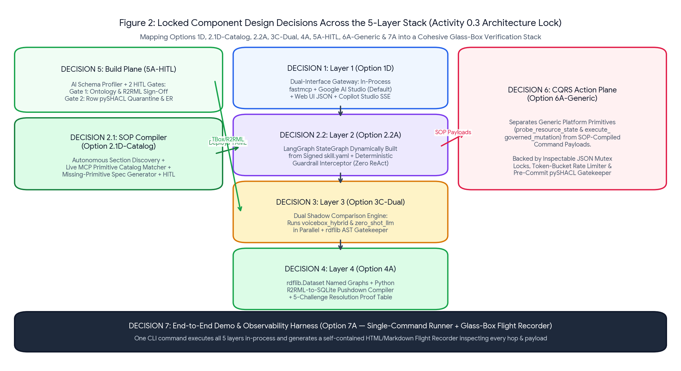
Figure 2: Master Overview of the 7 Locked Component Design Decisions (1D, 2.1D-Catalog, 2.2A, 3C-Dual, 4A, 5A-HITL, 6A-Generic, and 7A).
Decision Area | Evaluated Options | Locked Option | Core Engineering Rationale
1. Layer 1 Orchestrator | 1A (Local Only) | 1B (Cloud SSE Only) | 1C (IDE Host) | 1D (Dual-Interface) | Option 1D (Dual-Interface Gateway) | Combines 1-click zero-tunnel execution via Google AI Studio SDK with exported Web UI tool JSON and optional SSE endpoint for MS Copilot Studio.
2.1 Layer 2 SOP Compiler | 2.1A (Hardcoded Sec ID) | 2.1B (1-Shot LLM) | 2.1C (Manual) | 2.1D-Catalog | Option 2.1D-Catalog (Autonomous + Gap Spec) | Autonomously discovers relevant SOP sections from Use-Case Charter, binds to MCP Primitive Catalog, generates missing primitive specs, and checks contamination.
2.2 Layer 2 Worker Runtime | 2.2A (LangGraph YAML) | 2.2B (Google ADK) | 2.2C (Pure Loop) | 2.2D (ReAct) | Option 2.2A (LangGraph StateGraph + Guardrails) | Dynamically builds a deterministic LangGraph StateGraph from signed YAML with pre/post Guardrail Interceptors; eliminates ReAct improvisation.
3. Layer 3 NL2Semantics | 3A (Voicebox Hybrid) | 3B (Zero-Shot LLM) | 3C-Dual (Shadow Comparison) | Option 3C-Dual (Default dual_comparison) | Runs voicebox_hybrid and zero_shot_llm in parallel on a single demo run, rendering a side-by-side SPARQL comparison & rdflib AST audit card.
4. Layer 4 Compiler & Fed. | 4A (rdflib + Python R2RML Pushdown) | 4B (Bulk SQL Dump) | 4C (Java Ontop) | Option 4A (rdflib + R2RML-SQLite Compiler) | Proves true Zero-Copy Virtualization (0 virtual triples on disk) without Java daemons and emits the 5-Challenge Resolution Proof Table.
5. Track B Ingestion & ER | 5A (Auto Script) | 5A-HITL (2 HITL Gates) | 5B (Bulk SHACL) | 5C (Heavy ML) | Option 5A-HITL (Dual-HITL Semantic Build) | Enforces HITL Gate 1 (Ontology/Mapping Lock) and HITL Gate 2 (Row-level pySHACL quarantine queue, BITES scope review & fuzzy ER sign-off).
6. CQRS Action Plane | 6A-Generic (Reusable Primitives) | 6B (Hardcoded Tools) | 6C (Docker Redis) | Option 6A-Generic (Primitives vs. SOP Payloads) | Separates reusable MCP platform primitives from SOP-compiled command payloads; uses inspectable JSON mutex lock/rate-limit store + pySHACL.
7. Demo & Observability | 7A (Single-Command + HTML Flight Recorder) | 7B (Raw Stdout Logs) | Option 7A (Glass-Box Flight Recorder) | Eliminates multi-terminal complexity and captures every internal transformation across Layers 1–5 in a single visual HTML/MD timeline.

8. Master Demo Scenarios, State Management & Inspector Specification
To ensure complete control and visibility during both Design-Time (DT) and Runtime (RT) demonstrations, the verification harness implements an explicit System State Inspector alongside modular DT and RT scenario runners (incorporating OBS-13).
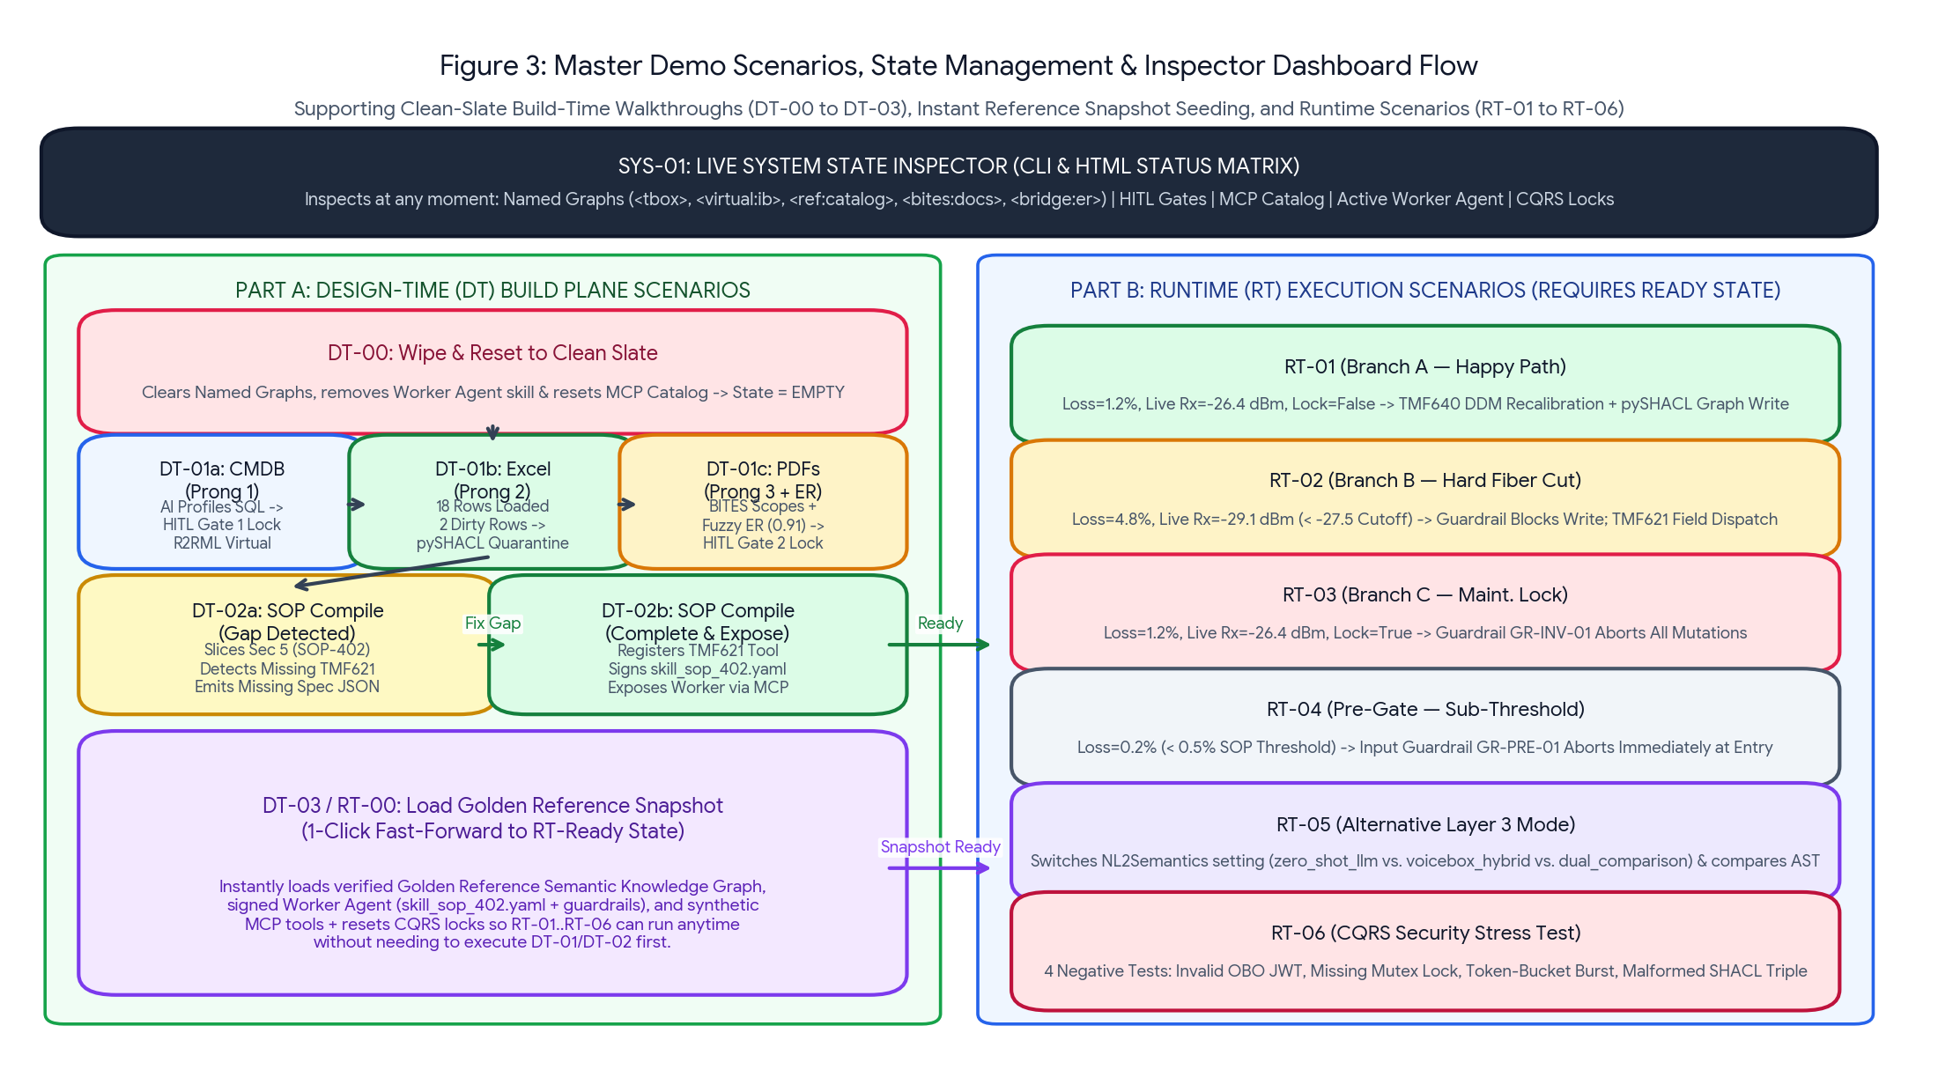
Figure 3: Master Demo Scenarios Lifecycle showing the Live System State Inspector (SYS-01), Granular Design-Time Scenarios (DT-00 to DT-03), Golden Reference Snapshot Loader, and Runtime Scenarios (RT-01 to RT-06).
8.1 Live System State Inspector (SYS-01 — Instant Visibility Across All Elements)
At any point before or after running a Design-Time or Runtime step, the operator can invoke the System State Inspector (python scripts/inspect_demo_state.py or view the top status bar in the HTML Flight Recorder) to inspect the exact live status of all seven architectural elements:
Inspected Element | Underlying Artifact / Endpoint | Possible States Shown in Inspector | Key Metrics & Details Displayed
1. Conceptual TBox & Mappings | tbox_sid_etom.ttl & cmdb_r2rml.ttl | EMPTY | CANDIDATE_PROPOSED | LOCKED_APPROVED | Class count (12–15 SID classes), skos:altLabel count, HITL Gate 1 sign-off status.
2. Prong 1: SQL CMDB Virtual Graph | <urn:telco:graph:virtual:ib> | UNBOUND | BOUND_ZERO_COPY | Persisted triples on disk (always 0), bound SQLite tables (3), excluded noise tables (1).
3. Prong 2: Excel Reference Graph | <urn:telco:graph:ref:catalog> | EMPTY | LOADED_WITH_QUARANTINE | Materialized triples count, valid B2B SKUs loaded (18), pySHACL quarantined rows (2).
4. Prong 3: PDF BITES & ER Bridge | <graph:bites:docs> & <graph:bridge:er> | EMPTY | CURATION_PENDING | PROMOTED | GLOBAL_SCOPE vs DOCUMENT_SCOPE triples, active PDF count (2), ER links ('A Corporate Enterprise B.V.' <-> CUST-ENT-409), HITL Gate 2 status.
5. Southbound MCP Primitive Catalog | config/mcp_primitives_catalog.json | PARTIAL_GAP (TMF621 Missing) | COMPLETE (All Bound) | Registered generic primitives across Semantic Read, Singleton Check, and Transactional Write servers.
6. Layer 2 Worker Agent & Skill | skill_sop_402.yaml & FastMCP Tool | REMOVED (No Agent) | GAP_HALTED | DEPLOYED_MCP_READY | Compiled state nodes, active guardrails (GR-PRE-01, GR-INV-01/02), northbound MCP tool availability (diagnose_l2_fiber_circuit).
7. Layer 3 & CQRS Runtime Settings | config.yaml & cqrs_runtime_state.json | ACTIVE_PRESET | Active Layer 3 mode (dual_comparison | voicebox_hybrid | zero_shot_llm), hardware telemetry preset, active port mutex locks, and token-bucket counter (3/3).

8.2 Part A: Design-Time (DT) Build Plane Scenarios (Clean Reset, 3-Step Ingestion, SOP Gap & Snapshot Load)
Scenario ID | Scenario Name | Execution Action | State Transition & Expected Visible Output
DT-00 | Wipe & Reset to Clean Slate | Clears all materialized Named Graphs, unbinds virtual mappings, deletes compiled Worker Agent skills, and resets MCP catalog to baseline. | System State transitions to EMPTY across all semantic graphs and REMOVED for the Worker Agent. Proves subsequent steps genuinely build from zero.
DT-01a | Prong 1 Ingestion: SQL CMDB & HITL Gate 1 | Runs AI Schema Profiler over cmdb_installed_base.db (4 tables, 104 rows), proposes pruned TMF SID TBox + R2RML mapping (excluding T_BILLING_AUDIT_NOISE), and locks via HITL Gate 1. | Generates reports/hitl_gate1_ontology_mapping_review.html. State of <tbox> becomes LOCKED_APPROVED and <virtual:ib> becomes BOUND_ZERO_COPY (0 triples on disk).
DT-01b | Prong 2 Ingestion: Excel Catalog & Row pySHACL Quarantine | Ingests Telco_Master_Product_SLA_Catalog_2026.xlsx (stripping merged banners & 2 distractor tabs), validates each B2B row via pySHACL, loads 18 valid SKUs, and quarantines 2 dirty rows. | State of <ref:catalog> transitions to LOADED_WITH_QUARANTINE (18 SKUs loaded; 2 dirty rows written to reports/shacl_quarantine_report.html).
DT-01c | Prong 3 Ingestion: PDF BITES, Fuzzy ER & HITL Gate 2 | Extracts Hardware Manual Page 4 (GLOBAL_SCOPE) & MSA Contract Annex A/B (DOCUMENT_SCOPE), computes 0.91 fuzzy ER match ('A Corporate Enterprise B.V.' <-> CUST-ENT-409), and approves via HITL Gate 2. | Generates reports/hitl_gate2_ingestion_er_curation.html. Persists knowledge_graph.trig; <bites:docs> and <bridge:er> transition to PROMOTED.
DT-02a | Autonomous SOP Slicing — Pass 1 (Missing Primitive Gap) | With TMF621 dispatch primitive disabled in catalog, feeds UC-001 Charter + 6-section Master Runbook to SOP Compiler. | Autonomously selects Section 5 (SOP-ASSUR-402), rejects Sections 2,3,4,6, detects missing Branch B TMF621 primitive, halts promotion (GAP_HALTED), and outputs missing_primitive_spec.json.
DT-02b | Autonomous SOP Slicing — Pass 2 (Complete & MCP Expose) | Enables/registers the TMF621 primitive in the MCP Catalog, re-runs SOP Compiler, passes Evaluator contamination check, signs HITL Diff, and deploys Worker Agent. | Generates skill_sop_402.yaml + guardrails_sop_402.json + reports/hitl_sop_skill_review.html. Worker Agent state becomes DEPLOYED_MCP_READY (exposed via FastMCP).
DT-03 (RT-00) | Load Golden Reference Snapshot & Default RT Settings | One-click seed command that loads verified Golden Reference Knowledge Graph, signed Worker Agent skill, complete MCP synthetic tools, and default RT settings. | Guarantees 100% READY state across all elements so RT-01 through RT-06 can be demonstrated immediately at any time without running DT-00..DT-02b first.

8.3 Part B: Runtime (RT) Execution Scenarios (Including Alternative Semantic Layer Mode RT-05)
Scenario ID | Scenario Name | Trigger & Simulated State / Mode | Expected End-to-End Execution & Flight Recorder Output
RT-01 (Branch A) | Soft Optical Degradation — Autonomous Recalibration (Happy Path) | Circuit CIR-994821, loss=1.2%. Live port OLT04-P12 Rx=-26.4 dBm (in [-25.0, -27.5] window), lock=False. Layer 3=dual_comparison. | Passes GR-PRE-01 -> Layer 3 Dual Comparison -> Layer 4 SQLite pushdown (filters expired SCD2 row 2000 in favor of active row 2001 2000 in favor of active row 2001) + 5-Challenge Proof -> Singleton 60s lock -> Branch A executes TMF640 recalibration + pySHACL graph writeback.
RT-02 (Branch B) | Hard Fiber Cut / Attenuation — Guardrail Blocks Write & Dispatches Tech | Circuit CIR-994821, loss=4.8%. Live port OLT04-P12 Rx=-29.1 dBm (< -27.5 dBm Nokia PDF cutoff), lock=False. | Steps 1–4 execute. Guardrail GR-INV-02 blocks TMF640 remote recalibration because -29.1 < -27.5 dBm. Routes deterministically to Branch B -> invokes TMF621 create_field_fiber_dispatch.
RT-03 (Branch C) | Active Maintenance Freeze Lock — Guardrail Aborts Mutation | Circuit CIR-994821, loss=1.2%. Live port OLT04-P12 Rx=-26.4 dBm, maintenance_lock=True. | Steps 1–4 execute. Guardrail GR-INV-01 catches maintenance_lock==True, aborts all network writes, releases mutex lock, and logs non-intrusive monitoring note.
RT-04 (Pre-Gate) | Sub-Threshold Packet Loss — Immediate Entry Guardrail Abort | Circuit CIR-994821, loss=0.2% (below 0.5% SOP threshold). | Input Guardrail GR-PRE-01 intercepts request at Layer 2 entry before any Layer 3/4 query or hardware probe is invoked; returns NO_ACTION_REQUIRED.
RT-05 (Alt Layer 3) | Alternative Semantic Layer Mode Execution (Zero-Shot LLM vs. Voicebox Hybrid) | Switches Layer 3 execution_mode to 'zero_shot_llm' (or 'voicebox_hybrid') via config.yaml or MCP tool arg nl2semantics_mode. | Demonstrates running the pipeline purely on the alternative Layer 3 setting: shows raw TBox zero-shot LLM SPARQL generation vs. Stored Template-guided Voicebox generation and logs AST audit differences.
RT-06 (Security) | CQRS & Security Gate Stress Test (Negative-Path Rejections) | Executes 4 invalid mutation calls against the CQRS Action Plane. | Proves 100% deterministic rejection of: (1) Unauthorized OBO JWT scope, (2) Missing/expired Singleton Mutex Lock, (3) 4th rapid call exceeding Token-Bucket limit (3/5m), and (4) Malformed SHACL triple.

9. 11-Step Incremental Co-Execution & Development Plan
Rather than generating the entire 5-layer architecture in a single monolithic script, implementation is decomposed into 11 strictly gated, incremental development steps executed via Google Antigravity. Each step delivers a specific subset of the SYS-01, DT-00..DT-03, or RT-01..RT-06 demo scenarios, includes dedicated unit tests (pytest), and verifies its state transition using the Live System State Inspector (SYS-01) before advancing to the next step.
9.1 Key Sequencing Principles of the 11-Step Plan
- 1. Immediate State Visibility & Clean-Slate Reset in Step 1: Step 1 builds the Live System State Inspector (SYS-01) and the Clean-Slate Wipe utility (DT-00) alongside config.yaml and the MCP Primitive Catalog. Every subsequent step (Steps 2–11) ends by running SYS-01 so the operator can visually confirm the exact state transition.
- 2. One-to-One Per-Prong Ingestion Steps (Steps 2, 3, and 4): Steps 2, 3, and 4 map directly to DT-01a (SQL CMDB & HITL Gate 1), DT-01b (Excel Catalog & pySHACL Quarantine), and DT-01c (PDF BITES, Fuzzy ER & HITL Gate 2), allowing each data prong to be demonstrated independently.
- 3. Golden Reference Snapshot Frozen Before Runtime Scenarios (Step 9): Once the Knowledge Graph (Step 4) and SOP-Compiled Worker Agent (Steps 7–9) are verified, Step 9 freezes the Golden Reference Snapshot (DT-03 / RT-00) so Runtime scenarios (RT-01..RT-06) in Step 10 can be executed anytime with one click.
- 4. Explicit Verification of Alternative Layer 3 Modes (Step 6 & Step 10): Step 6 and Step 10 explicitly test switching between dual_comparison, voicebox_hybrid, and zero_shot_llm (RT-05).
9.2 Master 11-Step Incremental Development & Verification Matrix
Step & Stage/Activity | Demo Scenario(s) Delivered | Exact Code & Artifacts Created in Antigravity | Verification Gate & State Inspector Check
Step 1: Stage 0 — Act 0.3 (Config, Catalog, Inspector & Wipe) | SYS-01 (State Inspector) & DT-00 (Wipe & Reset to Clean Slate) | config/config.yaml, src/config_loader.py, config/mcp_primitives_catalog.json, src/state_inspector.py, scripts/inspect_demo_state.py, scripts/reset_demo_state.py (DT-00). | Run DT-00 and SYS-01: verify console & HTML status matrix shows all 7 elements in clean EMPTY / REMOVED state.
Step 2: Stage 2 — Act B1 & B2 (CMDB Prong 1 & TBox) | DT-01a (Prong 1: SQL CMDB Profiling, TBox & HITL Gate 1 Lock) | src/track_b/s1_cmdb_tbox_profiler.py, data/semantic_store/tbox_sid_etom.ttl, mappings/cmdb_r2rml.ttl, shapes/*.ttl, reports/hitl_gate1_ontology_mapping_review.html. | Run DT-01a then SYS-01: verify Element 1 (<tbox>) = LOCKED_APPROVED and Element 2 (<virtual:ib>) = BOUND_ZERO_COPY (0 triples on disk).
Step 3: Stage 2 — Act B3 Pt 1 (Excel Prong 2 & Quarantine) | DT-01b (Prong 2: Excel Catalog & Row-Level pySHACL Quarantine) | src/track_b/s2_excel_shacl_ingestor.py, mappings/excel_catalog_rml.yaml, reports/shacl_quarantine_report.html. Updates <urn:telco:graph:ref:catalog>. | Run DT-01b then SYS-01: verify Element 3 (<ref:catalog>) = LOADED_WITH_QUARANTINE (18 valid B2B SKUs loaded; 2 dirty rows quarantined).
Step 4: Stage 2 — Act B3 Pt 2 (PDF Prong 3, ER & Gate 2) | DT-01c (Prong 3: PDF BITES, Fuzzy ER & HITL Gate 2 Lock) | src/track_b/s3_pdf_bites_er_ingestor.py, reports/hitl_gate2_ingestion_er_curation.html, persisted data/semantic_store/knowledge_graph.trig. | Run DT-01c then SYS-01: verify Element 4 (<bites:docs> & <bridge:er>) = PROMOTED (GLOBAL/DOCUMENT scopes + 0.91 ER link for 'A Corporate Enterprise B.V.').
Step 5: Stage 1/2 — Layer 4 (Federation & 5 Challenges) | Layer 4 Federation & 5-Challenge Proof (Supports RT-01..05) | src/layer4/r2rml_sqlite_compiler.py, src/layer4/federated_executor.py. Compiles virtual SQL (WHERE VALID_TO_TS IS NULL), joins all Named Graphs, and builds the 5-Challenge Proof Table. | Run Layer 4 verification test on CIR-994821: verify SQLite pushdown filters out expired SCD2 row CFS_ROW_ID=2000 (ETH-1G-SILVER) in favor of CFS_ROW_ID=2001 (ETH-10G-GOLD) and joins Excel + PDF + ER Bridge with 0 virtual triples on disk.
Step 6: Stage 1/2 — Layer 3 (Dual & Alt NL2Semantics) | RT-05 (Layer 3 Alternative Mode zero_shot_llm vs. voicebox_hybrid vs. dual_comparison) | src/layer3/nl2semantics_engine.py, src/layer3/ast_gatekeeper.py, src/mcp_servers/semantic_read_mcp.py. | Run Layer 3 in all 3 modes (RT-05): verify side-by-side SPARQL comparison card and rdflib Static AST security check.
Step 7: Stage 1 — Act A2 (Autonomous SOP Compiler) | DT-02a (SOP Pass 1: Gap Detected) & DT-02b (SOP Pass 2: Complete Skill) | src/track_a/sop_to_skill_compiler.py, reports/missing_primitive_spec.json (DT-02a), signed skills/skill_sop_402.yaml, skills/guardrails_sop_402.json, reports/hitl_sop_skill_review.html (DT-02b). | Run DT-02a -> SYS-01 shows GAP_HALTED (TMF621 missing). Enable primitive & run DT-02b -> SYS-01 shows SKILL_SIGNED.
Step 8: Stage 1 — Act A3 (CQRS Generic Primitives) | RT-06 (CQRS Generic Platform Primitives & 4-Gate Security Stress Test) | src/mcp_servers/singleton_check_mcp.py (probe_resource_state), src/mcp_servers/transactional_write_mcp.py (execute_governed_mutation), data/cqrs_state/cqrs_runtime_state.json. | Run RT-06: verify 100% deterministic rejection of bad OBO JWT, missing mutex lock, 4th burst call exceeding token bucket, and invalid pySHACL triple.
Step 9: Stage 1/3 — Layer 2 & Golden Snapshot Loader | Worker Agent MCP Exposure (DT-02b Final) & DT-03 / RT-00 (Golden Reference Snapshot Loader) | src/layer2/worker_agent_langgraph.py, src/mcp_servers/worker_northbound_mcp.py, data/golden_reference/*, scripts/load_golden_snapshot.py (DT-03 / RT-00). | Test sequence: Run DT-00 (Wipe) -> SYS-01 shows EMPTY. Run DT-03 (Load Snapshot) -> SYS-01 immediately shows all 7 elements READY / DEPLOYED_MCP_READY.
Step 10: Stage 1/3 — Layer 1 & Flight Recorder | RT-01 (Branch A), RT-02 (Branch B), RT-03 (Branch C), RT-04 (Pre-Gate), RT-05 (Alt L3) | src/layer1/orchestrator_gateway.py (Option 1D + ai_studio_tool_declarations.json + --transport sse), src/flight_recorder.py, scripts/run_demo_scenario.py (Option 7A). | Run RT-01 through RT-05 via single-command runner and inspect reports/uc001_flight_recorder.html (including Live State Bar + all layer cards).
Step 11: Stage 3 — Act 3.3 (30-Scenario Eval & Final Doc) | 30-Scenario Golden Benchmark & Final UCDIL Document | scripts/run_golden_eval_30.py, reports/golden_eval_scorecard.html. | Verify 30/30 pass across all 4 Readiness Gates, then generate the final Use Case Design & Implementation Document (.docx).

