ENTERPRISE REFERENCE ARCHITECTURE BLUEPRINT (REVISION V3)
Agentic AI & Semantic Knowledge Fabric for Telecom Operations
A 5-Layer Architecture Combining Dual-Interface MCP Orchestration, Autonomous SOP-to-Skill Compilation with MCP Primitive Gap Analysis, Dual-HITL Semantic Knowledge Graphs, and Reusable CQRS Platform Primitives

Document Attribute | Specification | Architectural Governance | Standard / Baseline
Document ID | ARCH-TELCO-AGENT-EKG-2026-V3 | Industry Alignment | TM Forum ODA, SID (GB922), eTOM (GB921), Open APIs
Target Domain | Telecom OSS/BSS Operations (Assurance, Fulfillment, Inventory) | Semantic Standards | W3C OWL 2, RDF-star, SPARQL 1.1, R2RML, SHACL, SKOS, QUDT
Revision Highlights | Incorporates OBS-01 to OBS-14 (SOP Slicing, Primitive Gap Spec, Dual-HITL KG, Generic CQRS Primitives) | Reference Stacks | Commercial: Stardog EKG + Voicebox | OSS/Local: Ontop/rdflib + Fuseki + FastMCP

Architectural Blueprint Structure (Table of Contents)
Part / Plane | Section | Core Architectural Focus & V3 Enhancements
Part I: Agentic Control Plane | Section 1 | Executive Summary & End-to-End 5-Layer Reference Architecture (Build Plane, Read Plane & CQRS Action Plane)
Part I: Agentic Control Plane | Section 2 | Layer 1: Platform-Agnostic Thin-Client Orchestration, Dual-Interface Northbound Gateway (1D) & Event Reflex Arc
Part I: Agentic Control Plane | Section 3 | Layer 2: Worker Agents, Autonomous Use-Case SOP Slicing (2.1D) & MCP Primitive Catalog Gap Analysis
Part II: Creating the Knowledge Graph | Section 4 | Telecom Domain Ontology (TM Forum SID / eTOM TBox), Dual-Slice Separation & HITL Gate 1 (Ontology/Mapping Lock)
Part II: Creating the Knowledge Graph | Section 5 | Three-Pronged Knowledge Ingestion, Row-Level SHACL Quarantine & HITL Gate 2 (Curation & ER Triage)
Part III: Using the Knowledge Graph | Section 6 | Runtime Read Plane: Layer 3 (NL2Semantics Dual Shadow Comparison) & Layer 4 (Deterministic Compiler & 5-Challenge Proof)
Part III: Using the Knowledge Graph | Section 7 | Runtime CQRS Action Plane: Explicit Separation of Reusable Platform Primitives vs. SOP-Compiled Command Payloads
Part III: Using the Knowledge Graph | Section 8 | End-to-End Sequence Walkthrough, OBO Security, Glass-Box Flight Recorder & 3-Tier Stack Comparison

1. Executive Summary & The 5-Layer Reference Architecture
1.1 Operational Challenges in Telecom OSS/BSS Environments
Modern Telecommunications Service Providers operate across deeply fragmented Operational Support Systems (OSS) and Business Support Systems (BSS). Executing routine operational workflows—such as Layer-2/Layer-3 enterprise fiber assurance, SLA degradation triage, complex B2B service fulfillment, and installed-base reconciliation—requires correlating live network state across relational Configuration Management Databases (CMDBs), semi-structured commercial product spreadsheets, and thousands of unstructured engineering PDFs and customer contract decks.
Deploying first-generation Large Language Model (LLM) agents directly over these raw telecom silos fails in production due to three systemic engineering failure modes:
- 1. Procedural Improvisation Risk: Free-form autonomous ReAct agents improvise troubleshooting steps, violating strict telecom Standard Operating Procedures (SOPs), bypassing pre-flight safety checks, and risking cascading network outages.
- 2. Semantic & Join Hallucinations: When LLMs are asked to write raw SQL or API queries against hundreds of normalized OSS/BSS tables with cryptic column names, volatile natural keys, and unaligned units (e.g., dBm, Mbps vs. Gbps), they hallucinate join paths and produce inaccurate SLA calculations.
- 3. Uncontrolled State Mutation: Granting probabilistic AI models direct write access to network provisioning APIs or knowledge repositories without deterministic schema validation (SHACL), singleton state verification, and blast-radius circuit breakers introduces unacceptable operational risk.
1.2 The 5-Layer Architectural Paradigm Across Three Functional Planes
To eliminate these failure modes while achieving high operational automation, this Reference Architecture enforces a strict separation of concerns across three distinct vertical planes: (1) the Design-Time / Build Plane, (2) the Runtime Operational Read Plane structured into five vertical layers (Layers 1–5), and (3) the parallel Runtime CQRS Action Plane (housing the Singleton Check MCP Server and Transactional Write MCP Server):
Layer / Plane | Architectural Component | Engine Type | Primary Operational Responsibility
Layer 1 (Read Plane) | Platform-Agnostic Orchestration Agent | Probabilistic AI (Thin Client / Dual-Interface 1D) | Hosts user/ticket interaction on any agent platform (Vertex AI, AI Studio, Copilot Studio, Bedrock, LangGraph) and handles proactive event awakening via northbound MCP.
Layer 2 (Read Plane) | Procedural Worker Agents ('Agent-as-a-Tool') | Deterministic State Machine (LangGraph 2.2A) | Encapsulates domain workflows as MCP tools. Executes strict state machines, SOP-compiled command payloads, and safety guardrails compiled from human-reviewed Telecom SOPs.
Layer 3 (Read Plane) | Semantic Intent Translation (NL2Semantics) | Probabilistic AI (Conceptual Slice / Dual Mode 3C) | Reads ONLY the business-facing TM Forum SID/eTOM Conceptual Ontology (TBox) and Stored Query Templates to translate worker intent into safe, canonical SPARQL AST queries.
Layer 4 (Read Plane) | Deterministic Semantic Compiler & Federation | 100% Deterministic Engine (Physical Slice 4A) | Compiles canonical SPARQL AST queries via R2RML/SMS2 into federated SQL pushdown and RDF reads across virtualized and materialized stores.
Layer 5 (Read Plane) | Heterogeneous Telecom Data & Network Sources | Storage & Live Network Endpoints | Houses live SQL Installed Base databases (CMDB), Excel service catalogs, unstructured PDF/PPTX documents, and live OSS/NMS APIs.
Runtime CQRS Action Plane | Singleton Check & Transactional Write MCP Servers | 100% Deterministic Reusable Platform Primitives (6A) | Exposes SOP-agnostic verification and mutation primitives invoked by Layer 2 with SOP-compiled command payloads to perform live pre-flight checks and SHACL-validated writes.

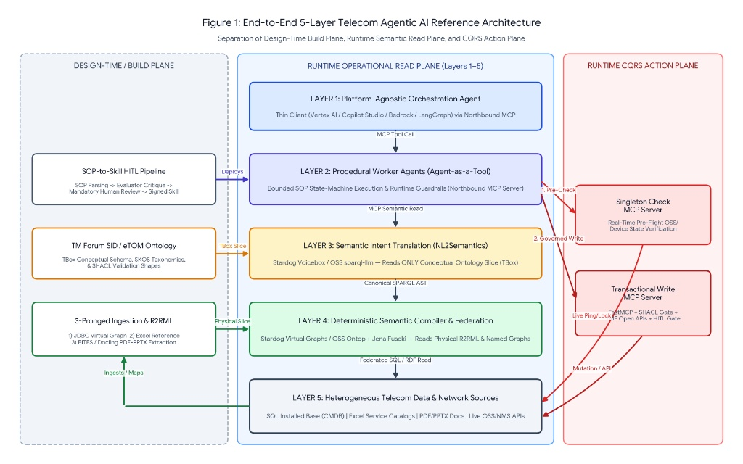
Figure 1: End-to-End 5-Layer Telecom Agentic AI Reference Architecture showing the separation of the Design-Time Build Plane (left), Runtime Operational Read Plane across Layers 1–5 (center), and Runtime CQRS Action Plane (right).
2. Layer 1: Platform-Agnostic Orchestration & Dual-Interface MCP Topology
2.1 Bring-Your-Own-Orchestrator (BYOO) & Dual-Interface Northbound Exposure (Option 1D)
Large telecommunications enterprises rarely standardize on a single AI interface. Customer service desks may use Microsoft Copilot Studio or ServiceNow Now Assist, network operations centers (NOCs) may deploy Google Cloud Vertex AI Agent Builder or Google AI Studio, and network engineering teams may run custom Python LangGraph pipelines. Layer 1 is architected as a strictly decoupled 'Thin-Client Orchestration Layer' governed by four engineering invariants:
- Zero Embedded Domain Logic: The Layer 1 Orchestrator contains zero telecom troubleshooting trees, zero OSS database credentials, and zero knowledge of underlying SQL table schemas or network element APIs.
- Dynamic Capability Discovery via MCP: At session initialization, the Layer 1 Orchestrator connects as an MCP Client to the Layer 2 Enterprise MCP Gateway, invoking tools/list to dynamically discover bounded Worker Agents exposed as discrete MCP tools.
- Context Window Minimization: Instead of stuffing 50-page network engineering SOPs or massive database DDL schemas into the Layer 1 system prompt, Layer 1 only sees concise MCP tool signatures (e.g., diagnose_l2_fiber_circuit) and receives synthesized, decision-ready JSON payloads back from Layer 2.
- Dual-Interface Northbound Exposure (Option 1D): To support both frictionless local/CI automated verification and external SaaS UI orchestrators simultaneously, the Layer 2 Northbound MCP Gateway exposes two concurrent interfaces: (1) an in-process/stdio FastMCP transport coupled with Google AI Studio (google-genai SDK) and exported tool declarations (ai_studio_tool_declarations.json) for zero-tunnel execution and web playground testing, and (2) an HTTP/SSE endpoint (--transport sse) with auto-generated connector manifests for SaaS orchestrators such as Microsoft Copilot Studio.
2.2 Proactive Event-Driven Awakening (Southbound Telemetry to Northbound Reflex Arc)
While conversational chat and ITSM ticket creation represent top-down ('pull') triggers, over 70% of telecom assurance operations (eTOM Assurance) originate as bottom-up ('push') network events. To support Zero-Touch NOC operations without flooding Layer 1 LLMs with raw syslog or SNMP storms, the architecture implements a deterministic Event Reflex Arc:
- 1. Telemetry Ingestion & Windowed Deduplication: High-velocity network alarms (gNMI telemetry, syslog bursts, SNMP traps, and TMF642 Alarm Management payloads) land in an Apache Kafka / Google Cloud Pub/Sub event bus. A deterministic stream processor suppresses flapping alarms and correlates child symptoms to root transport failures.
- 2. Asynchronous MCP Awakening: When a correlated threshold breach occurs (e.g., Optical Rx Power drops below -25.0 dBm or packet loss exceeds 0.5% on a trunk serving VIP enterprise circuits), the event gateway emits an asynchronous webhook / MCP notification that instantiates a headless Layer 1 Orchestrator session pre-populated with the TMF642 alarm payload and invokes the appropriate Layer 2 Worker Agent.
2.3 Zero-Trust Identity Propagation (OAuth2 On-Behalf-Of Flow)
To prevent privilege escalation across virtualized data sources, Layer 1 enforces strict identity propagation. When a human NOC engineer or automated service principal initiates a task, an OIDC/OAuth2 JWT containing their organizational roles, tenant clearances (e.g., Retail vs. Wholesale vs. Enterprise VIP circuits), and blast-radius scopes is attached to the MCP _meta request header. This cryptographic token is exchanged via OAuth2 On-Behalf-Of (OBO) delegation across Layer 2, Layer 3, Layer 4, and the Runtime CQRS Action Plane, ensuring downstream queries and mutations respect row-level and Named-Graph-level RBAC.
3. Layer 2: Worker Agents, Autonomous SOP Slicing & MCP Primitive Gap Analysis
3.1 The 'Agent-as-a-Tool' Encapsulation Pattern & LangGraph State Execution (Option 2.2A)
In Layer 2, each Worker Agent is packaged as a self-contained, bounded microservice exposed northbound to Layer 1 as a standard MCP Tool, while acting southbound as an MCP Client that consumes Layer 3/4 semantic read primitives and the Runtime CQRS Action Plane primitives. Unlike unconstrained autonomous ReAct agents, a Layer 2 Worker Agent operates as a deterministic finite state machine (dynamically compiled into a LangGraph StateGraph from a signed YAML skill specification) paired with a deterministic Guardrail Interceptor that validates pre-conditions and execution invariants before every tool call.
3.2 Autonomous Use-Case SOP Slicing, MCP Primitive Catalog Binding & HITL Pipeline (Option 2.1D-Catalog)
Real-world telecom Standard Operating Procedures (SOPs) are not isolated single-use-case files; they are comprehensive multi-procedure operational runbooks covering diverse technologies (e.g., BGP routing, 5G RAN, GPON residential fiber, Enterprise L2 Ethernet, and DWDM core optics). Furthermore, manually coding bespoke Python MCP tools for every SOP creates a severe bottleneck. To solve both challenges, the Design-Time SOP-to-Skill CI/CD Pipeline executes five governed stages:
Pipeline Stage | Execution Component | Architectural Transformation & Governance Function
Stage 1: Autonomous Use-Case Section Slicing (OBS-01 & OBS-07) | Structural AST Parser + Semantic Relevance Scorer | Takes ONLY the natural-language Use-Case Charter and the full multi-procedure Master Runbook. Scores all sections against the charter, isolates the target procedure (plus global safety governance), and logs all rejected distractor sections.
Stage 2: Skill, Guardrail & Command Extraction | Constrained LLM Compiler (Pydantic Schema) | Decomposes the sliced SOP prose into three formal artifacts: (a) a state-machine workflow (skill.yaml), (b) a declarative Guardrail Spec (guardrails.json), and (c) an SOP-Compiled CQRS Command Manifest (metrics, protocols, payload templates).
Stage 3: Live MCP Primitive Catalog Binding & Gap Spec Generation (OBS-12) | MCP Catalog Matcher & Gap Analyzer | Queries the live southbound MCP Primitive Catalog (tools/list). Binds SOP steps to existing platform primitives. If an SOP step requires a capability not yet in the catalog, halts auto-promotion and emits a formal Missing Primitive Specification Contract (missing_primitive_spec.json).
Stage 4: Evaluator Critique & Cross-SOP Contamination Check | Automated Verification Agent | Verifies 100% numeric threshold fidelity against the source SOP text and runs a Cross-Procedure Contamination Check confirming zero rules from rejected distractor sections leaked into the compiled skill.
Stage 5: Mandatory HITL Review Gate & Promotion | Lead Network Architect (Side-by-Side Visual Diff) | Presents the Section Discovery Table, Primitive Binding/Gap Report, Evaluator Scorecard, and line-by-line SOP-to-YAML diff. Requires human approval (approved: true) before deployment to Layer 2.

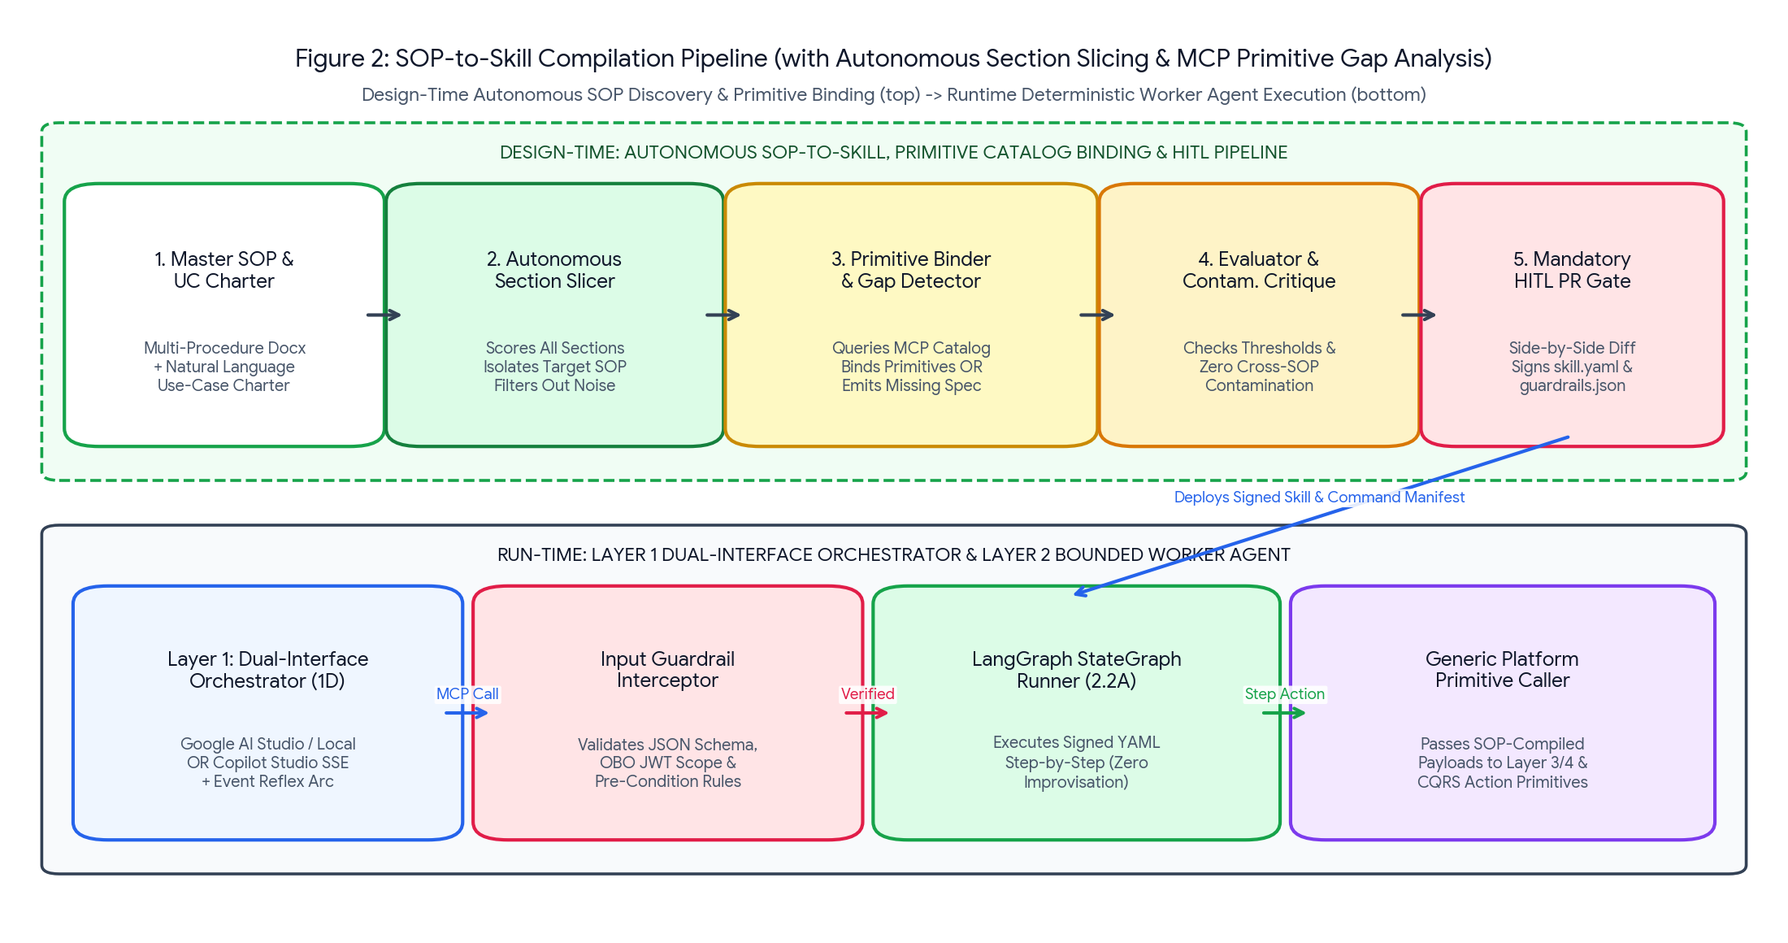
Figure 2: Updated SOP-to-Skill Compilation Pipeline showing Autonomous Use-Case Section Slicing, Live MCP Primitive Catalog Binding & Gap Detection, Cross-Procedure Contamination Critique, and Runtime LangGraph Execution.
3.3 Concrete Telecom Example: Compiling SOP-ASSUR-402 with Platform Primitive Bindings
When the compiler processes the 6-section Master Runbook against Use Case UC-001 ('Enterprise L2 Fiber Packet-Loss Triage & Optical DDM Recalibration'), it autonomously rejects Sections 2, 3, 4, and 6, extracts Section 5 (SOP-ASSUR-402), and binds each step to generic southbound MCP platform primitives:
Compiled Skill & Command Manifest (skills/l2_fiber_assurance_v3.yaml — Signed via HITL Gate)
skill_id: "telco.assurance.l2_fiber_degradation"
discovered_source_section: "Section 5: SOP-ASSUR-402 (Relevance Score: 0.98)"
rejected_distractor_sections: ["SOP-ASSUR-101 (BGP)", "SOP-ASSUR-205 (5G)", "SOP-ASSUR-310 (GPON)", "SOP-ASSUR-509 (DWDM)"]
approved_by: "Lead Transport Architect (HITL Gate Sign-Off: APPROVED)"
guardrails:
pre_conditions:
- id: "GR-PRE-01"
rule: "reported_packet_loss_pct >= 0.5"
on_fail: "ABORT_NO_ACTION_REQUIRED"
execution_invariants:
- id: "GR-INV-01"
rule: "NEVER invoke cqrs://transactional-write/execute_governed_mutation unless singleton_probe.maintenance_lock == false"
- id: "GR-INV-02"
rule: "IF singleton_probe.optical_rx_dbm < semantic_context.pdf_min_rx_dbm THEN FORBID protocol TMF640_SERVICE_ACTIVATION; FORCE BRANCH_B_DISPATCH"
workflow_states:
STEP_1_SEMANTIC_CONTEXT:
bound_primitive: "mcp://semantic-read/query_knowledge_fabric"
intent_template: "Retrieve Customer SLA tier, CFS/RFS topology, Nokia hardware Rx window/cutoff dBm, and MSA contract terms for circuit {circuit_id}"
next: "STEP_2_SINGLETON_OPTICAL_PROBE"
STEP_2_SINGLETON_OPTICAL_PROBE:
bound_primitive: "cqrs://singleton-check/probe_resource_state"
compiled_payload:
resource_iri: "{STEP_1.port_iri}"
requested_metrics: ["optical_rx_dbm", "optical_tx_dbm", "maintenance_lock"]
bypass_cache: true
acquire_mutex_ttl_sec: 60
branching:
- condition: "optical_rx_dbm < pdf_min_rx_dbm (-27.5)" -> "BRANCH_B_FIELD_DISPATCH"
- condition: "optical_rx_dbm >= -27.5 AND optical_rx_dbm <= -25.0 AND maintenance_lock == false" -> "BRANCH_A_REMOTE_RECALIBRATE"
- condition: "maintenance_lock == true OR optical_rx_dbm > -25.0" -> "BRANCH_C_ABORT_LOCK"
BRANCH_A_REMOTE_RECALIBRATE:
bound_primitive: "cqrs://transactional-write/execute_governed_mutation"
compiled_payload:
protocol: "TMF640_SERVICE_ACTIVATION"
operation: "ddm_optical_recalibration"
params: {"port_id": "{STEP_1.olt_port_id}", "cpe_sku": "{STEP_1.cpe_model}", "mode": "NON_INTRUSIVE"}
graph_writeback: {"target_graph": "urn:telco:graph:assurance:resolutions", "shacl_shape": "trouble_ticket_shape.ttl"}

4. Part II (Build Plane): Telecom Domain Ontology, Dual-Slice Split & HITL Gate 1
4.1 Accelerating the Semantic Layer with TM Forum SID & eTOM
To avoid greenfield modeling delays, the semantic layer anchors its Terminological Box (TBox) directly to two TM Forum standards:
- 1. TM Forum SID (GB922) Structural Spine: Imports a pruned subset of SID classes scoped to the active use-case domain: tmf:Customer -> tmf:Product -> tmf:CustomerFacingService (CFS) -> tmf:ServiceSpecification -> tmf:ResourceFacingService (RFS) -> tmf:PhysicalResource -> tmf:PhysicalResourceSpec -> tmf:TroubleTicket.
- 2. TM Forum eTOM (GB921) Controlled SKOS Taxonomy: Rather than polluting vector stores with raw eTOM guidebook prose, eTOM Level 1–3 process IDs (e.g., 1.3.7 Problem Handling, 1.4.5 Resource Trouble Management) are modeled as a lightweight skos:ConceptScheme linked to SID classes and Worker Skills via tmf:governedByProcess.
4.2 The Two-Slice Semantic Model Split & Mandatory HITL Gate 1 (Ontology & Mapping Lock)
The semantic repository is partitioned into two strictly decoupled metadata slices, governed at build time by Mandatory HITL Gate 1 (OBS-10):
- Slice A — The Conceptual Ontology Slice (TBox / SKOS / SHACL): Exposed exclusively to Layer 3 (NL2Semantics). Contains OWL classes, properties, natural language comments, skos:altLabel synonyms, and verified Stored SPARQL Query templates. Contains ZERO physical table or column names.
- Slice B — The Physical Mapping & Federation Slice (R2RML / SMS2 / Crosswalks): Exposed exclusively to Layer 4 (Deterministic Semantic Compiler). Contains W3C R2RML or Stardog SMS2 bindings projecting wide SQL tables into SID classes, SCD Type 2 temporal window filters, shadow enum translations, and QUDT unit conversion formulas.
- Mandatory HITL Gate 1 (AI-Assisted Schema Profiling & Architect Sign-Off): During Track B setup, an AI Schema Profiler scans raw SQL DDL headers, Excel tabs, and PDF outlines to propose candidate TBox bindings, SHACL shapes, and noise-column exclusions (e.g., flagging T_BILLING_AUDIT_NOISE and Internal_Finance_GL_Code for exclusion). A Data Architect reviews the generated HITL Ontology & Mapping Review Report and cryptographically signs off before the TBox and R2RML files are locked.
5. Part II (Build Plane): Three-Pronged Knowledge Ingestion & HITL Gate 2
Operational telecom data is buried inside wide, noisy enterprise sources. The architecture implements a Three-Pronged Ingestion Pipeline paired with Mandatory HITL Gate 2 (Curation & Entity Resolution Triage) to filter out distractors and quarantine dirty data before graph promotion.
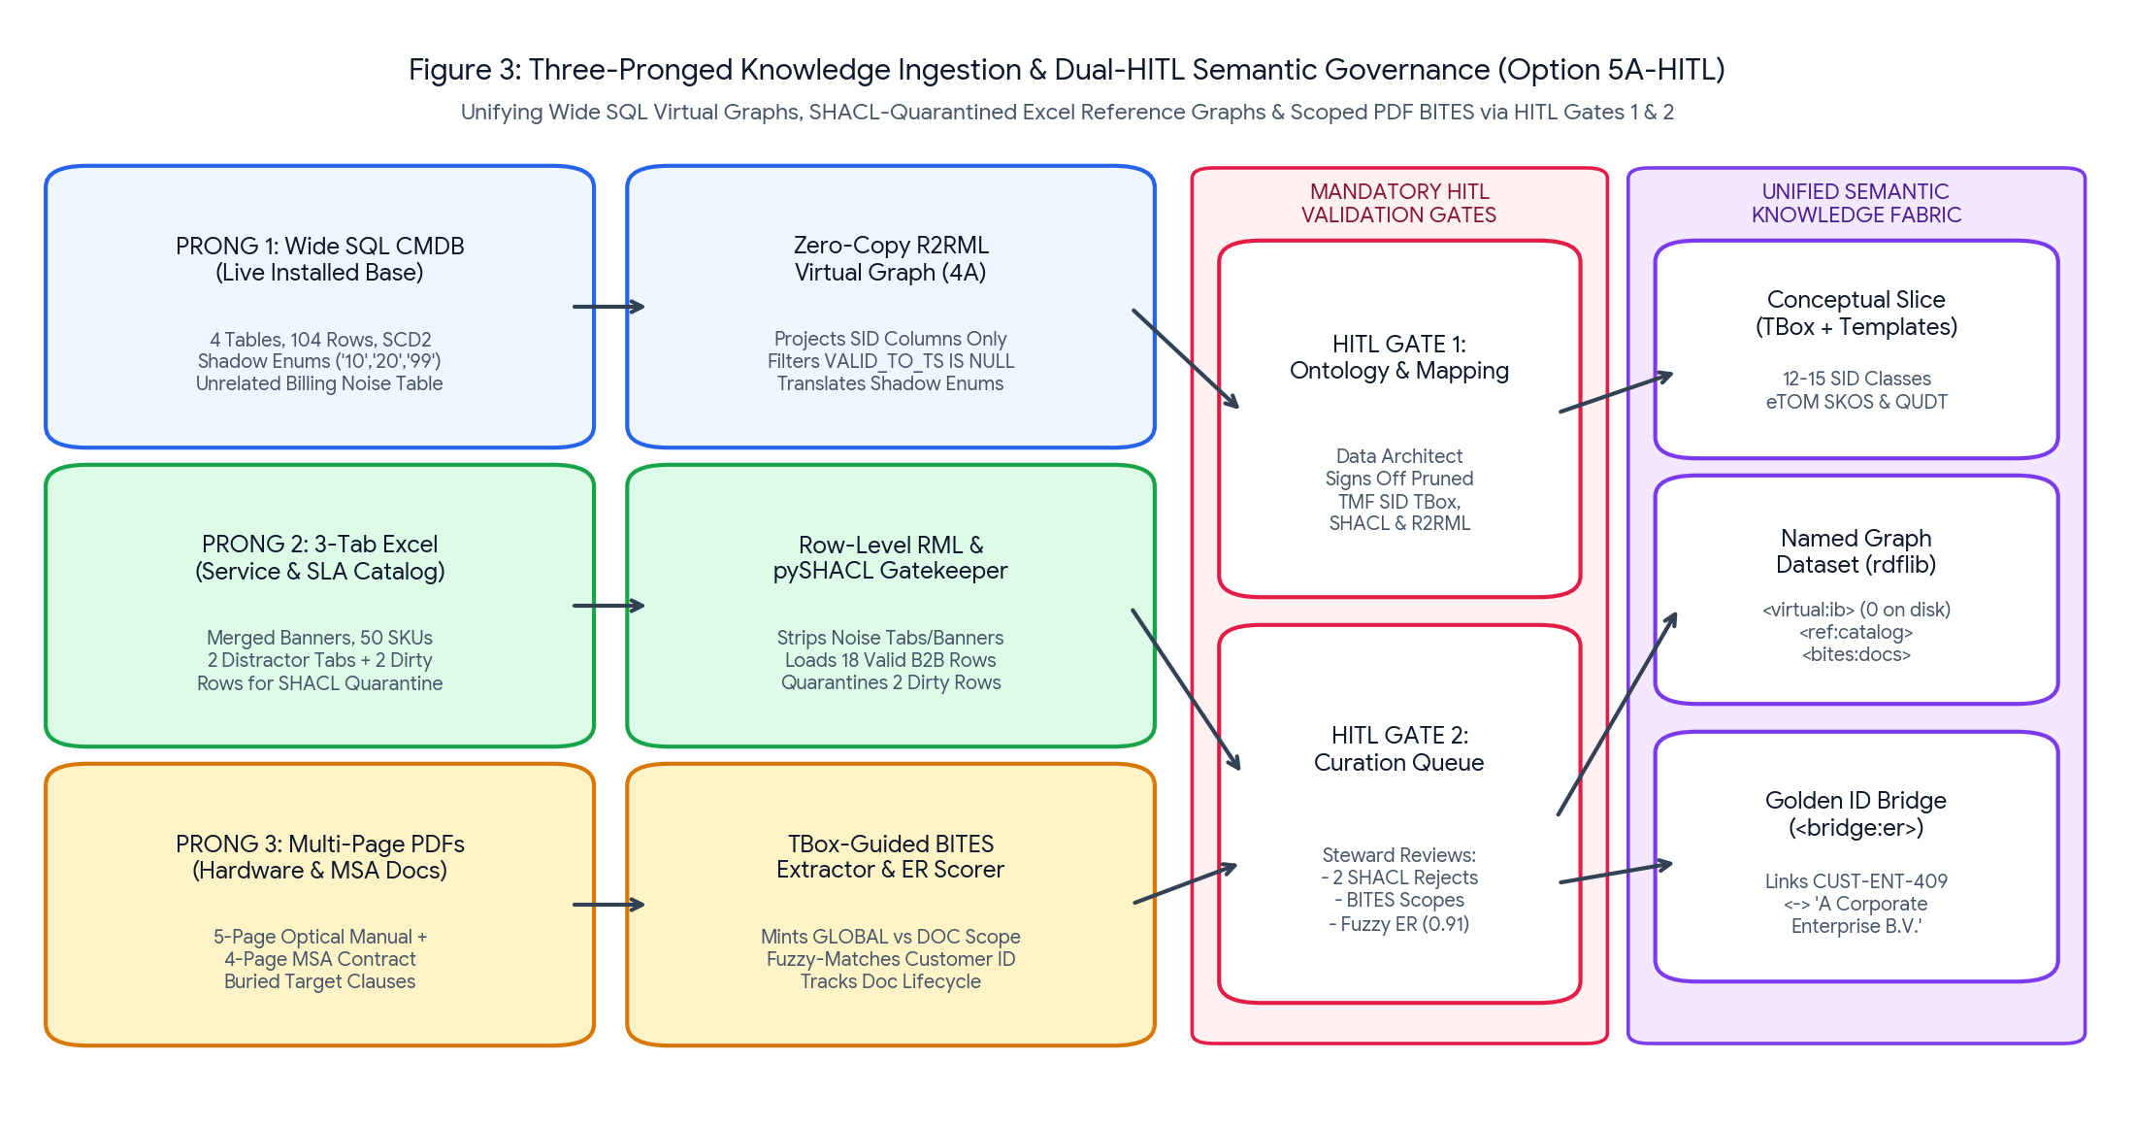
Figure 3: Three-Pronged Knowledge Ingestion Architecture incorporating Wide-Source Noise Filtering, Row-Level pySHACL Quarantine, and Mandatory HITL Validation Gates 1 & 2 (Option 5A-HITL).
5.1 Flow 1: Wide Relational SQL Installed Base via Zero-Copy Virtual Graphs
Zero SQL rows are copied to disk. The R2RML/SMS2 Virtual Graph mapping projects only the SID-relevant columns from wide CMDB tables (ignoring unrelated billing/audit tables), translates legacy shadow enums ('10' -> 'ACTIVE'), normalizes mixed bandwidth units ('Kbps'/'Mbps'/'Gbps'), and injects SCD Type 2 temporal filters (WHERE VALID_TO_TS IS NULL) at query time.
5.2 Flow 2: Multi-Tab Excel Workbooks via Row-Level pySHACL Quarantine Gate
The Excel ingestion pipeline strips merged banner rows, ignores distractor worksheets (e.g., residential or deprecated SKU tabs), and evaluates each candidate B2B product row individually against pySHACL shapes. Valid rows are promoted into <urn:telco:graph:ref:catalog>, while non-compliant/dirty rows (e.g., negative packet loss thresholds or invalid lifecycle flags) are automatically diverted into the HITL Quarantine Report without failing the valid batch.
5.3 Flow 3: Multi-Chapter PDFs via Ontology-Scoped BITES & HITL Gate 2 Curation
The PDF extraction pipeline (Stardog Voicebox BITES or pypdf/Docling + TBox-constrained LLM) scores document chapters against the TBox, ignoring irrelevant chapters (power supplies, cooling fans, general legal boilerplate). Extracted triples are assigned GLOBAL_SCOPE IRIs for shared catalog entities (e.g., NOK-7210-SAS-Mxp) or DOCUMENT_SCOPE IRIs for local contract clauses, tracked by a Document Lifecycle Metadata Graph (<urn:telco:graph:meta:doc-lifecycle>).
- Mandatory HITL Gate 2 (Quarantine, BITES Scope & Entity Resolution Triage): Surfaces quarantined Excel rows, BITES PDF candidate triples, and fuzzy Entity Resolution matches (such as linking 'A Corporate Enterprise B.V.' in the MSA PDF to 'A Corporate Enterprise' / CUST-ENT-409 in the SQL CMDB) in an expert curation queue for verification before promotion to <urn:telco:graph:bridge:er>.
6. Part III (Runtime Read Plane): Layer 3 (Dual NL2Semantics) & Layer 4 (Compiler)
6.1 Layer 3 (NL2Semantics) & Dual Shadow Comparison Mode (Option 3C-Dual)
Layer 3 translates Worker Agent semantic read requests into safe, read-only Canonical SPARQL AST queries using only the Conceptual TBox Slice. To provide complete architectural transparency and demonstrate why ontology-grounded Stored Query Templates outperform raw zero-shot LLM generation on multi-graph joins, Layer 3 supports Dual Shadow Comparison Mode (Option 3C-Dual):
- 1. Voicebox Hybrid Path (voicebox_hybrid): Prunes the TBox schema, matches verified Stored SPARQL Query Templates, parameterizes the query via LLM/template binding, and validates the resulting AST via rdflib's static parser.
- 2. Zero-Shot LLM Path (zero_shot_llm): Passes the raw TBox ontology to the LLM to synthesize a multi-graph SPARQL query from scratch, followed by static AST validation.
- 3. Default Dual Comparison Execution (dual_comparison): Executes both paths in parallel at runtime, routes the verified canonical AST to Layer 4, and records a Side-by-Side Comparison & AST Security Audit Card in the Flight Recorder.
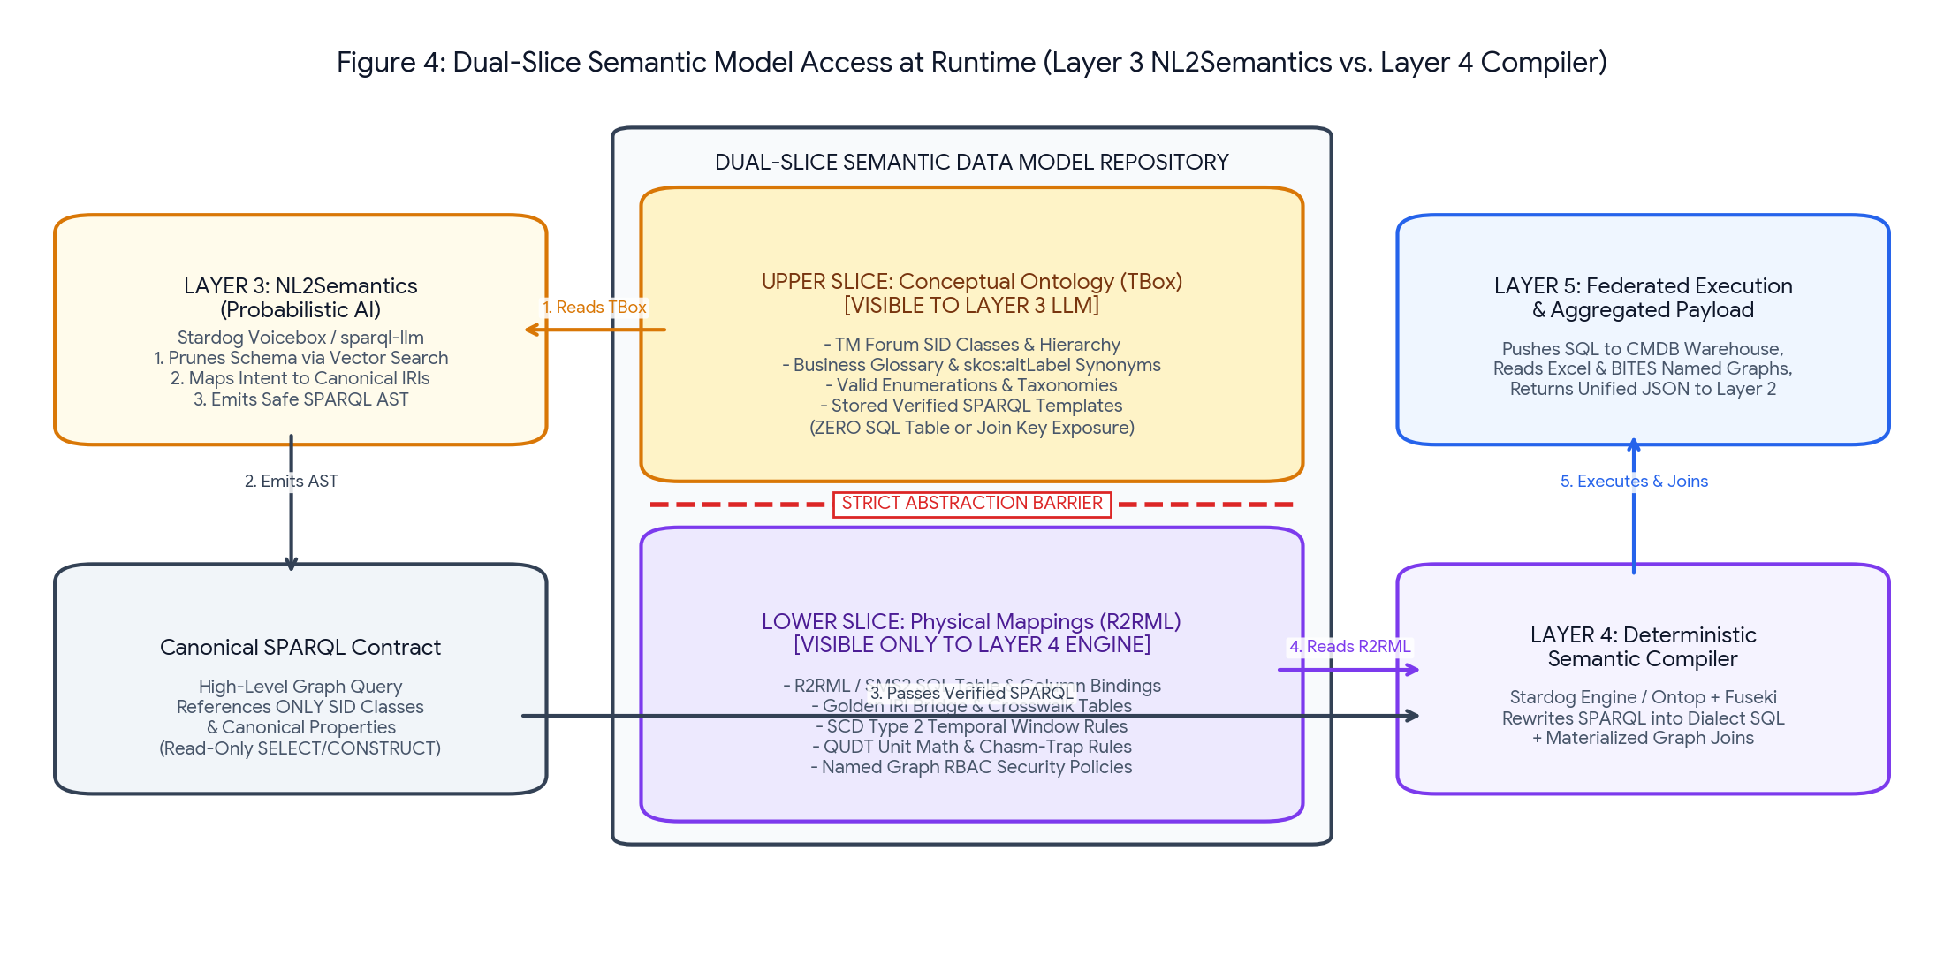
Figure 4: Dual-Slice Semantic Model Access at Runtime showing the strict abstraction barrier between Layer 3 (Conceptual TBox Slice) and Layer 4 (Physical R2RML Mapping Slice).
6.2 Layer 4 (Deterministic Semantic Compiler) & 5-Challenge Resolution Proof (Option 4A)
Layer 4 compiles the verified Canonical SPARQL AST across the physical mappings—executing live SQL pushdown against the CMDB for <urn:telco:graph:virtual:ib> (which maintains zero persisted triples on disk) and joining the result with the materialized Excel, BITES PDF, and Golden ID ER Named Graphs. Every execution emits an explicit 5-Challenge Resolution Proof Table:
Integration Challenge | Layer 3 & Layer 4 Deterministic Resolution Mechanism | Runtime Proof Logged in Flight Recorder
1. Semantic Gap & Unit Mismatch | TBox separates homonyms; skos:altLabel resolves synonyms; Layer 4 normalizes Kbps/Mbps/Gbps and dBm via QUDT conversion rules. | Shows raw SQL BW_VAL/BW_UNIT_CD normalized to canonical Gbps & dBm thresholds.
2. Unstable Universal Keys | Replaces fragmented natural/surrogate keys with Golden IRIs bridged via <urn:telco:graph:bridge:er>. | Shows SQL CUST-ENT-409 ('A Corporate Enterprise') joined with PDF 'A Corporate Enterprise B.V.'.
3. Structural Heterogeneity | Projects 3NF SQL tables, 2D Excel matrices, and unstructured PDF clauses into uniform RDF triples while pruning distractor tables. | Shows 3-table SQL join + Excel + PDF federated result with T_BILLING_AUDIT_NOISE pruned.
4. Temporal Drift (SCD Type 2) | Injects point-in-time SQL window predicates (WHERE VALID_TO_TS IS NULL) and checks document lifecycleStatus = 'ACTIVE'. | Proves expired CFS_ROW_ID=2000 (ETH-1G-SILVER) was filtered out in favor of active CFS_ROW_ID=2001 (ETH-10G-GOLD).
5. Data Hygiene & Shadow Enums | Row-level pySHACL quarantines dirty Excel rows at build time; R2RML translates shadow enum '10' -> 'ACTIVE' at query time. | Displays translated status 'ACTIVE' and links to the 2 quarantined Excel distractor rows.

7. Part III (Runtime CQRS Action Plane): Platform Primitives vs. SOP-Compiled Payloads
7.1 Why the Semantic Read Plane (Layers 3 & 4) is Strictly Read-Only
The Semantic Knowledge Layer (Layers 3 and 4) is strictly read-only (SELECT, ASK, DESCRIBE, CONSTRUCT) because virtual R2RML views over multi-table joins are mathematically non-invertible, direct database writes bypass TM Forum Open API state machines, LLM-generated SPARQL UPDATE statements risk graph poisoning, and semantic caches lag sub-second hardware state.
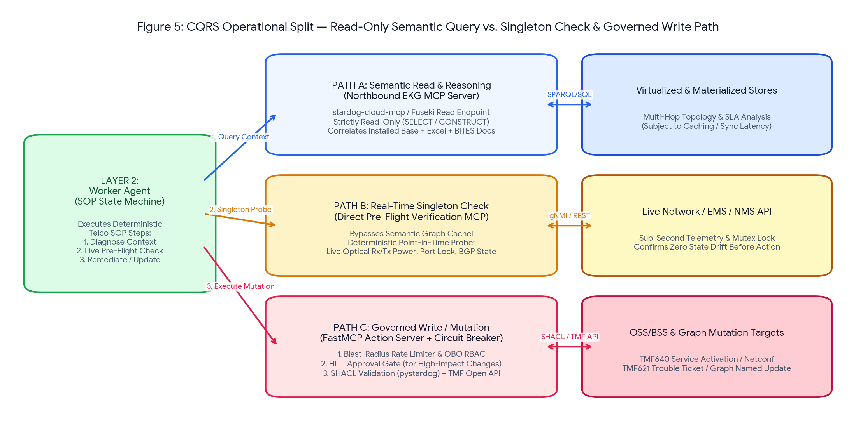
Figure 5: CQRS Runtime Operational Split separating Path A (Semantic Read via Layers 3 & 4) from Path B (Singleton Pre-Flight Probe) and Path C (Governed Write) in the Runtime CQRS Action Plane.
7.2 Explicit Architectural Separation: Reusable Platform Primitives vs. SOP-Compiled Steps (OBS-11)
A foundational principle of this architecture is that onboarding a new telecom SOP must NEVER require developers to manually code new use-case-specific Python functions inside the CQRS MCP servers. Instead, the Runtime CQRS Action Plane enforces a strict separation between (1) Generic, Reusable Platform Primitives and (2) SOP-Compiled Command Payloads:
Architectural Dimension | 1) Reusable CQRS Platform Primitives (Coded Once in Track A) | 2) SOP-Compiled Steps & Command Payloads (Auto-Generated from SOP)
Singleton Check MCP Server | Exposes generic primitive: probe_resource_state(resource_iri, requested_metrics[], bypass_cache, acquire_mutex_ttl_sec). Manages atomic mutex locks (SET NX EX) and southbound telemetry adapters. | SOP Compiler extracts target resource variable ({STEP_1.port_iri}), metric names (['optical_rx_dbm', 'maintenance_lock']), and lock TTL (60s) from SOP-ASSUR-402 into skill.yaml.
Transactional Write MCP Server | Exposes generic primitives: execute_governed_mutation(protocol, operation, params, lock_token, obo_jwt) and commit_validated_graph_triples(turtle_data, target_graph, shacl_shape). Enforces OBO RBAC, token-bucket rate limits, and pySHACL. | SOP Compiler extracts target protocol ('TMF640_SERVICE_ACTIVATION' or 'TMF621_TROUBLE_TICKET'), operation ('ddm_optical_recalibration'), parameter templates, and target SHACL shape from SOP prose.
Onboarding a New Use Case | Zero code changes to the Singleton Check or Transactional Write MCP servers (unless the SOP Compiler flags a brand-new southbound protocol in missing_primitive_spec.json). | Run the new SOP through the Option 2.1D-Catalog compiler to emit a new signed YAML skill and command manifest.

Reference Implementation: Generic Reusable CQRS Transactional Write Primitive (Option 6A-Generic)
@mcp_write.tool()
def execute_governed_mutation(
protocol: str, operation: str, params: dict,
resource_iri: str, singleton_lock_token: str, obo_jwt: str,
graph_writeback: dict | None = None
) -> dict:
# 1. Generic Platform Safety Gates (Zero hardcoded SOP or Nokia logic)
verify_obo_permission(obo_jwt, required_scope="telco:assurance:write")
verify_active_singleton_lock(resource_iri, singleton_lock_token)
check_blast_radius_token_bucket(caller_jwt=obo_jwt, protocol=protocol)
# 2. Dispatch SOP-Compiled Command Payload to Protocol Adapter (TMF640 / TMF621 / NETCONF)
api_result = dispatch_southbound_protocol(protocol=protocol, operation=operation, params=params)
# 3. Optional Pre-Commit pySHACL Gatekeeper for Curated Knowledge Graph Writeback
if graph_writeback:
conforms, _, report_txt = validate(
Graph().parse(data=graph_writeback["candidate_turtle"], format="turtle"),
shacl_graph=load_shacl_shape(graph_writeback["shacl_shape"]),
abort_on_first=True
)
if not conforms:
raise ValueError(f"SHACL Guardrail Violation - Write Rejected: {report_txt}")
commit_to_named_graph(graph_writeback["candidate_turtle"], graph_writeback["target_graph"])
return {"status": "COMMITTED", "protocol": protocol, "operation": operation, "api_result": api_result}

8. End-to-End Walkthrough, Glass-Box Observability & 3-Tier Stack Matrix
8.1 Unified Glass-Box Flight Recorder & Distributed Tracing (Option 7A)
To guarantee full operational transparency during verification and production troubleshooting, every request propagates a W3C traceparent ID across Layers 1–5 and writes a self-contained HTML/Markdown Glass-Box Flight Recorder report capturing: (1) Build-Time HITL artifacts, (2) Layer 1-to-2 MCP envelopes, (3) Layer 2 LangGraph state transitions and Guardrail checks, (4) Layer 3 Dual Shadow Comparison SPARQL cards, (5) Layer 4 compiled SQLite pushdown queries and the 5-Challenge Proof Table, and (6) CQRS Singleton Lock, Token-Bucket, and pySHACL validation logs.
8.2 Master 3-Tier Architectural Comparison: Commercial vs. Open-Source Cluster vs. Local Verification Profile
Architectural Layer / Component | Commercial Enterprise Stack (Stardog) | Open-Source W3C Cluster Stack | Local Python W3C Verification Profile (UC-001 Demo)
Layer 1: Orchestrator (1D) | Vertex AI / Copilot Studio / Bedrock | LangGraph / Open-Source MCP Host | Dual-Interface fastmcp.Client + Google AI Studio (google-genai) + Web UI JSON + Copilot SSE
Layer 2.1: SOP Compiler (2.1D) | Docling + LLM Compiler + Git PR UI | Docling + LLM Compiler + GitHub Gate | Autonomous Section Slicer + MCP Catalog Matcher & Gap Spec Generator + Evaluator + HITL Diff
Layer 2.2: Worker Runtime (2.2A) | LangGraph Platform + FastMCP | LangGraph + FastMCP Container | LangGraph StateGraph dynamically built from signed YAML + Deterministic Guardrail Interceptor
Layer 3: NL2Semantics (3C-Dual) | Stardog Voicebox | sparql-llm + Qdrant + vLLM | Dual Shadow Engine (voicebox_hybrid + zero_shot_llm in parallel) + rdflib Static AST Gatekeeper
Layer 4: Compiler & Fed. (4A) | Stardog EKG Virtual Graphs (SMS2) | Ontop (R2RML) + Apache Jena Fuseki | rdflib.Dataset Named Graphs + Transparent Python R2RML-to-SQLite Compiler + 5-Challenge Proof
Track B Ingestion & ER (5A-HITL) | Stardog Designer + ICV + BITES + ER | RMLMapper + pySHACL + Docling + Splink | AI Schema Profiler + HITL Gate 1 & Gate 2 + Row pySHACL Quarantine + pypdf BITES + Fuzzy ER
CQRS Action Plane (6A-Generic) | Custom FastMCP + Redis + pystardog | Custom FastMCP + Redis + Fuseki | Generic FastMCP Primitives + Inspectable JSON Mutex/Token-Bucket Store + Pre-Commit pySHACL

