CORTEX — Cognitive Resilient Teaming for Extreme Search and Rescue

Internal Pitch Document | AIT Center for Technology Experience

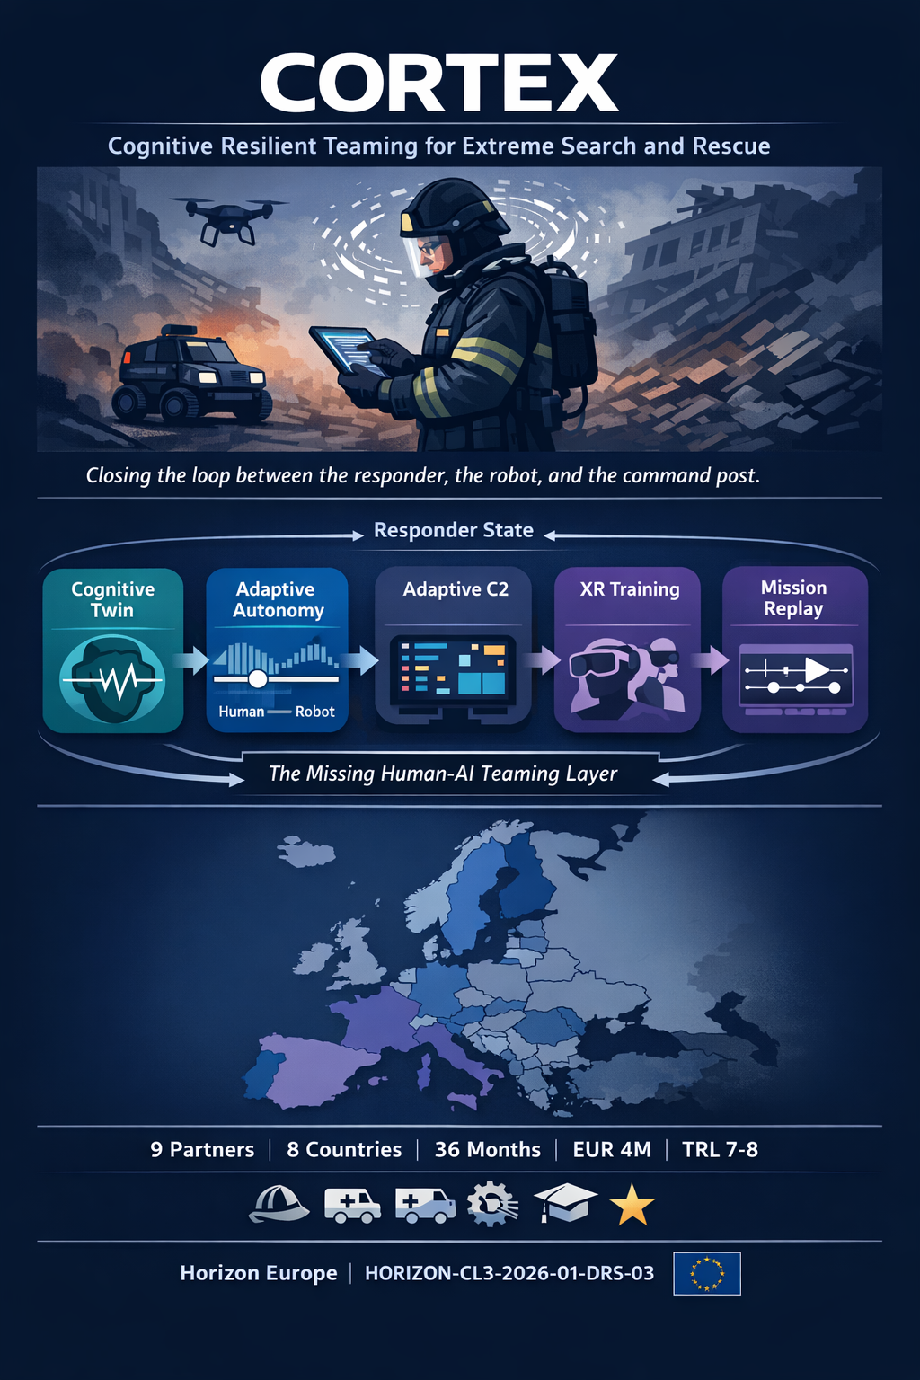

The Opportunity
Field | Detail
Call | HORIZON-CL3-2026-01-DRS-03
Topic | Innovative tools & technologies for search and rescue in hazardous conditions
Instrument | Innovation Action (IA)
EU Contribution | ~EUR 4M per project (2 projects funded)
AIT Budget Target | ~EUR 900k
Deadline | 5 November 2026
TRL Target | 7-8
Duration | 36 months

The Problem
Search-and-rescue operations in disaster environments (structural collapse, wildfire, earthquake) push human responders to their cognitive and physical limits. A decade of EU-funded innovation has produced better drones, smarter robots, and more sensors — but the human operating them is still unsupported:
- No closed loop. Biosignal monitoring of responders exists (SIXTHSENSE, FASTER, RESCUER) but stops at a dashboard nobody watches during a crisis. It never feeds back into operational decisions.
- All-or-nothing autonomy. SAR robots are either teleoperated or fully autonomous. There is no adaptation based on the operator’s current cognitive capacity.
- Static interfaces. C2 systems present all information equally, regardless of whether the commander is fresh or overwhelmed.
- No training for human-AI teams. Responders have never practiced working alongside adaptive autonomous systems.

Our Solution: The Missing Human-AI Teaming Layer
CORTEX closes the loop between the responder, the robot, and the command post — for the first time.

RESPONDER COMMAND POST TRAINING
+-----------+ +------------------+ +----------+
| Wearable |--edge---->| Adaptive | | XR Human-|
| Biosensors| node | Autonomy Manager | | AI Team |
| (PPE- | (real- | (advisory mode: | | Trainer |
| embedded)| time) | human confirms) | +----------+
+-----------+ +--------+---------+
|
+--------v---------+
| Adaptive C2 |
| Dashboard |
| (overlay on |
| existing C2) |
+--------+---------+
|
+--------v---------+
| Robot/Drone Fleet| Ethics &
| (partner-provided| Governance
| platforms) | (cross-cutting)
+------------------+
Five Key Exploitable Results:
- Cognitive Twin Engine — Real-time responder state inference (stress, fatigue, cognitive load) from PPE-embedded biosensors. Predicts degradation before the responder notices it.
- Adaptive Autonomy Manager — Middleware that adjusts robot/drone autonomy based on operator cognitive state. Advisory mode: the system recommends, the human confirms.
- Adaptive C2 Overlay — Plugin for existing C2/CAD systems that prioritizes information based on commander state. Stable layout, adaptive content.
- XR Training for Human-AI Teaming — VR/MR scenarios where responders practice trust calibration and collaboration with adaptive autonomous systems.
- Mission Replay Tool — “Black box for responders” — synchronized post-mission cognitive-operational after-action review.

Why AIT CTE Should Lead This
- Direct lineage from SHOTPROS + MED1stMR — XR training, biosignal measurement, human performance under stress. CORTEX is the natural next step.
- We own the innovation gap. 15 EU projects mapped — nobody has closed the biosignal-to-C2-to-autonomy loop. The robotics side is saturated (TRIFFID, HURRICANE, PROACTIF). The human side is wide open.
- 5 of 9 consortium partners are warm contacts from our past projects (PLUX, Campus Vesta, SAMUR-PC, Region Jamtland, Univ. Twente).
- We lead 4 of 8 WPs — WP1 (Management), WP2 (Cognitive Twin), WP3 co-lead (Adaptive Autonomy), WP4 co-lead (C2 Overlay), WP5 (XR Training). This is our project.
- Platform-agnostic middleware — high exploitation potential. Works with any robot and any C2 system. No hardware lock-in.

Innovation Positioning
What competitors will propose | What CORTEX proposes
“Better robots save more lives” | “Better-supported humans, teamed with robots, save more lives”
New drone/UGV platforms (TRL 4-5 to 7) | Middleware layer that works with existing platforms (lower risk)
Human factors as a token WP | Human state as the central control signal of the architecture
End-users test at the end | End-users co-design from Month 1 (5 warm contacts)
Silent on AI Act | Compliance by architecture — human-in-the-loop, advisory mode

Consortium (Proposed, 9 Partners, 8 Countries)
Partner | Country | Type | Role | Warm?
AIT CTE | Austria | RTO | Coordinator, WP1/2/3/4/5 | —
Robotnik | Spain | SME | Robotics (UGV/UAV)
IES / Webgenesys | Italy | SME | C2 platform (JIXEL)
PLUX Biosignals | Portugal | SME | Wearable biosensors | MED1stMR
Campus Vesta | Belgium | Public Body | Fire/rescue end-user, exercises | SHOTPROS + MED1stMR
Feuerwehr Dortmund / IFR | Germany | Public Body | Fire/USAR end-user, exercises
SAMUR-PC Madrid | Spain | Public Body | Medical emergency authority | MED1stMR
Region Jamtland Harjedalen | Sweden | Public Body | Medical/EMS authority | MED1stMR
Univ. Twente | Netherlands | University | ELSI / ethics | TechEthos with AIT
40+ backup candidates identified across all positions. Budget headroom (~500k) for a 10th partner (recommended: CNBOP-PIB, Poland — widening country bonus).

Budget Overview
Category | EUR | %
AIT CTE | 900,000 | 23%
Technology SMEs (Robotnik, IES, PLUX) | 1,250,000 | 31%
End-users (4 orgs) | 1,100,000 | 28%
ELSI (Univ. Twente) | 250,000 | 6%
Subtotal | 3,500,000 | 88%
Headroom (10th partner or buffer) | 500,000 | 12%
Total | ~4,000,000 | 100%
Note: IA funding rate is 70% (100% for non-profit). AIT as RTO qualifies for 100%. Lump sum grant.

Timeline
Phase | Months | Key Activities
Now - Nov 2026 | Pre-submission | Internal approval, consortium outreach, proposal writing
May 2026 | Call opens | —
Nov 2026 | Deadline | Submission
~Jun 2027 | Expected start | If funded
M1-M12 | Component maturation | Lab validation, co-design with end-users, DPIA
M13-M24 | Integration | Subsystem integration, indoor testbed, first integrated demo
M25-M36 | Field validation | 3 multinational field exercises (TRL 7-8)

What We Need to Proceed
- Internal GO decision to invest pre-proposal effort (~3-5 PM for concept development and proposal writing over 8 months)
- Approval to coordinate (AIT CTE as lead beneficiary)
- Green light for outreach to consortium partners (starting with 5 warm contacts)

Key Risk & Mitigation
Risk | Mitigation
Biosignal reliability under SAR conditions | Multi-modal fusion (no single-sensor dependency); confidence scoring; graceful degradation
Responder/union acceptance of monitoring | Co-design from M1; advisory-only; data stays on-device; works council engagement in timeline
Adaptive autonomy validation | Wizard-of-Oz before automation; conservative policy with safety constraints; A/B evaluation design
Competition (~8-13% success rate) | Human-centered angle is unique; 5 warm contacts de-risk consortium; strong AIT pedigree

Prepared by Horizon Europe OS | 2026-03-06 Contact: [PI] — AIT Center for Technology Experience

