Sir Aegis (Knight)
Attack: 20
Healt : 200

Sword Slash
Sir Aegis performs a classic sword slash, dealing damage to his opponent. The execution involves a swift, horizontal swing of his sword.

Sheild Block – 2 (dmg * 0.2)

Instead of an attack, Sir Aegis can use his shield defensively. He raises his shield to block incoming attacks, reducing the damage taken for a turn. This defensive move doesn't deal damage but helps him tank and protect his team.

Elara Shadowcaster (Mage)
Attack: 40
Healt : 100

Lightning Bolt
Elara conjures a powerful Lightning Bolt, targeting a single enemy and dealing high electrical damage. The execution involves her raising her staff and releasing a bolt of lightning from it.

Frost Nova – 2 (atk * 1.2)

Elara creates a chilling Frost Nova, freezing the area around her and damaging all nearby enemies. The execution style includes her raising her staff, and the ground or air around her freezes before shattering and damaging opponents.

Shrek (Ogre)
Attack: 30
Healt : 150

Ogre Smash
Shrek uses his immense strength to perform an Ogre Smash, delivering a powerful melee attack. The execution involves a ground-shaking stomp followed by a heavy punch or slam with his fists.

Ground Pound – 2 (dmg * 1.3)

Shrek performs a Ground Pound attack by leaping into the air and slamming the ground with force. This creates a shockwave that damages the enemy. The execution involves a noticeable jump and a powerful slam upon landing.

Draegon the Infernal (Demon)
Attack: 45
Healt : 160

Inferno Strike
Draegon channels the flames of the underworld into his body, delivering a devastating Inferno Strike. This melee attack engulfs his target in fiery wrath, dealing significant damage

Soul Drain – 1 (no *)
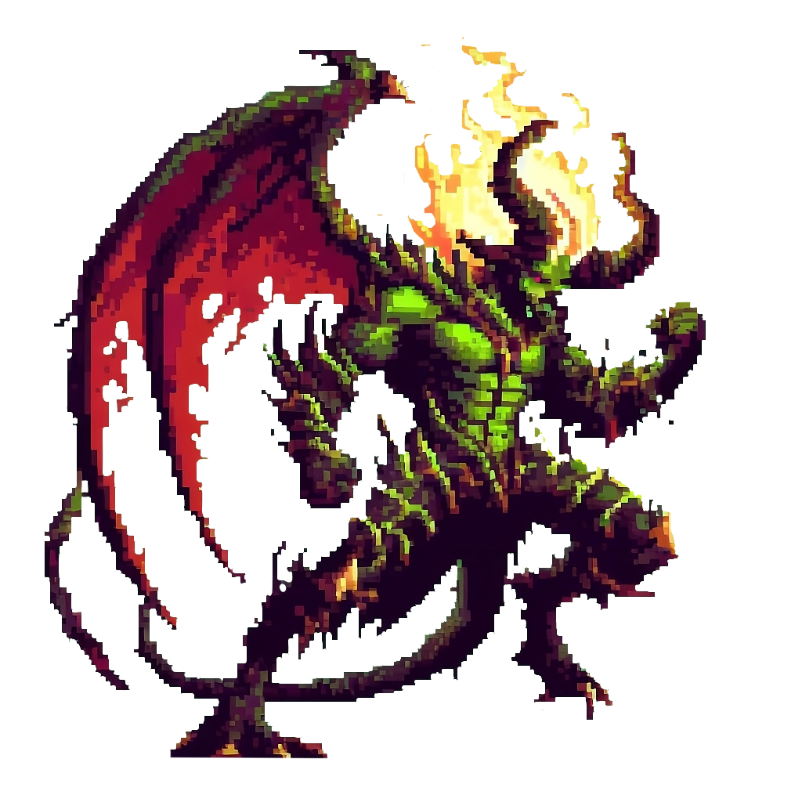
Draegon can drain the soul of his opponent to replenish his own health. He unleashes dark energy, reaching out to the enemy and draining their life force. This attack doesn't deal direct damage but instead absorbs a portion of the enemy's HP, transferring it to Draegon.

Seraphiel the Divine (Angel)
Attack: 50
Healt : 175

Radiant Beacon
Seraphiel creates a Radiant Beacon on the battlefield, which emits a brilliant aura of light. This aura weakens the opponent's accuracy, reducing their chance to hit Seraphiel with their attacks for a limited number of turns.

Heavenly Retribution

Seraphiel invokes the power of divine justice to deliver a Heavenly Retribution to the opponent. This attack deals moderate damage and inflicts a unique "Judgment" status on the enemy. While under this status, the opponent's next attack has a chance to backfire, damaging themselves instead.

Huemer (Administrator)
Attack: 60
Healt : 250

Playing with the odds - 1
He sets the balance, and it's determined by a dice roll. If the roll favors the enemy, there's a 60% chance that Huemer reflects the incoming damage, causing the enemy to take the damage that would have been dealt to him. If the roll favors Huemer, he gains the advantage and uses the ability.

Dice Manipulation - 2
Huemer has the power to manipulate the outcome of the dice roll. After a dice roll, he can choose to reroll with a 1.2 multiplier on all effects when it's in his favor and a 0.8 multiplier on all enemy effects when the dice roll is in favor of the enemy.


Mechanics

Base Attacks
Can be used when winning a dice roll

Abilities

Before the roll
Brings different outcomes when winning and losing the roll

After the roll
Can get chosen after the roll before attacks are made

Decay Effects
Take effect till it runs out
Either impulsing effect where the impulse is ones per round for example damage
static effect for example damage boost
ONE DECAY EFFECT PER TIME, the new one overrides the old one

