Framethrower

Non Disclosure Agreement

This Non Disclosure Agreement, effective as of {d.date}, is entered into by Framethrower, located at 2933 Grauman Road, V0N 2W1, Vancouver, BC, (the "Disclosing Party") and {d.firstname} {d.lastname} (“The Recipient", and together with the Disclosing Party, the "Parties", and each, a "Party").
For purposes of this agreement, “Confidential Data” shall include all information, data and material that has or could have commercial or other value in the business in which Framethrower is engaged.
The Recipient shall hold and maintain the Confidential Data in strictest confidence for the exclusive benefit of Framethrower. The Recipient shall restrict all access to the Confidential Data to employees, contractors and third parties and shall require those persons to sign confidentiality agreements at least as protective as those in this agreement. The Recipient shall not, without prior written approval of Framethrower, use for their own benefit, publish, copy, or otherwise disclose to others, or permit the use by others for their benefit or to the detriment of Framethrower, any Confidential Data.
The non disclosure provisions of this agreement shall survive the termination of this agreement and The Recipient’s duty to hold Confidential Data in confidence shall remain in effect until the Confidential Data no longer qualifies as a trade
secret or until Framethrower sends The Recipient written notice releasing The Recipient from this agreement.
This agreement expresses the complete understanding of the parties with respect to the subject matter and supersedes all prior proposals, agreements, representations and understandings. This agreement may not be amended except in a writing signed by both parties.
By signing this agreement, The Recipient also understands that any unauthorized use of such information may lead to legal proceedings against The Recipient and against any other third party involved in the infringement, without further notice or delay. This Agreement and each party’s obligations shall be binding on the representatives, assigns and successors of such party. Each party has signed this agreement through its authorized representative.
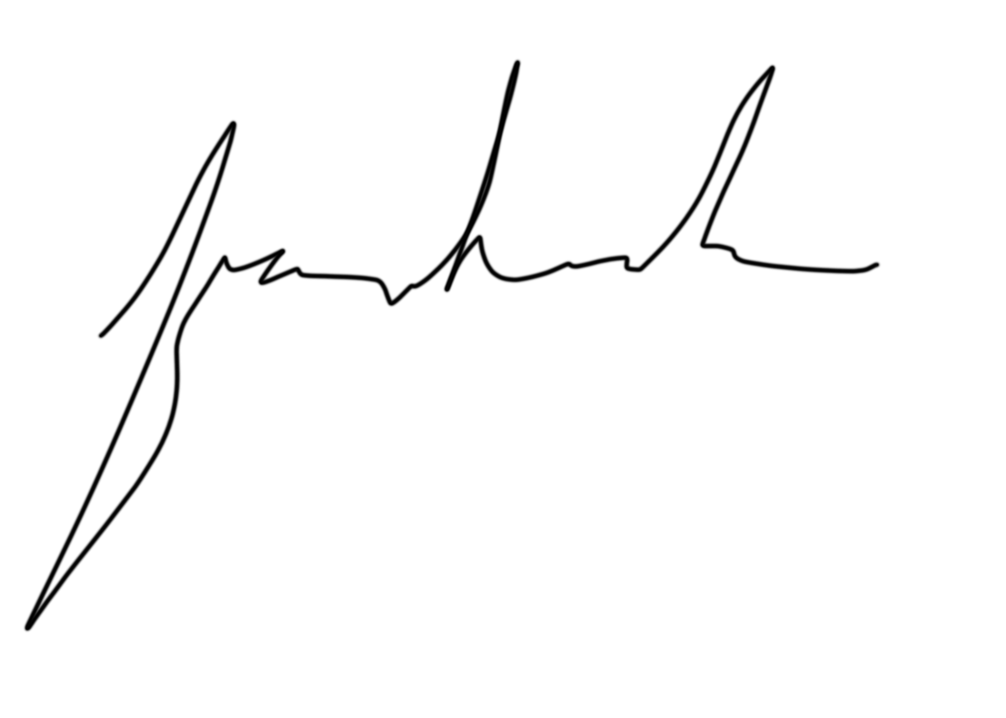

_______________________ | _______________________
{d.first} {d.lastname}, date | Ben Kousholt, date
 | Animator and Co-founder, Framethrower

