Labor – ACL

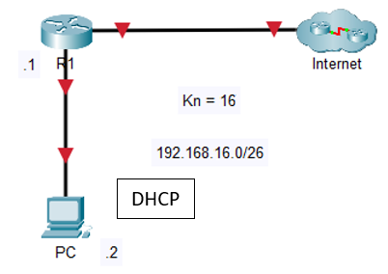

Show ip interface brief

Access mit matches:

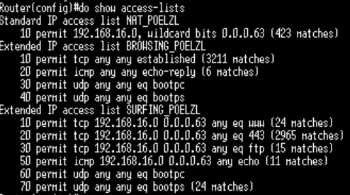

Nat:

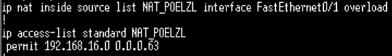

Show ip nat translate:

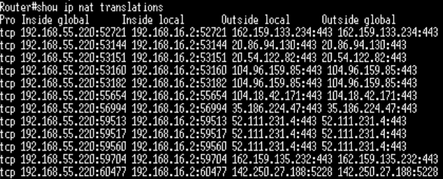

ip cef

ip dhcp excluded-address 192.168.236.1

!

ip dhcp pool DHCP_POELZL

network 192.168.16.0 255.255.255.192

default-router 192.168.16.1

dns-server 8.8.8.8

!

interface FastEthernet0/0

ip address 192.168.16.1 255.255.255.192

ip access-group SURFING_POELZL in

ip access-group BROWSING_POELZL out

ip nat inside

ip virtual-reassembly

duplex auto

speed auto

!

interface FastEthernet0/1

ip address dhcp

ip nat outside

ip virtual-reassembly

duplex auto

speed auto

!

ip http server

no ip http secure-server

ip nat inside source list NAT_POELZL interface FastEthernet0/1 overload

!

ip access-list standard NAT_POELZL

permit 192.168.16.0 0.0.0.63

!

ip access-list extended BROWSING_POELZL

permit tcp any any established

permit icmp any any echo-reply

permit udp any any eq bootpc

permit udp any any eq bootps

ip access-list extended SURFING_POELZL

permit tcp 192.168.16.0 0.0.0.63 any eq www

permit tcp 192.168.16.0 0.0.0.63 any eq 443

permit tcp 192.168.16.0 0.0.0.63 any eq ftp

permit icmp 192.168.16.0 0.0.0.63 any echo

permit udp any any eq bootpc

permit udp any any eq bootps

Tests:

Ping ins Internet:

Debug ip nat:

