crypto isakmp policy 99

encr aes 256

authentication pre-share

group 5

lifetime 3600

crypto isakmp key PW12345 address 172.30.99.2

!

!

crypto ipsec transform-set R1-R2-PW_MAP esp-aes esp-sha-hmac

!

crypto map R1-R2-PW_MAP 99 ipsec-isakmp

set peer 172.30.99.2

set security-association lifetime seconds 900

set transform-set R1-R2-PW_MAP

set pfs group5

match address 101

!

!

!

!

!

!

!

interface FastEthernet0/0

ip address 10.0.99.1 255.255.255.0

ip nat inside

ip virtual-reassembly

duplex auto

speed auto

!

interface FastEthernet0/1

ip address 10.23.12.191 255.255.255.0

ip nat outside

ip virtual-reassembly

duplex auto

speed auto

!

interface Serial0/0/0

ip address 172.30.99.1 255.255.255.252

crypto map R1-R2-PW_MAP

!

interface Serial0/1/0

no ip address

shutdown

clock rate 2000000

!

interface Serial0/2/0

no ip address

shutdown

clock rate 125000

!

interface Serial0/2/1

no ip address

shutdown

clock rate 125000

!

router ospf 10

log-adjacency-changes

network 10.0.99.0 0.0.0.255 area 10

network 172.30.99.0 0.0.0.3 area 10

!

ip forward-protocol nd

ip route 0.0.0.0 0.0.0.0 FastEthernet0/1

ip route 0.0.0.0 0.0.0.0 10.23.12.1

no ip http server

no ip http secure-server

!

!

ip nat inside source list NAT_POELZL interface FastEthernet0/1 overload

!

ip access-list extended NAT_POELZL

deny tcp 10.0.99.0 0.0.0.255 192.168.99.0 0.0.0.255

deny tcp 192.168.99.0 0.0.0.255 10.0.99.0 0.0.0.255

permit tcp 192.168.99.0 0.0.0.255 any

permit tcp 10.0.99.0 0.0.0.255 any

!

access-list 101 permit ip 10.0.99.0 0.0.0.255 192.168.99.0 0.0.0.255

!

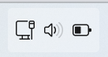

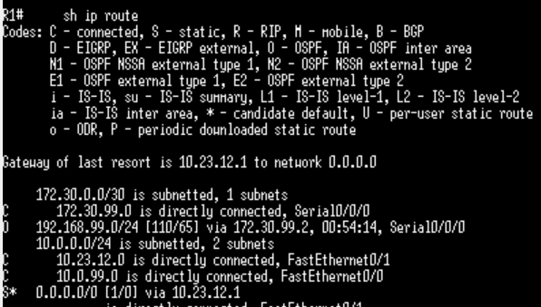

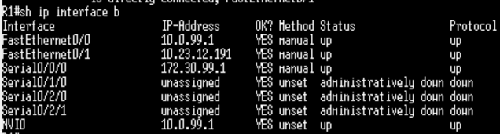

**Ich konnte GOOGELN**

