**USERGUIDE for Money Service**

Welcome to our program made by team North.

When you extract the ZIP-file the content of the folder will look like this:

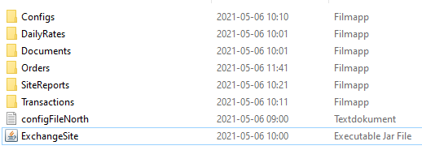

**Start the program by open command prompt, and write:**

C:\”FOLDER STORING THE FILES”\java -jar ExchangeSite.jar configFileNorth.txt

To change to different site just copy configFileNorth.txt and name it to desired site name.

Example: configFileCenter.txt

(the content of the file also needs to be changed, se part Config file further down).



When you start up the program it will look like this: (see picture below)

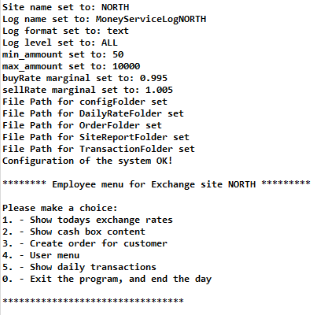

**In this menu you will have six choices as you see below on the picture.**

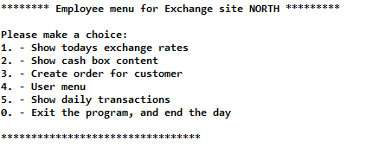

1. This choice will show you todays exchange rates for buy and sell with the service fee included.
2. This choice will print out the current amount of all currencies we have access to, amount and currency.
3. Creates an order for a customer with the options to buy or sell.

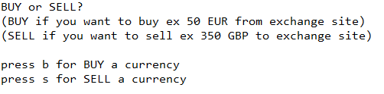

"b” for buy and “s” for sell. They work in the same concept, so if you press b for example. A screen like this will appear:

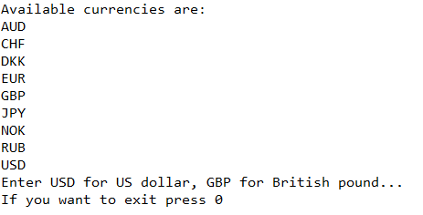

You can always go back to the Employee menu here if you press 0. Otherwise, you choose one of the currencies that are listed in front of you. After that you will choose an amount between the maximum and minimum amount that is displayed in the config file. (More about the config file later). the amount most be incremented in steps of 50. The program will auto adjust if you miss by a little and warn you in the next screen and ask you to confirm the order, it will display the cost and the exchange rate. Like you see in the pic below, choose to complete the order or cancel it.

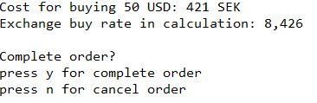

1. Takes you to the User menu for normal customers. With the same options as before with one exception. Employee menu, it requires a password that Is set in the config file.

The show exchange rate will show differently on this menu, as it’s meant for the customer.

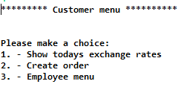

**5.** This choice will show you all the transactions for the day.

**0**. This option will stop program and shut down the service and backup the transaction file as serialized format and will save the site report. Site reports contains the moneybox.

**Config File**

The config file will look like this:

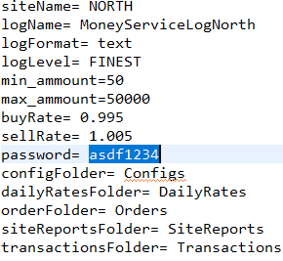

Logger is nothing to worry about, if something goes wrong with the program and you need help, you can contact us and send us those files and we will be able to work out what went wrong.

The site name is the name of the site it on, if you change it, it will adapt and save the files as the named site.

Min amount is the minimum amount you can enter to buy or sell currency.

Max amount is the maximum amount you can enter to buy or sell currency.

The buy rate is the amount the customer will receive from the exchange rate when making an order, for example 1,0 is 100%, 0,995 is 99,5% so the company will earn 0,5% from that order.

The sell rate is the amount the customer will pay when making an order for example 1,0 is 100%, 1,005% is a profit for the company with 0,5%.

Password Is the password you need to enter to go from customer menu to the employee menu, can be changed if it gets leaked.

Config folder is for pathing and creating folders if they don’t already exist.

Daily rates folder is for pathing and creating folders if they don’t already exist.

Order folder is for pathing and creating folders if they don’t already exist.

Site report folder is for pathing and creating folders if they don’t already exist.

Transaction folder is for pathing and creating folders if they don’t already exist.

**Vocabulary:**

Order: an order is a request for a customer to make a purchase or selling of currency.

Transaction: a receipt of a purchase or selling of an order.

Exchange site: It’s a place where you can buy and sell currencies.

Config file: is a place where you can adjust some options.

Console: it is a terminal where you can put inputs and receive outputs only requiring keyboard

GUI: stands for graphical user interface it’s like a console but prettier and you need a keyboard and mouse to press buttons.

Cash box: is a box that shows us what currencies we have and what amount.