# **1:1s for YOURNAME and OTHERNAME**

|  |  |  |
| --- | --- | --- |
| By DATE, the following will be true:  **STATEMENT**  And we’ll do this by... | | 💭 || ✅ |
| ✅ | GOAL1 [1/1/2018] | |
| 💭 | GOAL2 [2/1/2018] | |
| 💭 | GOAL3 [3/1/2018] | |

## **1:1 Notes**

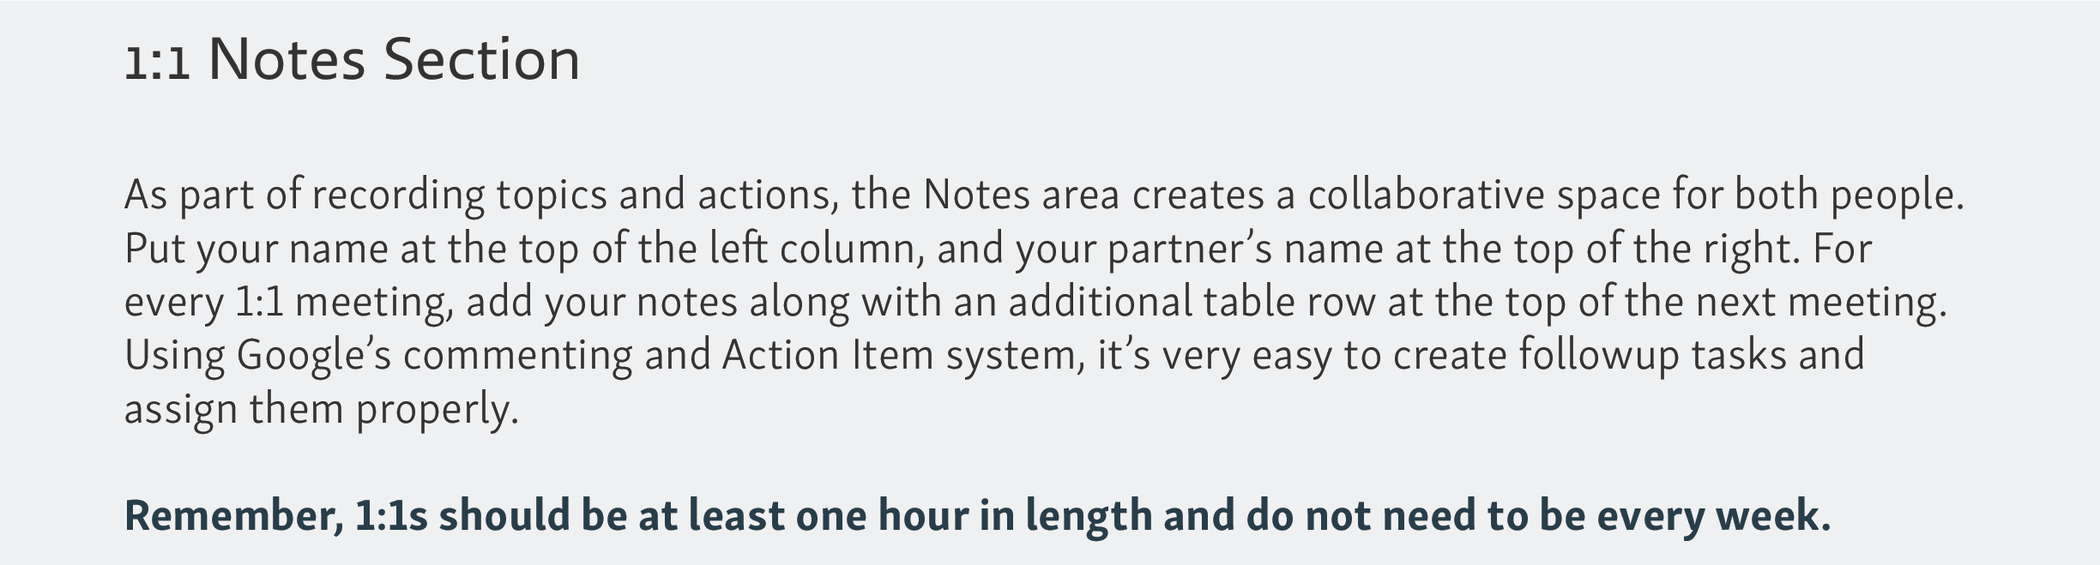

|  |  |  |
| --- | --- | --- |
| **Date** | **YOURNAME** | **OTHERNAME** |
| 1/1/2018 | * Topics   + Item   + Item * Notes   + Note 1   + Note 2 | * Topics   + Item   + Item * Notes   + Note 1 |

## 

