**Exploratory data analysis**

The top left histogram of Figure 1 shows that the perpendicular distances are generally close to the transect line. While distances are presumed to be measured accurately using a laser range finder, the angles were measured with a compass. The angles measured in the field are shown at the bottom right of Figure 1, this suggests that the angles have been rounded to the nearest 10 degrees and that angles under 20 have been heaped to 0. The distances measured from the observer seem to show some heaping at 25m, 50m, 100m, 350m and 400m.

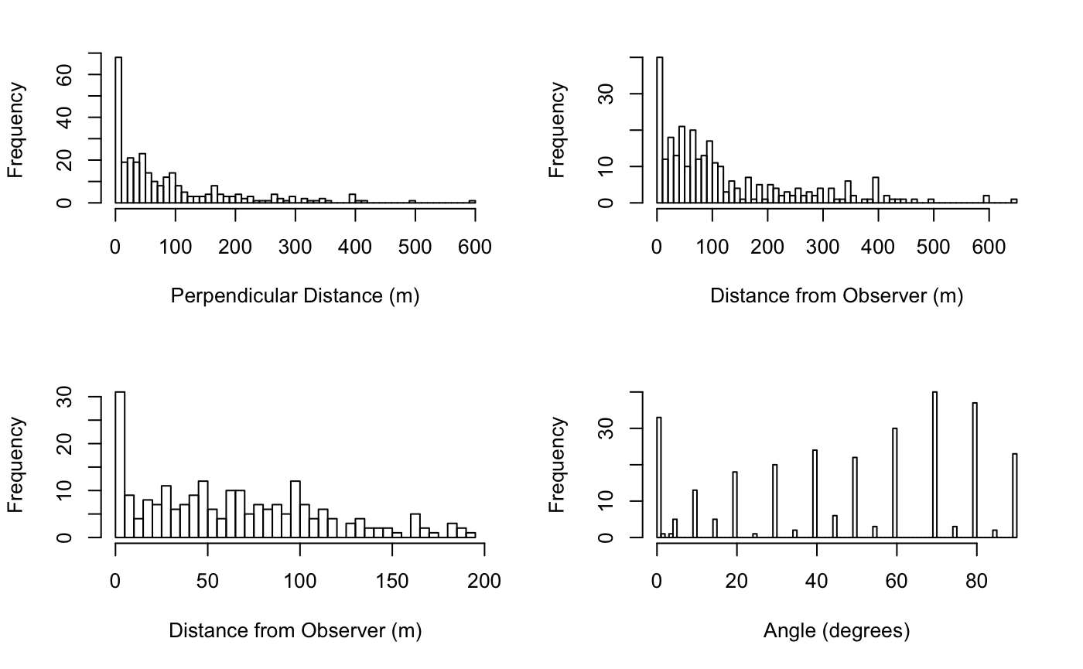

Figure 1 Analysis of Measurements taken during Survey

Buckland, 2001 (p267) suggests five ways of handling distance measurement error.

1. Record distances and angles more accurately
2. Use models for the detection function that always have a shoulder
3. Group the data before analysis
4. ‘Smear’ the data
5. Use radial distance models (this leads to non-robust models according to the text).

**‘Smearing’ the measured angles**

Buckland, 2001 (p269) says that although often criticized smearing is regularly used in cetacean surveys to handle errors in angle readings. Calculations used below are given by D. Kinzey, 2002 and based on the text in Buckland, 2001. The angles are adjusted within a given range using a uniform distribution

Sρ = | ρ + υ ∆ρ |

Where

ρ = recorded angle,

υ = uniform random number between -0.5 and 0.5,

∆ρ = range of angles to be smeared over.

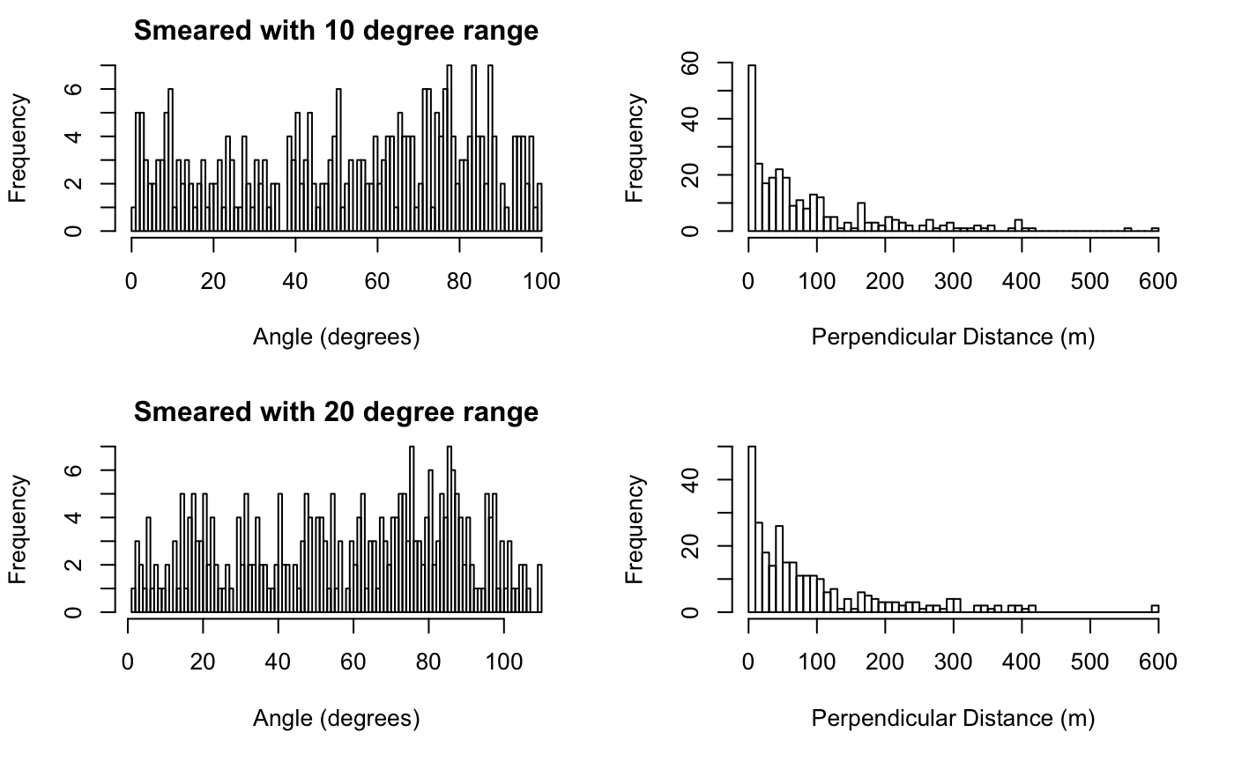

Figure 2 Effects of Smearing the Measured Angle

Figure 2 shows there is very little effect on the perpendicular distance when smearing the angle. Figure 3 shows that majority of the distances recorded with a low angle were for animals very close to the observer, which explains why the smeared angle has very little effect on the distance from the transect line.

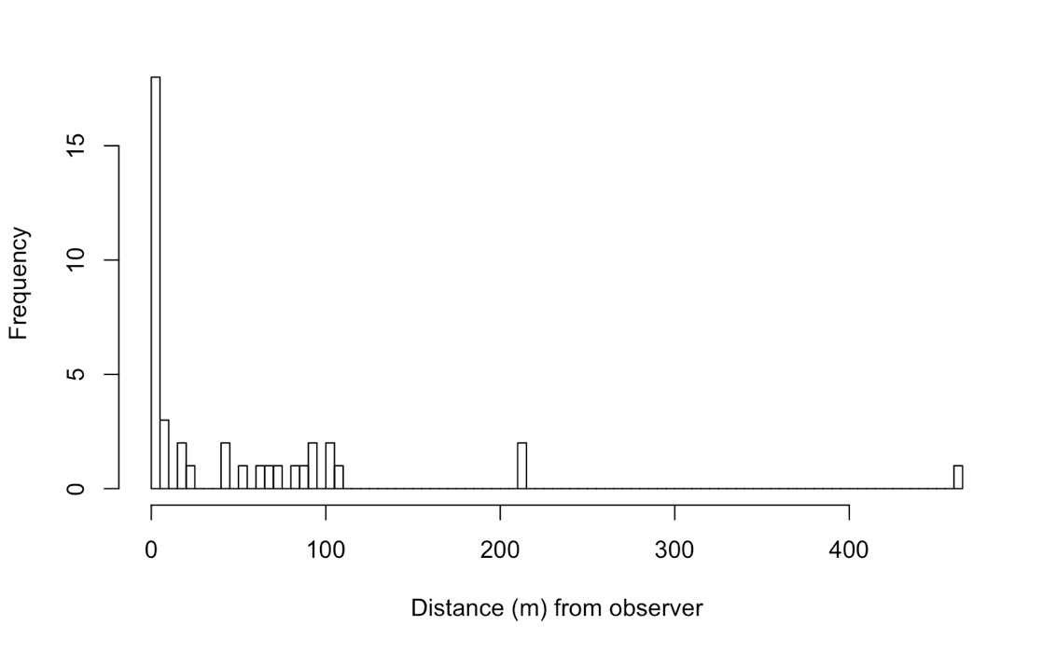

Figure 3 Distance of Animals from Observer where measured angle is less than 10 degrees

**Grouping the data**

Buckland, 2001 (p109) says that grouping should be used where there are measurement errors and that appropriate grouping can lead to a better model fit and improved estimates of density. The test suggests that cutpoints should be selected that avoid the rounding distances. When a lot of sightings fall on the transect (which is particularly common when using angles and distances) then a relatively wide first internal should be chosen. C Bibby, 1998 says that when grouping data to deal with heaping, the first interval chosen should be narrow and fall within the ‘shoulder’ and the other groups should increase with distance from the transect. Buckland, 2001 (p158) suggests that six to eight groups is a reasonable number for resolving heaping.

**Shape Criterion**

Buckland, 2001 (p42) discusses the shape criterion and says that a detection function should have a shoulder, which means that the derivative of the detection function on the transect is equal to 0, i.e. the observer detects all animals on and just off the transect. The text goes on to say that this is particularly important when heaping at zero is suspected.

**Cluster Size**

Larger cluster sizes are obviously more visible at distance than single animals. Thus there is a bias for only recording animals in large clusters at a far distance. Figure 4 shows that there is some cluster size bias in the hare data.

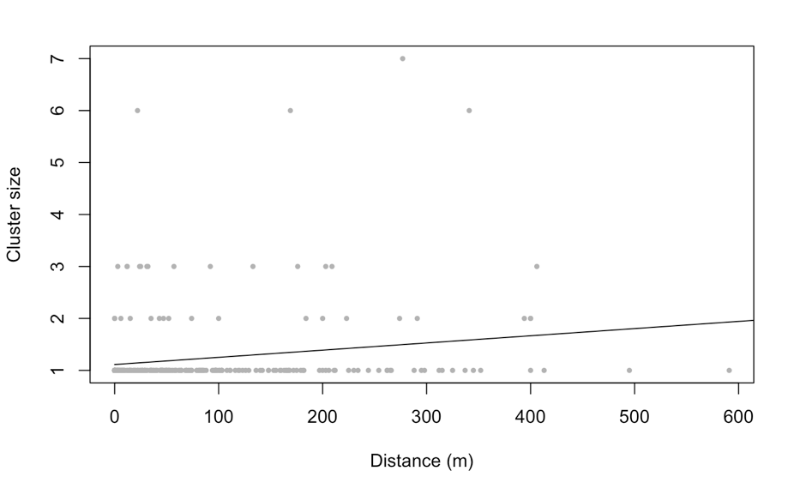

Figure 4 Detection of Large Clusters at Distance

Approaches for dealing with cluster size bias include:

1. Truncate the data to ignore large distances where bias occurs.
2. Add the cluster size as a covariate to the distance when modelling.
3. Calculate the mean cluster size using a regression estimator.
4. Replace clusters with individuals. When the number of detected clusters is small (13% of detections were clusters in the hare data) then this approach may perform poorly.

Fewer clusters of 2 or 3 hares were seen from about 200m.

**Truncation**

Right truncating the data may lead to a little loss of precision, however, losing some outliers will help reduce the number of parameters in the detection function and so reduce bias (Buckland, 2001 (p107)).

Truncation approaches include:

1. Truncating the furthest 5% - 15% of sightings.
2. Fitting a preliminary model and truncating any sightings at a distance with less that 15% chance of detection.

**Model Selection**

Models examined were uniform with polynomial adjustment, half normal with cosine adjustment and hazard rate with hermite polynomial adjustment. In general, trying every combination of detection function with adjustment will lead to very similar density estimates (L Thomas, 2010).

The model chosen uses a hazard rate detection model with no adjustment. It was generated on data truncated at 400m and with cutpoints at 25m, 50m, 100m, 200m and 300m. The first group falls just on the shoulder of the detection function and shows that there was nearly a 100% chance of seeing animals on the transect. The chi-squared test gave a P-Value of 0.65581 which is well above the acceptance value of 0.05. Although this model hasn’t handled cluster size bias, a similar model that had cluster size as a covariate gave a density estimate that was well inside the lower confidence interval.

|  |  |  |  |
| --- | --- | --- | --- |
|  | **Estimate** | **LCL** | **UCL** |
| Bleaklow | 0.02367299 | 0.013069198 | 0.04288025 |
| Margery Hill | 0.01551011 | 0.007499704 | 0.03207639 |
| Total | 0.01959155 | 0.012209739 | 0.03143628 |

**Bibliography**

Buckland 2001

INTRODUCTION TO DISTANCE SAMPLING

D. Kinzey 2002

ACCURACY AND PRECISION OF PERPENDICULAR DISTANCE MEASUREMENTS IN SHIPBOARD LINE-TRANSECT SIGHTING SURVEYS

C Bibby 1998

EXPEDITION FIELD TECHNIQUES - BIRD SURVEYS

L Thomas 2010

DISTANCE SOFTWARE: DESIGN AND ANALYSIS OF DISTANCE SAMPLING SURVEYS FOR ESTIMATING POPULATION SIZE