**Introduction**

Parakeets are an invasive species that are widespread across Europe. The British population is one of the largest in Europe, in 2015 there was 8,600 breeding pairs and 31,000 individuals [Pârâu, 2016].

Parakeets are cavity nesters and rely on cavities dug out by woodpeckers, they can however enlarge existing cavities [Newson, 2011], [Orchan, 2013]. Cavities are usually a limited resource [Orchan, 2013] and throughout western Europe natural cavities have been substantially reduced due to land management [Strubbe, 2007]. Parakeet numbers have been shown to be heavily correlated to cavity density which suggests that cavities may be a limiting factor to parakeet numbers [Strubbe, 2007].

Invasive species enter an existing community of native and other alien species [Orchan, 2013]. Cavity-nesting birds are a clearly defined community that potentially use and interact over the same resource – the nesting cavities [Orchan, 2013]. Parakeets are entering the community of cavity-nesting birds, the effects of this has been widely studied by inconclusive. Parakeets have been found to reduce nuthatch numbers in Belgium [Strubbe, 2007] but no correlation was found in a similar study in London [Newson, 2011]. Strong correlation has been found with reduced number of noctules but not with cavity-nesting birds in Tel-aviv [Hernández-Brito, 2018]. Parakeets have also been found to increase the amount of time tits spend being vigilant rather than feeding which potentially affects their fitness [Lord, 2014]. Common species may nest next to parakeets so as to benefit from parakeets’ aggression towards potential predators [Hernández-Brito, 2013].

Parks are important hot-spots for diversity and are also losing many native species due to increased exotic species [Nielsen, 2014]. This project will study the effect of parakeets on the cavity-nesting bird community within the parks and green spaces of Manchester.

**Hypothesis**

1. There is a significant difference in the cavity-nesting birds community make up between green space with parakeets and those without.
2. There is a significant correlation in the cavity-nesting species richness of a green space and the number of parakeets.
3. There is a significant difference in the cavity-nesting bird community composition between green spaces with parakeets and those without.

**Methods and Data**

56 green spaces in Manchester were visited and comprehensively surveyed. Each hectare of a green space was entered, and each site was searched for 5 minutes per hectare. Every sighting or call of a cavity-nesting bird was recorded.

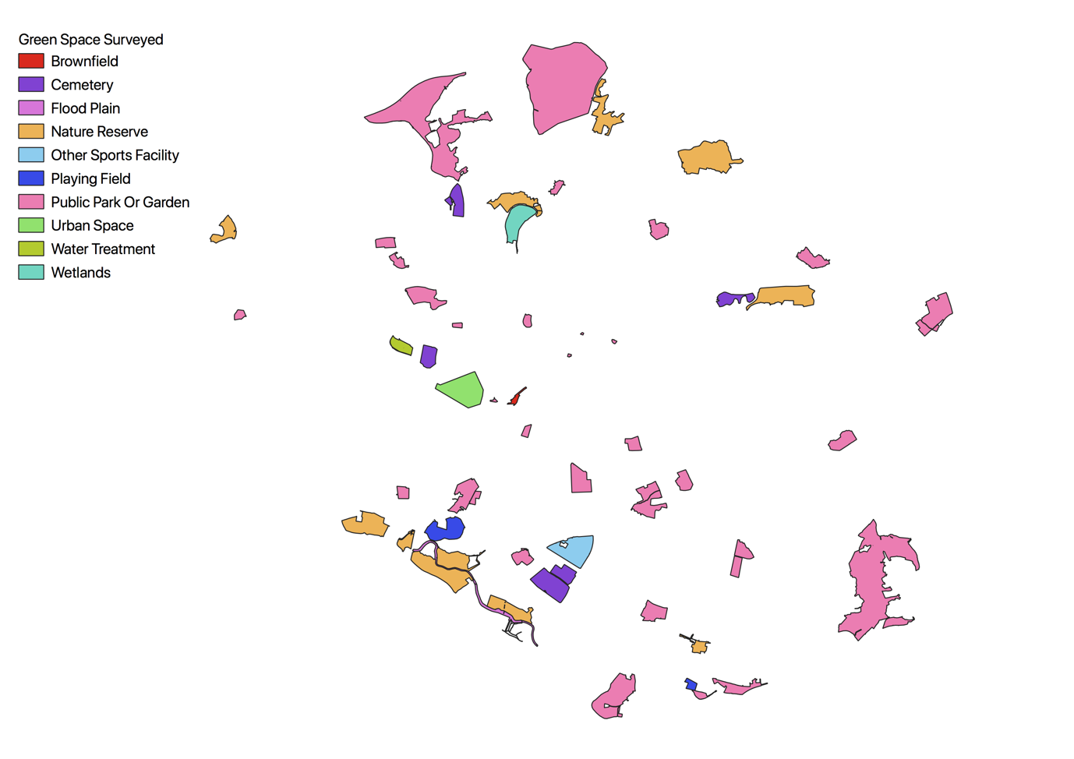

**Data Analysis**

The Shannon index was calculated for each site for the cavity-nesting birds found excluding parakeets. A Mann-Whitney U test was done to test parakeet presence against the this Shannon index. The test showed there was a significant difference in the Shannon index of cavity-nesting birds between sites with parakeets (mean±sd; 0.99±0.40) and sites without parakeets (mean±sd; 0.64±0.47) (p = 0.013).

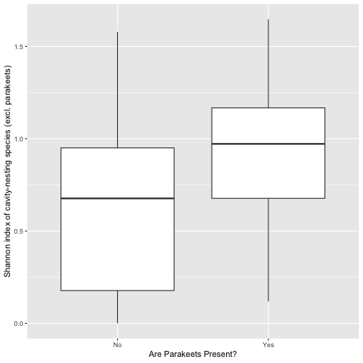

The species richness of each site was also calculated for cavity-nesting birds excluding parakeets. A Spearmans test was done to test correlation between the number of parakeets and this species richness. The test showed there is a positive correlation between the number of parakeets and the species richness of a site (n = 56, p < 0.01, rho = 0.53).

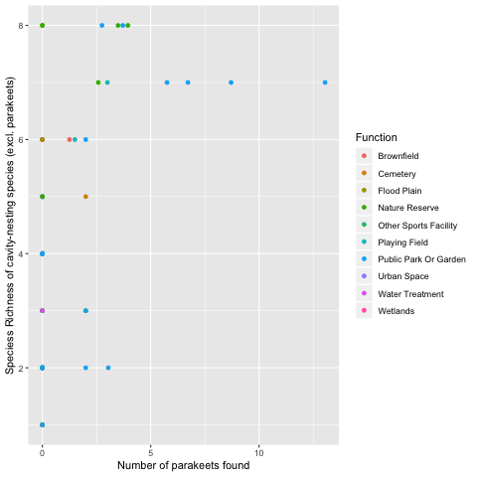

An NMDS was created using the cavity-nesting birds abundance excluding parakeets. This showed that the cavity-nesting birds community with parakeets was a subset of the communities without parakeets. An Analysis of Similarity was performed on the same data and this found that the composition difference was not significant (ANOSIM statistic R = 0.09076, p = 0.976).

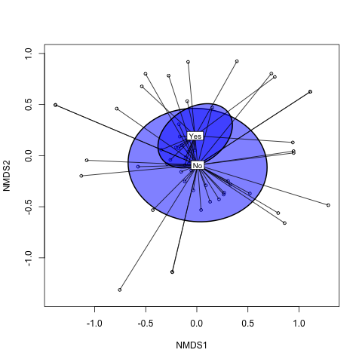

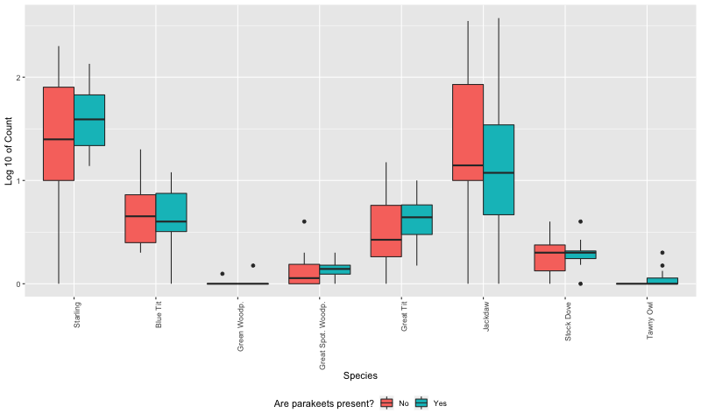

**Effect Size**

[Hernández-Brito, 2018] surveyed a single park from 1992 to 2017 to record the impact of parakeets on noctules, this created 25 years of data.

[Strubbe, 2007] surveyed 44 different sites across the Brussels region when a negative correlation was found between nuthatch and parakeet numbers.

[Newson, 2011] surveyed 180 sites across London when no negative correlation was found between parakeet numbers and other cavity-nesting species.

The 56 sites in Manchester are not as numerous as the number of sites from the London survey, however, they are in line with the two other surveys.

A power analysis was done for the correlation test which showed a power of 99% for the 56 sites with a significance level of 0.05 and the calculated rho of 0.53.

**Bibliography**

Hernández-Brito, D. (2014) 'Crowding in the City: Losing and Winning Competitors of an Invasive Bird.', PLOS ONE, 9(6) p. e100593.

Hernández-Brito, D. (2018) 'Nest-site competition and killing by invasive parakeets cause the decline of a threatened bat population.', Royal Society Open Science, 5(5), p. 172477.

Newson, S. E. (2011) 'Evaluating the population-level impact of an invasive species, Ring-necked Parakeet *Psittacula krameri*, on native avifauna.' Ibis, 153(3), pp. 509-516.

Nielsen, A. B. (2014) 'Species richness in urban parks and its drivers: A review of empirical evidence.', 17(1), pp.305-327.

Orchan, Y. (2013) 'The complex interaction network among multiple invasive bird species in a cavity-nesting community.', 15(2), pp. 429-445.

Lord, A. M. (2014) ‘Experimental evidence of impacts of an invasive parakeet on foraging behavior of native birds’, Behavioral Ecology, Volume 25, Issue 3, 1, Pages 582–590

Pârâu, L. G. (2016) ‘Rose-ringed Parakeet *Psittacula krameri* Populations and Numbers in Europe: A Complete Overview’, The Open Ornithology Journal, Volume 9

Strubbe, D. (2007) 'Invasive ring-necked parakeets *Psittacula krameri* in Belgium: habitat selection and impact on native birds.', Ecography, 30(4), pp. 578-588.