Student Name: Moegamat Thawhir Jakoet Student Number: 212087266 Group: 3A

1. <http://github.com/JakoetTH>

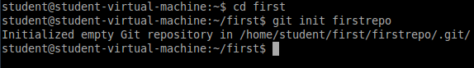

i.

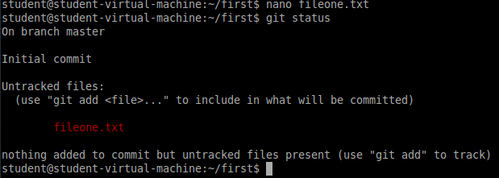

ii.

The file has been created but is untracked, it is shown in red.

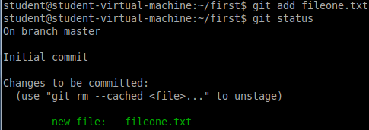iii.

The file is now tracked/staged.

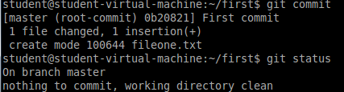iv.

The file has now been committed and is in the git repository.

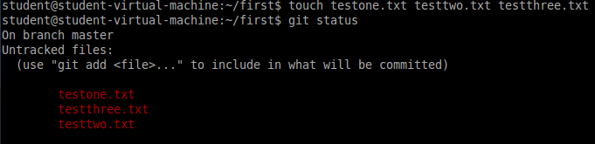v.

These files are untracked and will not be added to the repository if you use the git commit command.

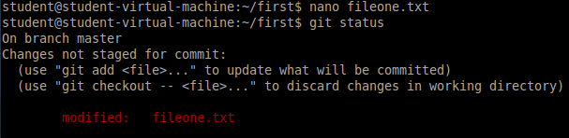vi.

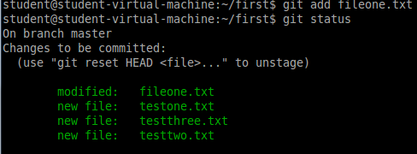

vii.

The files are now staged and will be added to the repository on the next commit.

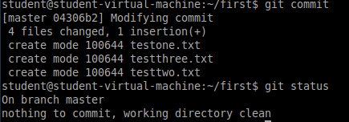viii.

ix.

x.

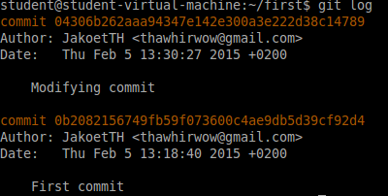

xi.

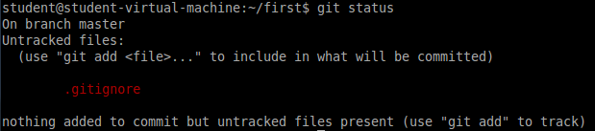

xii.

testthree.txt has been removed and is now considered as an untracked file.

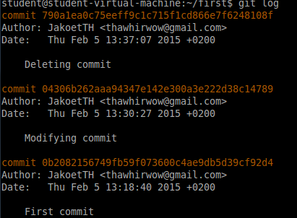 xiii.

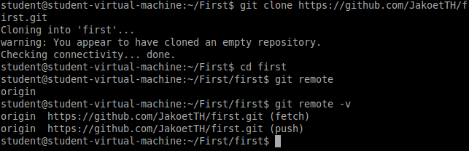3