

Career Development and Student Internship Services Office

CHECKLIST OF DOCUMENTARY REQUIREMENTS

Name of Intern: ELJOHN TRISTAN C. DEL ROSARIO Course/Yr.&Section: BSIT 4A

Age: 22 Gender: MALE

Contact #: 09998477658 Email Add: tristan123delrosario@gmail.com

Face-to-Face Internship

Full Address of HTE: 4th Floor BJS Bldg.1869 P. Domingo St.Brgy Kasilawan, Makati, Philippines,1204

**Directions**: Kindly tick the box that has fully accomplished.

(Please note that non-compliance to any of the requirements will deter your deployment).

* Approved work plan/training program
* BulSU Medical Pre-Internship Interview (*to be coordinated with the University Infirmary)*
* BulSU Psycho-emotional Health Questionnaire Form (Form C) *(to be coordinated with the University Guidance Counseling Services Center)*
* Notarized Consent of Parent/Guardian

I certify that the above documents are correct and accomplished as part of the documentary requirements needed for the Face-to-Face Internship.

**ELJOHN TRISTAN C. DEL ROSARIO**

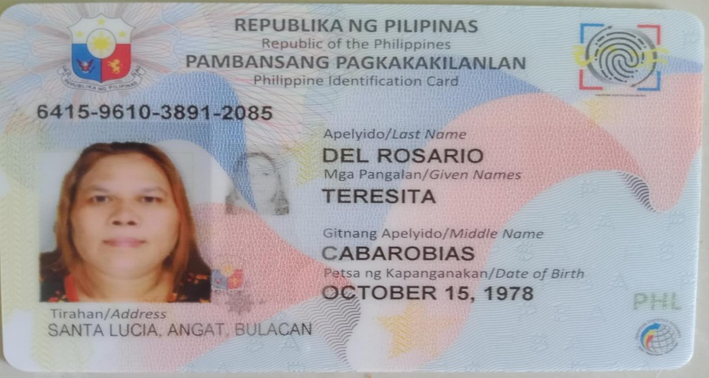 **Intern**

**TERESITA C. DEL ROSARIO**

**Guardian**

Certified true by:

LYN M. DALISAYMO, MIT

**Faculty Handling Internship**



[cardsis@bulsu.edu.ph](mailto:cardsis@bulsu.edu.ph) | (044) 919-7800 loc. 1042 Main Campus – Roxas Hall, Groundfloor