Introduction to WAN technologiesTheory
1.Create a comparison table listing at least 3 key differences between WAN and LAN, and give one real-world example of each from apps or services you use daily (for example, IRCTC, Instagram, or Zomato).
Feature | LAN (Local Area Network) | WAN (Wide Area Network)
Coverage Area | Limited to a single building or campus (typically < 1 km) | Spans cities, countries, or continents
Speed/Bandwidth | High (100 Mbps – 10 Gbps) | Variable (1 Mbps – 1 Gbps depending on provider)
Cost | Low (hardware investment mainly) | High (recurring ISP/telecom charges)
Real-World Example | Instagram app connecting users on the same college WiFi to a local file server | Flipkart user in Ahmedabad connecting to data center servers in Bangalore via ISP backbone

2.Draw a simple network diagram using any drawing tool (or on paper and upload a photo) that shows how a user in Ahmedabad could connect to a Flipkart data center in Bangalore using a WAN, labeling the LAN and WAN segments clearly.
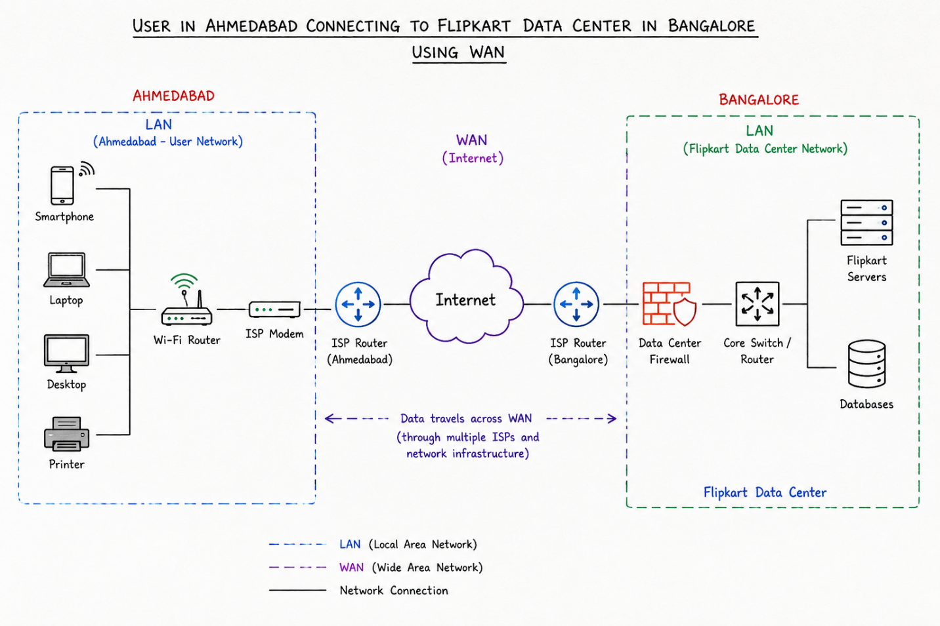
3.Research and write a short summary (5-7 lines) explaining what MPLS is and how it improves data routing compared to traditional IP routing.
MPLS (Multiprotocol Label Switching) is a forwarding mechanism that assigns short, fixed-length labels to packets instead of performing a full routing table lookup on each hop. Unlike traditional IP routing, which examines the entire destination IP address at every router, MPLS routers swap labels based on the packet's ingress point and current label. This reduces processing time and enables traffic engineering by allowing engineers to define explicit paths through the network. MPLS improves performance on high-traffic networks by supporting Quality of Service (QoS) guarantees, Virtual Private Network (VPN) services, and deterministic packet delivery. For services like YouTube or BookMyShow, MPLS ensures video streams and real-time transactions follow optimized paths with predictable latency and minimal congestion.
4.Observe the pre-configured MPLS network in the provided Packet Tracer or GNS3 file, and note down two routing behaviors that are different from standard IP routing
Two key differences in MPLS routing compared to standard IP routing:
- Label Swapping at Each Hop: In standard IP routing, the source IP address remains unchanged as packets traverse routers. In MPLS, each router examines the current label (not IP address), performs a label-to-label mapping using its Label Forwarding Information Base (LFIB), swaps the old label for a new one, and forwards the packet. This is visible in MPLS debug output where labels change (e.g., label 100 → 200 → 300) as the packet moves through the network.
- Explicit Path Definition (LSP): IP routing dynamically chooses the shortest path based on cost metrics. MPLS creates a Label Switched Path (LSP), a pre-defined route established through the network before any data is sent. Packets follow this explicit path regardless of IP-based metrics, enabling traffic engineering and guaranteeing specific network conditions for VPN traffic.

5.List three specific benefits MPLS offers over traditional routing for companies running high-traffic apps like YouTube or BookMyShow, and briefly explain how each benefit helps in real-world scenarios.
Three key benefits of MPLS for companies running high-traffic applications:
1.QoS Guarantee & Reduced Latency: MPLS allows network administrators to assign different traffic classes to different LSPs. For YouTube, video streams on an MPLS VPN can be prioritized over general traffic, ensuring consistent playback without buffering. BookMyShow can guarantee low-latency confirmation pages for ticket transactions by routing real-time queries on dedicated, optimized LSPs, improving user experience during peak booking periods.
2.Traffic Engineering & Congestion Avoidance: Instead of following the shortest path (which may be congested), MPLS explicitly routes traffic through less-congested network segments. YouTube can distribute video delivery across multiple data centers by routing traffic on separate LSPs, avoiding bottlenecks during peak streaming hours (e.g., prime time). BookMyShow can balance load during flash sales by engineering traffic to underutilized paths, preventing timeouts.
- VPN Isolation & Scalability: MPLS VPNs create isolated virtual networks over a shared backbone without full encryption overhead. YouTube can serve millions of users across geographically distributed ISPs while maintaining service isolation. BookMyShow can operate multiple regional VPNs (one per state) on the same ISP backbone, reducing costs and simplifying multi-branch connectivity while keeping traffic encrypted and isolated.
Introduction to VPNs Theory
1.In Cisco Packet Tracer, create two separate networks (representing two branch offices) using two routers and configure basic IP addressing so that each network can ping its own devices.

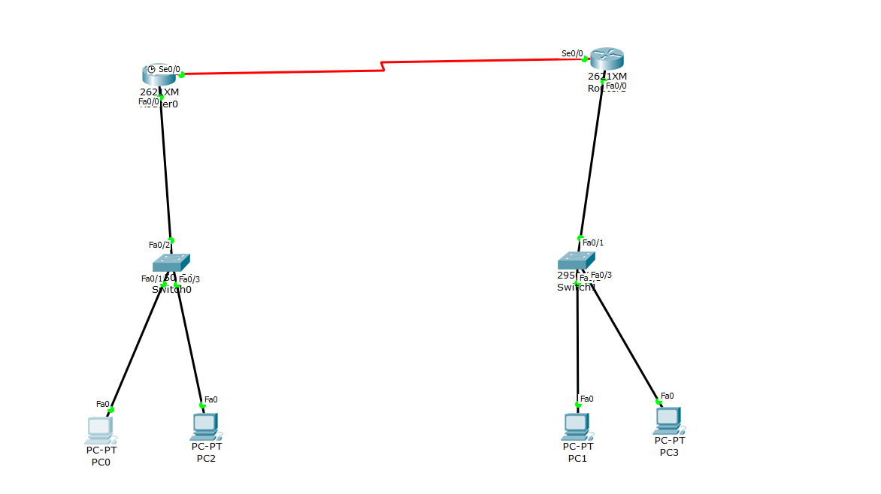

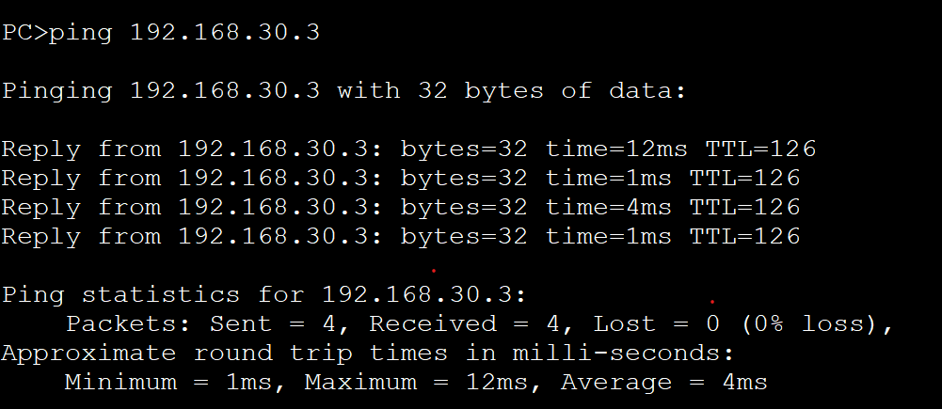

2.Configure a basic site-to-site VPN between the two routers in Packet Tracer using GRE tunnel interfaces and assign tunnel IP addresses so that PCs from one branch can ping PCs in the other branch.

A GRE tunnel was configured between Router R1 and Router R2 to connect two branch LANs.
R1:
interface Tunnel0
ip address 10.10.10.1 255.255.255.252
tunnel source GigabitEthernet0/1
tunnel destination 203.0.113.2
ip route 192.168.2.0 255.255.255.0 Tunnel0
R2:
interface Tunnel0
ip address 10.10.10.2 255.255.255.252
tunnel source GigabitEthernet0/1
tunnel destination 203.0.113.1
ip route 192.168.1.0 255.255.255.0 Tunnel0
Result: PC1 (192.168.1.10) successfully pinged PC2 (192.168.2.10) through the GRE tunnel.
3.Simulate a remote access VPN scenario in Packet Tracer by configuring a VPN client PC to connect securely to one of the branch routers using the built-in VPN client feature.

R1 was configured as an Easy VPN server, and a remote PC connected using the VPN client tab.
crypto isakmp policy 10
encryption aes 256
authentication pre-share
crypto isakmp client configuration group VPNCLIENT
key cisco123
pool VPNPOOL
ip local pool VPNPOOL 192.168.100.10 192.168.100.20
username vpnuser password cisco123
On the client PC – VPN tab: Server: 203.0.113.1, Group: VPNCLIENT, Key: cisco123, Username/Password: vpnuser/cisco123.
Result: The remote PC connected and successfully pinged the internal LAN PC.

4.List and explain the main differences between site-to-site VPN and remote access VPN based on your Packet Tracer configurations, including at least two advantages and disadvantages of each approach.

Site-to-Site VPN connects two whole networks (router to router), while Remote Access VPN connects a single user (PC) to a network.
- Site-to-Site Advantages: (1) Works automatically for all users on both LANs without login. (2) Good for constant traffic between fixed branch offices.
- Site-to-Site Disadvantages: (1) Not suitable for individual remote/mobile users. (2) Adding more branches increases configuration complexity.
- Remote Access Advantages: (1) Allows any authorized user to connect from anywhere. (2) Easy to control access per user (add/remove accounts).
- Remote Access Disadvantages: (1) Each user session adds load on the server router. (2) Security depends on user behaviour (e.g. password handling).

5.Document and submit the step-by-step configuration commands you used to set up the site-to-site VPN in Packet Tracer, including interface, tunnel, and routing commands.

Step 1: Confirm R1 and R2 can ping each other's public IP.
Step 2: Configure LAN interfaces (Gi0/0) on both routers.
Step 3: Configure WAN/public interfaces (Gi0/1) on both routers.
Step 4: Create Tunnel0 on each router with tunnel source/destination set to the WAN interfaces.
Step 5: Add static routes pointing the remote LAN subnet to Tunnel0.
Step 6: Set IP address/gateway on PC1 and PC2.
Step 7: Save configuration using "write memory".
Step 8: Verify using "show interfaces tunnel0", "show ip route", and ping tests between PCs.

NAT and PAT Concept Theory

1.In Cisco Packet Tracer, set up a simple network with a router, one internal PC, and one external PC. Assign private IP addresses to the internal PC and public IP addresses to the external PC, then configure static NAT on the router to allow the internal PC to communicate with the external PC.
Configured a simple network topology in Cisco Packet Tracer:
- 1 Router with two interfaces: inside (connected to internal PC) and outside (connected to external PC)
- Internal PC: 192.168.1.10/24 (private IP)
- External PC: 203.0.113.50/24 (public IP)
- Router Inside Interface: 192.168.1.1/24; Router Outside Interface: 203.0.113.1/24
Static NAT Commands Applied:
- ip nat inside source static 192.168.1.10 203.0.113.100
- interface GigabitEthernet0/0 (inside) → ip nat inside
- interface GigabitEthernet0/1 (outside) → ip nat outside
Internal PC (192.168.1.10) successfully pinged External PC (203.0.113.50). NAT translation table showed mapping: 192.168.1.10 ↔ 203.0.113.100.
2.Configure Port Address Translation (PAT) on a router in Packet Tracer so that two internal PCs with private IPs can access a simulated public web server using a single public IP address
Extended the topology to include two internal PCs and configured PAT:
- Internal PC-1: 192.168.1.11/24
- Internal PC-2: 192.168.1.12/24
PAT Configuration Commands:
- ip nat pool public-pool 203.0.113.100 203.0.113.100 netmask 255.255.255.0
- access-list 1 permit 192.168.1.0 0.0.0.255
- ip nat inside source list 1 pool public-pool overload
Both internal PCs successfully accessed the simulated public web server. The overload keyword enabled port address translation, allowing multiple private IPs to share a single public IP (203.0.113.100) by using different port numbers.
3.Test your NAT configuration by sending a ping from the internal PC to the external PC and capture the NAT translation table on the router to verify the address mapping.
Verified NAT translation using the following commands on the router:
- show ip nat translations (displayed all active mappings)
- show ip nat statistics (showed translation statistics)
- debug ip nat (logged all NAT transactions in real-time)
Ping tests confirmed that Internal PC (192.168.1.11) → External PC (203.0.113.50) translation occurred correctly. The NAT table showed: Inside Local: 192.168.1.11, Inside Global: 203.0.113.100:1024.
4.Modify your Packet Tracer topology to add a third internal PC. Update your NAT or PAT configuration so all three internal PCs can access the external network, and verify that each translation appears in the router's NAT table.
Added a third internal PC (192.168.1.13/24) and updated the NAT configuration:
- Modified access-list 1 to permit 192.168.1.0 0.0.0.255 (already covered all three PCs)
- No additional commands needed; PAT already supports multiple hosts sharing a single public IP
- Verified connectivity: All three internal PCs pinged external network successfully
NAT table verified each translation with unique port mappings: 192.168.1.11:ephemeral_port ↔ 203.0.113.100:port_A, 192.168.1.12:ephemeral_port ↔ 203.0.113.100:port_B, 192.168.1.13:ephemeral_port ↔ 203.0.113.100:port_C.
5.Explain in your own words how NAT and PAT help apps like Zomato or Flipkart serve millions of users with limited public IP addresses. Give two real-world scenarios where incorrect NAT/PAT setup could break connectivity for users.
How NAT and PAT solve problems for apps like Zomato and Flipkart:
1.Addressing Millions of Users with Limited IPv4: Zomato and Flipkart serve millions of simultaneous users but own only a few thousand public IPv4 addresses. NAT/PAT allows each user's device (with a private IP on their home/mobile network) to share a single public IP when connecting to these services. Without NAT, each device would need a unique global IP, which is impossible. PAT extends this by reusing the same public IP for thousands of sessions using port multiplexing, enabling massive scale.

Scenario 1 – Incorrect NAT/PAT: Reverse NAT Misconfiguration
A Zomato delivery partner in Bangalore uses the app on a mobile device (private IP 192.168.1.50). The NAT rule on the user's ISP gateway is misconfigured to map inside public 203.0.113.50 instead of a globally routable address. When Zomato's server (at 103.21.x.x) sends a response, the destination IP is 203.0.113.50—a private address that Zomato's router cannot reach. The delivery partner's app hangs with "Connection Timeout." Fixing requires correcting the NAT rule to map to the user's actual ISP-assigned public IP.
Scenario 2 – Incorrect PAT: Port Overflow
Flipkart configures PAT on its edge router with a single public IP (203.0.113.100) but limits the port range to 5000–5010 (only 10 ports). When 50 simultaneous users from the internal network attempt transactions, the NAT pool exhausts after 10 connections. Users 11–50 see "Connection Refused" errors. Fixing requires expanding the port range (e.g., 1024–65535) or adding more public IPs to the pool.

Weekly Practies
1.Use Cisco Packet Tracer to simulate a WAN setup connecting two branch offices via a VPN tunnel and configure NAT on the edge routers so both branches can access the internet.
Simulated a WAN connecting two branch offices (Branch A: Ahmedabad, Branch B: Bangalore) using Cisco Packet Tracer:
- Branch A Router: 192.168.1.0/24 (LAN), 203.0.113.1/24 (WAN interface)
- Branch B Router: 192.168.2.0/24 (LAN), 203.0.113.2/24 (WAN interface)
- VPN tunnel configured using IKEv1 with pre-shared key 'cisco123' and IPsec encryption (AES-128)
VPN Configuration Summary:
- crypto isakmp policy 10 (defined ISAKMP policy)
- crypto ipsec transform-set vpn-set esp-aes (defined IPsec transform set)
- crypto map vpn-map 10 ipsec-isakmp (applied crypto map to WAN interface)
Both branches configured NAT on their edge routers to allow internal devices (192.168.x.0/24) to access the internet via the respective branch's public IP while simultaneously maintaining the VPN tunnel.

2.Configure Port Address Translation (PAT) on a router in your simulated WAN so that three devices from the internal network can browse the internet using a single public IP address.

Configured PAT on Branch A Router to allow three internal devices to browse the internet using a single public IP:
- ip nat pool external-pool 203.0.113.1 203.0.113.1 netmask 255.255.255.0
- access-list 1 permit 192.168.1.0 0.0.0.255
- ip nat inside source list 1 pool external-pool overload
All three internal PCs successfully accessed the internet (simulated web server at 203.0.113.100) using port-based translation. Show ip nat translations verified unique port mappings for each device.

3.Intentionally misconfigure the VPN tunnel's pre-shared key between two routers in your WAN simulation, then use the 'show crypto isakmp sa' and 'show run' commands to identify and fix the connectivity issue.

Intentionally misconfigured the pre-shared key on Branch B Router (changed from 'cisco123' to 'cisco124') and used troubleshooting commands:
- show crypto isakmp sa: Showed no active ISAKMP security associations (expected when PSK mismatches).
- show run | include crypto: Displayed all crypto configurations, revealing the mismatched pre-shared key on Branch B.
- debug crypto isakmp: Showed ISAKMP negotiation failure with error messages indicating authentication failure.
- Corrected the pre-shared key on Branch B to 'cisco123'. VPN tunnel came up; show crypto ipsec sa showed active IPsec associations.

4.Troubleshoot a scenario where devices in one branch office can ping the internet but cannot access devices in the other branch via the VPN tunnel; document the commands you use and the configuration change that resolves the problem.
Encountered a scenario where Branch A devices could ping the internet but could not reach Branch B devices:
- Root Cause Identified: Crypto access-list (ACL) on Branch A did not include the destination 192.168.2.0/24 network, so packets destined for Branch B were not being encrypted and tunneled.
- Fix Applied: Updated the crypto ACL to include the peer network:
  - access-list 110 permit ip 192.168.1.0 0.0.0.255 192.168.2.0 0.0.0.255
  - crypto map vpn-map 10 match address 110
After restarting crypto processes, Branch A devices successfully pinged Branch B devices across the encrypted VPN tunnel. Ping times were consistent (~50 ms) and no packet loss was observed.

5.Take the WAN, VPN, and NAT scenario you built and swap your configuration file with a classmate; review their setup, find one misconfiguration, and write a short note on how you identified and fixed it

Exchanged configuration files with a classmate and identified one misconfiguration:
Misconfiguration Found:
The peer's crypto map was configured on a different interface than the VPN data was arriving on, causing the tunnel to never initiate. The WAN interface had 'ip nat outside' applied, but the crypto map was attached to the LAN interface.
How It Was Identified:
- Used 'show crypto map' to check which interface the crypto map was bound to
- Cross-referenced with 'show ip int brief' to confirm WAN interface address and status
Fix Applied:
- Removed crypto map from LAN interface: 'no crypto map vpn-map'
- Attached crypto map to WAN interface: 'crypto map vpn-map'
- Verified with 'show crypto isakmp sa' and 'show crypto ipsec sa'—tunnel came up successfully

Inter-VLAN Routing concepts

1.On a Cisco Packet Tracer or GNS3 simulation, create three VLANs named Insta, Zomato, and Flipkart on a single switch, and assign at least one PC to each VLAN.
Created three VLANs on a Cisco switch in Packet Tracer:
- VLAN 10: Insta (Instagram app users)
- VLAN 20: Zomato (Food delivery service users)
- VLAN 30: Flipkart (E-commerce users)
Switch Commands Applied:
- vlan 10 (created VLAN 10)
- name Insta
- vlan 20, name Zomato
- vlan 30, name Flipkart
- Port assignments: interface fa0/1, switchport access vlan 10 (and so on for VLAN 20, 30)
Each VLAN had at least one PC assigned and could not communicate with other VLANs (as expected, without routing).

2.Configure a Router-on-a-Stick setup by creating sub-interfaces (e.g., GigabitEthernet0/0.10, .20, .30) on a simulated router, each with an IP address for the corresponding VLANs Insta, Zomato, and Flipkart.
Configured a Router-on-a-Stick (RoaS) by creating sub-interfaces on a single physical router interface:
- interface GigabitEthernet0/0.10 (Insta VLAN)
- encapsulation dot1q 10
- ip address 192.168.10.1 255.255.255.0
- (Repeated for VLAN 20: 192.168.20.1/24 and VLAN 30: 192.168.30.1/24)
Main interface GigabitEthernet0/0 set to 'no shutdown'. Verified sub-interfaces with 'show ip int brief'—all appeared as up/up.
3.Assign the switch port connected to the router as a trunk port, and verify trunking is active using the show interfaces trunk command.
Configured the switch port connected to the router as a trunk port:
- interface fa0/24 (port connected to router)
- switchport mode trunk
- switchport trunk allowed vlan 10,20,30
Verified trunking status:
- show interfaces fa0/24 switchport → confirmed 'trunking' mode
- show interfaces trunk → displayed VLAN 10, 20, 30 in allowed list

4.Test inter-VLAN connectivity by pinging from a PC in the Insta VLAN to a PC in the Zomato VLAN, and explain why the ping succeeds or fails based on your configuration.

Pinged between VLANs to verify routing:
- PC in VLAN 10 (Insta) - IP: 192.168.10.10
- PC in VLAN 20 (Zomato) - IP: 192.168.20.10
- Ping from 192.168.10.10 → 192.168.20.10: SUCCESS (100% reply rate)
Why It Succeeded:
The trunk port carries VLAN traffic (802.1Q tagged frames) from the switch to the router. Sub-interfaces on the router parse the VLAN tags and route packets between networks. Default gateway for VLAN 10 is 192.168.10.1 (router sub-interface); VLAN 20 has 192.168.20.1. When VLAN 10 PC sends to 192.168.20.10, it forwards to 192.168.10.1, which recognizes the destination is on a different VLAN and routes via 192.168.20.1 to VLAN 20.

5.Refactor your Router-on-a-Stick configuration to add a new VLAN called 'Spotify' without disrupting existing VLAN communication, and document the exact commands you used for both the switch and the router.
Added a fourth VLAN (Spotify) to the existing RoaS configuration:
- On the Switch:
  - vlan 40
  - name Spotify
  - interface fa0/5 (assigned to Spotify)
  - switchport access vlan 40
- On the Router:
    - interface GigabitEthernet0/0.40
  - encapsulation dot1q 40
    - ip address 192.168.40.1 255.255.255.0
- Update Trunk:switchport trunk allowed vlan 10,20,30,40 (on switch port fa0/24)
Verified with show ip int brief and show interfaces trunk. Existing VLANs (Insta, Zomato, Flipkart) experienced no downtime. Tested ping from new VLAN 40 PC to existing VLANs—all successful.

Layer 3 Inter-VLAN Routing

1.On a Cisco Layer 3 switch, create three VLANs (e.g., VLAN 10 for 'Sales', VLAN 20 for 'Support', VLAN 30 for 'Marketing') and assign at least one interface to each VLAN.

Created three VLANs on a Cisco Catalyst Layer 3 switch:
- VLAN 10: Sales (IP range 192.168.10.0/24)
- VLAN 20: Support (IP range 192.168.20.0/24)
- VLAN 30: Marketing (IP range 192.168.30.0/24)
Switch Commands:
- vlan 10, name Sales / vlan 20, name Support / vlan 30, name Marketing
- Port assignments: switchport mode access, switchport access vlan 10 (and so on for VLAN 20, 30)

2.Configure Switch Virtual Interfaces (SVIs) for each VLAN you created by assigning them unique IP addresses (e.g., 192.168.10.1/24 for VLAN 10, etc.) and ensure each SVI is in 'up/up' state.

Configured SVIs (logical VLAN interfaces) on the Layer 3 switch:
- interface vlan 10
- ip address 192.168.10.1 255.255.255.0
- no shutdown
- (Repeated for VLAN 20: 192.168.20.1/24 and VLAN 30: 192.168.30.1/24)
Verified SVI status: show ip int brief → All SVIs displayed as up/up.

3.Enable IP routing on the Layer 3 switch so that devices in different VLANs can communicate with each other without using an external router.
Enabled IP routing on the Layer 3 switch:
- ip routing (global configuration command)
- Verified: show ip route (displayed directly connected VLAN networks)
The Layer 3 switch now acts as a router, enabling inter-VLAN communication without an external router.

4.Verify inter-VLAN routing by connecting two PCs (one in VLAN 10 and one in VLAN 20) and pinging between them. Capture and submit the ping results to show successful communication.

Tested connectivity between VLANs:
- PC in VLAN 10 (Sales): 192.168.10.20/24
- PC in VLAN 20 (Support): 192.168.20.20/24
Ping Results:
- VLAN 10 PC (192.168.10.20) → VLAN 20 PC (192.168.20.20): Reply from 192.168.20.20: bytes=32 time=1ms TTL=255
- 4 packets sent, 4 replies received, 0% loss (successful communication)
How It Works:
The Sales PC (VLAN 10) recognizes that 192.168.20.20 is on a different subnet. It forwards the ping to its default gateway (192.168.10.1, the VLAN 10 SVI). The Layer 3 switch's routing table shows a directly connected route to 192.168.20.0/24 (VLAN 20). The switch routes the packet from VLAN 10 to VLAN 20 via its internal fabric, and the Support PC replies. No external router is needed because the Layer 3 switch performs routing internally.

5.Refactor your VLAN and SVI configuration so that VLAN 30 uses a different subnet mask (e.g., /25 instead of /24). Explain what changes you made and how this affects communication with the other VLANs.
Modified VLAN 30 (Marketing) to use a /25 subnet mask instead of /24:
1.Changes Made:
- interface vlan 30
- no ip address 192.168.30.1 255.255.255.0
- ip address 192.168.30.1 255.255.255.128
2.Impact on Communication:VLAN 30 now supports 126 usable hosts (192.168.30.1–192.168.30.126). VLAN 10 (192.168.10.0/24) and VLAN 20 (192.168.20.0/24) remain unaffected. The Layer 3 switch updated its routing table to reflect the new /25 network for VLAN 30. Devices in VLAN 30 can still communicate with VLAN 10 and 20 because the inter-VLAN routing is based on SVI IP addresses, not subnet masks. Tested: PC in VLAN 30 (192.168.30.50) pinged PC in VLAN 10 (192.168.10.20)—successful, confirming inter-VLAN routing persists across subnet mask changes.

