A. Topic Introduction to WAN Technology
1.Create a table comparing at least three types of WAN connections (such as leased line, DSL, and MPLS) with columns for speed, cost, and typical use cases.
WAN Type | Speed | Cost | Typical Use Cases
Leased Line | 64 Kbps – 10 Gbps (dedicated, symmetric) | High — fixed monthly rent + distance-based charges | Enterprises needing guaranteed bandwidth; data-center interconnects; voice/video links
DSL | 1 – 100 Mbps (asymmetric, varies with distance from exchange) | Low to moderate | Home broadband; small offices; branch internet access
MPLS | 1 Mbps – 10 Gbps | High — per-site + per-Mbps pricing, but efficient for multi-site | Multi-site enterprises; VoIP and real-time apps needing QoS; bank/retail chain WANs
2.Draw a labeled diagram (on paper or using any drawing tool) showing how a CSU/DSU connects a router to a WAN service provider, and explain the role of each device in 2-3 sentences
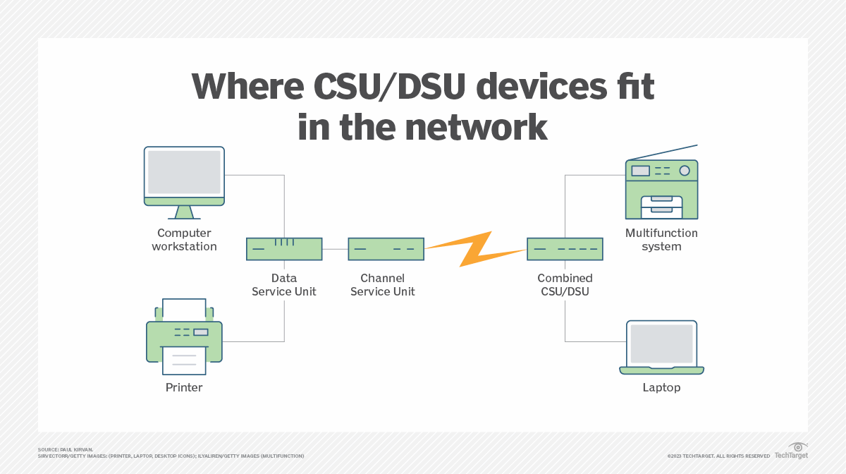
The CSU (Channel Service Unit) terminates the digital line from the provider, provides line conditioning, and protects the circuit from electrical surges. The DSU (Data Service Unit) converts data between the router's LAN-side frame format and the provider's WAN line format, and manages timing/clocking between the router and the carrier's line, sitting directly between the router's serial interface and the local loop.

3.List three real-world examples of popular apps or services (like IRCTC, WhatsApp, or Zomato) that rely on WAN connections, and briefly describe how WAN enables their functionality.

- IRCTC: Connects the Passenger Reservation System (PRS) data centers across India over WAN, so a user in any city can book/cancel train tickets in real time.
- WhatsApp: Uses the WAN (internet backbone) to relay messages, calls, and media between users' devices via geographically distributed data centers.
- Zomato: Uses WAN links to connect restaurant-partner apps, delivery-partner apps, and customer apps to central cloud servers for real-time order and delivery tracking.

4.Research online and find an image or datasheet of a physical WAN aggregator device used in enterprise networks. Paste the image or link, and write two key features of that device
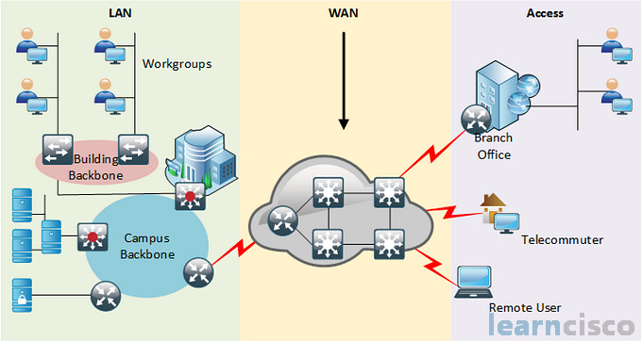
Datasheet link: https://www.cisco.com/c/en/us/products/collateral/routers/asr-1000-series-aggregation-services-routers/datasheet-c78-731632.html
Key features:
- Aggregates multiple WAN connections and network services (encryption, traffic management) and forwards them at line speeds from 2.5 to 200 Gbps, with hardware and software redundancy for high availability.
- Supports Cisco SD-WAN on the same hardware via IOS-XE, enabling centralized, secure, and application-aware management of all aggregated WAN links from one platform.

B. WAN Authentication Protocols
1.Draw a simple network diagram showing two routers connected over a WAN link and label where authentication is needed to prevent unauthorized access.
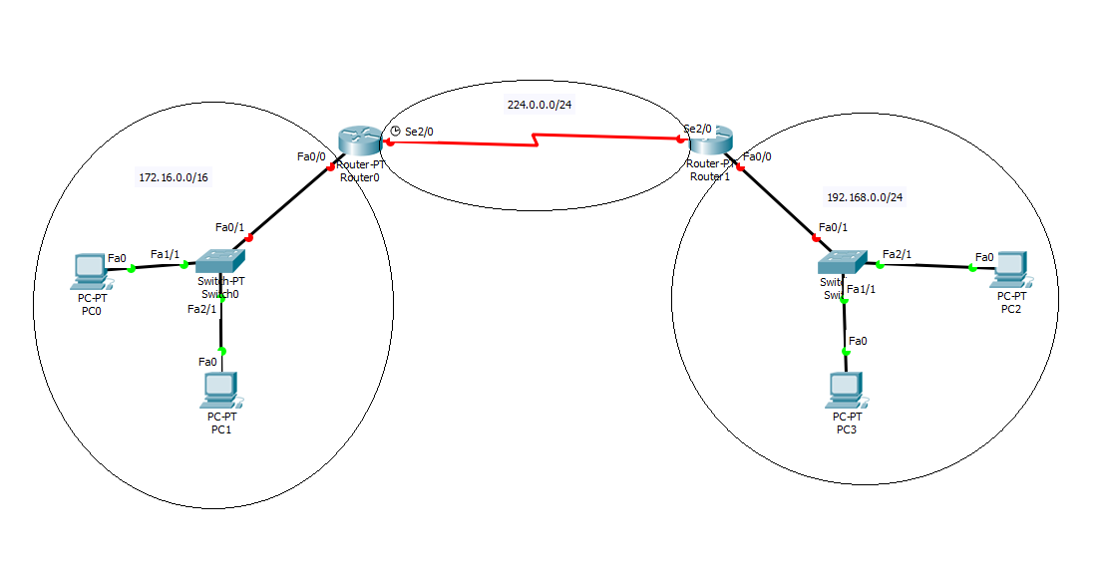
2.Configure a sample HDLC WAN connection between two routers using Packet Tracer or any network simulator, and explain why HDLC does not provide authentication.
Router(config)# interface serial0/0/0
Router(config-if)# encapsulation hdlc
Router(config-if)# clock rate 64000 (on DCE end only)
Router(config-if)# no shutdown
HDLC is purely a framing protocol for error control and delimiting frames — its header has no field for a username, password, or challenge exchange. Because it never asks the far-end router to prove its identity, any device with matching encapsulation and clocking can connect, so HDLC offers no built-in security against unauthorized routers.
3.Set up a PPP connection between two routers in Packet Tracer and enable PAP (Password Authentication Protocol) authentication. Show the configuration commands and explain what happens if the password is incorrect.
Router A (config)# interface serial0/0/0
Router A (config-if)# encapsulation ppp
Router A (config-if)# ppp authentication pap
Router A (config-if)# ppp pap sent-username R1 password cisco123

Router B (config)# username R1 password cisco123
Router B (config)# interface serial0/0/0
Router B (config-if)# encapsulation ppp
Router B (config-if)# ppp authentication pap
If the password is incorrect, PPP's LCP phase still completes, but the authentication phase fails: Router B replies with a PAP Authenticate-Nak, refuses to bring up the Network Control Protocol, and the line stays in an "up/down" state. A %LINEPROTO-5-UPDOWN error appears in the log, and no traffic passes until the correct credentials are configured.

4.Modify your PPP configuration to use CHAP (Challenge Handshake Authentication Protocol) instead of PAP, and describe one key difference in how CHAP improves security over PAP.
Router A (config)# username R2 password cisco123
Router A (config-if)# ppp authentication chap

Router B (config)# username R1 password cisco123
Router B (config-if)# ppp authentication chap
Key difference: PAP sends the username and password across the link in clear text once during setup, so it can be captured by anyone monitoring the line. CHAP never transmits the password at all — instead it uses a random challenge that the peer hashes (MD5) together with the shared secret, and only the hash result is sent back. This means the actual password never crosses the wire, and CHAP also re-challenges periodically during the session, making it far more resistant to eavesdropping and replay attacks.

5.Research and list two real-world scenarios (such as public WiFi login or mobile data authentication) where WAN authentication protocols like PAP, CHAP, or MS-CHAP are used, and explain why authentication is critical in each case.
- Public WiFi captive-portal login (mall/café/airport): the portal verifies a username/password (often PAP-style) before granting internet access — authentication prevents unauthorized users from freeloading on paid bandwidth.
- Mobile broadband / DSL dial-in sessions: ISPs use CHAP or MS-CHAP over PPP to verify a subscriber's identity before establishing the session — critical for accurate billing and to stop service theft by unauthorized devices.

C. AAA
1.Write a short scenario where a user tries to access a private WiFi network (like at a campus or airport) and describe how each of the three AAA functions—Authentication, Authorization, and Accounting—would apply step by step in this situation.
- Authentication: The user connects and enters their student ID/employee ID and password (or scans a QR code); the AAA server checks these credentials against its database to confirm the user is who they claim to be.
- Authorization: Once verified, the AAA server checks the user's role/profile and decides what they may access — e.g., a student gets internet + library portal access, while streaming/social media may be blocked, and staff get broader access.
- Accounting: The system logs the session start/end time, data volume used, and websites visited, which is later used for auditing, bandwidth management, or billing (e.g., at a paid airport hotspot).

2.Create a table comparing at least two different AAA deployment models (such as centralized vs distributed), listing three advantages and three disadvantages of each for a company like Zomato that handles sensitive user data.
Model | Advantages | Disadvantages
Centralized AAA | 1) Single, consistent security policy across all offices 2) Easier compliance auditing (one log source) 3) Faster to push updates/patches everywhere at once | 1) Single point of failure — outage affects all locations 2) Higher latency for offices far from the server 3) Can become a scaling bottleneck at high login volume
Distributed AAA | 1) No single point of failure — local outages don't affect other sites 2) Lower latency (authentication handled locally) 3) Scales better as new regional offices are added | 1) Harder to keep policies consistent across nodes 2) More complex to audit/monitor centrally 3) Higher management/maintenance overhead
3.Draw a simple network diagram (can be hand-drawn and photographed) showing how AAA servers are integrated into a typical enterprise network for user access control, labeling where Authentication, Authorization, and Accounting processes happen.
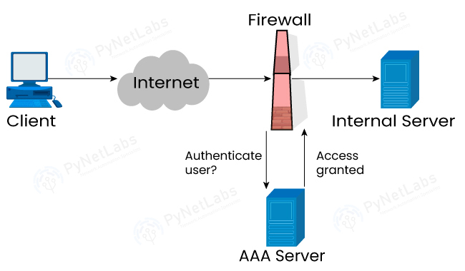

4.Pick any app you use daily (Instagram, Paytm, or Flipkart) and write a paragraph explaining how AAA concepts could be applied to secure user logins and actions within that app.
When you log in to Instagram, Authentication verifies your username/password (or 2FA/biometric); once verified, Authorization determines what you're allowed to do — a regular account can post, comment, and message, but only a verified business account can access ad and analytics dashboards; meanwhile Accounting runs quietly in the background, logging your login times, device/IP details, and actions for security monitoring, fraud detection, and ad-billing purposes.
5.Use ChatGPT or any AI tool to generate a sample AAA policy for a college WiFi network that restricts access to students only, allows certain websites, and logs all access attempts. Paste the generated policy and briefly explain how each AAA function is addressed.
Sample Policy:
- Authentication: Only users with a valid college ID (student_id@college.edu) and password verified via a RADIUS server may connect; personal devices require one-time MAC registration.
- Authorization: Students get access to academic portals, library databases, and general internet (HTTP/HTTPS); social media and streaming sites are blocked during class hours (9 AM–4 PM); faculty accounts get extended access including grade-management systems.
- Accounting: All login/logout times, data usage per user, and visited domains are logged for 90 days for security audits and bandwidth planning.
Authentication ensures only enrolled members can join the network; Authorization tailors access by role (student vs faculty); Accounting keeps a record trail that supports later investigation or troubleshooting.

D. RADIUS and TACACS+
1.Create a comparison table listing at least 4 key differences between RADIUS and TACACS+ features, focusing on protocol type, encryption, ports used, and command authorization.

Feature | RADIUS | TACACS+
Protocol type | Open IETF standard | Cisco proprietary
Transport | UDP (connectionless) | TCP (connection-oriented)
Ports used | 1812 (auth), 1813 (accounting) | 49
Encryption | Encrypts only the password in the Access-Request | Encrypts the entire packet body
Authentication vs Authorization | Combines authentication and authorization into one step | Separates authentication, authorization, and accounting — allows per-command authorization

2.Draw a simple flowchart or sequence diagram that illustrates the RADIUS authentication process for a user trying to log in to a Wi-Fi network (like at a coffee shop or college campus).
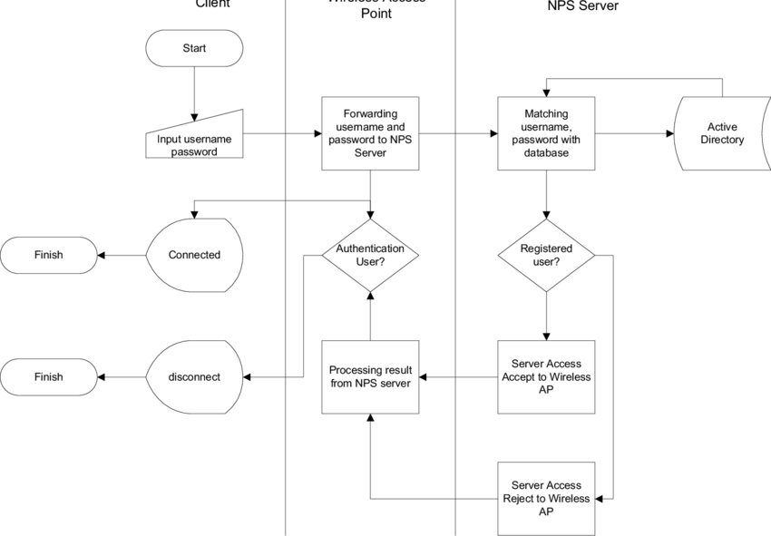
3.Describe a real-world scenario from any app you use (such as Zomato, Paytm, or IRCTC) where TACACS+ would be more suitable than RADIUS for managing admin access, and explain why.
For IRCTC's network operations team managing core routers and switches at its data centers, TACACS+ is preferable because it separates authorization from authentication, allowing granular command-level control — e.g., junior admins may run "show" commands, but only senior engineers are authorized for "configure terminal" or "reload." TACACS+ also encrypts the entire session (not just the password), which better protects sensitive infrastructure commands.
4.List two advantages and two disadvantages of using RADIUS for network authentication in a public hotspot (like those found in malls or airports).
Advantages:
- Open standard supported across virtually all vendors' access points and controllers, simplifying multi-vendor hotspot deployments.
- Lightweight UDP-based protocol handles large numbers of simultaneous login requests typical of malls/airports efficiently.
Disadvantages:
- Only the password is encrypted, not the full packet, making it less secure for handling sensitive data.
- Being connectionless (UDP), packet loss during peak congestion can cause authentication delays or failures.

5.Use ChatGPT or another AI tool to generate a sample TACACS+ configuration for a Cisco router, then review the output and highlight any commands you would modify for a college lab setup.
! Enable AAA
aaa new-model

! Create TACACS+ server
tacacs server TACACS-SERVER
address ipv4 192.168.1.100
key Cisco123

! Define TACACS+ server group
aaa group server tacacs+ TACACS-GROUP
server name TACACS-SERVER

! Authentication
aaa authentication login default group TACACS-GROUP local

! Authorization
aaa authorization exec default group TACACS-GROUP local

! Accounting
aaa accounting exec default start-stop group TACACS-GROUP

! Apply authentication to VTY lines
line vty 0 4
login authentication default
transport input ssh

! Create local backup user
username admin privilege 15 secret LabAdmin123
Changes for a college lab setup: replace the shared key with a strong, unique secret (not a guessable word); restrict the tacacs-server host address to the lab's private management VLAN only; keep "local" strictly as a fallback in case the TACACS+ server is unreachable; and add "aaa authorization commands 15 default group tacacs+ local" so privileged EXEC commands used by students are also controlled and logged.

E. Hybrid WAN
1.Create a comparison table listing at least 5 key differences between traditional WAN and SD-WAN, focusing on how data is routed, managed, and secured.
Aspect | Traditional WAN | SD-WAN
Routing | Static/manual routing over fixed MPLS circuits | Dynamic, application-aware routing chosen automatically
Management | Per-device CLI configuration at every site | Centralized controller/dashboard manages all sites
Security | Relies on perimeter firewalls; no built-in encryption | Built-in encryption (IPsec) and integrated security policies
Cost | Expensive dedicated MPLS circuits | Uses cheaper broadband/LTE links alongside or instead of MPLS
Flexibility/Scaling | Hard to scale — new circuit provisioning takes weeks | Cloud-based; new sites provisioned in hours via templates
2.Draw a simple network diagram (on paper or using a tool like draw.io) showing how SD-WAN connects multiple branch offices to cloud apps (like Office 365 or AWS) and the main data center. Label the SD-WAN controllers, edges, and at least two types of WAN links (e.g., MPLS, broadband).
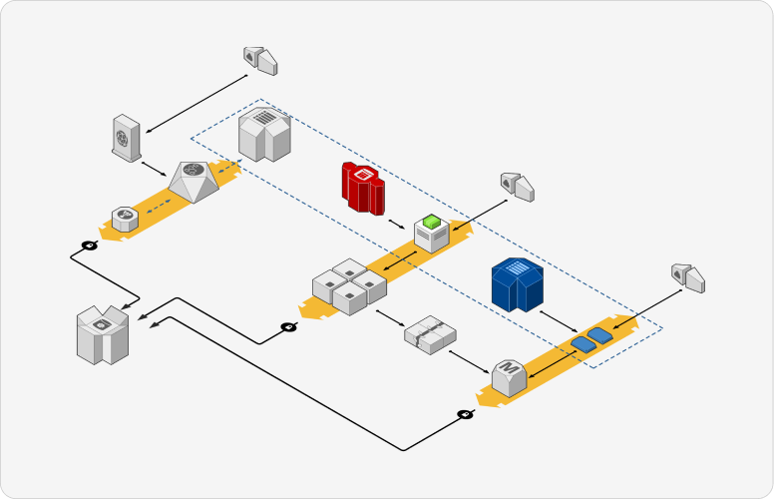
3.Pick any app you use daily (like WhatsApp, Zomato, or Instagram) and write a short scenario explaining how SD-WAN could improve user experience for that app when used across multiple cities in India.
For a communication app like WhatsApp used by employees between offices in different cities, SD-WAN could route voice/video call traffic over whichever link (broadband or MPLS) is performing best at that moment. If the Mumbai office's primary broadband link degrades, SD-WAN automatically shifts that traffic to a backup link, keeping calls to the Bangalore office clear and reducing lag — an example of the reliability and speed benefits SD-WAN principles bring to real-time communication.
4.List and explain three key benefits of SD-WAN for a company with offices in Ahmedabad, Mumbai, and Bangalore. For each benefit, give a real-world example of how it would help employees or customers.

- Centralized management: The IT team, working from any one city, can push a single security-policy update to all three branches simultaneously instead of configuring each router by hand.
- Cost savings: Branches can rely more on local broadband instead of expensive leased MPLS lines, cutting overall WAN costs while SD-WAN aggregates bandwidth from multiple links to maintain performance.
- Application-aware routing: Video-conferencing traffic between the three offices is automatically prioritized over routine file downloads, so meetings stay smooth even during peak network usage.

F. AAA
1.Create a table comparing Authentication, Authorization, and Accounting (AAA) by listing at least two real-world examples of each function from popular apps like Instagram, Zomato, or Paytm.
AAA Function | Example 1 | Example 2
Authentication | Instagram: login via password + OTP/2FA | Paytm: login via UPI PIN or biometric
Authorization | Zomato: only a restaurant partner can access their own order dashboard, not others' data | Paytm: unverified users get lower transaction limits; full KYC unlocks higher limits
Accounting | Instagram: login history and active-device list in security settings | Paytm: full transaction and billing history for every payment
2.Draw a simple network diagram showing how AAA is used to secure access to a WiFi network in a college campus, labeling where authentication, authorization, and accounting take place.
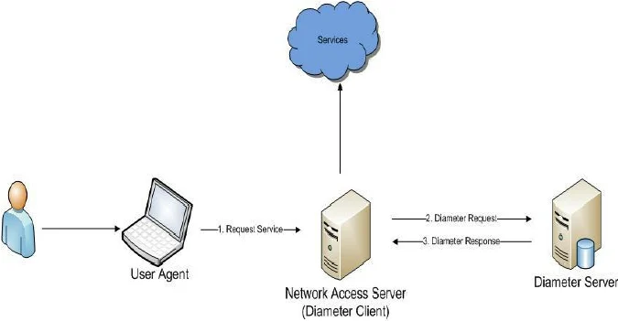
3.Explain the difference between centralized and distributed AAA deployment models by describing how each would work in a scenario where multiple Flipkart warehouses need secure network access.
Centralized: A single AAA server manages login credentials for staff across all Flipkart warehouses in India — access for a terminated employee can be revoked instantly company-wide, but if the central server goes down, staff at every warehouse could lose network access simultaneously.
Distributed: Each warehouse runs its own local AAA server, so operations continue even if the link to headquarters is down — but propagating a policy change (like revoking one employee's access) across every warehouse takes longer and risks temporary inconsistency between sites.
4.Pick any one AAA deployment model and list three advantages and two disadvantages of using it for a large-scale app like BookMyShow.
Model chosen: Centralized AAA
Advantages:
- Uniform security policy applied consistently across all regional ticketing servers.
- Easier auditing since all authentication/authorization logs sit in one place.
- Security patches and access-rule updates can be enforced everywhere at once.
Disadvantages:
- If the central AAA server fails during a high-demand movie release, all regions could lose booking access at once.
- Users/admins in regions far from the central server may experience higher authentication latency.

5.Use ChatGPT or another AI tool to generate a sample AAA policy for a Zomato-like app, specifying what actions are authenticated, which roles are authorized for each action, and what accounting logs should be kept. Paste the generated policy and highlight one thing you would change to make it more secure.
Sample Policy:
- Authentication: Customers log in via mobile number + OTP or Google/Facebook SSO; delivery partners authenticate with employee ID + password plus device binding.
- Authorization: Customers can browse, order, and rate restaurants; restaurant partners can update only their own menu/inventory; delivery partners can view/update only their assigned orders; admins have full dashboard access.
- Accounting: Every order placed, payment transaction, and delivery-status update is logged with a timestamp for dispute resolution and fraud detection.
Change for better security: add mandatory device-based two-factor authentication for delivery-partner accounts, since a compromised password there would expose customer addresses and payment details.

G. RADIUS and TACACS+
1.Create a comparison table listing at least 4 key features of RADIUS and TACACS+ side by side, highlighting which protocol supports each feature.
Feature | RADIUS | TACACS+
Transport protocol | UDP | TCP
Encryption scope | Encrypts only the password | Encrypts the entire packet payload
Authentication + Authorization | Combined into a single process | Separated — allows granular, per-command control
Primary use case | Network access (WiFi/VPN users) | Device administration (router/switch CLI access)
2.Draw a step-by-step flow diagram showing the RADIUS authentication process for a user logging in to a public WiFi hotspot, labeling each communication step between the client, network device, and RADIUS server.


3.List 3 real-world use cases where TACACS+ is preferred over RADIUS, and briefly explain why TACACS+ is better suited for each scenario.
- An ISP's backbone network, where TACACS+ restricts which specific commands (e.g., "reload" or "erase") each admin tier is allowed to run on core routers.
- A bank's data center, where full-packet encryption is required for regulatory compliance when admins remotely configure firewalls.
- A university network operations center, where interns and senior engineers need different command privileges on the same switches.

4.Given a scenario where a user tries to log into a network device but fails authentication, describe how RADIUS and TACACS+ would handle the logging and response differently
RADIUS bundles authentication and authorization together, so a failed login simply returns a single Access-Reject, and its accounting is comparatively coarse — mainly session start/stop and duration. TACACS+ keeps the stages separate, so a failed authentication is logged distinctly from a failed authorization (e.g., valid login but a denied command), giving administrators a more detailed audit trail that shows exactly which command was attempted and blocked.
5.Use ChatGPT or another AI tool to generate a sample RADIUS configuration snippet for a Cisco router, then review the output and list any changes you would make to adapt it for a college campus WiFi setup.
aaa new-model
radius server COLLEGE-RADIUS
address ipv4 192.168.1.50 auth-port 1812 acct-port 1813
key mysecretkey123
aaa authentication login default group radius local
aaa authorization network default group radius
Changes for a college campus WiFi setup: replace the shared key with a strong, randomly generated secret stored securely (not left in plaintext config); point the server address to the actual campus RADIUS server IP; add "aaa accounting network default start-stop group radius" to log student WiFi sessions; and keep "local" as a fallback so login still works briefly if the RADIUS server becomes unreachable during peak hours.

