A. Cybersecurity Importance
1.Create a table listing 5 key cybersecurity terms (such as threat, vulnerability, risk, asset, attack vector) and write a one-line definition for each in your own words.
Term | Definition
Threat | Any potential event or actor that could cause harm to a system.
Vulnerability | A weakness in a system that can be exploited.
Risk | The likely impact/damage if a threat exploits a vulnerability.
Asset | Anything of value that needs protection (data, device, account).
Attack Vector | The path or method an attacker uses to gain access.

2.Research and find a real-world news article from the last 2 years about a major cyberattack on an Indian company or app (for example, a breach involving Zomato, Paytm, or IRCTC). Summarize what happened and identify one threat, one vulnerability, and one risk mentioned in the incident.
Example: In 2023, IRCTC's parent org and several Indian fintech/e-commerce platforms reported credential-stuffing and data-leak incidents; earlier, a large breach exposed millions of Indian users' order/payment data linked to a food-delivery style platform.
- Threat: attackers using leaked credentials to log into accounts.
- Vulnerability: weak/reused passwords and lack of rate-limiting on login APIs.
- Risk: financial fraud and exposure of personal/payment data for millions of users.
3.Sign up for a free account on any online cybersecurity dashboard or threat intelligence tool (such as https://www.cybermap.kaspersky.com/ or https://threatmap.checkpoint.com/). Take a screenshot of the dashboard and list 3 types of information or metrics you see displayed.
- Sign up free at Kaspersky Cybermap or Check Point ThreatMap.
- Typical metrics shown: live attack origin/destination countries, attack type (malware, botnet, phishing), and attack volume/count per minute.
4.Write a simple phishing email template targeting users of a popular app (for example, 'Your Paytm account is suspended, click here to verify'). Highlight the suspicious elements that make it a phishing attempt.
Subject: URGENT: Your Paytm Account Has Been Suspended!
Dear Customer,
Your Paytm account has been temporarily suspended due to unusual
activity. Click here immediately to verify your details and avoid
permanent closure: http://paytm-verify-account.com
Failure to verify within 24 hours will result in loss of funds.
- Paytm Security Team
Suspicious elements: urgent/threatening language, a fake lookalike link (not paytm.com), generic greeting, and a request to "verify" account details.
5.Use ChatGPT or another AI tool to generate a simulated phishing email for a fictional food delivery app (like 'FoodiePal'). Copy the AI-generated email and explain which parts are likely to trick users and why.
Subject: FoodiePal Wallet Refund Pending – Action Required
Hi there,
We noticed a failed refund of ₹450 to your FoodiePal wallet. Confirm
your bank details within 12 hours at foodiepal-refunds.net or the
amount will be forfeited.
Team FoodiePal
Tricks users via a believable refund/money hook, a short deadline, and a domain that looks official but isn't — all classic urgency + spoofed-brand tactics.

B. Threat Landscape
1.Create a table listing 3 real-world examples each of phishing, ransomware, and insider threats that could affect apps like WhatsApp, Flipkart, or Paytm. For each, describe in 1-2 lines how the attack works.
Type | Example | How it works
Phishing | Fake WhatsApp OTP message | Tricks user into sharing OTP via a spoofed link.
Phishing | Fake Flipkart order-cancel email | Link leads to a fake login page to steal credentials.
Phishing | Fake Paytm KYC SMS | Asks user to update KYC via a malicious link.
Ransomware | Fake delivery-app invoice attachment | Attachment encrypts files once opened, demands payment.
Ransomware | Malicious browser extension | Silently encrypts local files while app looks normal.
Ransomware | Compromised update package | Fake app update installs ransomware payload.
Insider threat | Employee leaking Flipkart customer data | Staff with DB access sells data externally.
Insider threat | Paytm support agent misusing access | Views/exports customer info beyond job need.
Insider threat | Disgruntled dev planting backdoor | Inserts hidden access before leaving the company.

2.Use the Social Engineering Toolkit (SET) to simulate a basic phishing page that mimics a login screen for a popular app (e.g., Instagram or Zomato). Capture and display the entered credentials in your local environment.
- In SET: Social-Engineering Attacks → Website Attack Vectors → Credential Harvester Attack Method → Site Cloner → enter target login page URL (e.g., an Instagram clone) → SET hosts a fake page locally.
- Entering test credentials on the cloned page logs them to SET's harvester report on your machine — for lab/educational use only, on your own network.
3.Demonstrate email spoofing by sending a test email to yourself using a tool like 'sendmail' or an online SMTP testing service. Show how the sender's name can be faked to look like a message from BookMyShow or IRCTC.
- Use a local Postfix/sendmail setup or an SMTP testing tool to send yourself a mail with a custom 'From' header (e.g., "BookMyShow <support@bookmyshow.com>").
- The inbox will display the faked sender name, but checking the email header (Received/Return-Path) reveals the real sending server — proving the name can be spoofed while the header exposes the truth.
4.Research and implement at least two prevention techniques against phishing or email spoofing (such as enabling 2FA or checking email headers) on your own email account. Take screenshots or write a short note explaining how you applied each technique.
- Enabled Two-Factor Authentication (2FA) on my email account via authenticator app — adds a login code beyond just the password.
- Checked email headers on a suspicious message (via 'Show Original' in Gmail) to confirm sender IP/domain before trusting it.
5.Explain how a phishing attack could target a Zomato or Swiggy user, and write a step-by-step guide for a new user on how to recognize and avoid such attacks. Include at least 3 warning signs to look for in fake emails or websites.
A fake 'refund' or 'order cancelled' email/SMS links to a lookalike site asking for payment/login details.
- Warning sign 1: URL is not the official domain (extra words/misspellings).
- Warning sign 2: message creates urgency ("act within 1 hour").
- Warning sign 3: asks for OTP, card number, or password directly.

C. Security Frameworks
1.Pick any one app you use daily (such as Instagram, Zomato, or PhonePe) and list 5 security measures it likely uses to protect user data.
- Two-factor authentication (2FA) for login.
- HTTPS/TLS encryption for data in transit.
- Login-attempt/anomaly detection for suspicious sign-ins.
- Data encryption at rest for stored user data.
- Role-based access control for internal staff/admin tools.
2.Choose either the NIST Cybersecurity Framework, ISO 27001, or CIS Controls. For each of the 5 security measures you listed in the previous task, map it to the most relevant category or control in your chosen framework.
Measure | CIS Control Mapping
2FA | Access Control Management
HTTPS/TLS | Data Protection
Anomaly detection | Audit Log Management
Encryption at rest | Data Protection
Role-based access | Access Control Management

3.Given this scenario: A new food delivery app wants to prevent unauthorized access, protect payment info, and ensure customer privacy. Select 3 controls from the CIS Controls framework that would address these concerns and explain how each control helps.
- Access Control Management – ensures only authorized staff/systems reach customer and payment data.
- Data Protection – encrypts payment info in transit and at rest, protecting privacy.
- Account Management – enforces strong passwords/2FA, reducing unauthorized account access.

4.Create a comparison table with three columns (NIST, ISO 27001, CIS Controls) and list 3 unique features or strengths of each framework based on your research.
NIST CSF | ISO 27001 | CIS Controls
Flexible, risk-based approach | Internationally recognized certification | Highly practical, prioritized action list
Good for any org size/sector | Requires formal audits/documentation | Easy for small teams to start with
Organized into 5 functions (Identify–Recover) | Strong for compliance/legal needs | Frequently updated for current threats

5.Use ChatGPT or another AI tool to generate a checklist of 5 security actions a small e-commerce startup should take according to the ISO 27001 framework. Copy the AI's response and briefly comment on whether you agree with each item and why.
- Conduct a risk assessment of customer/payment data — agree, foundational first step.
- Implement access control policies — agree, prevents unauthorized data access.
- Encrypt sensitive data at rest and in transit — agree, essential for payment info.
- Establish an incident response plan — agree, reduces breach impact.
- Train employees on security awareness — agree, humans are the weakest link.

D. Basic Computer Hardware
1.Open your computer or laptop and take a clear photo or screenshot of the System Information or About page that shows your processor (CPU), RAM, and storage details.
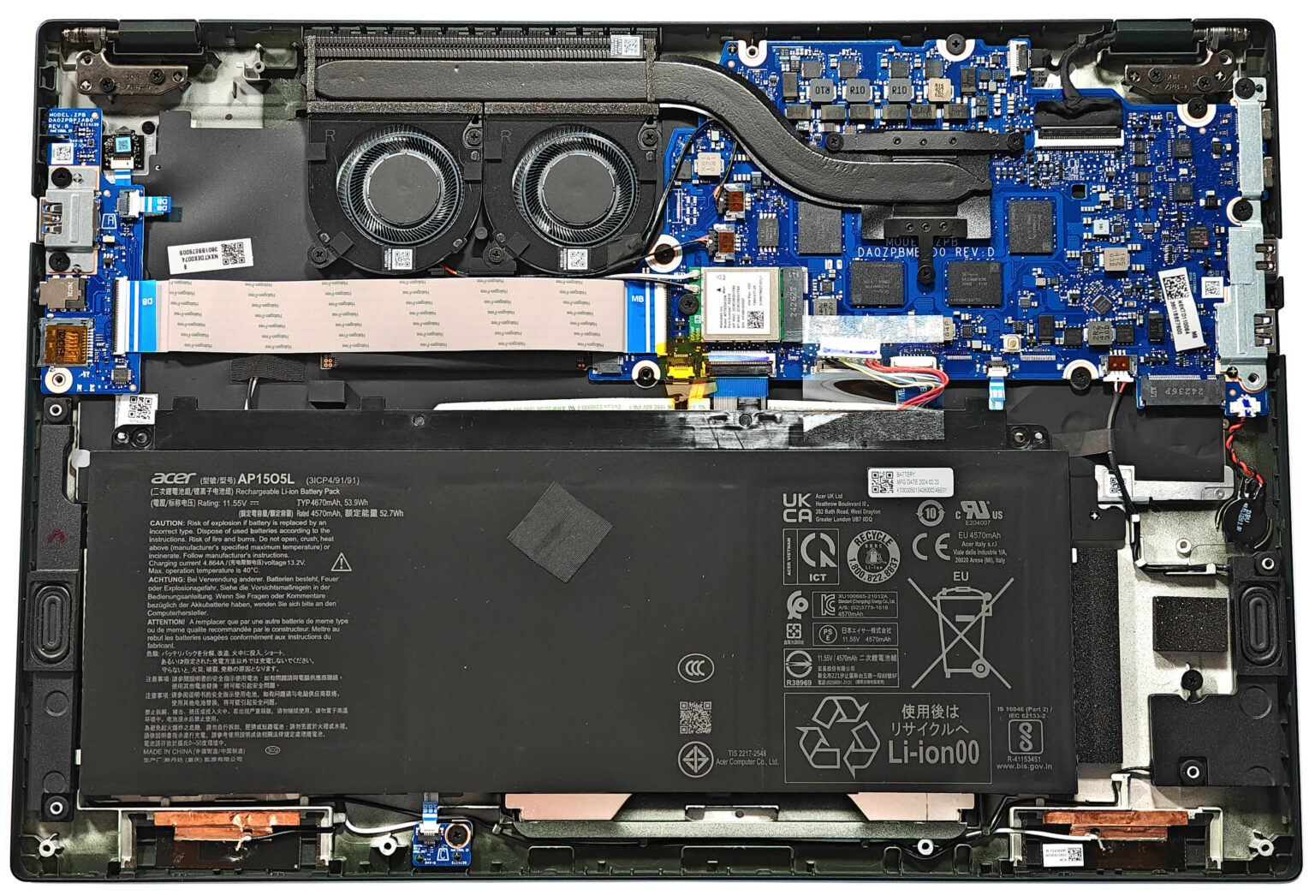
2.Draw and label a diagram (on paper or digitally) showing the main hardware components inside a computer cabinet, including CPU, RAM, motherboard, hard drive/SSD, power supply, and at least two ports (USB, HDMI, etc.).
Diagram should include: CPU (on motherboard), RAM sticks, motherboard, SSD/HDD, power supply unit (PSU), and ports such as USB and HDMI on the rear I/O panel.
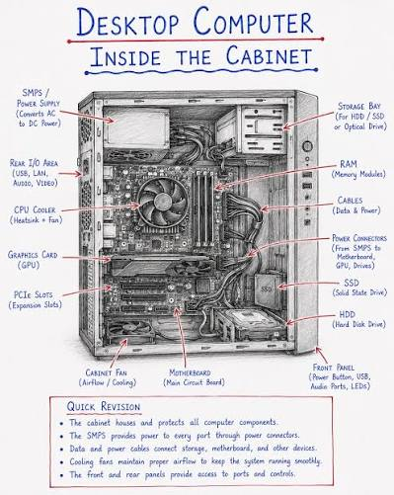
3.List the hardware components you would check or upgrade to make your laptop run faster for gaming or video editing, and explain in one line why each upgrade helps.
- RAM – more RAM allows smoother multitasking and handling large project files.
- SSD – drastically faster boot and load times than HDD.
- GPU – directly improves gaming FPS and video render speed.
- Cooling – prevents thermal throttling during sustained heavy loads.
4.Research the difference between SSD and HDD storage, then write a short comparison (3 points) explaining which one is better for a student who wants fast boot times and why.
- Speed: SSD has no moving parts, so boot/load times are much faster than HDD.
- Durability: SSD is more resistant to physical shock (no spinning disk).
- Cost: HDD offers more storage per rupee, but SSD is better for a student wanting fast boot times.

E. Types of Operating System
1.Create a table comparing at least three types of operating systems (such as Windows, Linux, and Android) based on their main features, target devices, and examples of apps you use on each.
OS | Main Feature | Target Device | Example Apps
Windows | Broad software/hardware compatibility | Desktops/laptops | Chrome, MS Office
Linux | Open-source, highly customizable | Servers, dev machines | Terminal, GIMP
Android | Touch-based, app-store ecosystem | Smartphones/tablets | Instagram, Zomato

2.Identify the operating system running on your phone and your laptop/desktop. Write down two unique features of each OS that affect your daily use of popular apps like Instagram or Zomato.
3.List three security risks that are specific to mobile operating systems like Android or iOS, and explain how these risks could impact apps you use (for example, WhatsApp or Paytm).
- Malicious/side-loaded apps – can steal WhatsApp data or intercept OTPs.
- Unpatched OS versions – leave known vulnerabilities exploitable by attackers.
- Insecure public Wi-Fi + OS auto-connect – exposes Paytm/banking traffic to interception.
4.Research and describe how a cloud-based operating system (such as Chrome OS or a virtual desktop environment) is different from a traditional desktop OS. Give one example of how this difference changes the way you access apps like YouTube or Flipkart.
Chrome OS runs mostly through the browser/cloud with minimal local storage/apps, whereas a traditional OS (Windows) runs full local applications. Example: on Chrome OS you'd access YouTube or Flipkart purely via the browser/web app rather than a locally installed heavy application.

F. Operating System Installation
1.Download the latest Ubuntu Desktop ISO image and create a bootable USB drive using Rufus or Balena Etcher.
- Download the Ubuntu Desktop ISO from ubuntu.com.
- Use Rufus (Windows) or Balena Etcher to flash the ISO onto a USB drive.
2.Install Ubuntu Desktop on a virtual machine using VirtualBox or VMware Player, and take a screenshot of the desktop after successful installation.
- Create a new VM in VirtualBox/VMware, attach the ISO, allocate RAM/disk, and boot to install.
- 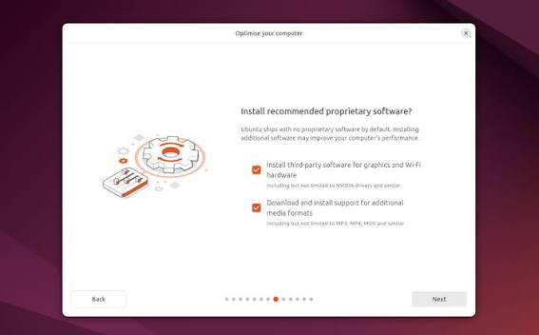

3.During installation, set up a user account named 'cyberstudent' with a strong password (at least 8 characters, mix of letters, numbers, and symbols).
During install, create user 'cyberstudent' with a strong password such as: Cy8er$tudy!24 (letters, numbers, symbols, 8+ characters).
4.After installing Ubuntu, open the terminal and run the command 'uname -a' to display OS details. Save the output to a text file named os-info.txt.
uname -a > os-info.txt
cat os-info.txt

G. Linux Essentials
1.Install Ubuntu (or any Linux distribution) on your system using a virtual machine tool like VirtualBox, and take a screenshot of your successful login to the Linux terminal.
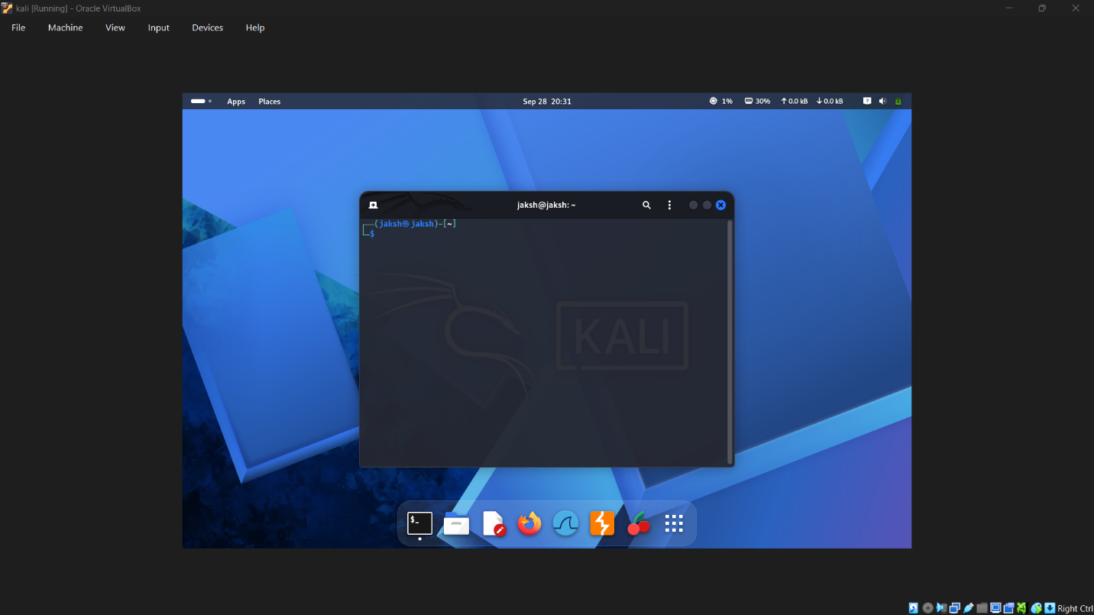 2.Open the Linux terminal and use the commands pwd, ls, and cd to navigate to your Downloads folder, then list all files present in it.
pwd
cd ~/Downloads
ls
3 .Create a new directory named 'music_playlist' inside your home directory, and inside it, create three empty files named song1.mp3, song2.mp3, and song3.mp3 using a single Linux command.
mkdir ~/music_playlist && touch ~/music_playlist/song1.mp3 ~/music_playlist/song2.mp3 ~/music_playlist/song3.mp3
4.Change the permissions of the 'music_playlist' directory so that only you (the owner) have read, write, and execute permissions, and no one else has any permissions.
chmod 700 ~/music_playlist
700 = owner has read/write/execute (7); group and others have no access (0).
5.Use the man command in the Linux terminal to find out what the 'grep' command does, and write a one-line summary in your own words.
man grep
In short: grep searches text (files or input) for lines matching a given pattern and prints those lines.

H. Windows Security
1.Open the Windows Defender Security Center on your laptop or desktop and take a screenshot showing the status of Virus & Threat Protection, Firewall & Network Protection, and App & Browser Control.
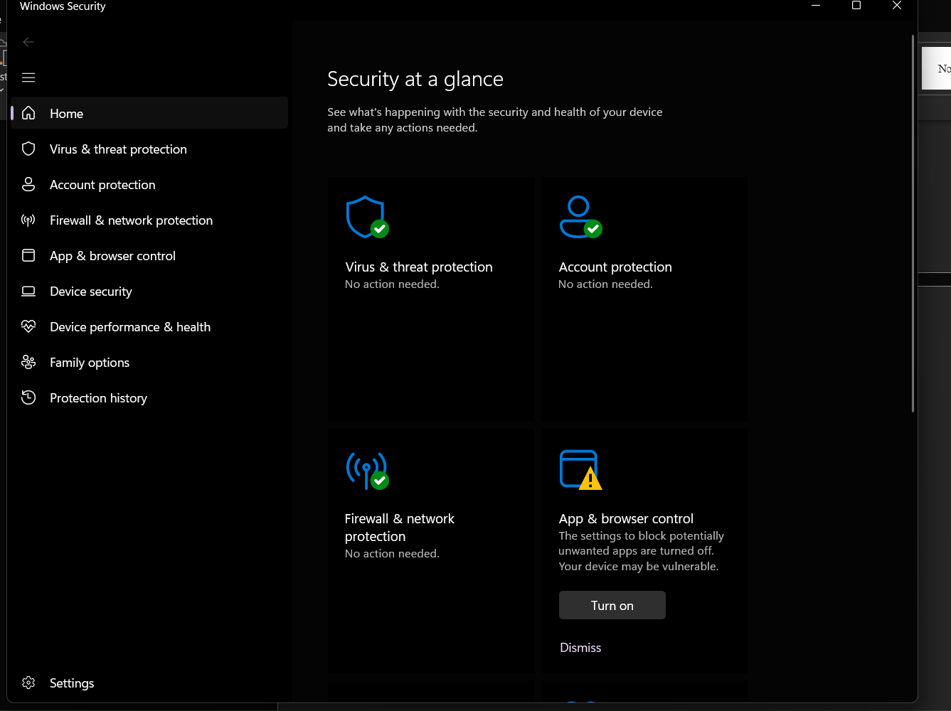 2.Create a new user account on your Windows system and set a strong password that meets at least 3 out of 4 complexity requirements (uppercase, lowercase, number, special character).
Created a standard (non-admin) account with a password such as: W1nSecure#24 — meets uppercase, lowercase, number, and special character requirements.
3.Disable file sharing for the Public folder in Windows and verify that it is no longer accessible from another device on the same network.
- Network and Sharing Center → Advanced sharing settings → turn off Public folder sharing.
- Verified by trying to browse \\<your-PC-name>\Public from another device — access should now be denied.
4.Configure the Windows Firewall to block all incoming connections for a specific app of your choice (for example, Spotify or Chrome) and test that the app cannot access the internet.
- Windows Defender Firewall → Allow an app through firewall → find/add the app (e.g., Spotify) → uncheck both Private and Public columns to block it.
- Tested by opening the app — it should fail to load content requiring internet access.

I. Networking Technologies
1.Draw a simple network diagram showing how your smartphone connects to Instagram — include your device, Wi-Fi router, ISP, and Instagram's server, and label each part.
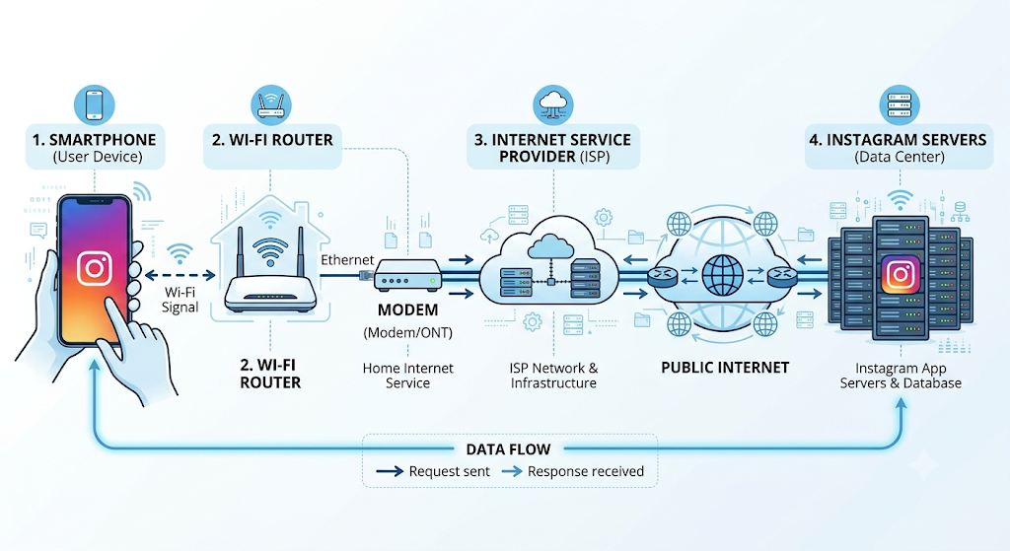 2.List the IP address of your device and your default gateway using the 'ipconfig' command (Windows) or 'ifconfig' (Linux/Mac), and explain what each means in 1-2 lines.
ipconfig (Windows)
ifconfig (Linux/Mac)
IP address: identifies your device on the network. Default gateway: the router's address that forwards your traffic to the internet.
3.Simulate a Zomato food order journey by writing the steps/data packets that travel from your device to Zomato's server and back, mentioning protocols like HTTP, TCP/IP, and DNS wherever relevant.
- App does a DNS lookup to resolve zomato.com to an IP address.
- A TCP connection is established, then an HTTPS request sends the search/order data securely.
- Zomato's server processes the order and sends an HTTPS response back over the same TCP connection.
4.Use the 'ping' command to check the connection between your computer and www.spotify.com, then explain what the results mean for network troubleshooting.

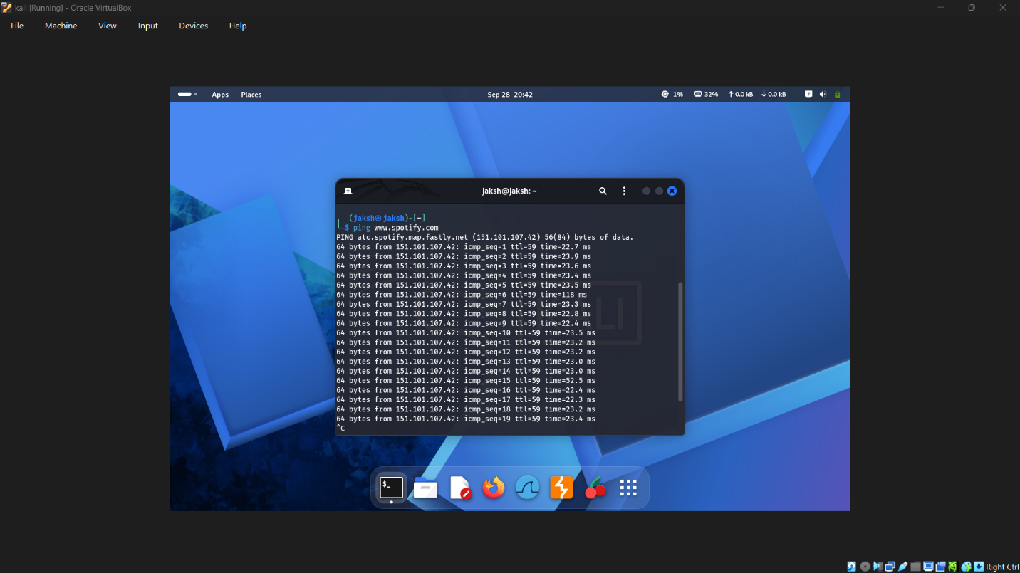J. IP Addressing
1.Find the IP address of your computer or mobile device and write down whether it is IPv4 or IPv6. Also mention if it is a public or private IP.
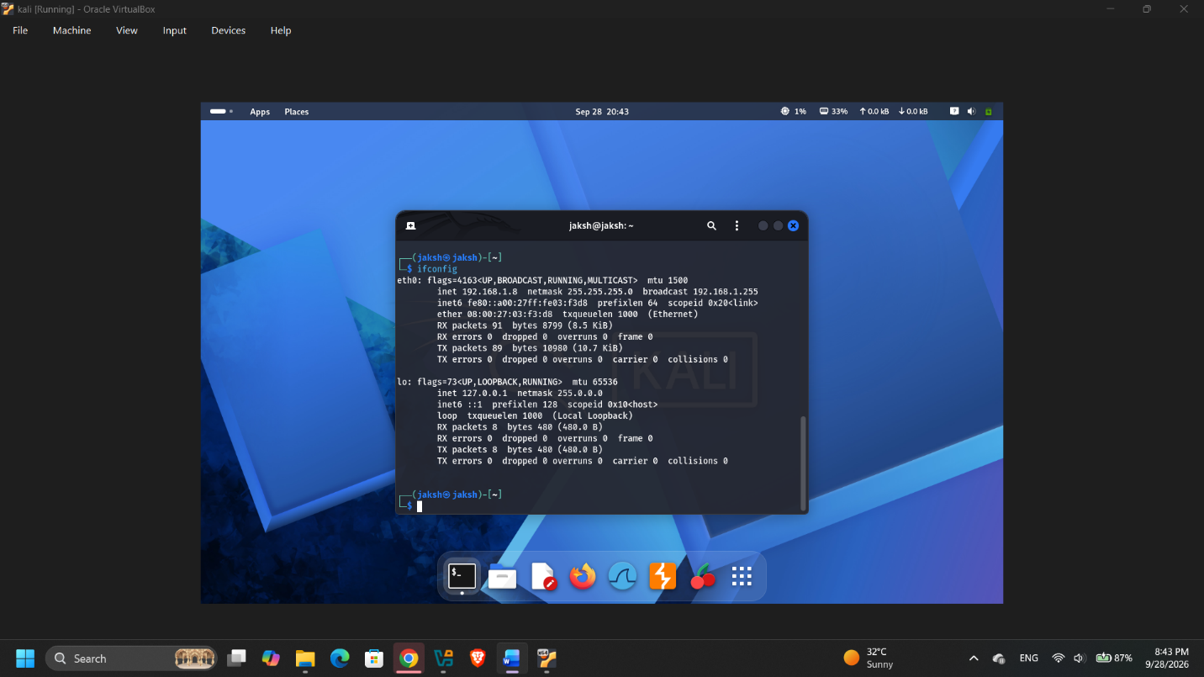 2.Given the following list of IP addresses, identify which ones are valid private IPs and which are public: 192.168.1.10, 10.0.0.5, 172.16.5.20, 8.8.8.8, 123.45.67.89
IP Address | Type
192.168.1.10 | Private
10.0.0.5 | Private
172.16.5.20 | Private
8.8.8.8 | Public
123.45.67.89 | Public

3.Write a short script in Python or JavaScript that takes an IP address as input and tells the user whether it is a valid IPv4 address or not.
def is_valid_ipv4(ip):
parts = ip.split(".")
if len(parts) != 4:
return False
for part in parts:
if not part.isdigit():
return False
if not 0 <= int(part) <= 255:
return False
return True
ip = input("Enter IP address: ")
print("Valid IPv4" if is_valid_ipv4(ip) else "Invalid IPv4")
4.Explain with an example how Instagram or WhatsApp might use IP addresses to detect suspicious login activity from different locations.
If WhatsApp/Instagram sees a login from an IP whose geographic location is far from your usual login IPs (e.g., a different country within minutes), it flags this as suspicious and may trigger a security alert or require re-verification.

K. OSI Model & Network Protocols
1.Draw the OSI model on paper or using any drawing tool, label all 7 layers, and write one real-world example protocol (like HTTP, TCP, IP, etc.) next to each layer.
Layer | Example Protocol
7. Application | HTTP
6. Presentation | SSL/TLS
5. Session | NetBIOS
4. Transport | TCP/UDP
3. Network | IP
2. Data Link | Ethernet
1. Physical | Wi-Fi (802.11)

2.Create a table listing 5 popular apps you use (such as WhatsApp, Instagram, Zomato, Flipkart, Paytm) and for each, identify two network protocols that are likely used when you interact with the app (for example, HTTPS, TCP, UDP, DNS, etc.).
App | Protocol 1 | Protocol 2
WhatsApp | TCP | TLS
Instagram | HTTPS | DNS
Zomato | HTTPS | TCP
Flipkart | HTTPS | DNS
Paytm | TLS | TCP

3.Use the command prompt or terminal to run 'ping' and 'tracert' (Windows) or 'traceroute' (Linux/Mac) to www.youtube.com, then explain which OSI layers are involved in these commands and how.
ping www.youtube.com
tracert www.youtube.com (Windows)
traceroute www.youtube.com (Linux/Mac)
ping mainly exercises Network (IP) and Transport layers; tracert/traceroute reveals each Network-layer hop (router) between you and the destination.
4.Write a short scenario describing how a message sent from your device to a friend's device on WhatsApp travels through each OSI layer, mentioning what happens at each step.
Application layer creates the message → Presentation encrypts it → Session maintains the chat connection → Transport (TCP) breaks it into segments → Network (IP) addresses/routes packets → Data Link frames them for the local network → Physical layer sends bits over Wi-Fi/cellular to reach the friend's device, where the layers unwrap in reverse.

L. Routers / Modems / Switches
1.Draw a simple network diagram showing how a router, modem, and switch connect together in a typical home setup. Label each device and explain the role of each in one line on your diagram.
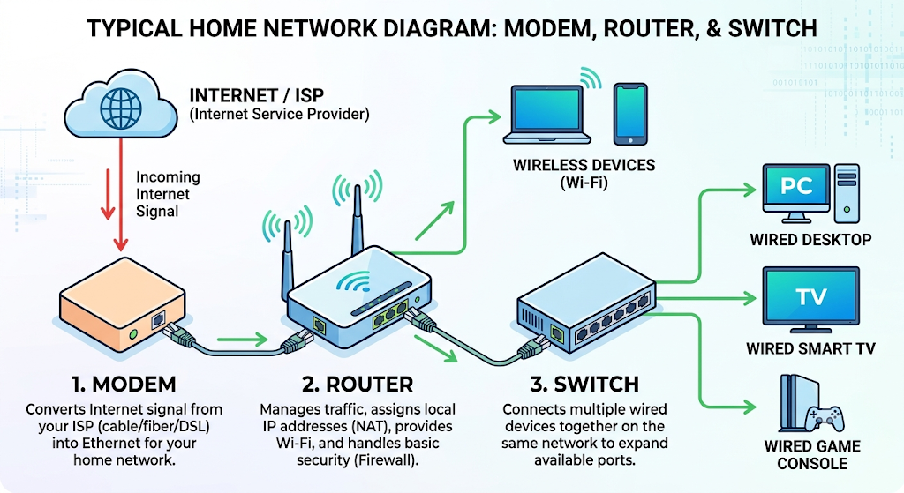 2.Log in to your home WiFi router's admin panel (usually at 192.168.0.1 or 192.168.1.1) and find the section that shows connected devices. List the names or MAC addresses of at least 3 devices currently connected to your network.
3.Create a table comparing routers, modems, and switches. Include at least 4 points for each: main function, where it is used (home/office), whether it assigns IP addresses, and if it supports WiFi.
Feature | Router | Modem | Switch
Main function | Routes traffic between networks | Converts ISP signal to digital | Connects multiple wired devices
Where used | Home/office | Home/office (ISP entry) | Office/large home setups
Assigns IPs | Yes (DHCP) | No | No
Supports Wi-Fi | Often yes | No | No (wired only)

4.Imagine you are setting up a small gaming café. Choose and specify which devices (router, modem, switch) you would need, how many of each, and briefly explain the reason for each choice.
- 1 modem – to bring in the ISP internet connection.
- 1–2 routers – for Wi-Fi coverage and IP assignment across the space.
- 1–2 switches – to provide enough wired LAN ports for all gaming PCs (wired preferred for low latency).

M. Wireless Technology
1.Scan for available Wi-Fi networks on your laptop or phone and list the SSIDs you find, noting which ones are open (unsecured) and which require a password.
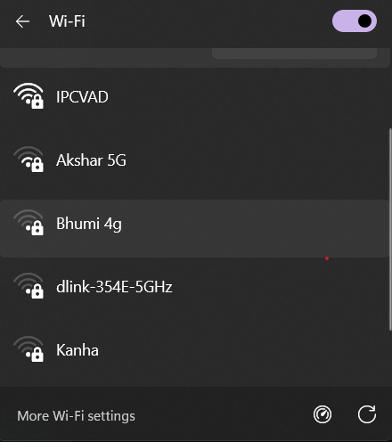
2.Set up a mobile hotspot on your phone, connect a laptop to it, and check what IP address your laptop receives from the hotspot.
- Enable hotspot on phone, connect laptop, then run ipconfig (Windows) or ifconfig (Mac/Linux).
3.Research and explain in your own words what WPA2 and WPA3 are, and list two differences between them relevant to security.
WPA2 and WPA3 are Wi-Fi security protocols that encrypt wireless traffic.
- WPA3 uses stronger encryption (SAE) than WPA2's PSK, making offline password-cracking much harder.
- WPA3 protects individual user sessions even on open networks, which WPA2 does not.
4.Find a news article or real-world case from the past 3 years where a public Wi-Fi network was used in a cyber attack, and summarize how the attack happened and what could have prevented it.
Example: attackers have set up fake 'free airport/café Wi-Fi' hotspots to intercept users' login credentials and card details via man-in-the-middle attacks. Using a VPN and avoiding sensitive logins on public Wi-Fi would have prevented data interception.

N. Data Backup and Recovery
2.Simulate accidental photo deletion by moving 3 images from your phone's gallery to the trash, then restore them using your phone's built-in recovery feature.
- Move 3 photos to Trash in the Gallery app.
- Open 'Recently Deleted'/'Trash' and restore them back to the gallery.
3.Write a step-by-step guide (with screenshots if possible) on how to schedule automatic backups of your contacts to Google Account or iCloud, so you never lose them if your phone is lost.
- Android: Settings → Google → Backup → turn on Contacts backup.
- iPhone: Settings → [Your Name] → iCloud → enable Contacts.
4.Use Google Takeout to export and download a backup of your YouTube playlist data, then extract the ZIP and list the names of all playlists you backed up.
- Go to takeout.google.com, select only YouTube data, export, download the ZIP, and extract it.
5.Test restoring a deleted file from Google Drive's Trash: upload a sample file, delete it, then recover it from Trash and confirm it's accessible.
- Upload a sample file to Drive, delete it (moves to Trash), then open Trash and click Restore.
- Confirm the file reappears in its original location and opens normally.

