Car App <https://github.com/JakuPiot29/Car_App_Project>

Jakub Piotrowski 20090234| Software Systems Development 2 | 3 May 2021

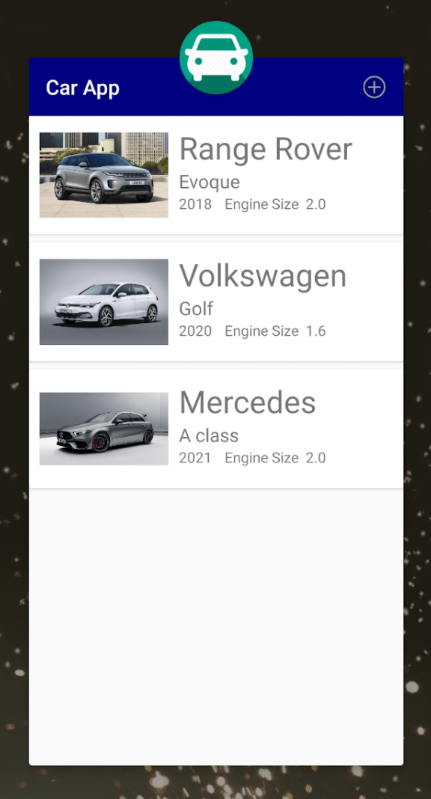

Contents

Overview of the App 1

Motivations and Context 1

Object model 1

Detailed Analysis 1

Prototyping / Material Design / Wireframes 1

Completed Rubric Template 0

# Overview of the App

This app allows users to add different makes and models of cars and display them below each other. Users can also change the make, model, year, engine size and image of any car by tapping on the car card, updating the information and pressing ‘Save Car’. Cars can also be deleted by tapping on the chosen car and hitting the delete icon in the top right.

## Motivations and Context

I created this app because I have an interest in cars. I think it could be used by collectors who have many, many cars and want to have an app where they can check what cars they have. It can also be used by anyone who wants to store cars they like or store cars they want to have in the future. A category could be added to sort between ‘Wanted’, ‘Favourite’ and ‘Owned’ cars.

# Object model

The objects in my app are cars. For each car I am storing the id, make(String), model(String), year(Short), engine size(Double) and image.

# Detailed Analysis

# Prototyping / Material Design / Wireframes

# Completed Rubric Template

TODO: Fill in each cell below (max 20 words per cell) in relation to your App i.e. have you attempted it and how complete is it.

|  |  |  |  |  |  |  |  |
| --- | --- | --- | --- | --- | --- | --- | --- |
| **Standard** | **Functionality**  **(40%)** | **Persistence**  **(17.5%)** | **Data Validation**  **(7.5%)** | **Repository**  **(7.5%)** | **UI/UX (7.5%)** | **Creativity & Originality**  **(10%)** | **Report**  **(10%)** |
| **Baseline** | Create,Read,  Update,Delete  Functionality |  | Checking for empty strings and validating engine size so that its > 0 |  | User Interface Considerations (layout, fonts, components, etc) | I don’t think my app is very creative because the layout is similar to the Placemark App, but it is an original app about something I like that could be used by car collectors. | Description of project, motivations and context. |
| **Good** |  | JSON persistence | Github repo with updates | Object model |
| **Very Good** |  |  | Read.me file |  |  |
| **Excellent** |  |  |  |  |  |