|  |  |  |  |  |  |
| --- | --- | --- | --- | --- | --- |
| Student Name: | Jakub Lukáč | Student Number: | S00255726 | Class Group: | C |

## 1. Proposed 4 Page Web Site Topic

|  |
| --- |
| [Short description of the website goals and objectives and intended audience]  Full remake of existing website of my floorball club back in Slovakia **(http://florbalbb.sk/)**  **Audience** – past, current, future players or anyone interested in floorball in Slovakia, town Banska Bystrica.  Current website lacks visual design, content is very poorly displayed, sometimes there are multiple pages with almost the same content. Also is overflowing with lengthy articles, so definitely I will try to shorten in.  Reduction of some content as it is not needed, adding some necessary content which is not displayed currently. |

## 2. Proposed Design

|  |
| --- |
| [Short description of the website logo, main navigation, colours, sources of information]  Logo used will be the one that is used currently, as it is recently updated and would fit the website design.  Navigation bar will consist of 6 links total, 3 on left side and 3 on the right side, in the middle (in between them) logo will be displayed.  **Left side links** – News, Applications, Club, Gallery (for Home page), News and Applications will just scroll down on the HomePage  **Left side links** – Home, Club, Gallery (for other pages)  **Right side links** – Contact, Sponsors, Fan Shop  **Colour scheme:**  #f5eded  #d72323  #3e3636  #000000  **Google Fonts:**  Fira Sans  Inconsolata  Bebas Neue |

## 3. Proposed Design of each page content

|  |
| --- |
| [Short description of the website content of each page, colours, text font types etc and sources]  Firstly, I would like to ask if the content displayed can be in Slovak or must be in English. Personally, for the assessment purposes I do not mind displaying it in English, just clarifying so the content formatted same on every page.  **Home page** – Hero section with picture covering almost whole front page, navigation bar and logo in middle. Under Hero section, News section, with full articles about recent games or events. Under News section, Application section, where people can submit their applications to join the team. Last Footer with copyright mark and all sponsors.  **About Club page** – Displaying information, possibly some pictures about picture, who runs it, etc. and then displaying short article about history and beginnings of the club.  **Gallery page –** Display photos from summer camps, matches through all categories, photos of beginnings of club.  **Contact us page –** Will contain contact form with google maps of location of the main building of the club. Will also contain list of all the team members (regular coaches, condition coaches and their personal information like achievements and skills )  **Sponsors page –** Displaying probably logos (not completely sure yet), brand names of sponsors. 4 sections : Main sponsors, Media sponsors, Who we work with, Become a Sponsor.  **Fan shop page** – General information about items on sale, who and how to contact in case of interest. List of all available items + tables with sizes. (at this point I just think about displaying the items available, in the future definitely implementing basic shop, payment functions) |

## 4. Rough Proposed sketch of website home page -

|  |
| --- |
| [example in Chapter 18 (slide 40) can sketch by hand or use app and include photo image]  Screenshots starting from page 3 of this document. |

## Notes: Project outline

Create a simple website on a topic of your choice. A proposed topic and design brief must be submitted on or before submission date. Once your lecturer will approve your design and marked on moodle.

## Included in your Website

* Good coding practices - Code Comments, Code Indentation, White space,
* Web pages should Clear consistent design, Visually attractive clear and clean and aligned. Suitable use of colours and fonts, all text and images referenced.(Public domain images).
* All text content must be clear concise and meaningful and reference link to source. **Do not reference any personnel details, name etc or any reference to ATU Sligo on the web pages**.
* Place on the following text on the **home page**. *This is a college project completed as part of an assignment.*

*Project will consist of the following and you will be provided with a complete check list of features which will form the marking scheme for the project*

* Internal and external styling (CSS), minimum of 4 html pages, appropriate use of sematic HTML 5 on every page, background and foreground, tables of statistical data, internal and external links, lists numbered and bullet, video, a contact form, radio buttons etc , google map, footer on every page with Copyright notice.
* Also additions marks for addition features not outlined above. Project checklist and marking scheme will be available on Moodle.

## Proposal submission

* Use this Word document and upload on Moodle with sections 1-4 above completed

**Obrázok, na ktorom je text, nehybný, rukopis, kniha

Automaticky generovaný popis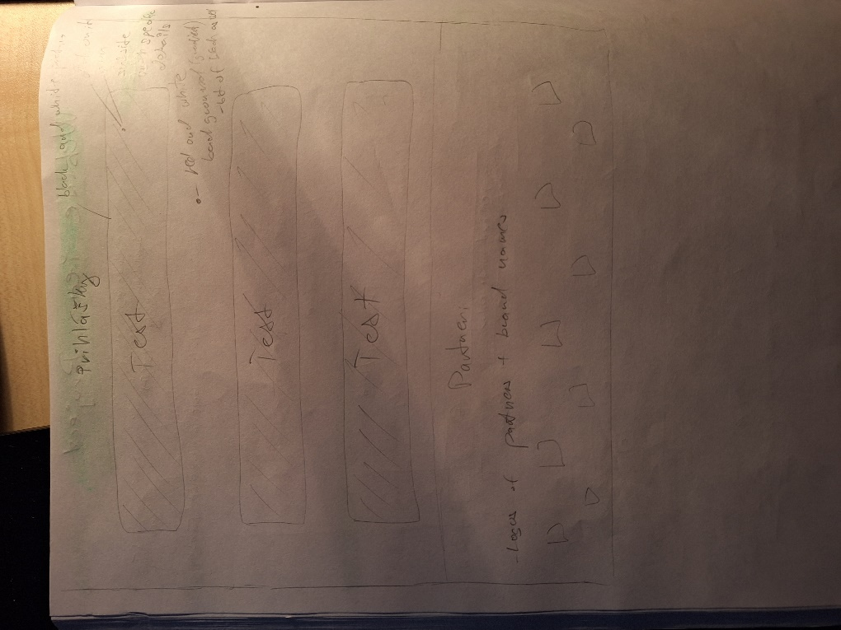Website design Low Fidelity Screenshots:**

