Slew Guard: Real-Time voltage protection for GPU workloads
Members: Nikhil Reddy Mummadi, Jakub Mroczek

Abstract
Slew Guard is a closed-loop software controller that protects a GPU's power-delivery network (PDN) from load-voltage droops caused by rapid workload current changes (di/dt). The system runs an end-to-end ResNet-18 workload on a live GPU, models the PDN as an RLC circuit with an envelope filter driven by NVML telemetry, and throttles the kernel's batch size in real time so the modelled load voltage (Vload) never falls below a user specified minimum voltage (Vmin). A hysteresis controller with a tunable deadband issues shrink or grow decisions every 50 us based on a single operational threshold Vshrink derived from Vsafe = Vmin + 30 mV. All PDN parameters for DC power level, noise amplitude, and derived voltage thresholds are calibrated automatically from live NVML measurements at startup.
Background and Motivation

Proposed Methodology

Results and Discussion
Effectiveness of batch throttling:
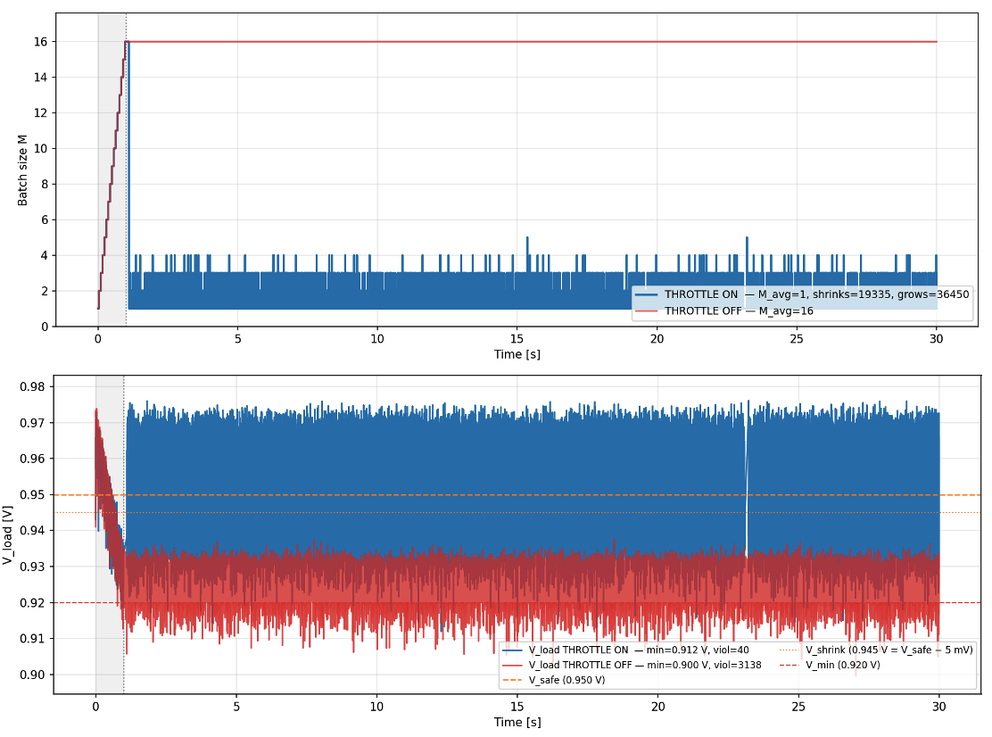
Figure 1: ResNet-18 Performance with dynamic throttling ON (blue) and OFF (red)

Without batch throttling (Throttle OFF), the workload experiences 3,138 V_min violations, leading to immediate system failure. Activating throttling reduces these violations to just 40, a 98.7% reduction.
While throttling introduces batch size variability (averaging a batch size M = 1-4 after the initial ramp), it enables a sustained throughput of 0.887 TFLOP/s. This confirms that throttling transforms a fatal power delivery issue into a manageable performance tradeoff.
Capacitive Sensitivity Analysis:
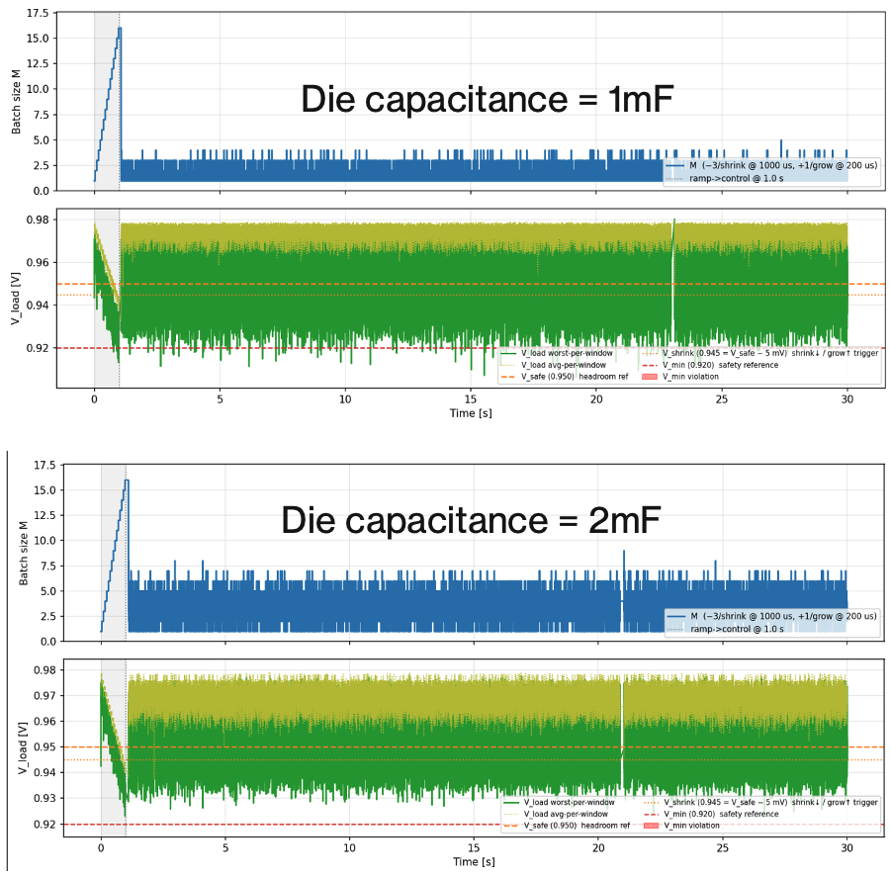
Figure 2: Batch Throttling with Die capacitance sweep
Capacitance acts as a primary buffer against high-frequency voltage droops. The sensitivity analysis reveals a non-linear benefit to increasing die capacitance:
- Performance Scaling: Doubling the die capacitance from 1mF to 2mF results in a massive throughput increase, jumping from 0.919 TFLOP/s to 2.022 TFLOP/s (a ~120% improvement).
- Violation Elimination: The higher capacitance provides sufficient local charge reservoirs to eliminate V_min violations entirely (reducing them from 110 to 0).
- Throttling Behavior: With 2mF, the system experiences significantly less frequent "shrinks" in batch size, allowing the hardware to maintain higher occupancy for longer durations.
Inductive Sensitivity Analysis:
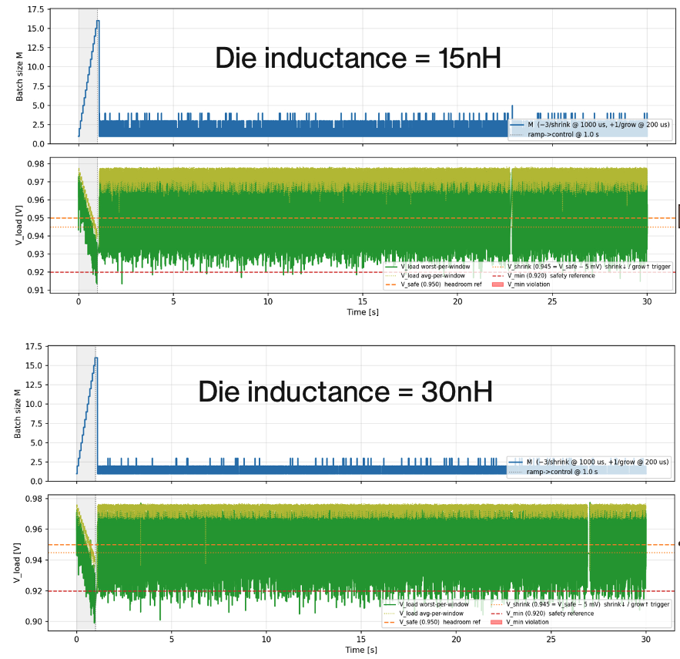
Figure 2: Batch Throttling with Die inductance sweep
Inductance is the primary antagonist to stable power delivery during rapid current changes (di/dt events) caused by neural network execution.
- Increased Noise: Increasing die inductance from 15nH to 30nH exacerbates high-frequency noise. This resistance to rapid current changes forces the voltage to drop more sharply during execution bursts.
- Reliability Degradation: The doubling of inductance causes V_min violations to skyrocket from 18 to 565, even with throttling active.
- Performance Penalty: The increased noise triggers more aggressive batch throttling to protect the system, resulting in a throughput drop from 0.859 TFLOP/s to 0.756 TFLOP/s.

Challenges and Learning Outcomes

Challenge: Controller grow-steps stacking and causing self-inflicted shrinks

Successive grow events compounded their Vac undershoots, triggering the shrink path before the batch size (M) rises high enough. This prevented batch size from climbing higher above the minimum batch size (Mmin).
Fix: Enforce grow_period >= tau_env so each undershoot decays to near zero before the next grow fires
Learning: The timing between controller events matters as much as the thresholds themselves. A fast controller is not always a stable one.

Conclusion and Future Work
While dynamic batch throttling is an effective insurance policy that prevents system crashes, it is not a substitute for high-quality hardware design. Relying solely on throttling leads to significant performance degradation (lower TFLOP/s). The data proves that power integrity is a dual-domain challenge requiring both firmware and hardware solutions. The interaction between PDN parasitics and throttling logic leads to several key conclusions for system design:

Parameter | Change | Impact on Vmin​ Violations | Performance Impact
Batch Throttling | OFF ON | Massive Reduction (~3000 to 40) | Enables functional execution
Capacitance | 1mF 2mF | Eliminated (110 to 0) | +120% TFLOP/s
Inductance | 15nH 30nH | Massive Increase (18 to 565) | -12% TFLOP/s
Table 1: Summary of Findings

While dynamic throttling can protect the system against larger sustained voltage droops, the PDN is the only line of defense against high-frequency, nanosecond-scale noise events that occur too fast for software to detect or mitigate. True performance maximization is achieved by optimizing the PDN, specifically by increasing die capacitance and reducing inductance to minimize the need for throttling, thereby allowing the chip to operate at its highest possible throughput (TFLOPS) with a safe, narrow voltage guard band.
Future work worth exploring:
Predictive model controller: Replacing the existing 2-state hysteresis controller with a lightweight predictive controller that can forecast the Vload over the next N ticks and pre-emptively issue shrinks before crossing Vshrink will help in faster batch size recovery and reduce the performance (TFLOPS) penalty.

Team Contributions
- Prototyping batch-size–driven power sensitivity using PyNVML polling to lay the groundwork for Slew Guard: Jakub
- Power Delivery Network (PDN) and Controller System Design: Nikhil
- Controller Validation with worst-case tiled GEMM kernels to establish impact of dynamic throttling: Nikhil
- ResNet-18 workload design and integration into Slew Guard flow: Jakub
- Optimize the PDN to characterize RLC effects and their interaction with dynamic throttling on ResNet-18 performance: Nikhil and Jakub
- Compile performance results and reports: Nikhil and Jakub

