Flashcards for User 1
dd8093dc-fd74-4817-ba21-61884710ec70.jpg
Opis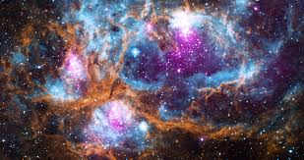

saaaaa

