Single-page web application Flask Project

Student Name: Jakub Biesek

Student Number : G00313966

# Brief

The single page web application that I have created as a part of Data Representation and Querying module is a Flask framework based page with interactive jQuery library elements and AJAX and XML content. By AJAX the website content changes without reloading the page. The whole page is designed with Bootstrap template and CSS code. My single page web application uses MySQL database and python queries to fetch data from database. The website theme is about sport cars overall.

# Simple user Guide

1.My single page web application first feature is hiding of HTML and Bootstrap elements with jQuery pop up message after successful hided element.





2. Another interactive feature without reloading the website is Python code containing a message called by jQuery function and replaced with html elements.

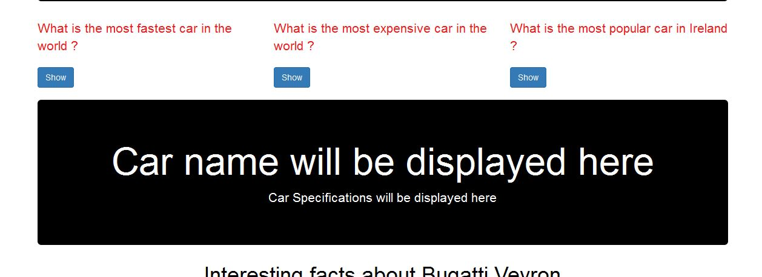

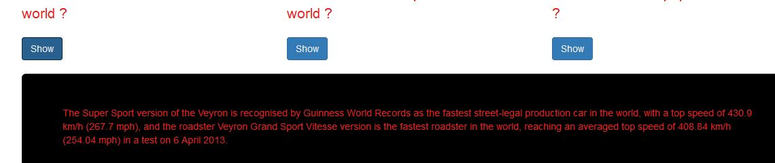

3.This interactive elements uses python,mysql and jQuery features to display the “interesting facts about Bugatti Veyron”. By clicking on one of the buttons the html element will be replaced with database table content.

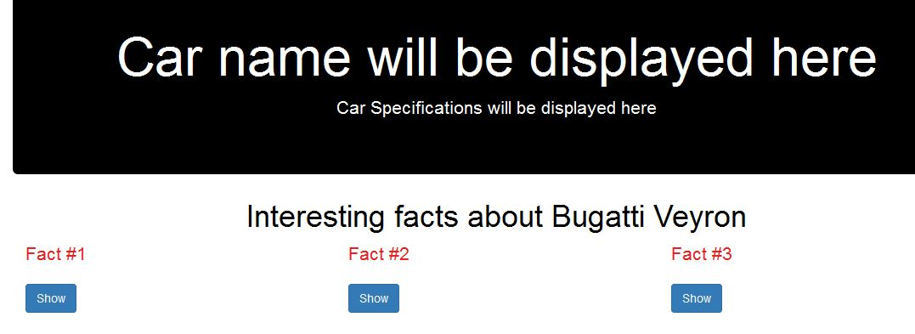

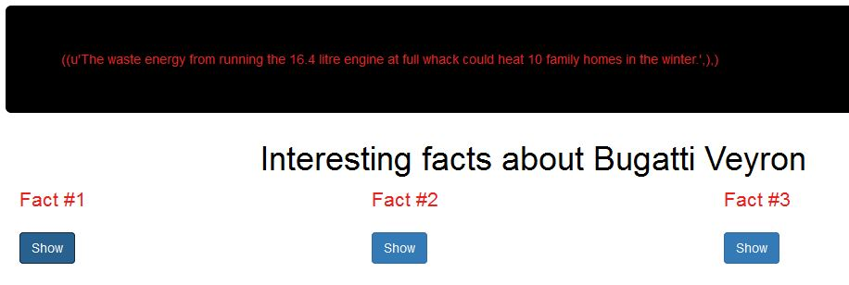

4.Last interactive feature on my website is AJAX function calling the XML file. The XML content is display on html div elements called by AJAX function. With AJAX code the whole page can display XML contents without reloading the page.





# Technology Used

Flask Frame with python –I used the FLASK framework to create a single page web application. I used anaconda cloud to run the python <http://127.0.0.1:5000/> server.

Bootstrap with HTML CSS - I used the Bootstrap template along with HTML and CSS to make my page design more attractive and responsive.

JQuery – I have used the jQuery library to make interactive content and create functions calling python code.

AJAX and XML – I used AJAX and XML to call XML file content onto HTML elements withour reloading the page.

MySQL – I used python to query MySQL database table and by jQuery function call that fetched table rows into html document.