1. Introduction
2. Status Quo
3. Concept
4. Interfaces
5. Functional requirements
6. Non-functional requirements
7. Risk acceptance
8. Development cycle and Architecture
9. Deliverables
10. Acceptance criteria
11. **Introduction**

The purpose of this element is to put all of the information about our project in one place, so we can have clear view on what our customer wants and what we will put in our application.

Our task is to create a Phonebook in Java for a “SmallComp” that will be used by their employees. We will also going to use SQL to store the data of phone numbers.

1. **Status Quo**

Our current situation is not so bright. Thanks to our lack of experience and a deadline that’s pretty short this task might be challenging, but the fact that this program will be done in Java gives us a lot because we are fluent in this programming languages.

1. **Concept**

Our application will contain a table that will show a phone number, name of its owner and his email. It will also contain 2 buttons; first to edit data, second to delete it. We will have 4 fields to add new employee data. There will also be a field to find specified employees. As a bonus thing we will add option to switch languages between English and Deutsch.

1. **Interfaces**

Our program will run in Java. We will use Intellij to create layout of our application and Apache Derby for an database management. To enter the application user will simply have to double click on its icon and program will start running. To use it functions user will be using buttons and text fields as illustrative photo below.

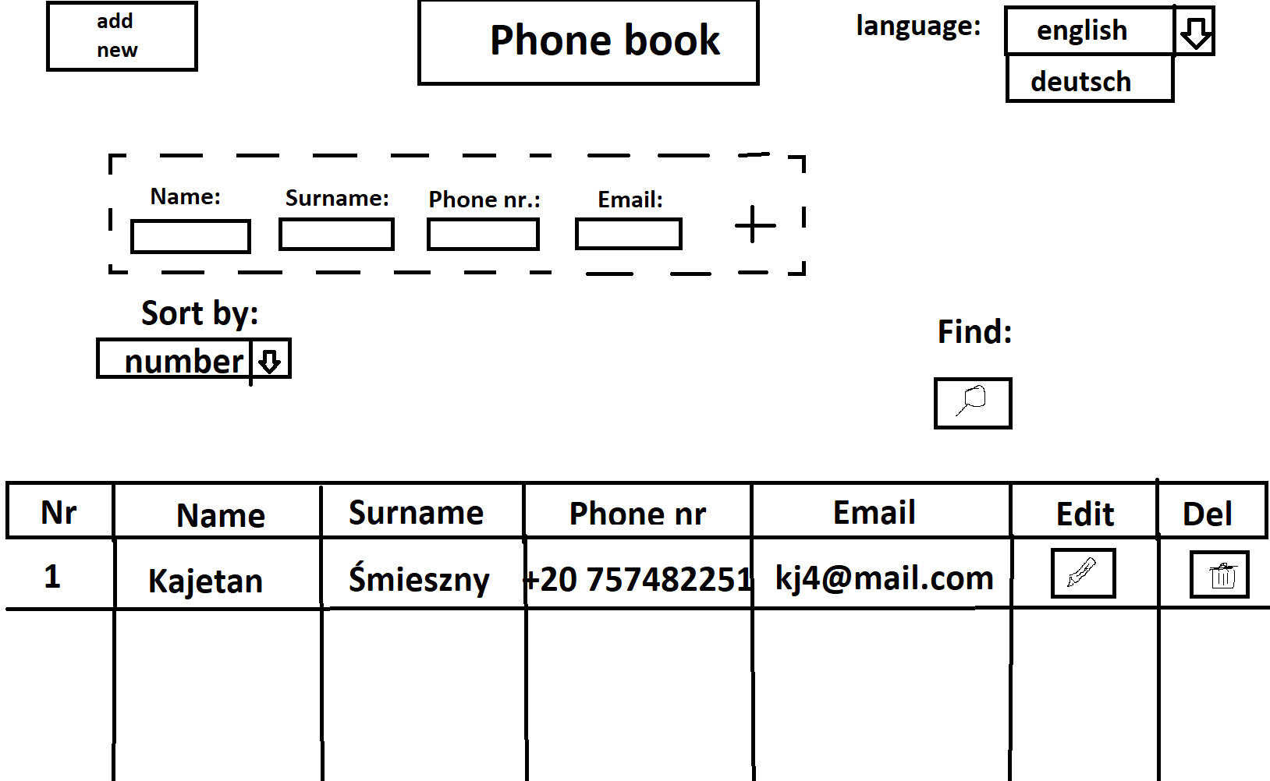

Our project will be also supported by SQL – data pictured in table will be taken from SQL table containing employees data.

1. **Functional requirements**

addNew()- this function will show four text fields to add information about new employees and one button to add him to database

edit()- this function will modify data of chosen employee

delete()- this function will delete chosen employee

find()- this function will allow user to find an employee by his name, surname, phone number or e-mail. After pushing the search button, where will pop up a new window with inputs to put in data that we want to search for an employe (as pictured below). After pushing a search button the table in main window will be updated by search parameters given by user

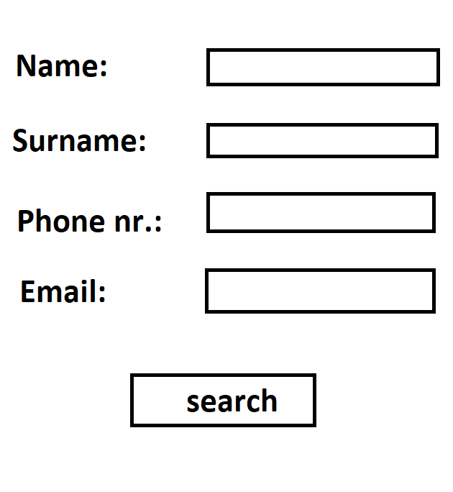

sort()- this function will sort the table by selected type

changeLang()- this function will change applications language

showTab()- this function will create data table in our program

Also we will add validation to text fields that add new employe.

1. **Non-functional requirements**

|  |  |  |  |  |
| --- | --- | --- | --- | --- |
| Criterium | Very important | Important | Less important | Unimportant |
| Usability | **x** |  |  |  |
| Reliability | **x** |  |  |  |
| Efficiency |  | **x** |  |  |
| Changeability |  |  | **x** |  |
| Transferability |  |  |  | **x** |
| Maintainability |  | **x** |  |  |

1. **Risk acceptance**

**The main risk in our project is at a short deadline- there's a danger of not getting the job done for time.**

**Other risk is a limitations of Java- its not the most flexible language for this task witch may cous some problems during creation of our application.**

**There is also risk of losing all of the data from SQL by accident while making operations on it, witch would cous a huge delay in our work.**

**As the last risk we consider the fact that we do not know the programs recommended by our client to create an application. We never worked in Apache Derby or Intellij IDEA, witch can cous us a lot of trouble. In case of a bigger problems with learning this programs, we will switch to more familiar environment for us, witch is NetBeans (for creating layout of our application) and XAMPP (for managing database).**

1. **Development cycle and Architecture**

**Milestones:**

* **Create a layout of application;**
* **Create list in SQL;**
* **Add function to show table of data;**
* **Add functions to find employees;**
* **Create a layout of pop-up window for searching employees;**
* **Add functions to add new employee;**
* **Add function to delete an employee;**
* **Add function to modify a chosen employee;**
* **Add function to sort data in table;**
* **Add function to change applications language;**
* **Add validation to text fields;**
* **Test our application and fix bugs if they occur;**
* **Present project to our client and discuss what to change;**
* **Implement changes and send project to our client.**

1. **Deliverables**

Our project will be delivered as a ready to use exe file. We are going to do that by transferring jar file to exe using external tool, witch will be “Jar to Exe Converter” from site called “Genuine Coder”.

1. **Acceptance criteria**

Our project will be considered as done when:

* We initiate all of the visuals pictured earlier in this document
* We make all of the functions work
* We make our application easy to use for our customer

It is necessary for our application to run properly, that there will be Java 17 and SQL server installed on users PC.