AllegroStyle – Online Marketplace Platform DOCS

# 1. Application Name

AllegroStyle – Online Marketplace Platform

# 2. Problem Area

AllegroStyle addresses the needs of small‑to‑medium retail businesses that want to expand their sales channels beyond brick‑and‑mortar by offering a distributed e‑commerce platform similar to Allegro. It provides a public marketplace storefront where individual shoppers can browse, compare, and purchase goods from a single seller or brand.

# 3. Project Goals

* Deliver a scalable, distributed web application following a client–server architecture (React front‑end + Spring Boot REST back‑end).
* Simplify online shopping for customers with fast search, intuitive navigation, and secure checkout.
* Give the seller (admin) powerful management tools, including real‑time inventory control and advanced analytics.
* Ensure high security, reliability, and maintainability through Spring Security, Bean Validation, CI/CD, and containerized deployment.

# 4. System Responsibilities

AllegroStyle will:

* Authenticate and authorize users with role‑based access (buyer vs. admin).
* Expose RESTful endpoints for all core business resources (products, carts, orders, users).
* Persist data in a relational database with version‑controlled schema migrations.
* Provide a responsive SPA front‑end that consumes the API.
* Generate analytical reports and visual charts for the admin dashboard.

# 5. System Users

* **Guest** – Unregistered visitor browsing products.
* **Buyer** – Registered customer with a personal cart, orders, and profile.
* **Administrator** – Store owner with full CRUD privileges and analytics dashboard.

# 6. Functionalities

* Secure user registration, login, logout (JWT + refresh tokens).
* Buyer profile management (edit personal data, change password, view order history).
* Product catalogue: browse, full‑text search, filter, category navigation.
* Product details with gallery, price history, ratings & reviews.
* Shopping cart (session‑aware), wishlist, recently viewed items.
* Order placement, payment integration (mock provider), shipment tracking.
* **Admin‑only** product CRUD, bulk import/export (CSV).
* Complex sales analytics: revenue charts, top products, inventory alerts.
* Dark/light theme & fully responsive UI.
* Public REST API documented with OpenAPI/Swagger.
* API rate‑limiting and input validation (Bean Validation).
* Dockerized local dev & production stacks.

# 7. User Requirements

Part 1: Domain Structure (Entities, Properties, Relationships)

* **User**: id, name, email, password, role {BUYER, ADMIN}, address, created_at
* **Product**: id, sku, name, description, price, stock, category_id, created_at
* **Order**: id, user_id, placed_at, status, total, shipping_address
* **OrderItem**: order_id, product_id, quantity, unit_price
* **Cart**: id, user_id, created_at
* **CartItem**: cart_id, product_id, quantity
* **Review**: id, user_id, product_id, rating, comment, created_at
* **Category**: id, parent_id, name
* Relationships:
* User 1‑* Order, User 1‑1 Cart, Product 1‑* Review
* Order 1‑* OrderItem, Product 1‑* OrderItem
* Category self‑hierarchy, Product *‑1 Category

Part 2: Expected Functionality

* Register / login / logout (JWT)
* Edit profile & address book
* Browse & search catalogue; filter by category/price/keyword
* Add/remove items to cart & wishlist
* Checkout → create Order, clear Cart
* Leave product review (only after purchase)
* **Admin**: manage users, products, categories, orders; generate analytics

Part 3: Constraints

* Must support the latest 3 versions of Chrome, Firefox, and Edge.
* Passwords hashed (bcrypt, strength ≥ 12).
* Handle ≥ 100 concurrent buyers with p95 response < 2 s.
* Daily automated database backup (retention 30 days).
* 99 % monthly uptime; automated health checks & alerting.

# 8. Functional Requirements

# 9. System Structure (Conceptual Diagram)

# 10. Non‑functional Requirements

|  |  |
| --- | --- |
| Constraint | Metric |
| Browser compatibility | Latest 3 versions of Chrome/Firefox/Edge (QA quarterly) |
| Authentication security | bcrypt hash ≥ 12, JWT expiry 1 h (pentest report) |
| Performance | ≤ 2 s p95 latency @ 100 concurrent users (JMeter load test) |
| Backup | Daily dump, 30‑day retention, recovery test monthly |
| Uptime | ≥ 99 % per calendar month (monitoring SLA) |

# 11. Database Schema

# 12. API Endpoints

|  |  |  |
| --- | --- | --- |
| Endpoint | Method | Description |
| /api/auth/register | POST | Register new buyer |
| /api/auth/login | POST | Login & receive tokens |
| /api/products | GET | List / search products |
| /api/products/{id} | GET | Product details |
| /api/products | POST | Create product (admin) |
| /api/products/{id} | PUT | Update product (admin) |
| /api/products/{id} | DELETE | Delete product (admin) |
| /api/cart | GET | Current cart |
| /api/cart/items | POST | Add item |
| /api/cart/items/{id} | PATCH | Update quantity |
| /api/cart/items/{id} | DELETE | Remove item |
| /api/orders | POST | Place order |
| /api/orders | GET | Buyer order history |
| /api/admin | GET | Analytics (admin) |

# 13. Technologies & Tools

|  |  |  |
| --- | --- | --- |
| Technology | Layer | Purpose |
| **React + Vite** | Front‑end | SPA user interface |
| **TypeScript** | Front‑end | Type safety |
| **Spring Boot** | Back‑end | REST API, business logic |
| **Spring Security** | Back‑end | AuthN & AuthZ |
| **Bean Validation** | Back‑end | Input/data validation |
| **Spring Data JPA + Hibernate** | Back‑end | ORM data access |
| **MySQL 8** | Database | Primary relational store |
| **Flyway** | DevOps | Schema migrations |
| **Docker / Docker Compose** | DevOps | Containerization |
| **JWT** | Security | Stateless sessions |
| **Chart.js** | Front‑end | Visual analytics |
| **OpenAPI (Swagger)** | Docs | API documentation |

# 14. UI/UX Mock‑ups

* Sign in

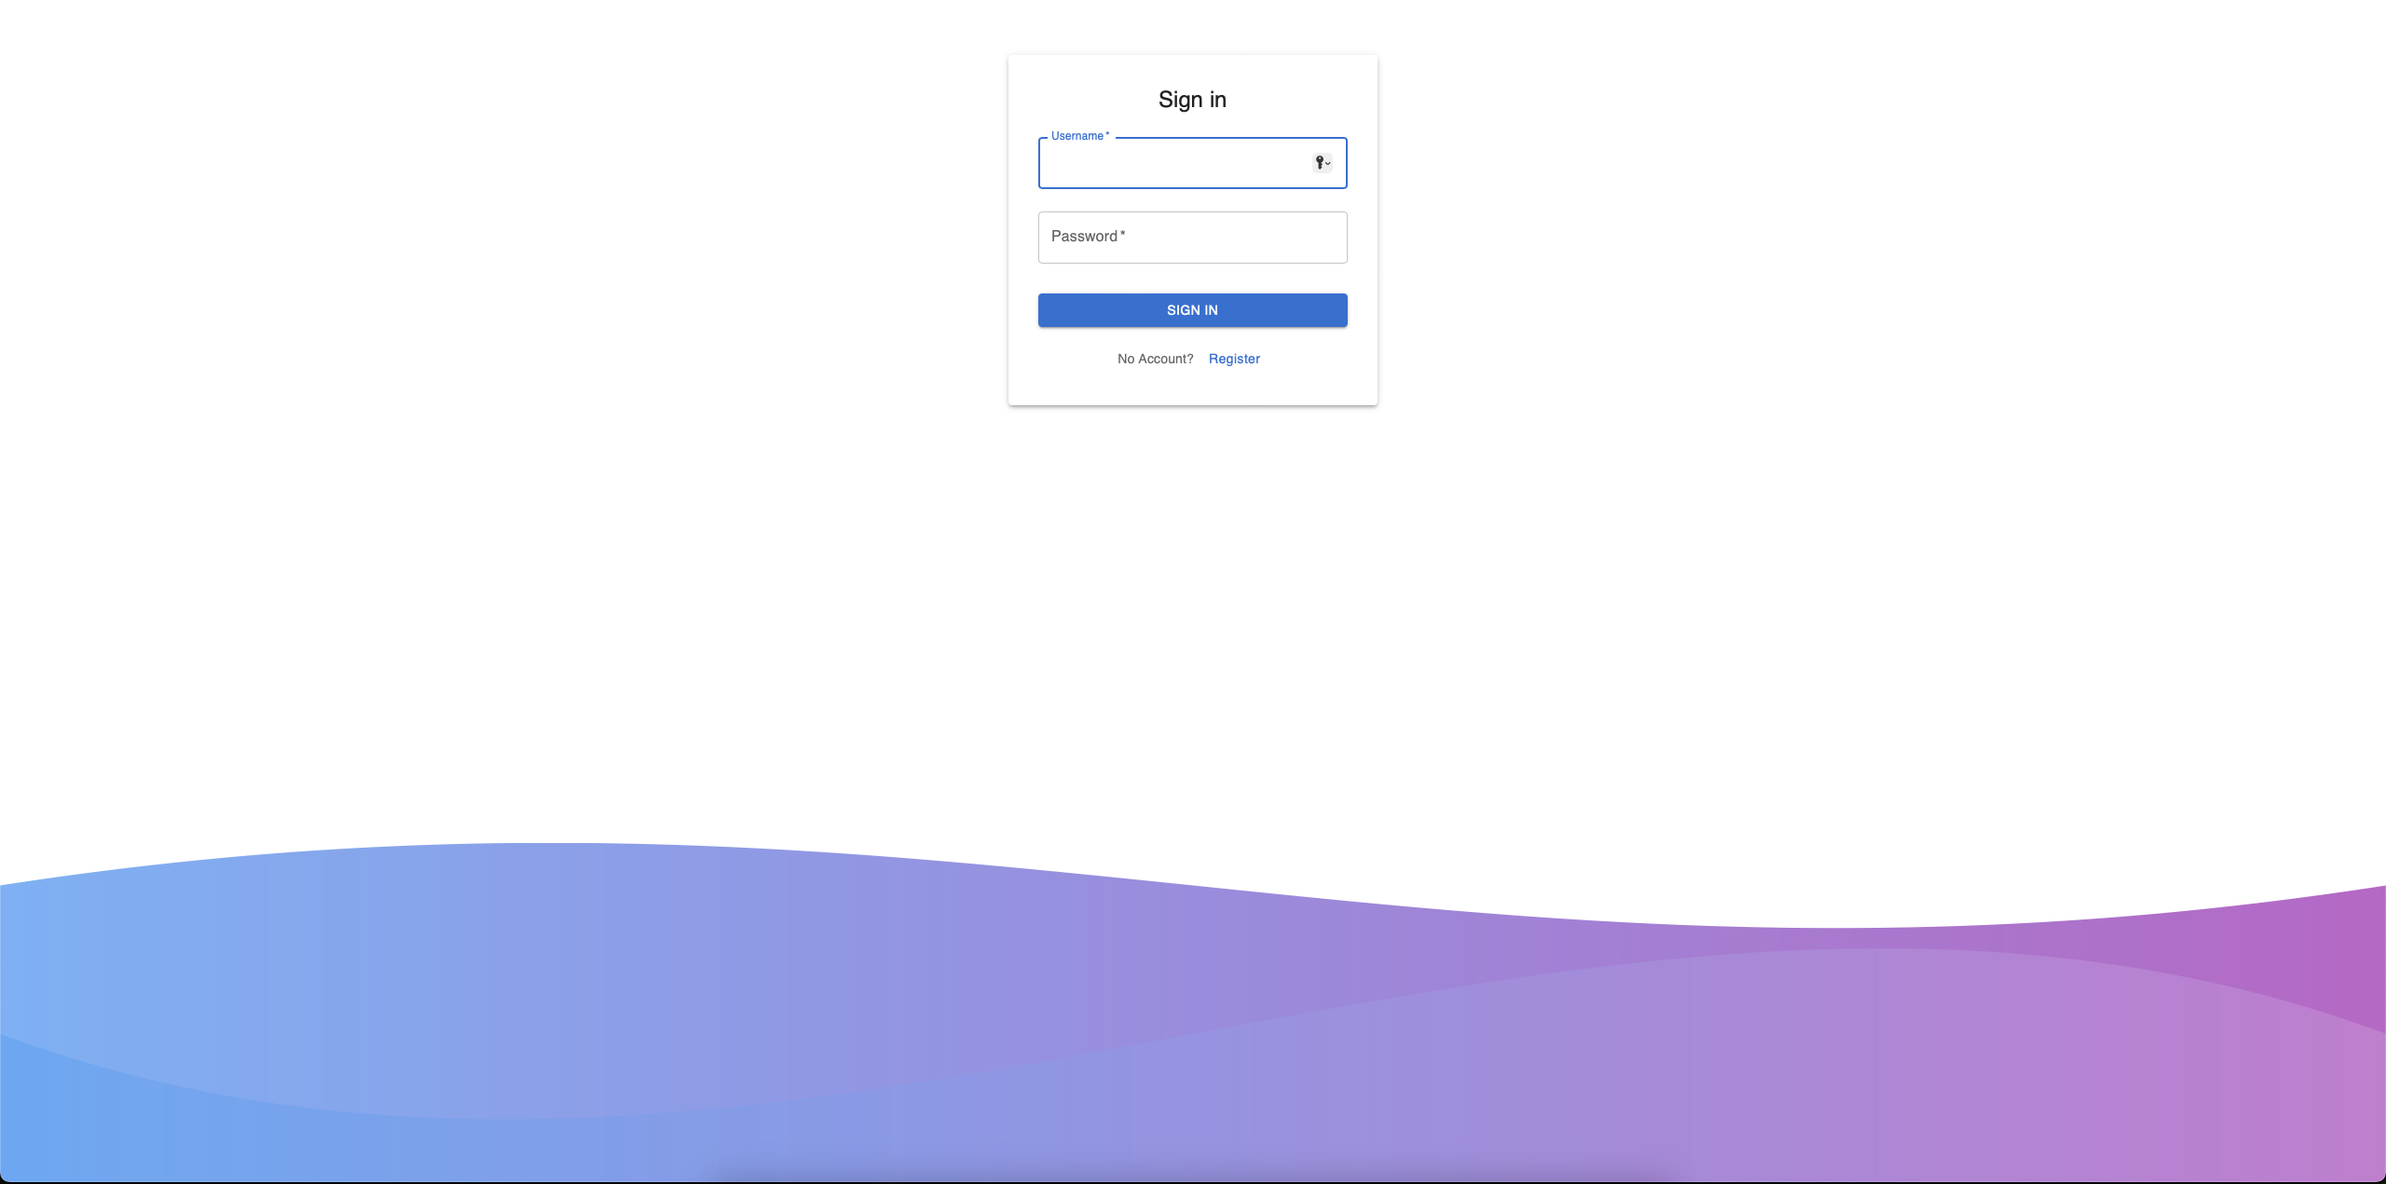

* Register

* Sign In ERROR

* Home Page

* Buyer Profile

* Navbar

* Admin Dashboard (sales charts)

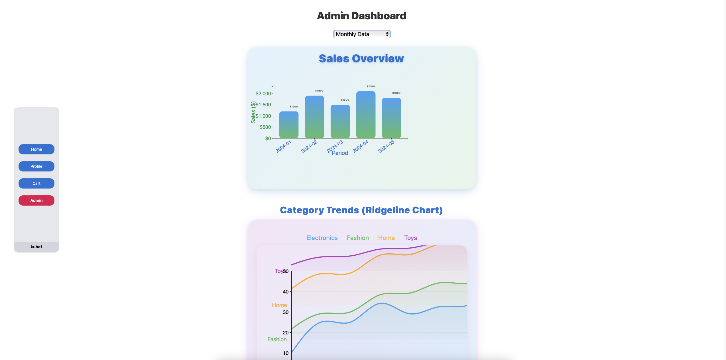

* Sales Overview

* Category Trends

# 15. Project Team

* Jakub Graliński (s30351) & Mateusz Laskowski (s30613)