2021

Tested url: https://www.naturativ.pl/

Start time: 12:40

End time: 13:00

My environment: Windows 10 Home, Chrome browser Ver. 92.0.4515.159 (64bit)

Exploration test of the website Naturativ

Tester: Jakub Klimas

Objective: Testing the functionality of the Homepage of website NATURATIV

**Bugs found:**

**1.**

**Title:** Impossible to add more than one of the same product to the basket.

**Type of bug:** Content

**Frequency:** Every time

**Priority:** Medium

**Action performed:**

1. Open the website: <https://www.naturativ.pl/>

2. Scroll down until you see the products.

3. Press the button „Add to cart”.

**Expected result:** We should be able to select the amount of the product.

**Actual result:** We can add only one product to the cart.

**Suggestion:** Add option to select amount of the product from the Homepage.

**Screen:**

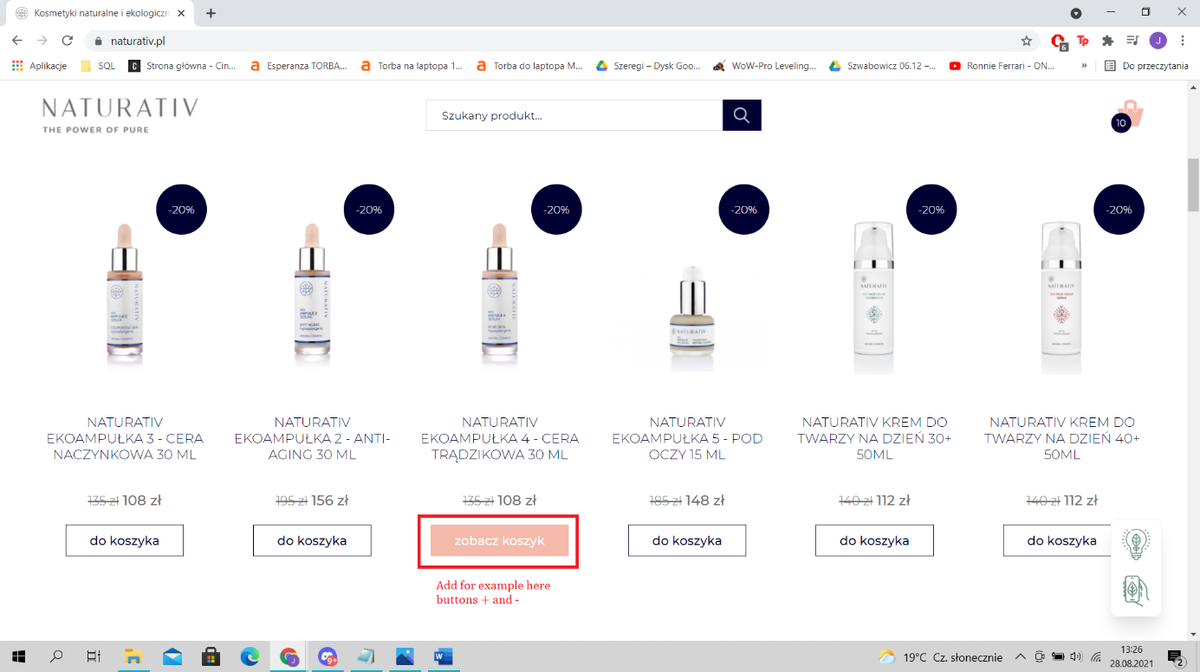

**2.**

**Title:** After adding product to the cart and refreshing the page, the button „in the basket” doesn’t work.

**Type of bug:** Functional

**Frequency:** Every time

**Priority:** High

**Action performed:**

1. Open the website: <https://www.naturativ.pl/>

2. Scroll down until you see products.

3. Press the button „Add to cart”.

4. Refresh the page.

5. Scroll down until you see product which you added to cart.

**Expected result:** We should be able to interact with the button „in cart”.

**Actual result:** Nothing happenes when we press this button.

**Screen:**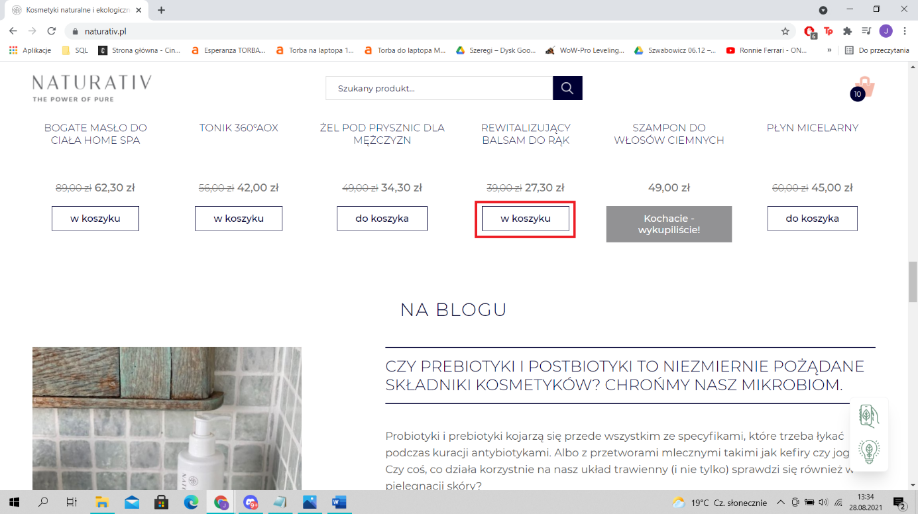

**3.**

**Title:** Impossible to go back to a previous banner

**Type of bug:** Content

**Frequency:** Every time

**Priority:** Low

**Action performed:**

1. Open the website: <https://www.naturativ.pl/>

2. Scroll down until you see a banner under the „NATURAL AND ECOLOGICAL COSMETICS - POLISH PRODUCER”.

**Expected result:** We should be to able to go to next and previous banner.

**Actual result:** We have to wait until banner automatically changes.

**Suggestion:** Add buttons „next” and „previous”.

**Screen:** 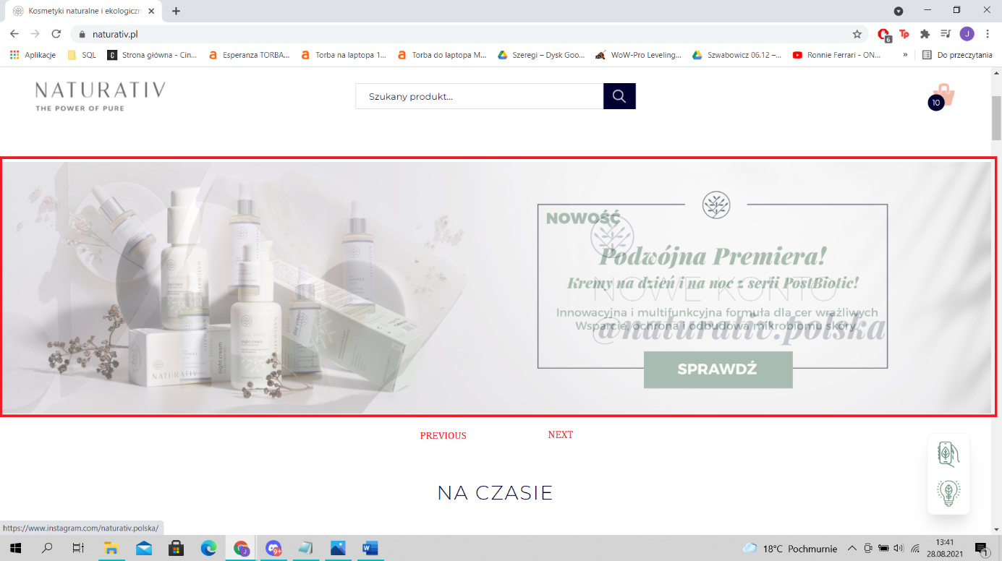

**4.**

**Title:** We can sign up for newsletter using letters and symbols.

**Type of bug:** Functional

**Frequency:** Every time

**Priority:** High

**Action performed:**

1. Open the website: <https://www.naturativ.pl/>

2. Scroll down until you see a banner under the „Subscribe to SMS with exclusive offers!”.

3. Write random symbols or random letters (without digits).

4. On the next website accept “I consent to receiving electronic correspondence from and NATURATIV Sp. z o.o. and AROMEDA Sp. z o.o. containing information about the cosmetics offer of these companies as well as about promotions and available discounts.”

5. Click „Sign up”.

**Expected result:** We shouldn’t be to able to sign up.

**Actual result:** We can sign up.

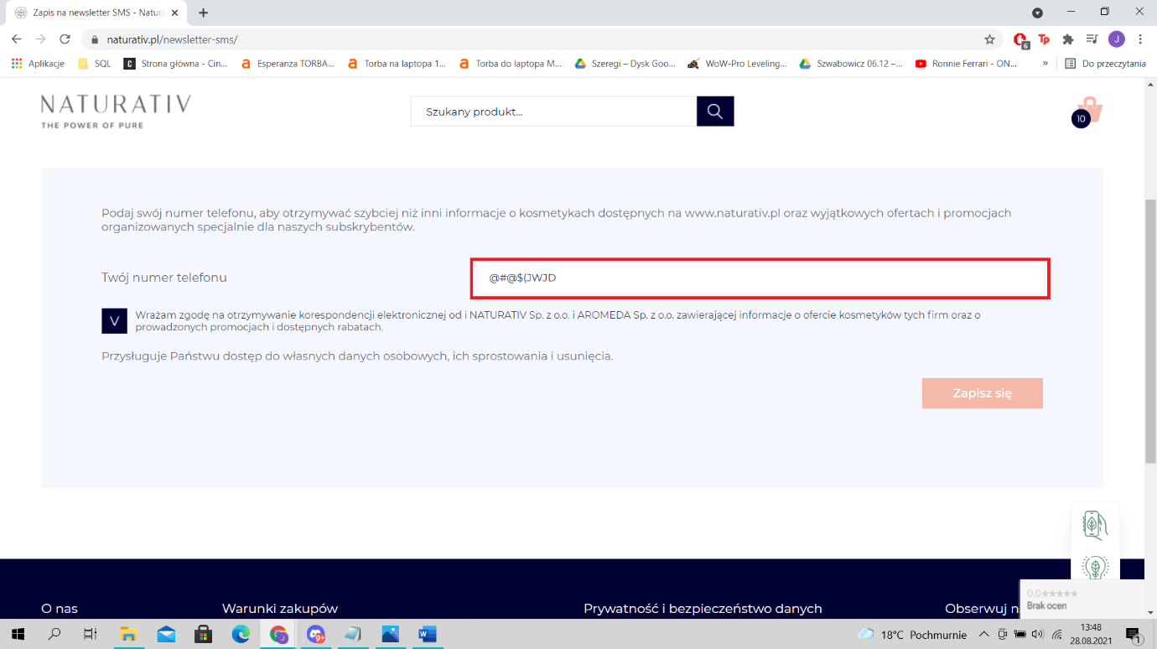**Screen:**

**5.**

**Title:** After clicking on „Payment form” button we are transferred to the website with broken images.

**Type of bug:** Visual

**Frequency:** Every time

**Priority:** Medium

**Action performed:**

1. Open the website: <https://www.naturativ.pl/>

2. Scroll down to the buttom of the page until you see „Payment form”.

3. Click on “Payment form” button.

**Expected result:** We should be transferred into website with working images.

**Actual result:** Images on the „Payment form” page are broken.

**Screen:**

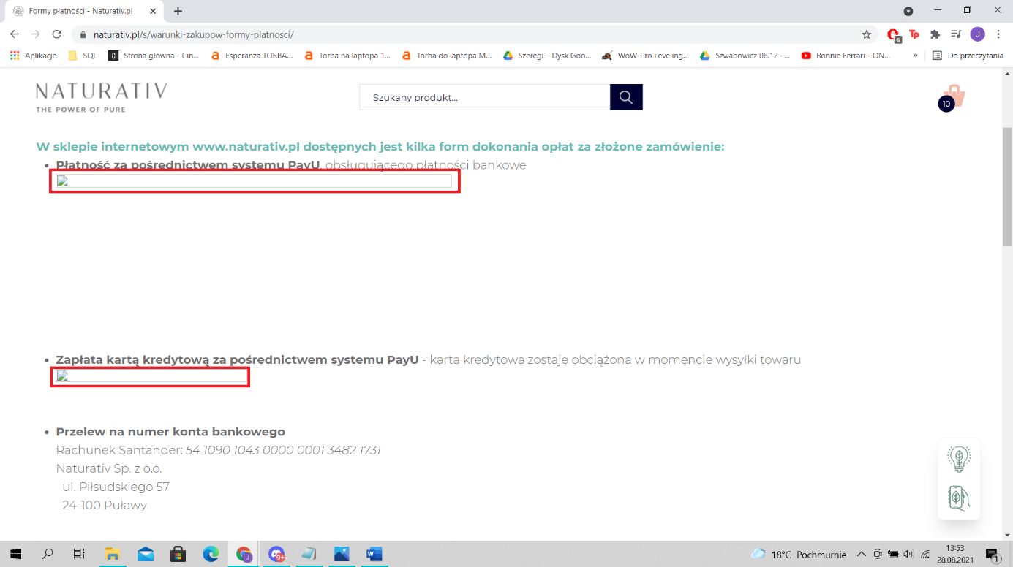

**Lighthouse test report:**

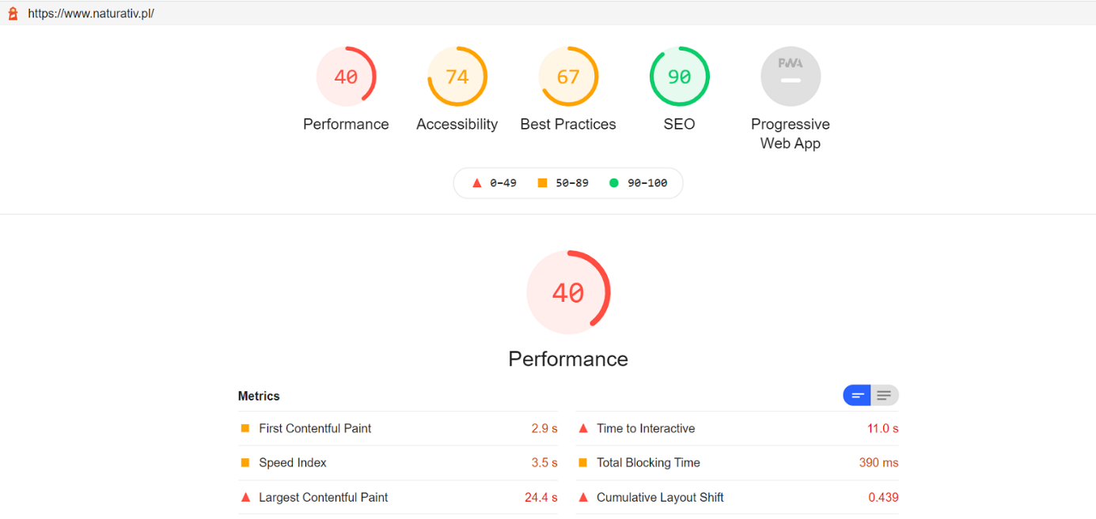

**Tips about increasing performance of the website:**

Save images in next-gen formats:

Image formats like JPEG 2000, JPEG XR, and WebP often provide better compression than PNG or JPEG, which means faster downloads and less data consumption.

Reduce unused JavaScript:

Reduce unused JavaScript and defer loading scripts until they are required to decrease bytes consumed by network activity.

Eliminate render-blocking resources:

Resources are blocking the first paint of your page. Consider delivering critical JS/CSS inline and deferring all non-critical JS/styles.

**Issues for further analysis:**

Carrying out tests for individual subpages.