Open Source Software: A Practical Case for Adoption, Contribution, and Trust
  - A concise advocacy document for developers, companies, and everyday users

Executive Summary
Open source software is no longer a niche alternative; it is a foundation of modern computing, cloud infrastructure, artificial intelligence, security tooling, web platforms, and everyday productivity. For programmers, it offers learning, visibility, reuse, and collaboration. For companies, it can reduce costs, improve flexibility, accelerate innovation, and avoid unnecessary vendor lock-in. For users, it can provide transparency, long-term access, and community-driven improvement.

Why Open Source Matters
- Transparency: Source code can be inspected, audited, improved, and adapted.
- Innovation speed: Communities can experiment, review, and ship improvements faster than isolated teams.
- Cost efficiency: Many organizations adopt open source to reduce license costs and total software spend.
- Interoperability: Open standards and open implementations make systems easier to integrate.
- Talent development: Developers learn from real-world codebases and build public portfolios.
- Digital sovereignty: Organizations can retain more control over their technology stack and deployment choices.

Evidence of Adoption
Recent industry reporting shows that open source adoption remains extremely strong: the 2025 State of Open Source findings highlighted that 96% of organizations either increased or maintained their use of open source software in the previous year, with cost efficiency as the leading motivation. GitHub’s Octoverse reporting also shows rapid growth in global developer participation and a major rise in public generative AI projects, reinforcing that open collaboration is central to current software innovation.

Simple Adoption Snapshot
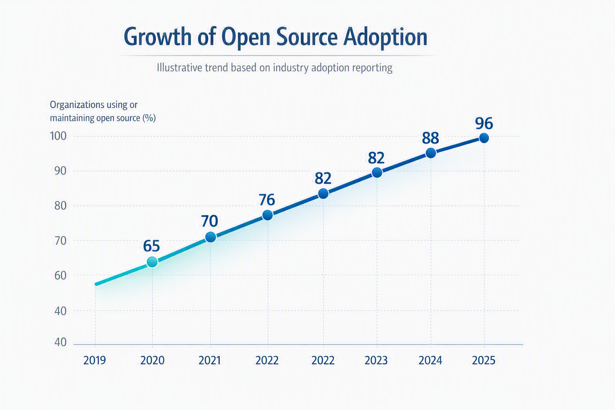

Successful Open Source Projects
Project | What it does | Why it matters
Linux | Operating system kernel | Powers servers, Android devices, embedded systems, cloud infrastructure, and supercomputers.
Apache HTTP Server | Web server software | Helped build the modern web by providing a reliable, extensible server platform.
Kubernetes | Container orchestration | Standardized large-scale cloud-native deployment and operations.
PostgreSQL | Relational database | Offers a powerful, standards-oriented database trusted by startups, enterprises, and public institutions.
Git | Distributed version control | Transformed software collaboration and enabled modern distributed development workflows.
Blender | 3D creation suite | Shows that professional creative tools can thrive with community and industry support.
Firefox | Web browser | Promotes web standards, user choice, and privacy-focused browsing.

Arguments for Developers, Companies, and Users

For Developers
Open source gives developers access to production-grade code, real review processes, issue discussions, and communities where skills become visible. Contributions can support career growth, improve technical judgment, and create opportunities for collaboration beyond one employer.

For Companies
Companies benefit when they treat open source as a strategic asset rather than simply free software. A mature approach combines selection criteria, security updates, license compliance, contribution policies, internal ownership, and community engagement. This reduces risk while preserving the flexibility that makes open source attractive.

For Users
Users gain from software that can be inspected, translated, customized, supported by multiple providers, and preserved even if a single vendor changes direction. Open source is especially valuable where trust, privacy, longevity, and public accountability matter.

Risks and How to Manage Them
- Security: Use dependency scanning, update policies, and vulnerability monitoring.
- Licensing: Track licenses and obligations before including components in products.
- Maintenance: Prefer active projects with documented governance and release history.
- Skills: Train teams and assign internal ownership for important open source dependencies.
- End-of-life software: Maintain migration plans for unsupported components.

Recommended Call to Action
- Start with a small pilot project using a well-supported open source tool.
- Create a basic open source policy covering security, licensing, and contribution rules.
- Encourage developers to read, report issues, document fixes, and contribute responsibly.
- Evaluate total value, not only license cost: independence, interoperability, speed, talent, and risk reduction all matter.
- Support critical projects through contributions, sponsorship, bug reports, testing, or documentation.

