The United States of America: Origins, Culture, Nature, and Historical Transformation
  - A C2-Level Analytical Overview
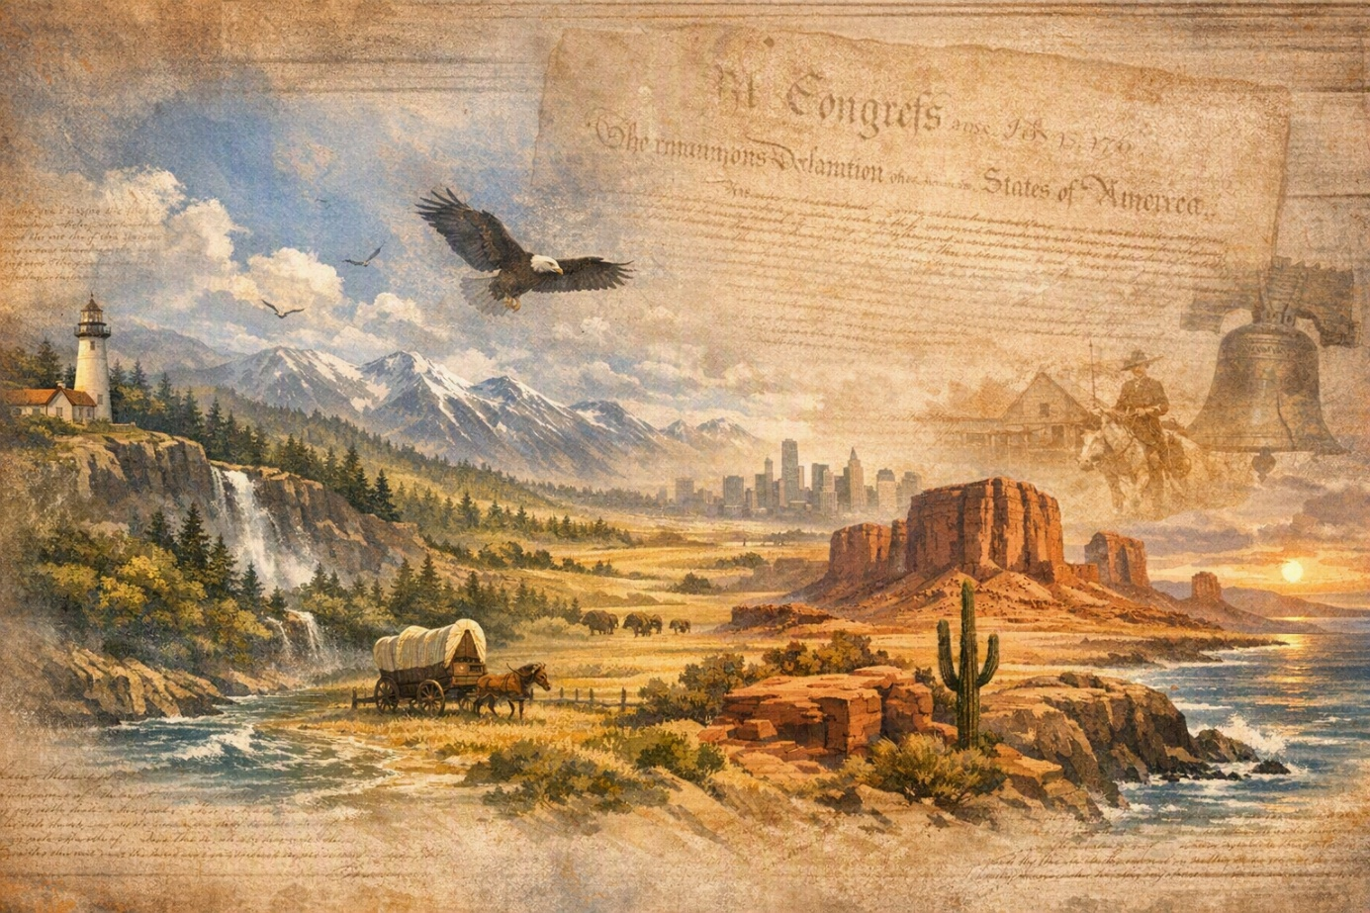

Table of Contents
Table of Contents 1

1. Before the United States: Indigenous Worlds and Continental Diversity
Long before the United States existed as a political entity, the North American continent contained densely varied Indigenous societies whose histories stretched back many millennia. Communities adapted with extraordinary sophistication to coastal fisheries, river valleys, woodland agriculture, arid plateaus, grasslands, and sub-Arctic environments. Their economies, spiritual traditions, diplomatic systems, and ecological knowledge were not marginal prefaces to American history; they were foundational realities that shaped every later encounter. The eventual United States emerged not from an empty wilderness, but from a continent already inhabited, named, cultivated, traded across, and interpreted through complex cultural worlds.
The geographic diversity of the future United States helped produce cultural diversity. Pacific coastal peoples developed maritime technologies and rich artistic traditions; Plains societies became associated with mobility, bison economies, and far-reaching intertribal exchange; Eastern woodland communities integrated agriculture, hunting, and diplomacy; and Southwestern peoples built settlements, irrigation networks, and ceremonial systems suited to demanding landscapes. Any serious account of America’s origins must therefore begin with plurality, not singularity.

2. Colonization and the Formation of Thirteen British Colonies
European colonization transformed the continent through commerce, settlement, disease, warfare, forced labor, religious aspiration, and imperial rivalry. English colonists established Jamestown in 1607 and Plymouth in 1620, while Spanish, French, Dutch, and other European powers pursued competing claims. Over time, thirteen British colonies developed along the Atlantic seaboard, each with distinctive economic structures and social hierarchies. New England evolved around towns, churches, seaborne trade, and small-scale farming; the Middle Colonies became marked by religious and ethnic pluralism; and the Southern Colonies increasingly depended on plantation agriculture and the brutal institution of slavery.
Colonization was thus both creative and destructive: it produced new legal institutions, towns, markets, and cultural identities, yet it also dispossessed Indigenous nations and expanded systems of coercion. The contradiction between liberty and domination would become one of the enduring moral tensions of American life.

3. Revolution, Independence, and Constitutional Design
The American Revolution arose from a convergence of imperial policy, colonial self-confidence, Enlightenment political thought, and disputes over taxation and representation. After Britain’s victory in the Seven Years’ War, Parliament attempted to tighten control over the colonies. Resistance escalated from petitions and boycotts to armed conflict, beginning in 1775. On 4 July 1776, the Declaration of Independence articulated a radical claim: legitimate government rests on consent, and human beings possess rights that governments must not violate.
Independence, however, did not immediately solve the problem of governance. The Articles of Confederation created a weak central authority, and the Constitutional Convention of 1787 sought a more durable balance between national power and local autonomy. The Constitution established federalism, separation of powers, checks and balances, and later, through the Bill of Rights, explicit protections for speech, religion, assembly, due process, and other liberties. Yet the founding settlement also compromised with slavery, leaving unresolved conflicts that would eventually tear the republic apart.

Diagram: From Colonies to Republic
Colonial Grievances | Revolutionary Action | Institutional Outcome
Taxation, imperial regulation, limits on settlement, and disputes over representation | Boycotts, congresses, armed resistance, declaration of independence | Articles of Confederation, then the Constitution and Bill of Rights
Local political experience and Enlightenment ideas | Claims about consent, rights, and republican self-government | Federal republic with elected institutions and divided powers

4. Expansion, Civil War, and Reconstruction
During the nineteenth century, the United States expanded dramatically across the continent through purchase, war, diplomacy, migration, and coercive removal. The ideology of Manifest Destiny presented expansion as providential and inevitable, but its consequences were profoundly contested. Indigenous nations faced forced displacement and broken treaties; Mexico lost vast territories after war; and the extension of slavery into new lands intensified sectional conflict.
The Civil War, fought from 1861 to 1865, was the decisive crisis of the American republic. It tested whether a nation founded on popular government could survive internal rupture and whether slavery would continue to define its political economy. The Union victory preserved the United States and led to the abolition of slavery, but Reconstruction’s promise of interracial democracy faced violent resistance and was ultimately curtailed. The struggle over citizenship, voting rights, and equality remained central to American history long after the war ended.

5. Industrialization, Immigration, and Urban Modernity
After the Civil War, the United States became an industrial power at remarkable speed. Railroads integrated national markets; steel, oil, electricity, and finance transformed production; and cities grew into laboratories of modern life. Millions of immigrants arrived from Europe, Asia, Latin America, and elsewhere, reshaping languages, cuisines, religions, labor movements, and neighborhood cultures. The same era produced immense wealth and severe inequality, prompting debates about monopoly, workers’ rights, political corruption, and the social responsibilities of capitalism.
American culture became increasingly hybrid. Jazz, vaudeville, popular newspapers, immigrant literature, sports, and new forms of consumer entertainment helped create a mass culture, while regional traditions persisted. The United States was becoming not merely a larger country, but a more interconnected and self-consciously modern society.

6. The Natural Environment: Scale, Variety, and Imagination
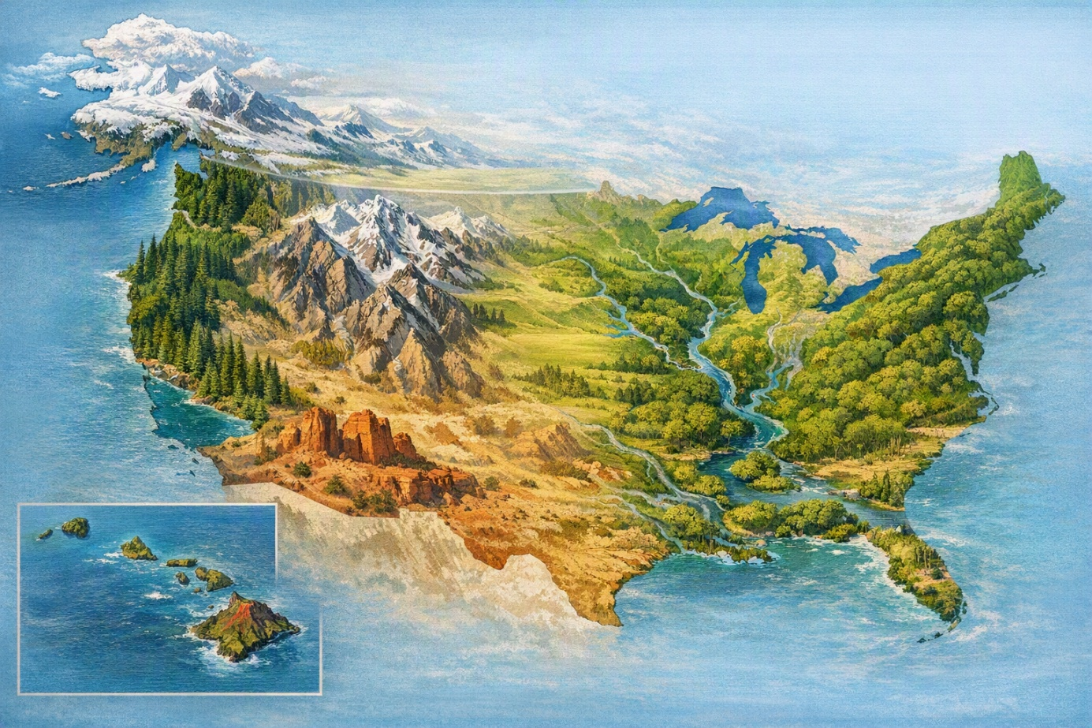
The natural geography of the United States is unusually expansive and varied. Its environments range from Alaskan tundra and Hawaiian volcanoes to Pacific rainforests, Rocky Mountain ranges, Great Plains grasslands, Mississippi floodplains, Appalachian ridges, Southwestern deserts, and Atlantic coastal wetlands. This environmental breadth has shaped economic development, settlement patterns, literature, tourism, conservation politics, and national mythology.
Nature has also functioned as a moral and aesthetic vocabulary in American culture. The wilderness could symbolize divine grandeur, democratic renewal, commercial opportunity, or environmental fragility. National parks such as Yellowstone and Yosemite helped institutionalize the idea that certain landscapes should be preserved for public benefit, even as conservation itself often involved tensions with Indigenous sovereignty and local livelihoods.

Diagram: Landscapes and Cultural Meanings
Landscape | Representative Meaning | Cultural Impact
Frontier and plains | Mobility, risk, expansion, reinvention | Western literature, film, national mythology
Mountains and wilderness | Sublimity, preservation, spiritual renewal | National parks, landscape painting, environmentalism
Cities and coasts | Immigration, commerce, creativity, inequality | Music, architecture, journalism, political movements

7. Culture: Pluralism, Popular Forms, and Global Influence
American culture is best understood as a dynamic argument rather than a fixed essence. It combines Indigenous legacies, European colonial traditions, African diasporic creativity, immigrant reinvention, religious experimentation, commercial media, and regional distinctiveness. The result is not uniformity, but a recurring capacity to absorb, remix, commodify, contest, and export cultural forms.
Music offers a particularly vivid example. Spirituals, blues, jazz, gospel, country, rock and roll, soul, hip-hop, and electronic genres emerged from specific communities yet acquired national and global resonance. Literature likewise moved from Puritan sermons and captivity narratives to transcendentalism, realism, modernism, the Harlem Renaissance, postmodernism, and contemporary multicultural writing. Film, television, advertising, and digital platforms have made the United States a central engine of global popular culture, even as American culture remains internally contested by questions of race, gender, class, region, migration, and memory.

8. The Twentieth Century: Crisis, Power, and Rights
The twentieth century transformed the United States into a global power. The country participated decisively in two world wars, experienced the Great Depression, built New Deal welfare and regulatory institutions, and entered the Cold War as one of two superpowers. Economic abundance after 1945 expanded the middle class, suburbanized daily life, and strengthened consumer culture, yet prosperity was unevenly distributed and often built on exclusionary structures.
The civil rights movement challenged segregation and demanded that the nation honor its constitutional promises. Women’s rights activism, Native sovereignty movements, Latino and Asian American organizing, labor struggles, environmental campaigns, and LGBTQ+ advocacy broadened the meaning of citizenship. American history in this period is therefore not simply a story of power abroad; it is also a story of democratic pressure from below.

9. Contemporary America: Innovation, Division, and Global Interdependence
Contemporary America is marked by technological innovation, demographic complexity, cultural influence, and political polarization. Silicon Valley, biotechnology, higher education, finance, entertainment, and military capacity contribute to American power, while inequality, racial injustice, climate change, immigration debates, public health challenges, and distrust in institutions reveal deep vulnerabilities. The United States remains a nation of extraordinary creative possibility, but its democratic future depends on whether it can reconcile freedom with responsibility, pluralism with solidarity, and prosperity with ecological restraint.

10. Conclusion: America as an Unfinished Project
The history of the United States is not reducible to triumph, failure, innocence, or hypocrisy alone. It is a history of founding ideals and exclusions, breathtaking landscapes and environmental exploitation, cultural brilliance and social conflict, democratic expansion and recurring backlash. Its most enduring characteristic may be its unfinishedness: the promise that political principles can be argued over, expanded, contradicted, and renewed. To understand America is therefore to study a country continually making and remaking itself through memory, struggle, imagination, and power.

Selected Sources
- Encyclopaedia Britannica, entries on the United States and its history.
- Library of Congress, U.S. History Primary Source Timeline and Creating the United States exhibition.
- Smithsonian Institution, resources on American history and culture.

