- Creating s3 bucket for terraform remote backend
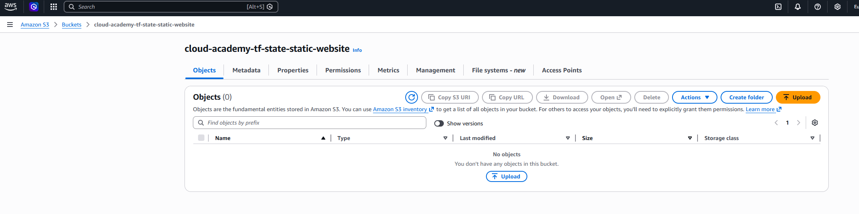
- Creating DynamoDB
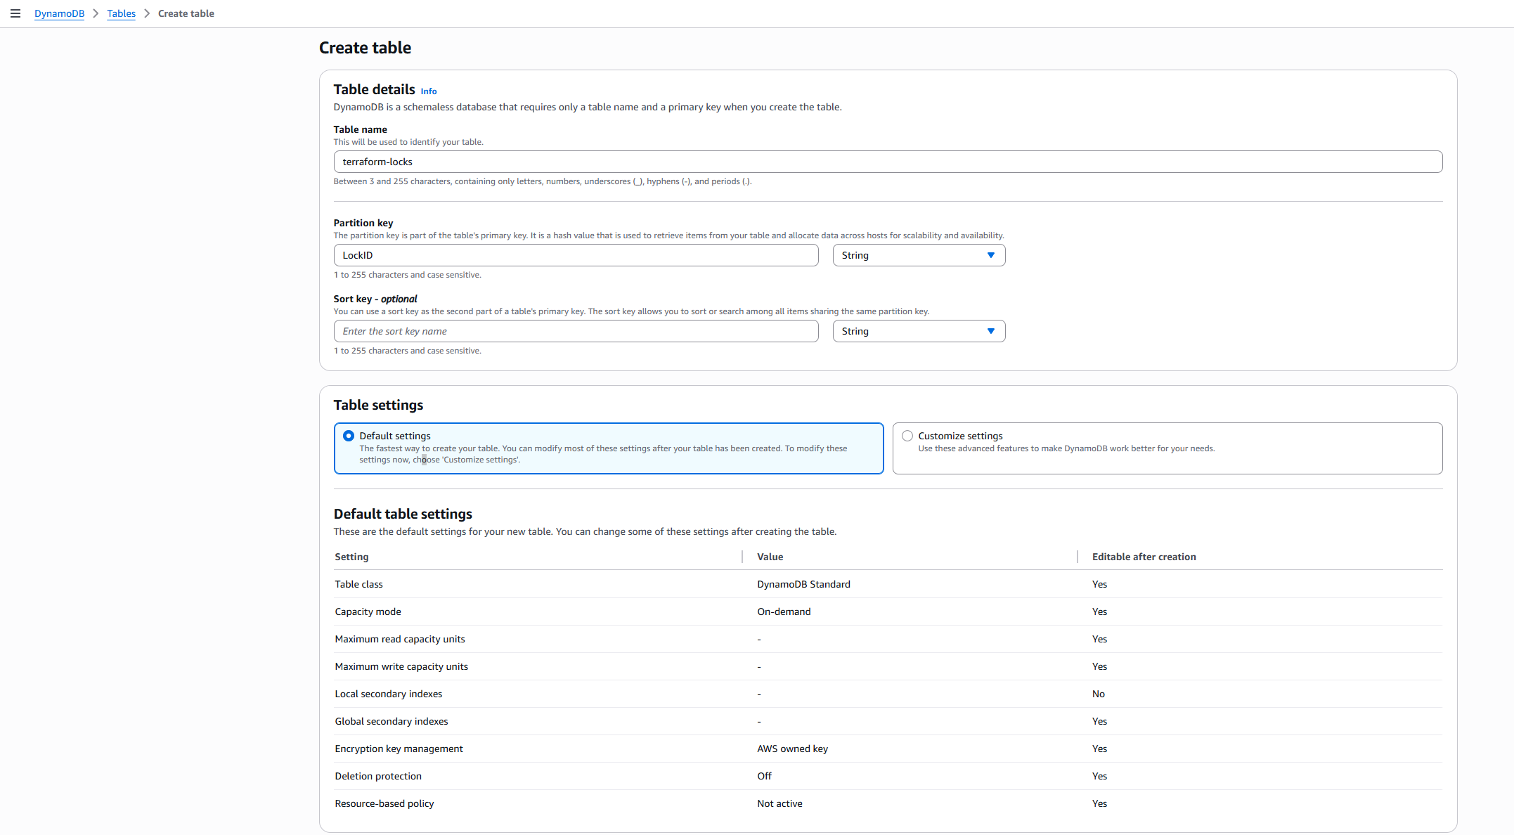
- AWS CLI profile configuration
- Setting up remote backend after setting my profile
