Software Maintenance Report - Copy/Paste in JHotDraw
Maintaining the Basic Editing Copy/Paste Feature
[Fill in full name]
11 June 2026
Table of Contents

Report Information
Field | Value
Full name | [Fill in full name]
Student exam number | [Fill in exam number]
Student email | [Fill in student email]
Course number | SB5-MAI Software Maintenance, 5 ECTS
Lecturer | [Fill in lecturer name and email]
Repository | https://github.com/JakubPotocky/JHotDraw
Branch | copy-paste-basic-editing-labs
Inspected commit | b4eea56487ea289d6c1855d9ba32150e16b31366
Local checkout | /home/bob/Desktop/university/softwareMaintenance/JHotDraw
Number of pages | Update after final export

Abstract
This report is part of the 5 ECTS Software Maintenance course. The objective is to maintain an existing software project by locating a feature in unfamiliar code, analysing the impact of a change, removing bad code smells, improving internal structure, and verifying that behaviour is preserved.
The case study is JHotDraw, a Java/Swing drawing framework. The selected work area is Basic Editing Copy/Paste. Copy/Paste already existed in the repository, so this is preventive maintenance rather than a new feature. The implemented change removes duplicated paste-import logic from DefaultDrawingViewTransferHandler, extracts importTransferData(...) and firePasteUndoableEdit(...), removes a dead private method, improves comments, and makes small documentation/immutability cleanup in CompositeTransferable.
Verification was added through 13 JUnit 4 tests, including 5 BDD-style Given-When-Then scenarios. Local Maven verification passed for both the sample module and the full reactor. The repository contains a GitHub Actions workflow for develop push/pull-request events, but no remote CI result for this feature branch was available from the inspected evidence. Therefore, this report claims local verification and CI readiness for PR integration, not an already merged or remotely green branch.

Introduction
JHotDraw is a framework for building structured two-dimensional drawing editors. It is suitable for software maintenance because it is large enough to require real concept location: the maintainer must understand actions, Swing transfer mechanisms, clipboard wrappers, drawing views, figure models, and input/output formats before changing a simple-looking user feature.
The selected feature is Copy/Paste under Basic Editing. It was chosen because it is user-visible and central to a drawing editor, but technically spread across several layers. A user expects to select a figure, copy it, paste it back, and continue editing without manually recreating the same object.
Layer | Copy/Paste role
Actions | CopyAction, CutAction, and PasteAction expose user commands.
Clipboard | ClipboardUtil, platform clipboards, and CompositeTransferable handle transfer data.
Swing transfer | TransferHandler performs component-level import/export.
Drawing view | DefaultDrawingView owns selection and installs the handler.
Transfer handler | DefaultDrawingViewTransferHandler performs the central copy/paste coordination.
Formats | InputFormat and OutputFormat decide which data formats can be read or written.
Model | Drawing and Figure are the copied and pasted domain objects.
The maintenance objective was to improve this existing feature without changing its public behaviour: locate the implementation, identify a concrete code smell, refactor the duplicated paste path, and verify the result with automated tests.

Initiation

Software Change Process
The work follows the course software change process: initiation, concept location, impact analysis, prefactoring, actualization, postfactoring, verification, and conclusion.
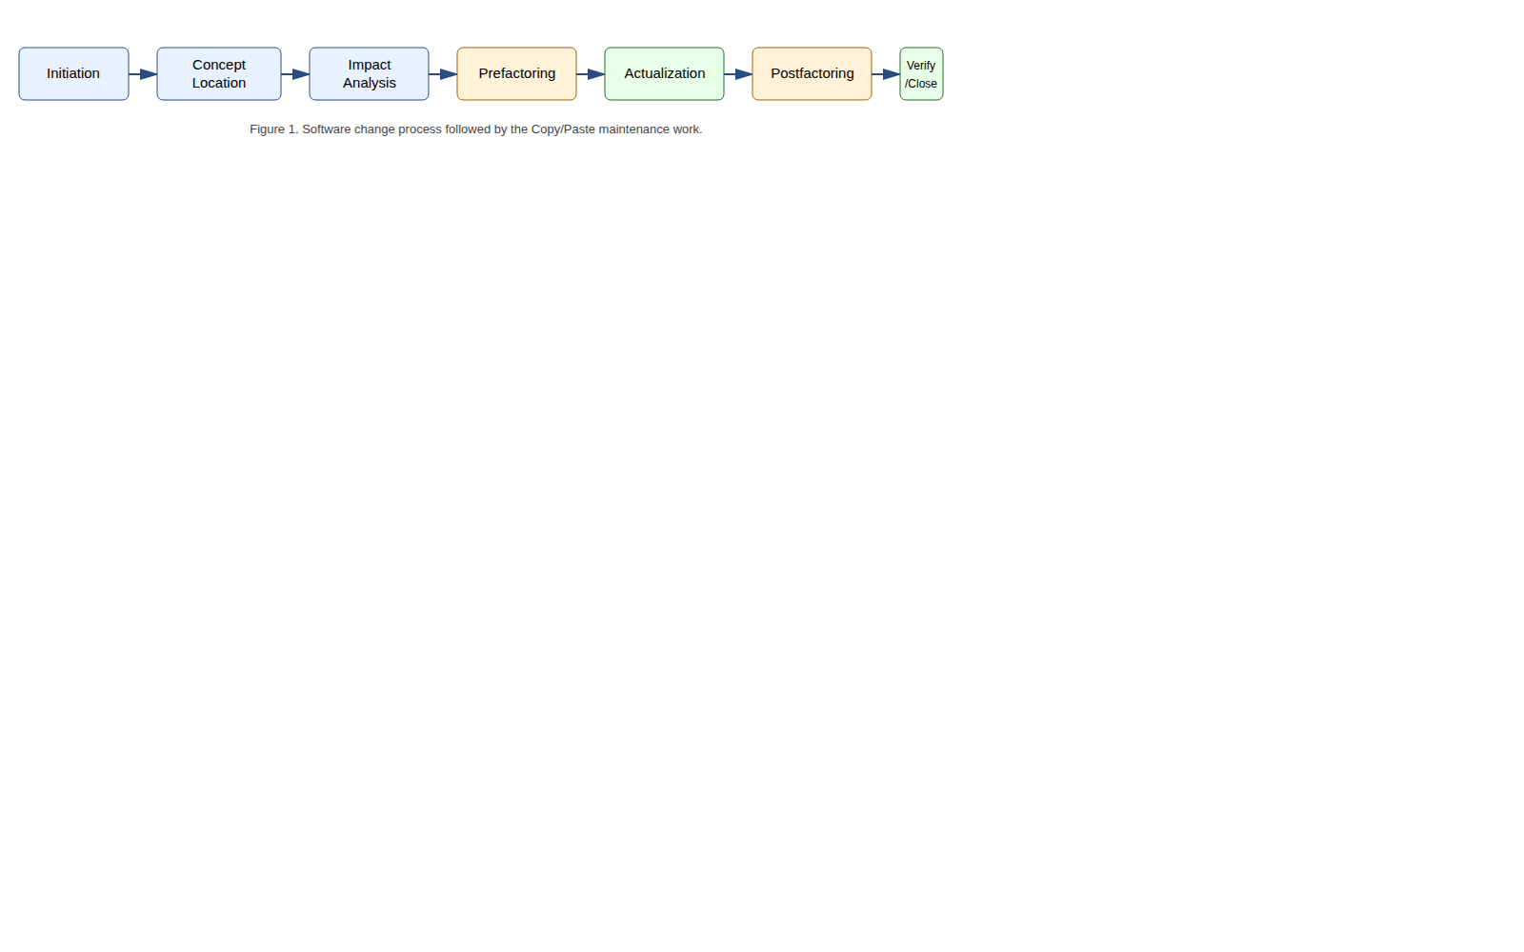
Software change process applied to this work
The process matters because maintenance work can easily grow beyond the original request. Here, impact analysis was used to keep the change focused on the duplicated paste-import logic instead of rewriting adjacent action or GUI code.

Change Request and User Story
The change request is:
Maintain the existing JHotDraw Basic Editing Copy/Paste feature by improving maintainability and adding verification while preserving current user-visible behaviour.
The main user story is:
As a user editing a drawing, I want to copy selected figures and paste them back into the drawing, so that I can duplicate existing work without recreating it manually.
Acceptance criteria:
Requirement | Acceptance criterion
Copy selected figures | A selected figure can produce transferable drawing data.
Empty copy | Copy with no selected figures creates no drawing-figure transferable.
Paste supported data | Supported transfer data is imported into the active drawing.
Selection after paste | Pasted figures become selected.
Undoable paste | Undo removes pasted figures and redo restores them.
Unsupported data | Unsupported clipboard data is rejected safely.
Extensibility | Registered InputFormat/OutputFormat implementations continue to drive supported formats.

Team Pipeline
The work lives on the feature branch copy-paste-basic-editing-labs. The repository has a GitHub Actions workflow at .github/workflows/maven.yml that runs on pushes and pull requests targeting develop. It sets up Temurin JDK 23, caches Maven dependencies, builds with mvn -B clean install --file pom.xml, and runs mvn test --file pom.xml.
Important limitation: the workflow trigger is develop, not every feature-branch push. The local branch is not proven merged into develop, and no remote Actions success for commit b4eea564 was available during inspection. This report therefore does not claim a merged PR or remote CI success for the branch.

Concept Location
The objective of concept location is to map the words in the user story - copy, paste, clipboard, selected figure, drawing - to concrete code. The search started with grep/static search for copy, paste, clipboard, Transferable, TransferHandler, InputFormat, and OutputFormat, then followed dependencies from the action classes into the transfer handler and format strategies.
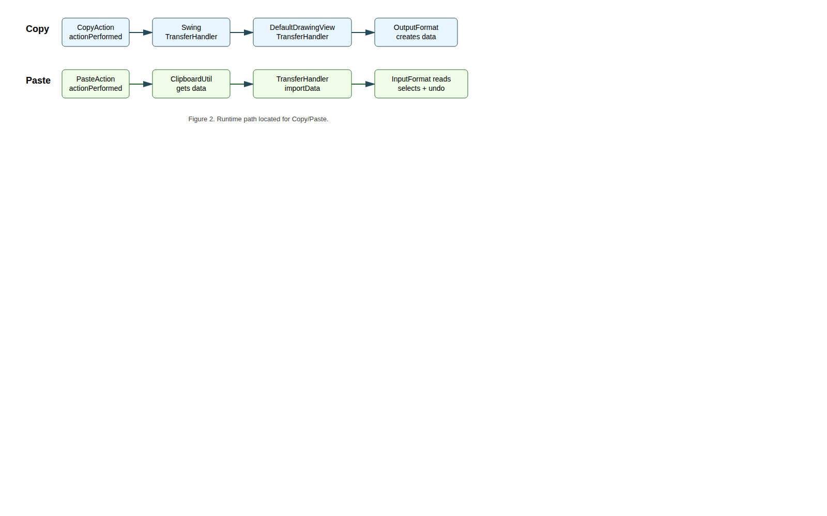
Copy/Paste runtime path
CopyAction and PasteAction were useful entry points, but they are thin controllers. CopyAction delegates export to Swing’s TransferHandler; PasteAction gets clipboard contents through ClipboardUtil and delegates import to the focused component’s transfer handler. In a drawing view, the installed handler is DefaultDrawingViewTransferHandler.
Domain class | Responsibility
CopyAction | Entry point for Copy; delegates to TransferHandler.exportToClipboard.
PasteAction | Entry point for Paste; retrieves clipboard content and delegates to TransferHandler.importData.
CutAction | Related clipboard action using move/export behaviour.
ClipboardUtil | Provides system/fallback clipboard access.
CompositeTransferable | Combines several transfer flavours for one clipboard payload.
DefaultDrawingView | Drawing canvas; owns selection and installs the transfer handler.
DefaultDrawingViewTransferHandler | Core import/export coordinator for drawing views.
Drawing / Figure | Model and copied/pasted drawing objects.
InputFormat / OutputFormat | Strategy interfaces for reading/writing transfer data.
DOMStorableInputOutputFormat | Native JHotDraw figure transfer format in the Draw sample.
TextInputFormat | Supports text paste when registered on a drawing.
DrawView / DrawingPanel | Sample setup that registers formats and exposes actions.
Concept-location conclusion: Copy/Paste is a framework collaboration, not one single method. The central class for the selected maintenance change is DefaultDrawingViewTransferHandler, because that is where the duplicated paste-import logic was found.

Impact Analysis
The purpose of impact analysis is to estimate which files may be affected before changing code. For Copy/Paste, concept location visits many classes, but the safe changed set is small.
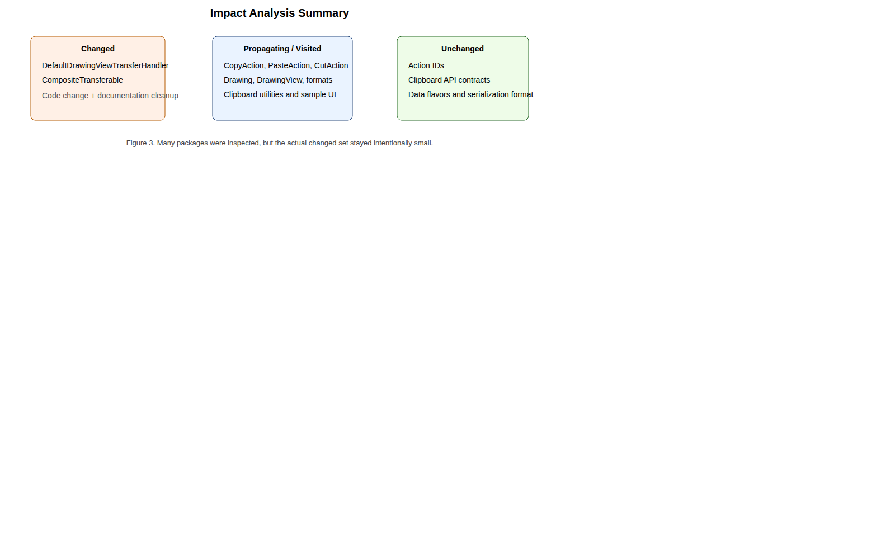
Visited vs. changed impact summary

Static Impact Analysis
The initial impact set included CopyAction, PasteAction, DefaultDrawingViewTransferHandler, DefaultDrawingView, Drawing, InputFormat, OutputFormat, DOMStorableInputOutputFormat, ClipboardUtil, and CompositeTransferable.
The public contracts did not need to change. The actions already delegate through Swing transfer APIs, and the handler already depends on abstractions such as DrawingView, Drawing, and InputFormat. Therefore, the actual code change could stay inside private helper structure.

Dynamic Impact Analysis
The changed method importTransferData(...) is called from the paste importData(...) flow after a compatible InputFormat is found. The added tests exercise this path by creating real drawings, registering real formats, producing or crafting Transferable objects, and calling the real DefaultDrawingViewTransferHandler.importData(...).
The tests avoid the operating-system clipboard because that would make CI unreliable, but they still exercise the changed handler logic.

Package List
Package | Classes visited | Comment
org.jhotdraw.action.edit | 5 | Copy, cut, paste, duplicate, selection actions. Unchanged.
org.jhotdraw.api.gui | 1 | Editable component contract. Unchanged.
org.jhotdraw.draw | 6 | Contains the changed transfer handler.
org.jhotdraw.draw.figure | 3 | Figure abstractions and concrete figures. Unchanged.
org.jhotdraw.draw.io | 7 | Input/output format strategies. Unchanged.
org.jhotdraw.datatransfer | 7 | Clipboard/transfer wrappers; CompositeTransferable cleaned.
org.jhotdraw.app | 2 | Menu/application integration. Unchanged.
org.jhotdraw.gui.action | 1 | Toolbar/popup action registration. Unchanged.
org.jhotdraw.samples.draw | 3 | Draw sample setup and test fixtures. Tests added.
Actual production changed files:
jhotdraw-core/src/main/java/org/jhotdraw/draw/DefaultDrawingViewTransferHandler.java
jhotdraw-datatransfer/src/main/java/org/jhotdraw/datatransfer/CompositeTransferable.java

Prefactoring
Prefactoring prepares the code for change. In this project, the maintenance change itself is a refactoring, so Clean Code concepts were applied directly to the work area.
The main smell was Duplicated Code in DefaultDrawingViewTransferHandler.importData(...). The method has Mac and non-Mac search branches because the Apple JVM historically ordered data flavours differently. That difference is valid, but both branches repeated the same successful-import sequence:
- snapshot existing figures;
- read the transferable into the drawing;
- compute imported figures;
- clear selection;
- select imported figures;
- add imported figures to the transfer set;
- move to drop point if needed;
- fire paste undoable edit.
The file-list branch also repeated undo-edit construction. Other smells were a dead private getDrawing() method, noisy comments, and Javadoc typos in CompositeTransferable.
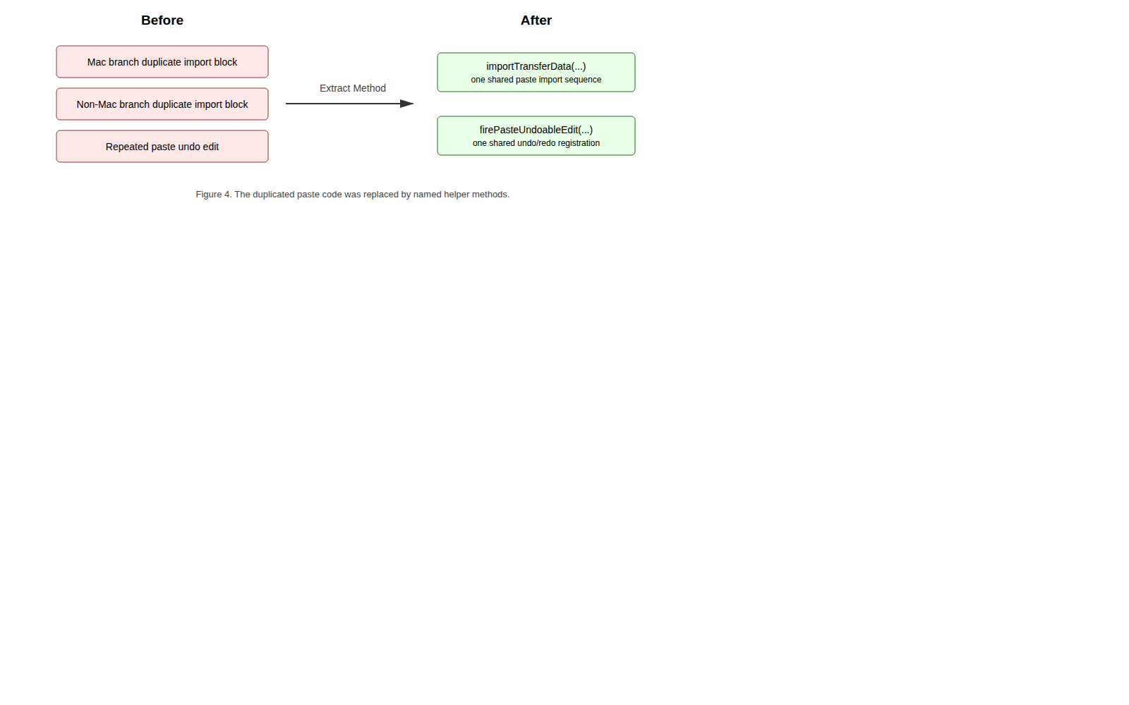
Before and after refactoring
Smell | Refactoring
Duplicated import transaction | Extracted importTransferData(...).
Duplicated undo construction | Extracted firePasteUndoableEdit(...).
Dead code | Removed unused private getDrawing().
Misleading/noisy comments | Rewrote comments to explain intent.
Documentation typos | Fixed CompositeTransferable Javadoc.
Never-reassigned fields | Declared CompositeTransferable collections final.

Clean Code Concepts
Meaningful names: importTransferData(...) and firePasteUndoableEdit(...) name the work that used to be hidden in repeated blocks.
Functions and the Stepdown Rule: importData(...) now reads at a higher level: search for a supported format, try the import, and stop on success. The lower-level details live in helper methods.
Comments: Comments now explain intent, for example why a failed read should try the next format.
Formatting: Extracted methods improve vertical openness by separating responsibilities, while related operations stay vertically close inside the import transaction.

Actualization
Actualization incorporates the change into the existing system. Since this is preventive maintenance, public behaviour and architecture were preserved.
Area | After actualization
Actions | CopyAction and PasteAction still delegate to Swing transfer handling.
Transfer handler | DefaultDrawingViewTransferHandler still coordinates import/export.
Format strategies | InputFormat and OutputFormat remain the extension points.
Domain model | Drawing and Figure still represent the model.
Clipboard infrastructure | ClipboardUtil and CompositeTransferable remain infrastructure.
The important production change is:
if (format.isDataFlavorSupported(flavor)) {
if (importTransferData(comp, t, transferFigures, dropPoint, view, drawing, format)) {
retValue = true;
break SearchLoop;
}
}
The helper method now owns the import transaction:
format.read(t, drawing, false);
final LinkedList<Figure> importedFigures = new LinkedList<>(drawing.getChildren());
importedFigures.removeAll(existingFigures);
view.clearSelection();
view.addToSelection(importedFigures);
transferFigures.addAll(importedFigures);
moveToDropPoint(comp, transferFigures, dropPoint);
firePasteUndoableEdit(drawing, importedFigures);

SOLID Principles
Principle | Result in this change
Single Responsibility | Method-level responsibilities are clearer: search, import transaction, movement, undo registration.
Open-Closed | New clipboard formats can still be added through new InputFormat implementations.
Liskov Substitution | The handler treats all InputFormat implementations uniformly.
Interface Segregation | InputFormat and OutputFormat keep import/export responsibilities separate.
Dependency Inversion | The handler depends on drawing and format abstractions, not concrete format classes.
The class as a whole is still large, but the selected paste behaviour now has a clearer internal structure.

Postfactoring
Postfactoring checks the result after actualization.
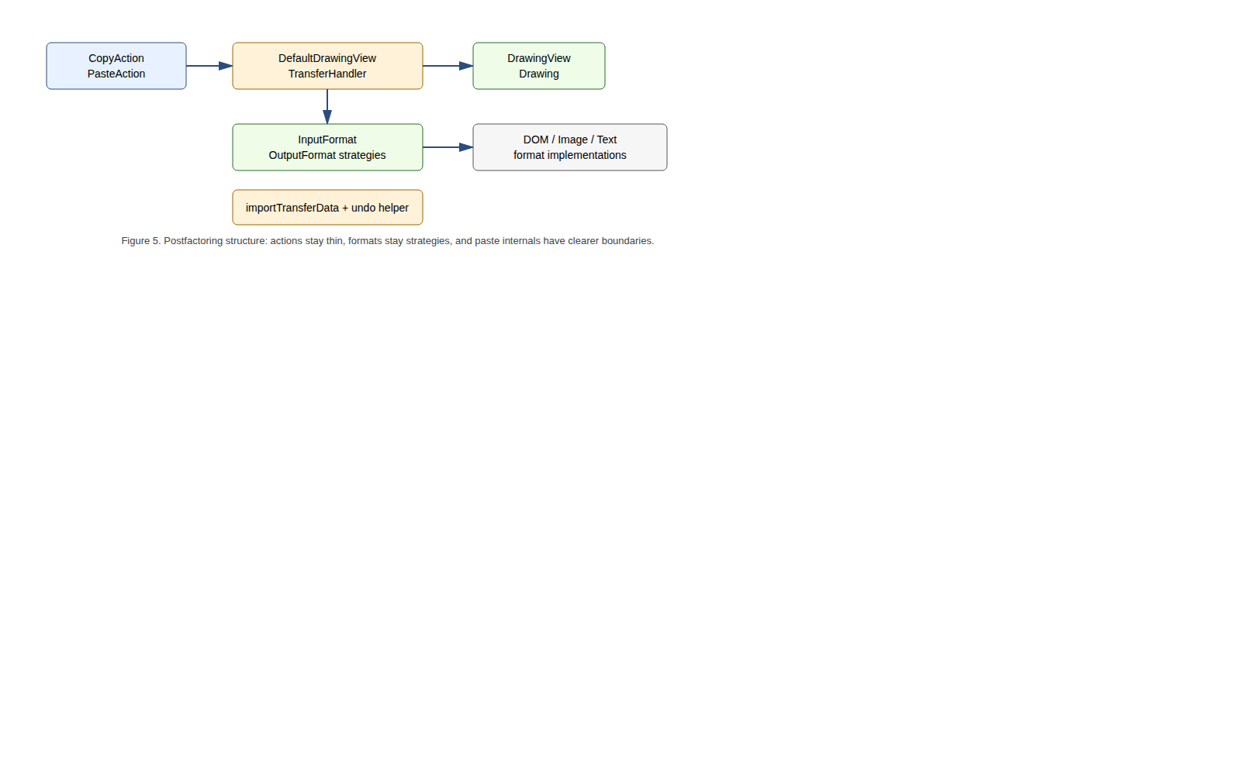
Postfactoring structure
Before:
importData(...)
Mac branch -> duplicated import block
non-Mac branch -> duplicated import block
file-list branch -> duplicated undo construction
After:
importData(...)
Mac branch -> importTransferData(...)
non-Mac branch -> importTransferData(...)
file-list branch -> firePasteUndoableEdit(...)
importTransferData(...)
read, compute imported figures, select, move, fire undo
firePasteUndoableEdit(...)
undo removes imported figures
redo adds imported figures again
This makes future changes safer. If selection-after-paste or paste undo behaviour changes, there is now one obvious place to edit. The remaining debt is also clear: DefaultDrawingViewTransferHandler is still a large integration class, importTransferData(...) has many parameters, and the action classes still have similar focus-owner lookup logic.

Verification
The verification target is the changed paste path and the native DOM transfer round-trip used by Copy/Paste.

Test Files
Test file | Tests | Purpose
DOMStorableInputOutputFormatTest.java | 3 | DOM transferable round-trip and unsupported flavour rejection.
DefaultDrawingViewTransferHandlerTest.java | 5 | Selected copy, empty copy, supported paste, selection, unsupported paste, undo/redo.
CopyPasteBddTest.java | 5 | User-story scenarios in Given-When-Then style.
The tests use real DefaultDrawing, DefaultDrawingView, DefaultDrawingViewTransferHandler, DOMStorableInputOutputFormat, DrawFigureFactory, RectangleFigure, TextFigure, and UndoManager. They avoid the real OS clipboard by passing Transferable objects directly into the handler, which makes the suite deterministic and headless-safe.

Requirement to Test Traceability
Acceptance criterion | Automated evidence
Copy selected figure creates transfer data. | copySelectedFigureCreatesTransferable
Empty copy creates no transferable. | copyWithoutSelectionCreatesNoTransferable
Supported paste imports a distinct figure. | pasteSupportedTransferableAddsAndSelectsImportedFigure
Pasted figure becomes selected. | Same handler test and BDD scenario 1.
Paste is undoable. | pasteFiresUndoableEditThatCanUndoAndRedoImportedFigure
Unsupported data is safe. | rejectsUnsupportedDataFlavor, unsupported paste tests.
Registered formats drive support. | DOM round-trip and text-paste BDD scenario.

BDD Scenario Analysis
JGiven was discussed in the lab, but this branch does not add a JGiven dependency. Instead, it uses JUnit 4 tests with Given-When-Then method names. This keeps the build simple while still mapping user stories to executable scenarios.
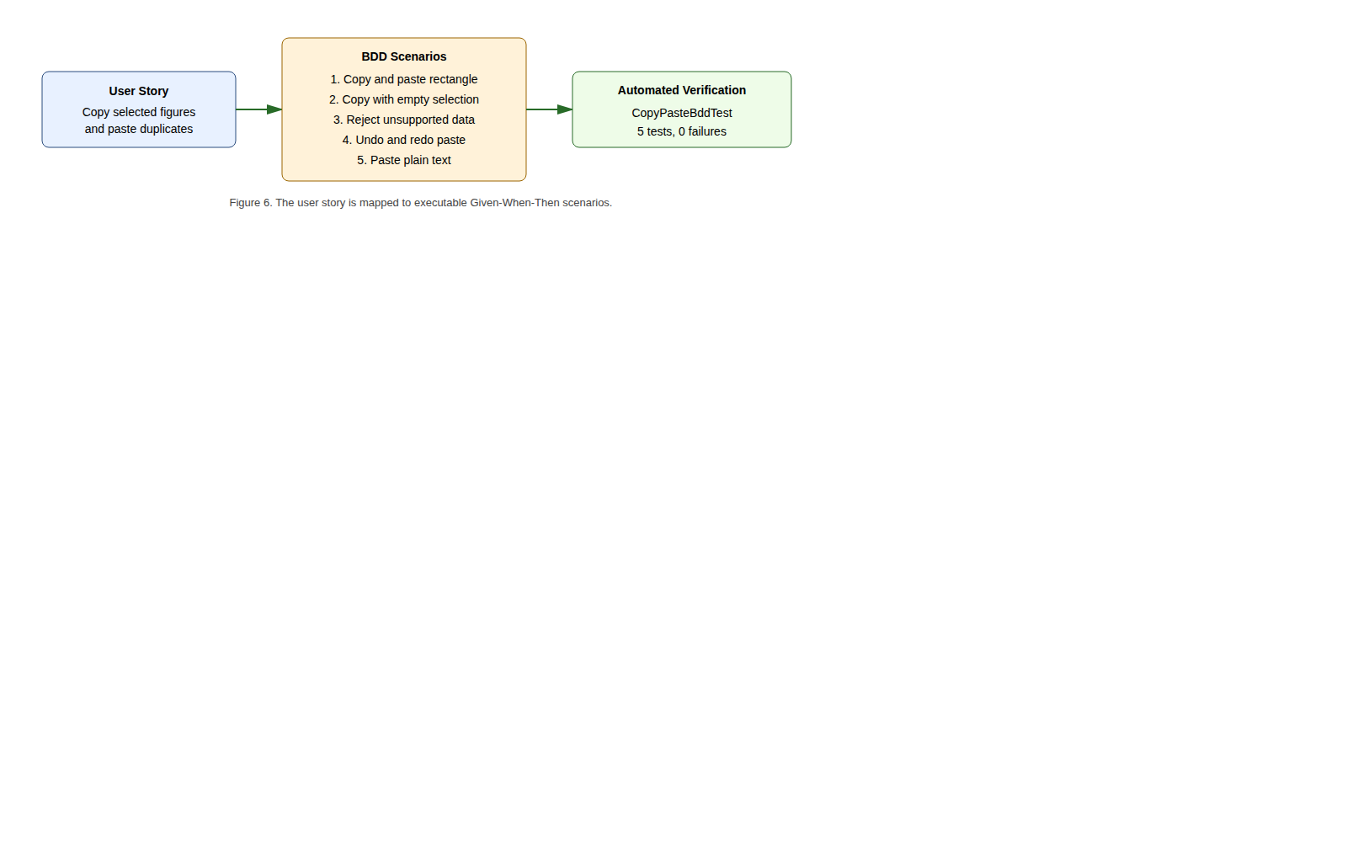
BDD verification
Scenario | Test method
Given one selected rectangle, when copy and paste are invoked, then the drawing contains two rectangles and the pasted one is selected. | givenDrawingWithOneSelectedRectangle_whenUserCopiesAndPastesIt_thenDrawingContainsTwoRectanglesAndPastedRectangleIsSelected
Given no selected figures, when copy is invoked, then no drawing-figure transferable is produced. | givenDrawingViewWithNoSelectedFigures_whenUserInvokesCopy_thenNoDrawingFigureTransferableIsProduced
Given unsupported data, when paste is invoked, then the drawing remains unchanged. | givenClipboardContainsUnsupportedData_whenUserInvokesPaste_thenDrawingRemainsUnchanged
Given pasted figures, when undo and redo are invoked, then pasted figures are removed and added back. | givenUserPastedFiguresIntoDrawing_whenUserInvokesUndoAndRedo_thenPastedFiguresAreRemovedAndAddedBack
Given plain text and a registered text format, when paste is invoked, then a text-holder figure is added. | givenClipboardContainsPlainTextAndDrawingRegistersTextInputFormat_whenUserInvokesPaste_thenTextHolderFigureIsAdded

Local Verification Result
Command:
mvn -pl jhotdraw-samples/jhotdraw-samples-misc test
Result:
Tests run: 13, Failures: 0, Errors: 0, Skipped: 0
BUILD SUCCESS
The full reactor was also verified:
mvn test --file pom.xml
Result: BUILD SUCCESS.

Verification Limits
The automated tests do not prove the full GUI path through menus, focus, keyboard shortcuts, and real system clipboard ownership. That should be covered by manual screenshots or a dedicated GUI automation test if required. This report does not claim those screenshots exist.

Conclusion
This report documents a complete maintenance pass over JHotDraw’s Basic Editing Copy/Paste feature. Concept location found that Copy/Paste is a collaboration between actions, clipboard utilities, Swing transfer handling, drawing views, format strategies, and the drawing model. Impact analysis showed that many classes must be understood, but the actual production change could remain small.
The main smell was duplicated successful paste-import logic inside DefaultDrawingViewTransferHandler.importData(...). The implemented refactoring extracted importTransferData(...) and firePasteUndoableEdit(...), removed dead code, improved comments, and preserved the existing public architecture. CompositeTransferable received small documentation and field-cleanup improvements.
The result is easier to maintain: successful import and paste undo behaviour now have named locations instead of repeated blocks. Verification was strengthened with 13 JUnit 4 tests, including 5 BDD-style scenarios. Local Maven verification passed for both the sample module and the full project reactor. The CI workflow is available for develop push/PR events, but remote branch CI success and merge status are not claimed without evidence.

Discussion

What Could Have Been Better
The refactoring could have gone one step further by introducing an ImportContext object, because importTransferData(...) has many parameters. This was left out to keep the change small and reviewable.
The action layer still has duplication: CopyAction, CutAction, and PasteAction share similar focused-component lookup behaviour. That is a real follow-up smell, but changing it would widen the impact set and should be protected by additional tests.
The cut path is less tested than the paste path. Before removing or changing cut-specific code, a cut + undo/redo characterization test should be added.
Finally, the full GUI path is not automated. The current tests are intentionally headless and deterministic; a final submission can be improved with screenshots of the Draw sample showing copy, paste, undo, and redo through real menu/keyboard interaction.

What Failed and How It Was Mitigated
Testing through the real operating-system clipboard is fragile because the clipboard is global, depends on the host environment, and may not exist in headless CI. The mitigation was to pass crafted Transferable objects directly to DefaultDrawingViewTransferHandler. This still verifies the changed logic while avoiding environment-dependent failures.
Another risk was documentation overclaiming. Some drafts said the branch had already passed GitHub Actions or had been merged into develop. The local branch graph and status evidence do not prove that. This final report corrects the wording: tests pass locally, and CI is configured for develop push/PR events.
The main lesson is that impact analysis protects scope. JHotDraw contains more smells than one report should fix. The safe maintenance approach is to locate the feature, change the smallest responsible area, test the behaviour, and record remaining debt honestly.

References and Sources
[1] R. C. Martin, Clean Code: A Handbook of Agile Software Craftsmanship. Prentice Hall, 2008.
[2] R. C. Martin, Clean Architecture: A Craftsman’s Guide to Software Structure and Design. Prentice Hall, 2017.
[3] M. Fowler, Refactoring: Improving the Design of Existing Code, 2nd ed. Addison-Wesley, 2018.
[4] M. Fowler, “Continuous Integration,” 2006. Available: https://martinfowler.com/articles/continuousIntegration.html
[5] D. North, “Introducing BDD,” 2006. Available: https://dannorth.net/introducing-bdd/
[6] JGiven, “BDD in plain Java.” Available: https://jgiven.org
[7] Team fork repository: https://github.com/JakubPotocky/JHotDraw, branch copy-paste-basic-editing-labs, commit b4eea56487ea289d6c1855d9ba32150e16b31366, inspected 11 June 2026.
[8] SDU Software Maintenance course material: Intro Lab, Change Request Lab, Concept Location Lab, Analysis Lab, Refactoring Lab, Actualization Lab, Testing Lab, BDD Lab, and Continuous Integration Lab.

Appendix

Appendix A - Changed Production Files
jhotdraw-core/src/main/java/org/jhotdraw/draw/DefaultDrawingViewTransferHandler.java
jhotdraw-datatransfer/src/main/java/org/jhotdraw/datatransfer/CompositeTransferable.java

Appendix B - Added Test Files
jhotdraw-samples/jhotdraw-samples-misc/src/test/java/org/jhotdraw/samples/draw/DOMStorableInputOutputFormatTest.java
jhotdraw-samples/jhotdraw-samples-misc/src/test/java/org/jhotdraw/samples/draw/DefaultDrawingViewTransferHandlerTest.java
jhotdraw-samples/jhotdraw-samples-misc/src/test/java/org/jhotdraw/samples/draw/CopyPasteBddTest.java

Appendix C - Verification Commands
mvn -pl jhotdraw-samples/jhotdraw-samples-misc test
mvn test --file pom.xml

Appendix D - Claims Not Made Without Evidence
Claim | Status
Feature branch merged into develop. | Not proven by local branch graph.
Remote GitHub Actions success for b4eea564. | Not available from inspected evidence.
JGiven-generated report. | Not present; tests use JUnit 4 Given-When-Then naming.
Manual GUI screenshots. | Not included unless added after an actual manual run.

