News API Website

X00164430 – Jakub Wysocki

**Deployed URI:**

Website is deployed however it doesn’t show anything because my API’s CORS is only enabled for localhost. I only realized that after publishing and it was too late to start from scratch

<https://ca3-120221213220253.azurewebsites.net>

**Github Repo:**

<https://github.com/JakubWysocki1/EAD-CA3>

**Video URL:**

https://streamable.com/qywe80

**Overview:**

After searching for a suitable API, I came across the news API which provided data in JSON format of the top news around the world. I chose API because it is easy to use and it gave an easy possibility to implement functionality that can manipulate the API’s data. Some data in the API had null values for its content so I made the system excludes data that contained them. The only validation present on my website is the button, which is disabled until text is typed in

When you enter the website the first thing you see it the heading “Top news in Ireland” and the corresponding news underneath it. This includes an image, article title and a summary of the content. I chose to display this by default because we are in Ireland so it would make sense to have this. Each news panel also has a read me button where once clicked, redirects the user to the source website. This is useful if the reader wants to read more about a topic.

Beside the heading is a dropdown menu with a default, disabled value - “News from other countries”. Once clicked, 4 options of other major countries appear from the dropdown list. The user can select any of them. Once selected the system makes a new call to the API to get news form the selected country. The news is then displayed in the same manner as previously. Everything happens asynchronously meaning that the website does not have to refresh.

The other thing that I implemented in the system is the possibility to search for news. There is a search bar included where a user can input the topic they’re interested in. Once the button search is pressed, the search is performed and related news articles are displayed on the website.

**Code Quality/Metrics:**

For code quality and metrics, I tried to make the code as readable as possible. I gave variables and functions names that correspond with what they do. I also tried to have no duplicating code. Unfortunately, this wasn’t fully possible as some things wouldn’t work otherwise. Another thing that I did was keep the related variables and functions together. I also tried to make the layout of my code consistent – Variables first with the related functions underneath them.

**Testing:**

|  |  |  |  |  |
| --- | --- | --- | --- | --- |
| **Test Case** | **Description** | **Expected Result** | **Actual Result** | **Test Passed** |
| 1 | Test Open Selectbox | Select box opens | Select box opens | Yes |
| 2 | Test Select Country | Select box Closes, country name is in placeholder, Country name changes in title | Select box Closes, country name is in placeholder, Country name changes in title | Yes |
| 3 | Test Search button without input | Button disabled – can’t click on it | Button disabled – can’t click on it | Yes |
| 4 | Test Search button with input | Button enabled – can click on it | Button enabled – can click on it | Yes |
| 5 | Test search | Title changes to topic searched, Related Topic articles are displayed | Title changes to topic searched, Related Topic articles are displayed | Yes |

**Screenshots:**

Home page

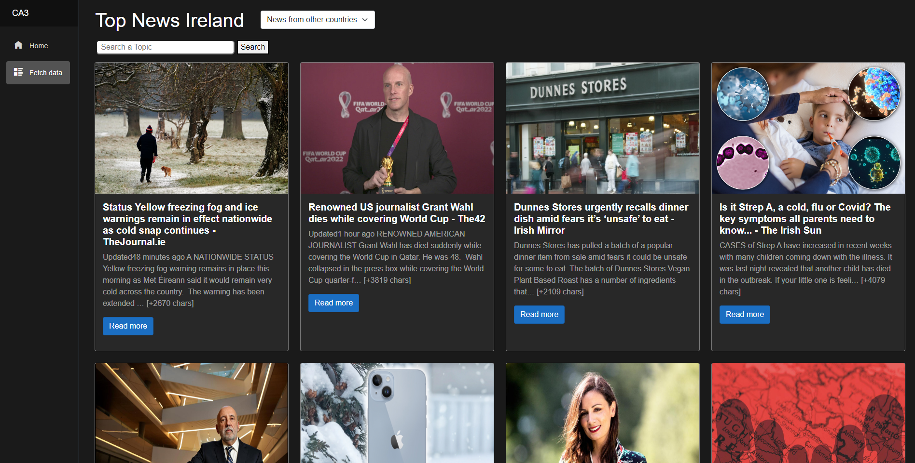

Selecting country

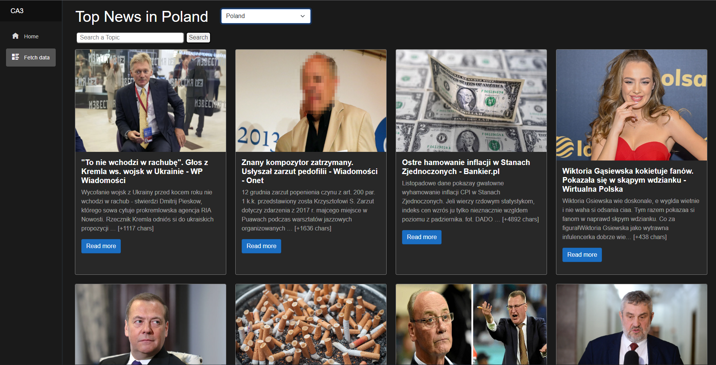

Searching a topic

