Part 1

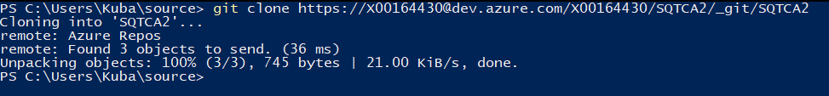

Part 2

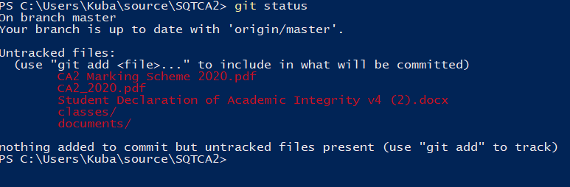

Part 3



Part 4

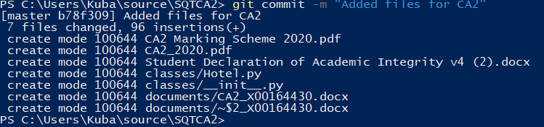

Part 5

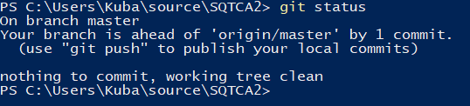

Part 6

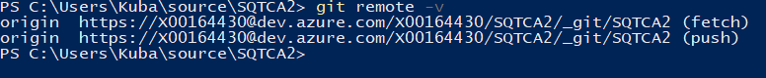

Part 7

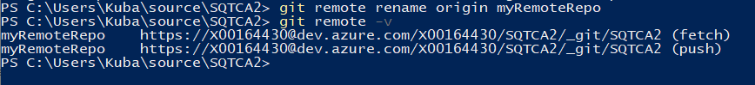

Part 8

