

**Part A (To be referred by students)**

**SAVE THE FILE AND UPLOAD AS (RollNo_Name_Exp1)**

**Topic covered:** To Study Fundamentals of Web

**Learning Objective: Learner would be able to**

1. To understand website with its types and need.
2. To present an introduction to Web Programming, with an emphasis on the Web Programming languages like HTML,XML &JSON, webservers & URL.
3. Describe different architectural components used in web development.

**Prerequisites:-**

* PPS

**Outcomes:-**

* Student will know about web browser & how it interprets web pages.

**FUNDAMENTAL’s OF WEB DEVELOPMENT**

* **Web site:** A set of interconnected web pages, usually including a homepage, generally locatedon the same server, and prepared and maintained as a collection of information by a person, group, or organization.
* **Web Page:** A web page is a document that's created in html that shows up on the internet whenyou type in or go to the web page's address.
* **Types of Web Pages:**
* **Static web page**: is delivered exactly as stored, as web content in the web server's filesystem. Contents cannot be changed.
* **Dynamic web page**: is generated by a web application that is driven by server-sidesoftware or client-side scripting. Dynamic web pages help the browser (the client) to enhance the web page through user input to the server. Contents can be changed as evolution over time.

**Browsers & their types**

A web browser (commonly referred to as a browser) is a software application for retrieving, presenting and traversing information resources on the World Wide Web.

The major web browsers are Google Chrome, Firefox, Internet Explorer, Opera, and Safari.

**Client –Server Model**

The client–server model is a distributed application structure in computing that partitions tasks or workloads between the providers of a resource or service, called servers, and service requesters, called clients. Often clients and servers communicate over a computer network. A server is a host that is running one or more server programs which share their resources with clients. A client requests a server's content or service function.

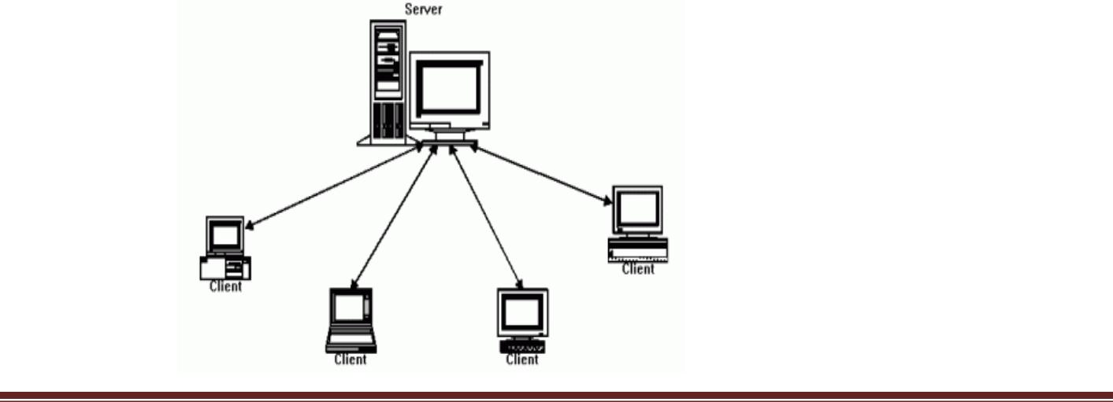

BASIC WEB DESIGN LAB MANUAL

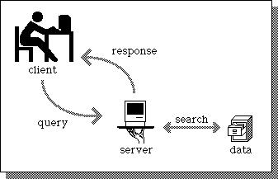

**Web –Server**

Web server refers to either the hardware (the computer) or the software (the computer application) that helps to deliver web content that can be accessed through the Internet.

The most common use of web servers is to host websites, but there are other uses such as gaming, data storage or running enterprise application.

**Working of different types of web pages**

The different types of web pages are:

**Advocacy:** An advocacy web page is one sponsored by an organization to influenceopinion. URL ends with .org

**Business and marketing:** It is one sponsored by a commercial enterprise to sell ormarket their services. URL ends with .com

[**News:** It](News:it)providestimely information about current events and issues.

**Informational:** This includes reports, research findings, schools and college information.

URL ends with .edu or .gov.

**Personal:** It is created by an individual for his /her own personal need.URL has tidle(~).

**General structure of a Web Page**

A basic HTML page contains a Head section and a Body section. The contents of the head section are normally invisible in a web browser and mainly consists of some Metatags. The Body consist of those HTML elements that you want to have displayed in your browser.

<html>

<head>

</head>

<body>

</body>

</html>

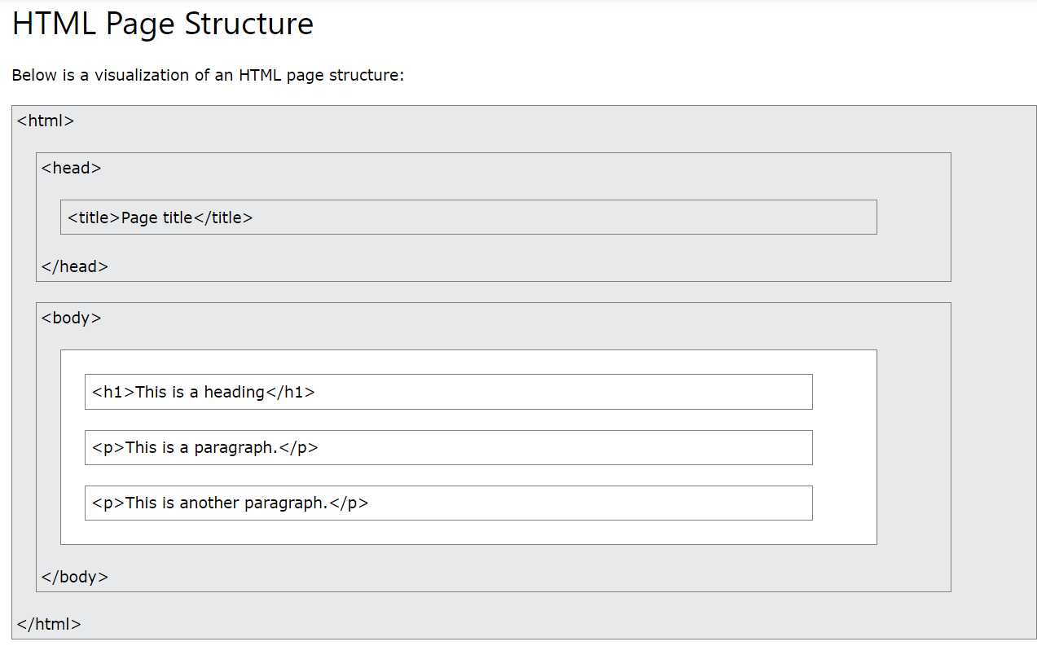



BASIC WEB DESIGN LAB MANUAL



**Scripting language:** A scripting language or script language is a programming languagethat supports the writing of scripts, programs written for a special runtime environment that can interpret and automate the execution of tasks which could alternatively be executed one-by-one by a human operator.

**URL:** A uniform resource locator (URL), also known as web address, is a specific characterstring that constitutes a reference to a resource. In most web browsers, the URL of a web page is displayed on top inside an address bar. An example of a typical URL would be "http://en.example.org/wiki/Main_Page".

**Popular Search Engines**

* Yahoo Search
* Google Search
* Bing
* Info.com
* Search.com
* Infospace

1. The World Wide Web (WWW) is a system of interlinked hypertext documents accessed via the Internet. With a web browser, one can view web pages that may contain text, images, videos, and other multimedia, and navigate between them via hyperlinks.

**ILLUSTRATING HTML TAGS AND THEIR ATTRIBUTES**

**HTML:**Hyper Text Markup Language is the most widely used language to write webpages.it is a markup language.

**Hypertext :**Refers to the way in which web pages are linked together.

**Markup Language:** The user simply markups a text document with tags that tell a webbrowser how to structure it to display.

**Creating HTML document :**To begin coding HTML user needs only two things:

1. A simple text editor (notepad).
2. A web browser.



Dept. Of CSE Govt. Polytechnic,Turuvekere

BASIC WEB DESIGN LAB MANUAL



HTML



HTML is the standard markup language for creating Web pages.

* HTML stands for Hyper Text Markup Language
* HTML is the standard markup language for creating Web pages
* HTML describes the structure of a Web page
* HTML consists of a series of elements
* HTML elements tell the browser how to display the content
* HTML elements label pieces of content such as "this is a heading", "this is a paragraph", "this is a link", etc.

<!DOCTYPE html>  
<html>  
<head>  
<title>Page Title</title>  
</head>  
<body>  
  
<h1>My First Heading</h1>  
<p>My first paragraph.</p>  
  
</body>  
</html>

* The <!DOCTYPE html> declaration defines that this document is an HTML5 document
* The <html> element is the root element of an HTML page
* The <head> element contains meta information about the HTML page
* The <title> element specifies a title for the HTML page (which is shown in the browser's title bar or in the page's tab)
* The <body> element defines the document's body, and is a container for all the visible contents, such as headings, paragraphs, images, hyperlinks, tables, lists, etc.
* The <h1> element defines a large heading
* The <p> element defines a paragraph

**HTML document structure:** An HTML document starts and ends with <html> and </html>tags.These tags tell the browser that the entire document is composed in HTML.Inside these two tags,the document is split into 2 sections:

1. The <head>……</head> elements contains information about the document such as title of the document etc.
2. The <body>…. </body> elements contains the real content of the document that you see on your screen.

**ATTRIBUTES:**

An attribute is used to define the characteristics of an element and is placed inside the element’s opening tag. All attributes are made up of 2 parts: a name and a value.

-The name is the property you want to set.

-The value is what you want the value of the property to be.

Example: <font face=”arial” color=”red”>

BASIC WEB DESIGN LAB MANUAL



**Part B (to be completed by students)**

(Students must submit the soft copy as per the following segments. A soft copy containing Part A and Part B must be uploaded on the platform specified by the Practical Teacher. The filename should be **RollNo_Name_Exp1**)

|  |  |
| --- | --- |
| **Roll No.: K005** | **Name: Jal Bafana** |
| **Prog/Yr/Sem:Btech. Cyber sec ( Sem – 3)** | **Batch: K1** |
| **Date of Experiment: 18.7.2024** | **Date of Submission: 18.7.2024** |

1. **Explain the 3-Tiered Architecture.**

**Ans: -** A three tiered Architecture is a modular client-server architecture that consists of a presentation tier, an application tier and a data tier. The data tier stores information, the application tier handles logic and the presentation tier is a Graphical User Interface (GUI).

* **Presentation Tier**: -This tier, is built in with HTML, CSS and JavaScript to develop frontend of a webpage.
* **Application Tier**: -This tier, is also referred as logic tier, is written in programming languages such as which contains the logic that supports the website’s core functions.
* **Data Tier**: -This tier, consists of a database and programs to manage read and write operations on the database.

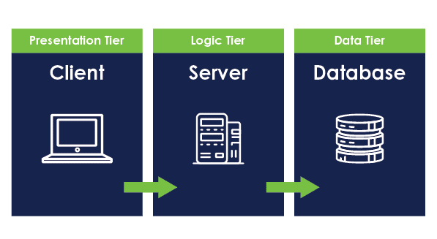

1. **What to you understand by web browsers and web server in your own language.**

**Ans: -** Web Browsers are an application for accessing websites. When a user requests a webpage or a website from the browser, the browser fetches it files from the server and then displays it on the screen. Most used one is Google chrome with more than 50% of market share. Web Browsers and Search Engines are not the same. A search engine is itself a website that provide links to other websites.

Web Server is a software that is below the hardware layer that works on HTTP (a network protocol) or HTTPS (more secure version) or any other protocol to take actions based on requests made on WWW (world wide web). Its main job is to display website or webpages to users.

1. **XML Vs. JSON**

**Ans: -**Extensible Markup Language(XML) is a markup language like HTML, which is used to store and transport data. It is quite self-descriptive language (easy to learn). Xml is designed to carry or relocate data and focus on what data is.

JavaScript Object Notation (JSON) is just plain text written in java script object notation, essentially used for sending data between computers. It is language independent. The JSON format is syntactically similar to the code for creating JavaScript objects. And this can help a lot since JavaScript program can easily convert JSON data into JavaScript objects.

1. **Design a page having suitable background color and text color with title “My First Web Page” using all the attributes of the Font tag.**

**Procedure:**

1. Go to start ->all program – >accessories-> notepad.
2. Type the html code.
3. Include title ”my first web page” in title tag.
4. Set the background for the webpage by using bgcolor attributes of the body tag.
5. Use font tag to display text.
6. Go to file->save->save the file with html extension.
7. Run the html code using browser.

<html >

<head>

<title>My first web page</title>

</head>

<body bgcolor="green">

<font size="16" color="white" face="Arial">MY FIRST WEBPAGE.</font>

</body>

</html>



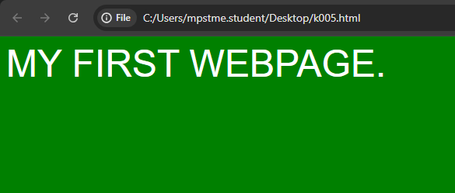

**5.Create a HTML document giving details of your [Name, Age], [Address, Phone] and [Register Number, Class] aligned in proper order using alignment attributes of Paragraph tag.**

**Procedure:**

1. Go to start ->all program – >accessories-> notepad
2. Type the html code
3. Align [name,age]to center by using align =”left ” of <p> tag
4. Align [register,number,class] to right using align=”right” of <p> tag
5. Go to file-> save->save the file with html extension
6. Run the html code using browser

<html>

<head>

<title>program 02</title>

</head>

<body>

<p align="center">

Name: <br>

Age: 16

</p>

<p align="right">

Address: XYZ<br>

Phone: 123535615

</p>

<p align="left">

Reg No: 169cs15015<br>

Class:2nd Sem C’s

</p>

</body>

</htmL>

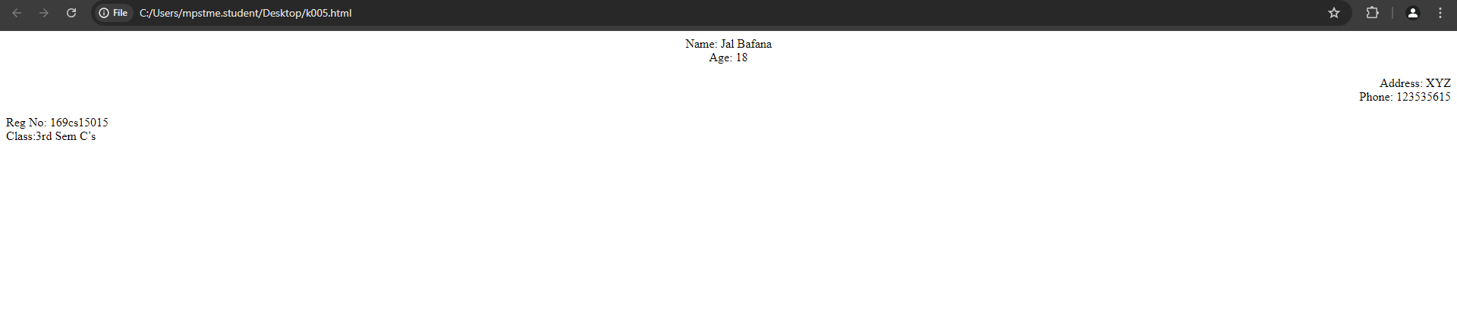

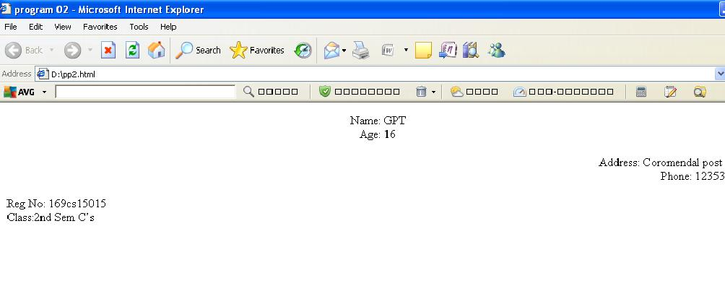





**6.Write HTML code to design a page containing some text in a paragraph by giving suitable heading style.**

**Procedure:**

1. Go to start ->all program –> accessories-> notepad
2. Type the html code
3. Use<h1> to<h6>tag to display heading
4. Use <p> tag for the paragraph
5. Go to file- >save->save the file with html extension
6. Run the html code html using browser

<html>

<head>

<title>program 03</title>

</head>

<body>

<center>

<h1>Basic Web design Lab</h1>

</center>

<h2 align="left"> Definition </h2>

<h3 align="left">Website</h3>

<p>

A set of inter connected web pages usually including a home page and many other web pages

</p>

</body>

</html>

**\*\*\*\*\*\*\*\*\*\*\*\*\*\*output\*\*\*\*\*\*\*\*\*\*\*\*\*\***

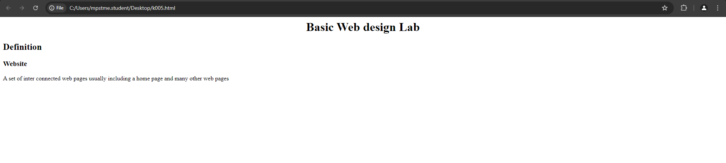



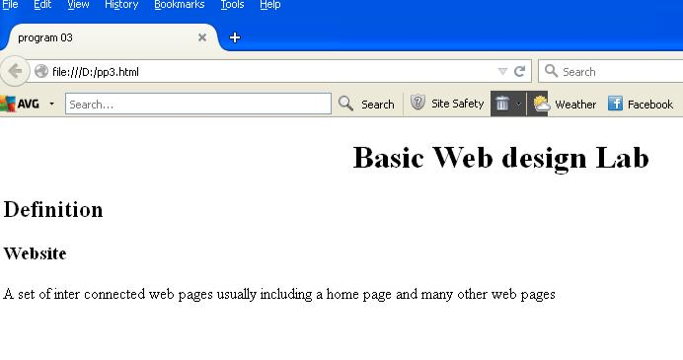



BASIC WEB DESIGN LAB MANUAL



1. **Create a page to show different character formatting (B, I, U, SUB, SUP) tags.**

***viz :*** ***log* bmp= p *log*bm**

**Procedure:**

1. Go to start ->all program – >accessories-> notepad
2. Type the html code
3. Include <b>,<u>,<sup>,<sub>,tags
4. Go to file->save-> save the file with html extension
5. Run the html code using browsers

<html>

<head>

<title>program 04</title>

</head>

<body>

<p> <b> <i> log</i></b> <sub>b </sub>m<sup> p</sup> =p<b> <i> log </i> </b><sub>b</sub> m</p>

</body>

</html>

**\*\*\*\*\*\*\*\*\*\*\*\*\*\*output\*\*\*\*\*\*\*\*\*\*\*\*\*\***

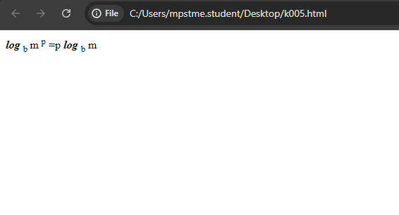



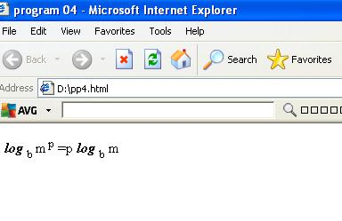

BASIC WEB DESIGN LAB MANUAL



1. **Write a HTML code to create a web page with pink color background and display moving message in red color.**

**Procedure:**

1. Go to start->all programs->accessories->notepad
2. Type the html code
3. Include bgcolor=”pink” attribute in the body tag
4. Use font tag to display moving text in red color by setting color=”red” attribute
5. Include marquee tag inside font tag to display moving text
6. Go to file –>save->save the file with html extension
7. Run the html code using browser

<html>

<head>

<title>program 09</title>

</head>

<body bgcolor="pink">

<font color="red"><marquee direction="left">

Welcome to NMIMS</marquee></font>

</body>

</html>

**\*\*\*\*\*\*\*\*\*\*\*\*\*\*\*\*\*\*\*\*\*\*\*output\*\*\*\*\*\*\*\*\*\*\*\***



