**Part A (To be referred by students)**

***Forms, Input Types & Media***

**SAVE THE FILE AND UPLOAD AS (RollNo_Name_Exp4)**

**Topic covered:**Basic Tags of HTML, Forms,Frames& Media

**Learning Objective: Learner would be able to**

1. To present an introduction to Web Programming, with an emphasis on the Web Programming languages like HTML.
2. Describe different architectural components used in web development.

**Aim:**

Create a static-web pages using HTML

1. Login page (Now, implement it using form tag)
2. Design a form and try to apply all elements under it.
3. Implement Multimedia Elements.

**Prerequisites:-**

* Basic HTML& form Tags

**Outcomes:-**

* Students will get idea about how to work with HTML list, table, images.
* Students will be able to work with hyperlinks & its various options.
* Student will be able to design form and frame.

**Theory:-**

**Its good practice to follow following html format:-**

<!DOCTYPE html>  
<html lang="en-us">  
<head>

<meta charset="utf-8">  
  <title>Title</title>  
</head>  
<body>  
  
</body>  
</html>

**Anchors <a>**

**Types of link:-**

* Absolute (link to website )
* Relative (link to other files in same system(local file link), link to other section of page)
* Internal
* Graphical
* <a></a>Tag defines a hyperlink
* Attribute is href…
* By default, links will appear as follows in all browsers:
  + An unvisited link is underlined and blue
  + A visited link is underlined and purple
  + An active link is underlined and red
* The **HTML <body>vlink Attribute**is used to specify a color of a visited link in a Document.
* The **HTML <body>alink Attribute** is used to specify the color of an active link in a document.
* The **HTML <body> link Attribute** is used to specify the default color for a unvisited link in a document.

**Target Attribute: -**

* The target attribute specifies where to open the linked document.
* Syntax:-

<a target="_blank|_self|_parent|_top|*framename*">

* **Attribute values:-**

|  |  |
| --- | --- |
| **Value** | **Description** |
| _blank | Opens the linked document in a new window or tab |
| _self | Opens the linked document in the same frame as it was clicked (this is default) |
| _parent | Opens the linked document in the parent frame |
| _top | Opens the linked document in the full body of the window |
| *framename* | Opens the linked document in the named iframe |

**HTML Form**

* Form is a container where user provides their information, this can be personal information or feedback.
* <form></form> are used to create interactive GUI
* Form contains following form elements.
* Elements of forms are
  + Text Box.
  + Text Area.
  + Radio Button
  + Check Box
  + Drop Down List
  + Buttons
  + Files
  + Slider etc….
* Forms cannot be nested, but a web page can contain multiple form.
* The actual working of form involves the setting of action and method(GET & POST)attributes.
* Following elements can be used to create an HTML form
  + Form
    - Form elements defines form.& Form element support action attribute.

<form action= “confirm.html”>

* + - Confirm.html File will be opened when user submits the data of the form.
  + Input
    - It enables us to insert
      * Radio button
      * Check boxes
      * Text box
      * password
    - input elements are implemented by <input></input> container tag.
    - Following are the attributes of input
      * Name
      * Type
      * Value
      * MaxLength
      * Size
  + Select & option
    - Used to create a menu or drop down list.
  + Textarea
    - In textarea user can enter large amount of text.
    - Has following attributes
      * Rows
      * Cols
      * name

Note:- Here table tag is used to go give proper look to form

**TextBox& Password**

* Enables us to create text field.
* Values of input element is **“text”**for textbox.
* Values of input element is **“password”**for Password Field.

<form>

<tr>

<td align="right">user name</td>

<td><input type="text" name="usrnm” maxlenghth=15 size=10/></td>

</tr>

<tr>

<td align="right">Password</td>

<td><input type="Password" name="pw" maxlenghth=15 size=10/></td>

</tr>

</form>

**Output**

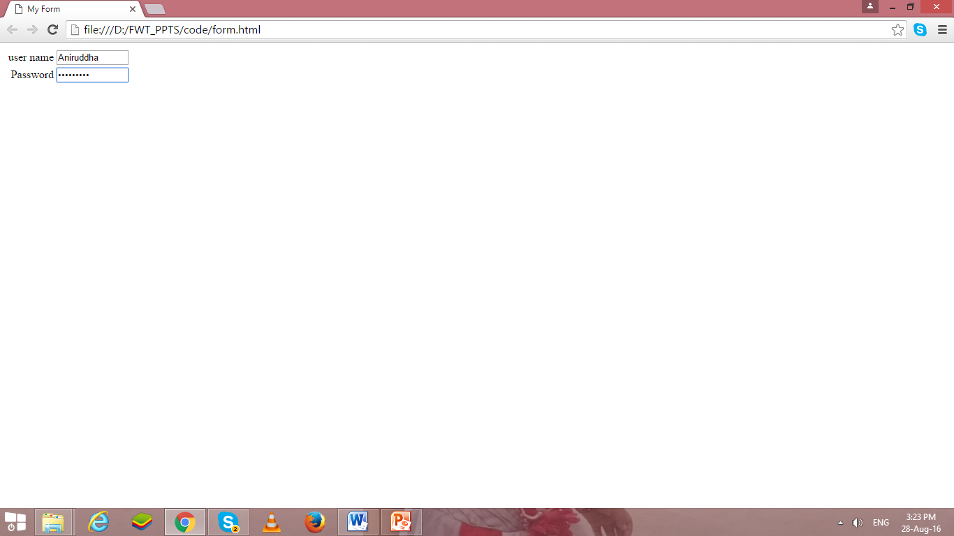

**Text Area**

* Text Area is require for large amount of text.
* Following are commonly used attributes for <textarea>
  + Rows
    - Sets the number of rows of text that visible without scrolling up or down in the fields.
  + Cols
    - Sets the number of rows of text that visible without scrolling left or right in the fields.
  + Name
    - Specifies name of text area.

<form>

<tr>

<td align="right">User Details</td>

<td><textarea rows=5 cols=40></textarea></td>

</tr>

</form>

**OutPut**

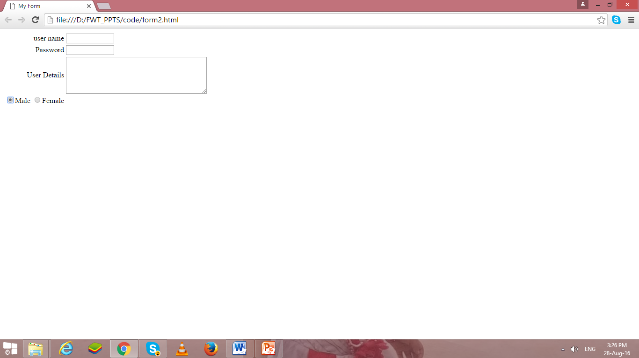

**Radio Button**

* Values of input element is **“radio”**for radio.
* Enables to create radio button.
* We can select only one radio button at a time from group of radio buttons.

<form>

<tr>

<td align="Right"> Gender:

<input type="radio" name="gen" value="m">Male

<input type="radio" name="gen" value="F">Female

</td>

</tr>

</form>

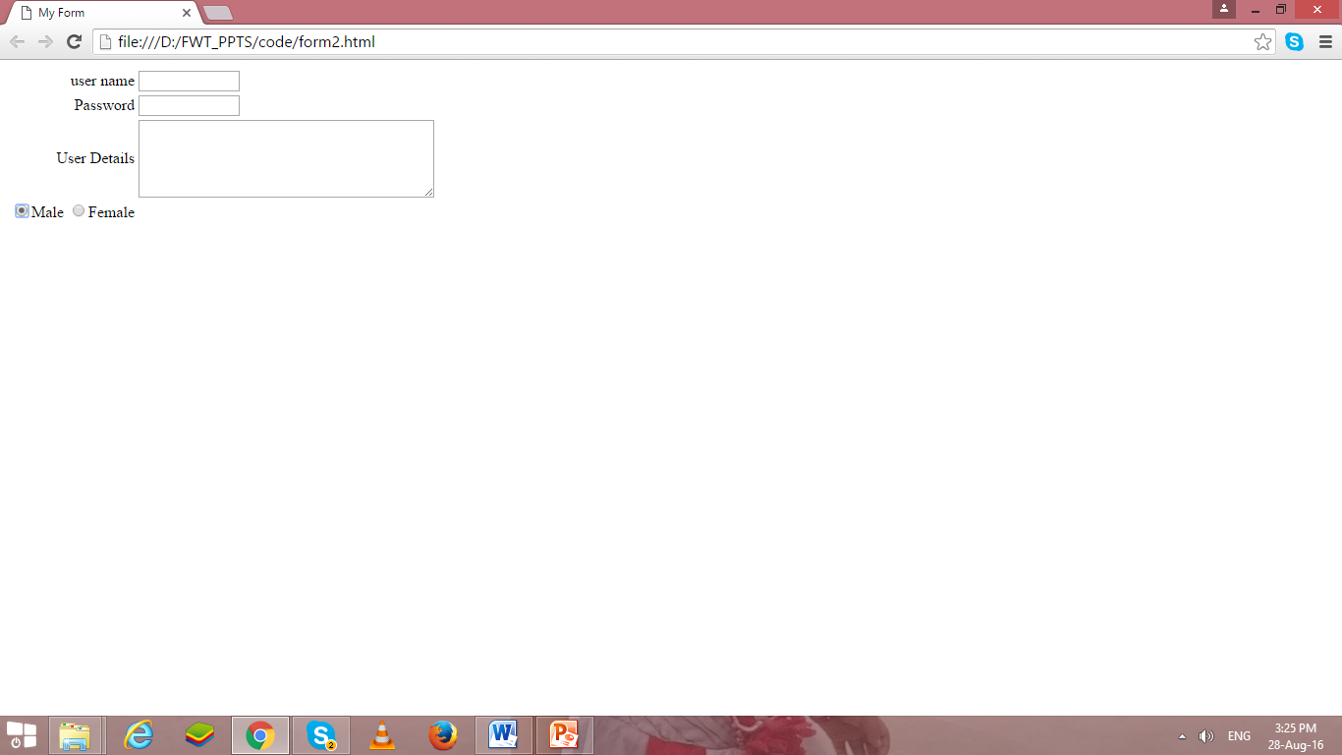

**Check Box**

* Values of input element is **“checkbox”**for enabling checkbox.
* We can select multiple check boxes.

<form>

<tr>

<td align="Right"> Sports Interest:

<input type="checkbox" name="sprt" value="h">Hockey

<input type="checkbox" name="sprt" value="ft">FootBall

</tr>

</form>

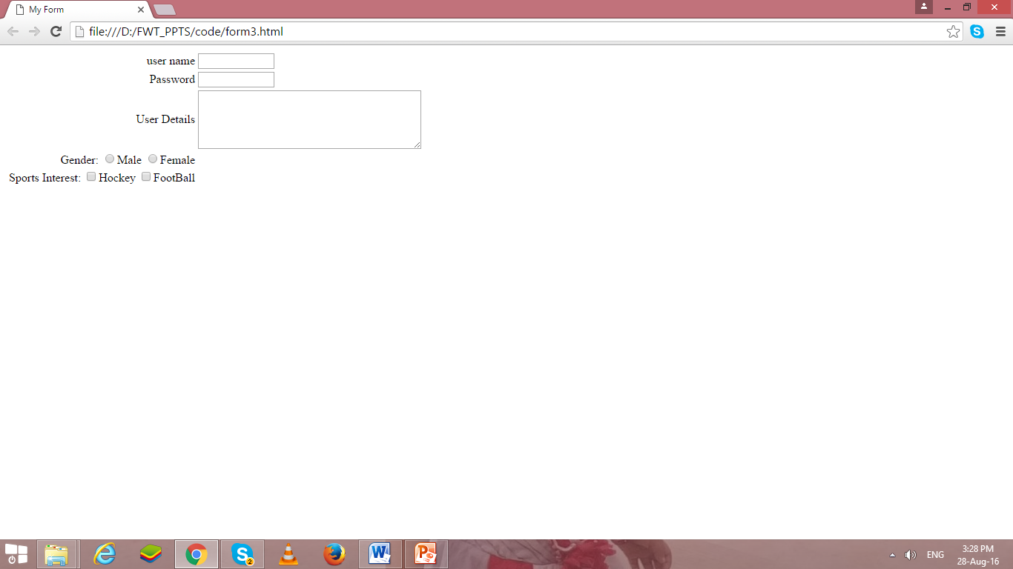

**Drop Down List**

* The select element enables us to create a menu or drop down list in a form, depending on the attribute specified.
* The Select element specifies that the text follows is a list.
* Select element is used with the option element.
* The option element enables us to specify the items of the list created using the select element.
* Functionality of select element is similar to that of unordered list(<ul></ul>) and ordered list(<ol></ol>) element.
* The option element is similar to list item element (<li>)
* The select element is implemented by using <select></select> tag
* The option element is implemented by using <option></option> tag.

<td align="Right"> Branch:</td><td align="left">

<select name="Branch" size=“4”>

<option value="#">--Select--</option>

<option value="ce">Comp Engg</option>

<option value="cs">Comp Science</option>

<option value="cse">Comp Sci&Engg</option>

</select>

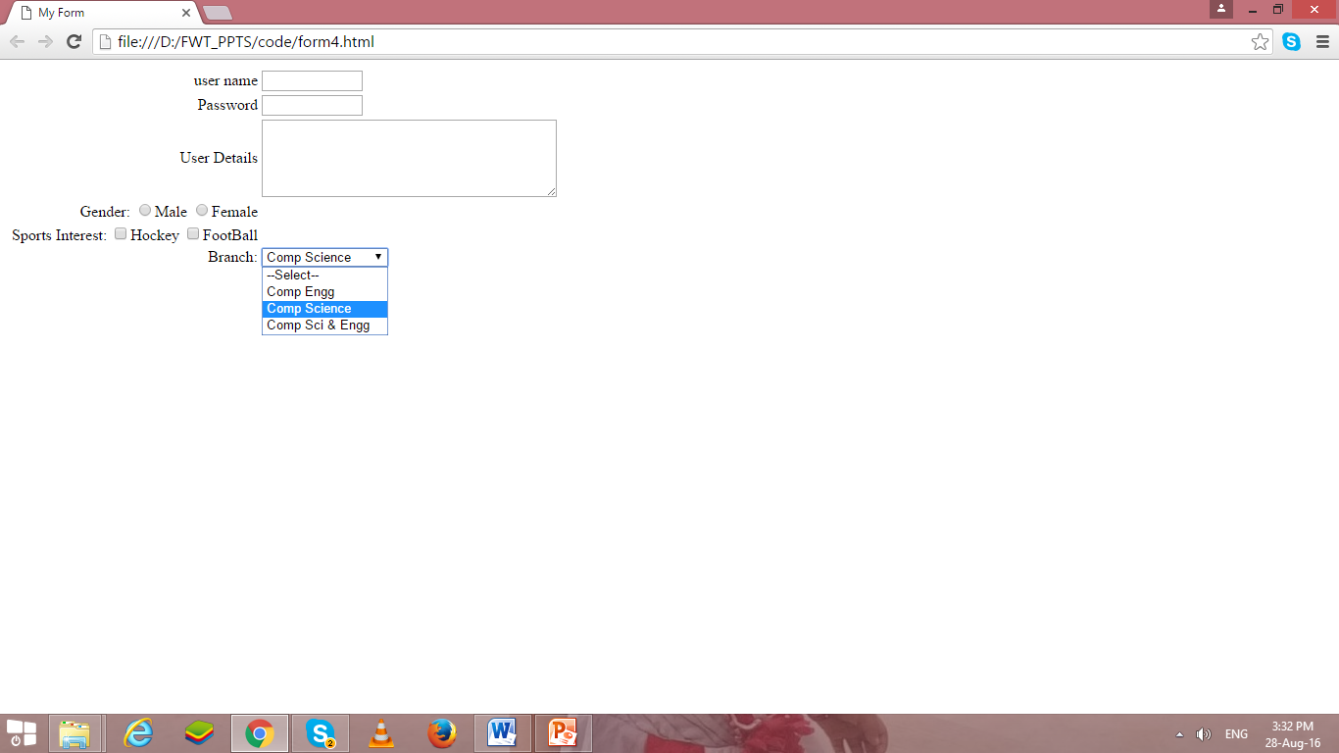

**Button**

* Values of input element is **“submit”** for submit button.
* Values of input element is **“reset”** for reset/clear button.
* Reset and Submit are buttons.
* “Submit” enables to create submit button, when we click submit button, the values of the from are submitted to the web page specified in the action attribute of the form.
* “reset” enables to create reset/clear button , when we click reset button, the values entered in the form are cleared automatically and set back to default values.

</tr>

<tr><td colspan=2 align="center">

<input type="submit" value="Add to DB"/>

<input type="reset" value="Clear"/>

</tr>

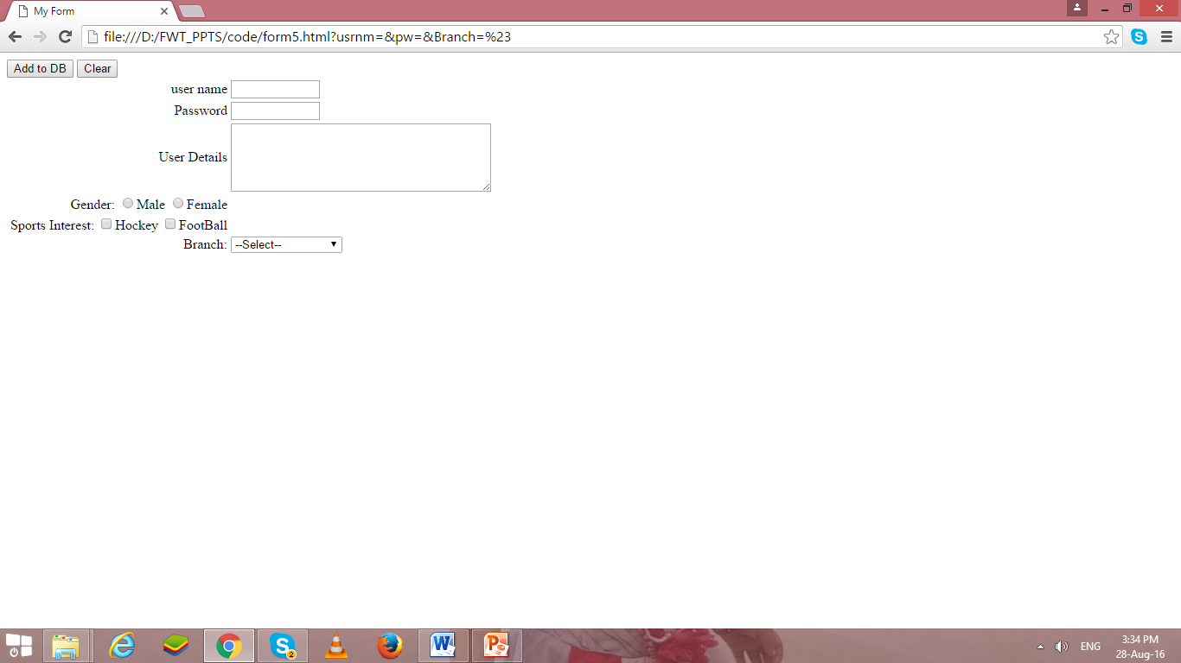

**File**

* Values of input element is **“file”**for uploading file.
* the file are submitted to the path/url specified in the action attribute of the form???

<tr>

<td align=“right"> Select Image to Upload

<input type=“file" value=“upload"/>

</tr>

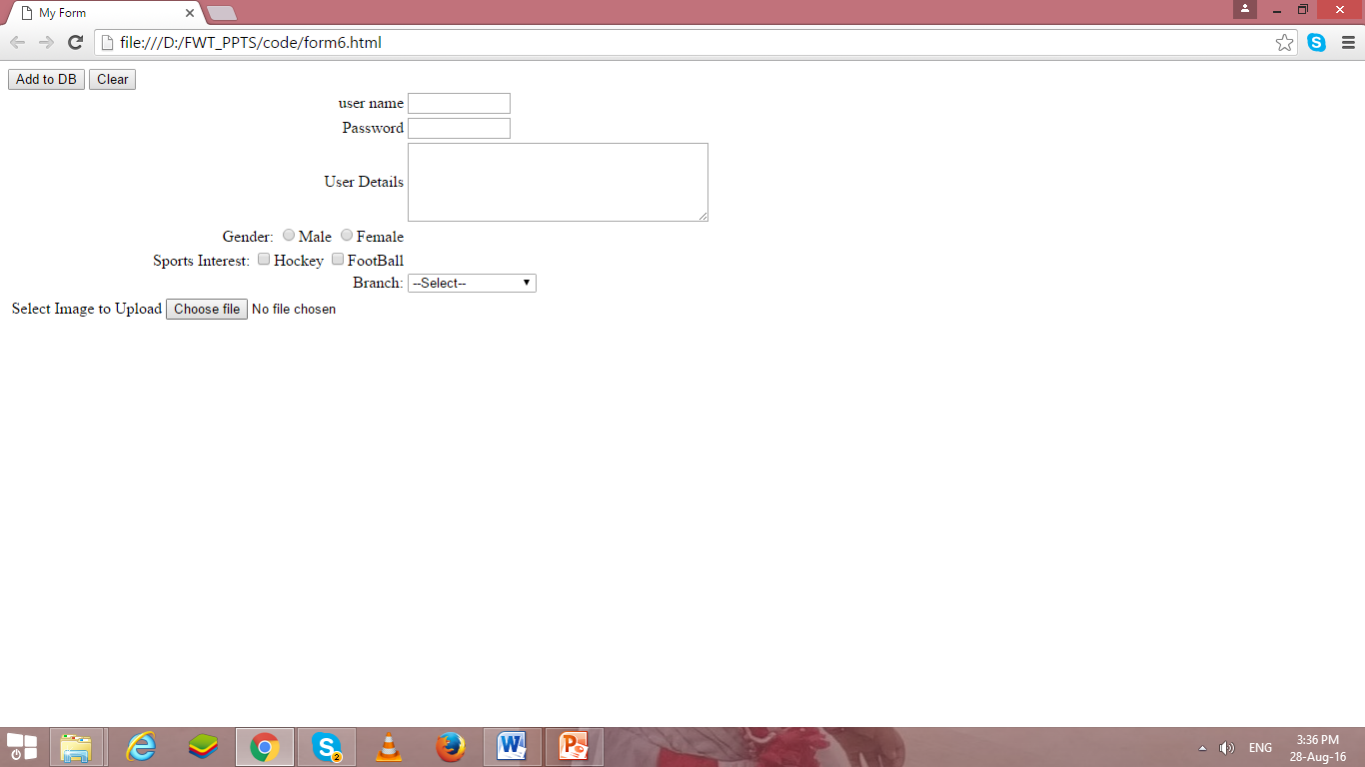

**Image Control**

* Values of input element is **“image”** for graphical submit button.
* If any error occur to open image, then alt values will be displayed.

<tr>

<td align=“right"> Select Image to Upload

<input type=“image" src=“ dj.jpg” alt=“submit”/>

</tr>

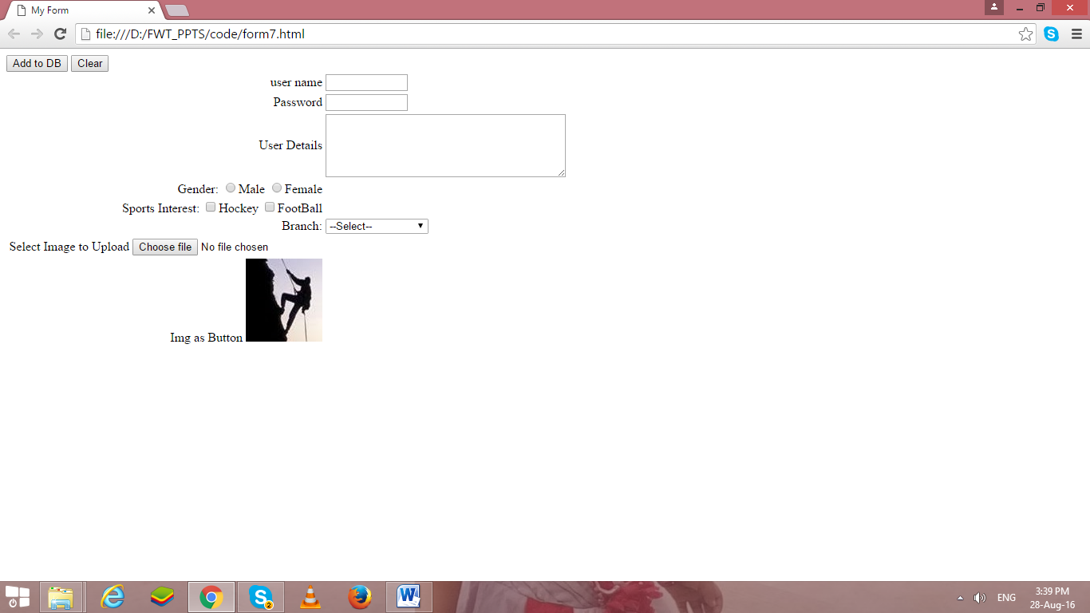

If we integrate above all code, it will generate following form as output.

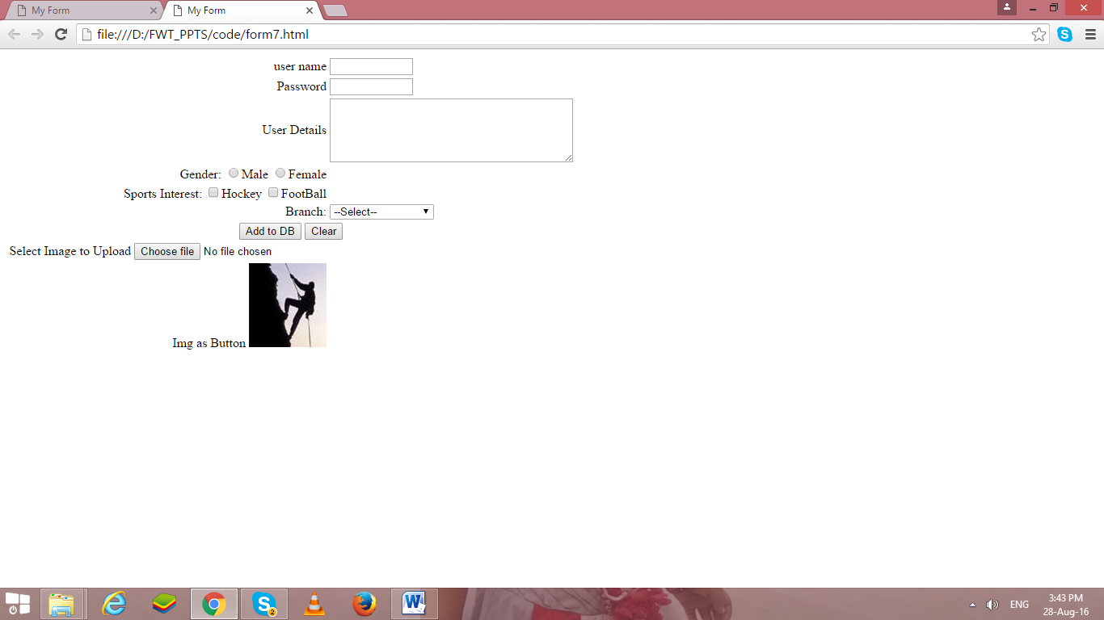

Because the attributes used with input elements varies so much depending on the type of input you want to use, we have provided several specific examples of using different types of input.

**File:-**

<input type = "file"

multiple = "false"

accept = "image/*"

">

* type is file
* multiple = "false" indicates user cannot select multiple files
* accept = "image/*" indicates user can only select image files
* value is default value

**Video:-**

Video element <video>

* Video tag uses a src attribute or embedded <source>
* Common attributes
  + height, width
  + autoplay
  + loop
  + controls
* Text inside <video>..</video> is displayed if browser cannot support tag

**Audio:-**

* Audio tag uses a src attribute to link to audio file, typically .mp3 or .wav
* Common attributes
  + autoplay, controls, loop
  + buffered
  + muted

**PART B**

**Aim: - Design following –webpages using HTML Forms**

Create a static web pages using HTML

1. Login page (Now, implement it using form tag)
2. Design a form and try to apply all elements under it.
3. Implement Multimedia Elements.
4. Design a web page using frames and to make page attractive.

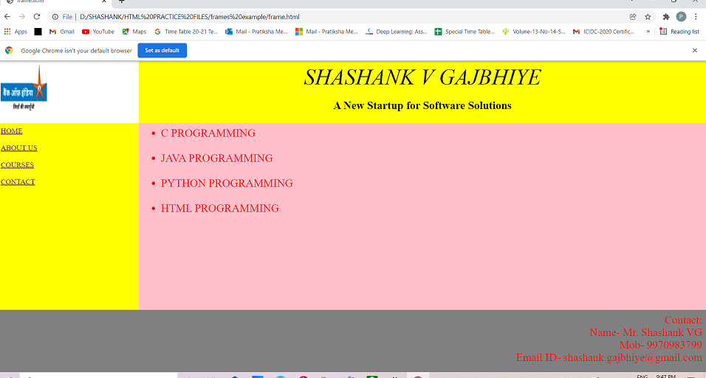

**Note: Create Web Page for forms using following tags with your creativity…**

* Use media tags <audio>,<video>
* The forms created in previous practical’s need to updated with more HTML 5 tags and attributes (Use

<input> tags type attribute as radio, checkbox, number, range, datetime-local,

**Note:- Don’t use any type of CSS in your code…**

**HTML Code 1: -**

<!DOCTYPE*html*>

<html*lang*="en">

<head>

    <meta*charset*="UTF-8">

    <meta*http-equiv*="X-UA-Compatible"*content*="IE=edge">

    <meta*name*="viewport"*content*="width=device-width, initial-scale=1.0">

    <title>Login Page</title>

</head>

<bodybgcolor="cyan">

    <form*action*="" align="center">

        <h1>LOGIN</h1>

        <h3>Username:</h3><input*type*="text"*name*="Enter your Username"*id*="">

        <h3>Password:</h3><input*type*="password"*name*="Enter your Password"*id*="">

        <br>

        <br>

        <input*type*="submit">  <input*type*="reset">

    </form>

</body>

</html>

**Output (only in print screen format) Code 1**

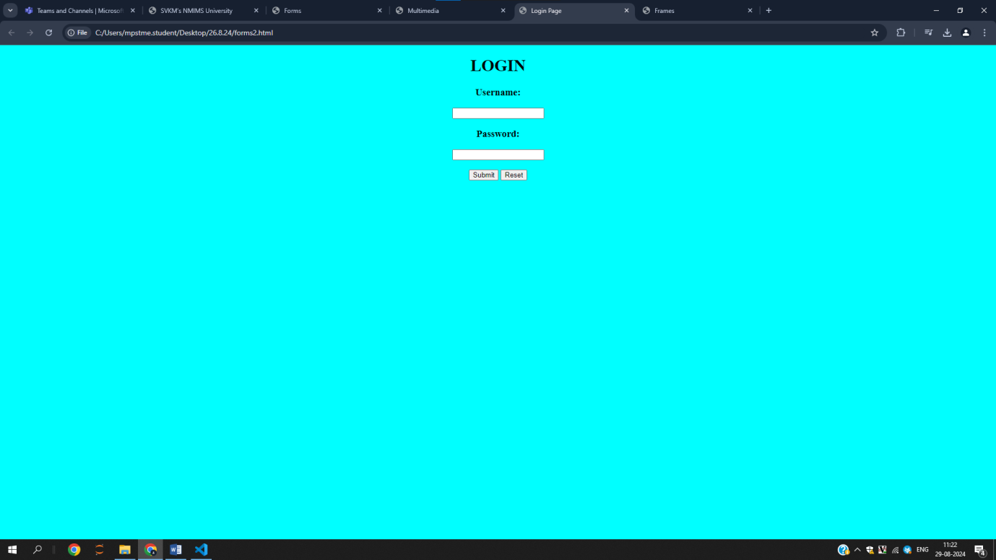

**HTML Code 2: -**

<!DOCTYPE*html*>

<html*lang*="en">

<head>

    <meta*charset*="UTF-8">

    <meta*http-equiv*="X-UA-Compatible"*content*="IE=edge">

    <meta*name*="viewport"*content*="width=device-width, initial-scale=1.0">

    <title>Forms</title>

</head>

<body>

    <table*style*="margin: 50px auto; text-align: center;">

        <form>

            <tr>

                <td><label>User Name:</label></td>

                <td><input*type*="text"></td>

            </tr>

            <tr>

                <td><label>Password:</label></td>

                <td><input*type*="password"></td>

            </tr>

            <tr>

                <td><label>User Details:</label></td>

                <td><textarea*rows*="7"*cols*="50"></textarea></td>

            </tr>

            <tr>

                <td><label>Gender:</label></td>

                <td>

                    <input*type*="radio"*name*="Gender">

                    <label>Male</label>

                    <input*type*="radio"*name*="Gender">

                    <label>Female</label>

                </td>

            </tr>

            <tr>

                <td><label>Sports Interest:</label></td>

                <td>

                    <input*type*="checkbox"*name*="Sports Interest">

                    <label>Hockey</label>

                    <input*type*="checkbox"*name*="Sports Interest">

                    <label>Football</label>

                </td>

            </tr>

            <tr>

                <td><label>Branch:</label></td>

                <td>

                    <select*name*="dropdownName">

                        <option>Select</option>

                        <option>Comp Engg</option>

                        <option>Comp Science</option>

                        <option>Comp Sci&Engg</option>

                    </select>

                </td>

            </tr>

            <tr>

                <td><input*type*="submit"*value*="Add to DB"></td>

                <td><input*type*="reset"*value*="Clear"></td>

            </tr>

            <tr>

                <td><label>Select Image to Upload:</label></td>

                <td><input*type*="file"></td>

            </tr>

            <tr>

                <td*colspan*="2">

                    Img as Button

                    <input*type*="image"*src*="images.jpg"*width*="100"*height*="100"*alt*="submit">

                </td>

            </tr>

        </form>

    </table>

</body>

</html>

**Output (only in print screen format) Code -2**

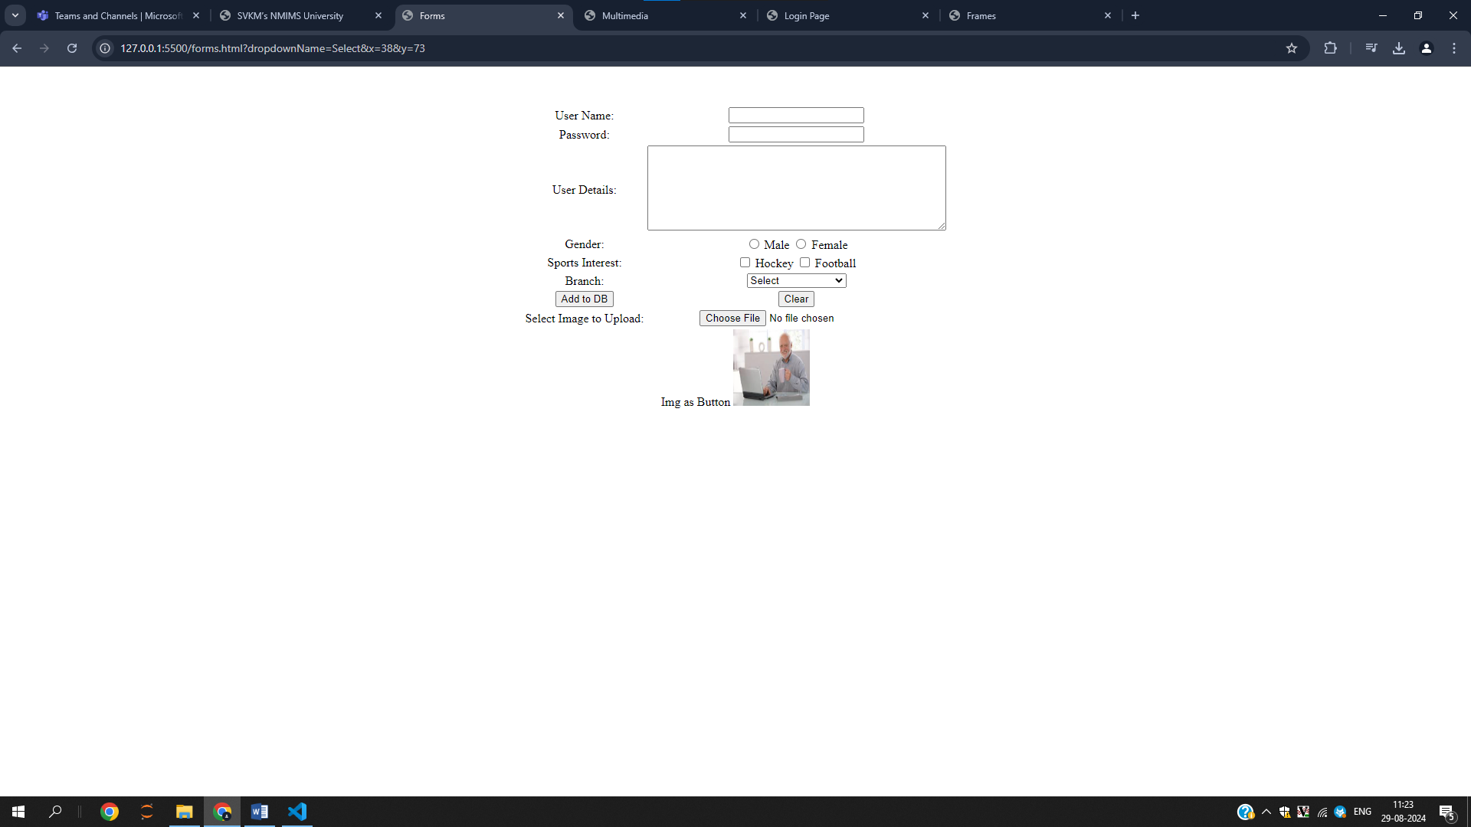

**HTML Code 3: -**

<!DOCTYPE*html*>

<html*lang*="en">

<head>

    <meta*charset*="UTF-8">

    <meta*http-equiv*="X-UA-Compatible"*content*="IE=edge">

    <meta*name*="viewport"*content*="width=device-width, initial-scale=1.0">

    <title>Multimedia</title>

</head>

<body>

    <video*src*="video.mp4"*height*="500"*width*="500"*controls*></video>

    <audio*src*="song.mp3"*controls*></audio>

</body>

</html>

**Output (only in print screen format) Code -3**

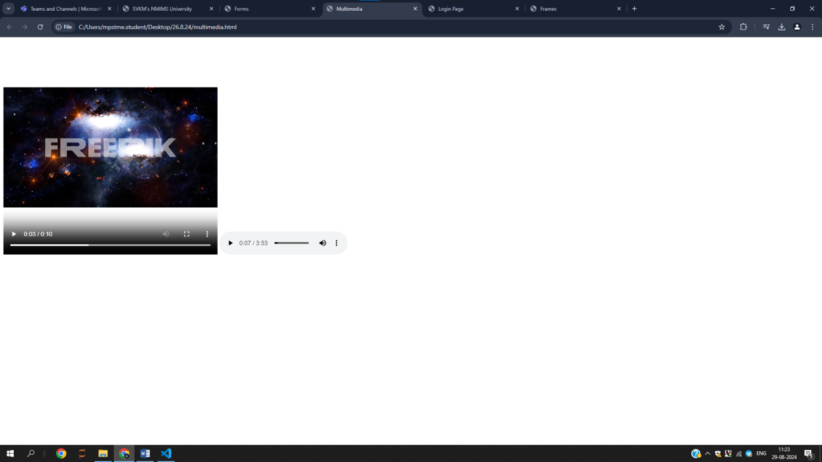

**HTML Code 4: -**

<!DOCTYPE html>

<html>

<head>

   <title>HTML Frames</title>

</head>

<frameset rows="20%,60%,20%">

   <frameset cols="10%,90%">

      <frame name="top_left" src="topleft.html" />

      <frame name="top_right" src="topright.html" />

   </frameset>

   <frameset cols="10%,90%">

      <frame name="center_left" src="middle1.html" />

      <frame name="center_right" src="middle2.html" />

   </frameset>

   <frameset>

    <frame name="center_left" src="lower.html" />

 </frameset>

   <noframes>

      <body>

         Your browser does not support frames.

      </body>

   </noframes>

</frameset>

</html>

<!DOCTYPE html>

<html lang="en">

<head>

    <meta charset="UTF-8">

    <meta http-equiv="X-UA-Compatible" content="IE=edge">

    <meta name="viewport" content="width=device-width, initial-scale=1.0">

    <title>topleft</title>

</head>

<body bgcolor="white">

    <img src="Capture001.png" alt="">

</body>

</html>

<!DOCTYPE html>

<html lang="en">

<head>

    <meta charset="UTF-8">

    <meta http-equiv="X-UA-Compatible" content="IE=edge">

    <meta name="viewport" content="width=device-width, initial-scale=1.0">

    <title>topright</title>

</head>

<body bgcolor="yellow" align="center">

    <h1>Jal Bafana</h1>

    <p>A New startup for Software Solutions</p>

</body>

</html>

<!DOCTYPE html>

<html lang="en">

<head>

    <meta charset="UTF-8">

    <meta name="viewport" content="width=device-width, initial-scale=1.0">

    <title>middle1</title>

</head>

<body bgcolor="yellow">

    <a href="home.com">HOME</a>

    <a href="aboutus.com">ABOUT US</a>

    <a href="courses.com">COURSES</a>

    <a href="contact.com">CONTACT</a>

</body>

</html>

<!DOCTYPE html>

<html lang="en">

<head>

    <meta charset="UTF-8">

    <meta name="viewport" content="width=device-width, initial-scale=1.0">

    <title>middle2</title>

</head>

<body bgcolor="pink">

    <ul>

        <li>C PROGRAMMING</li>

        <li>JAVA PROGRAMMING</li>

        <li>PYTHON PROGRAMMING</li>

        <li>HTML PROGRAMMING</li>

    </ul>

</body>

</html>

<!DOCTYPE html>

<html lang="en">

<head>

    <meta charset="UTF-8">

    <meta name="viewport" content="width=device-width, initial-scale=1.0">

    <title>lower</title>

</head>

<body bgcolor="grey" align="right">

    Contact: <br>

    Name- Jal Bafana <br>

    Mob- 1000123456 <br>

    Email ID- hello@gmail.com <br>

</body>

</html>

**Output (only in print screen format) Code -4**

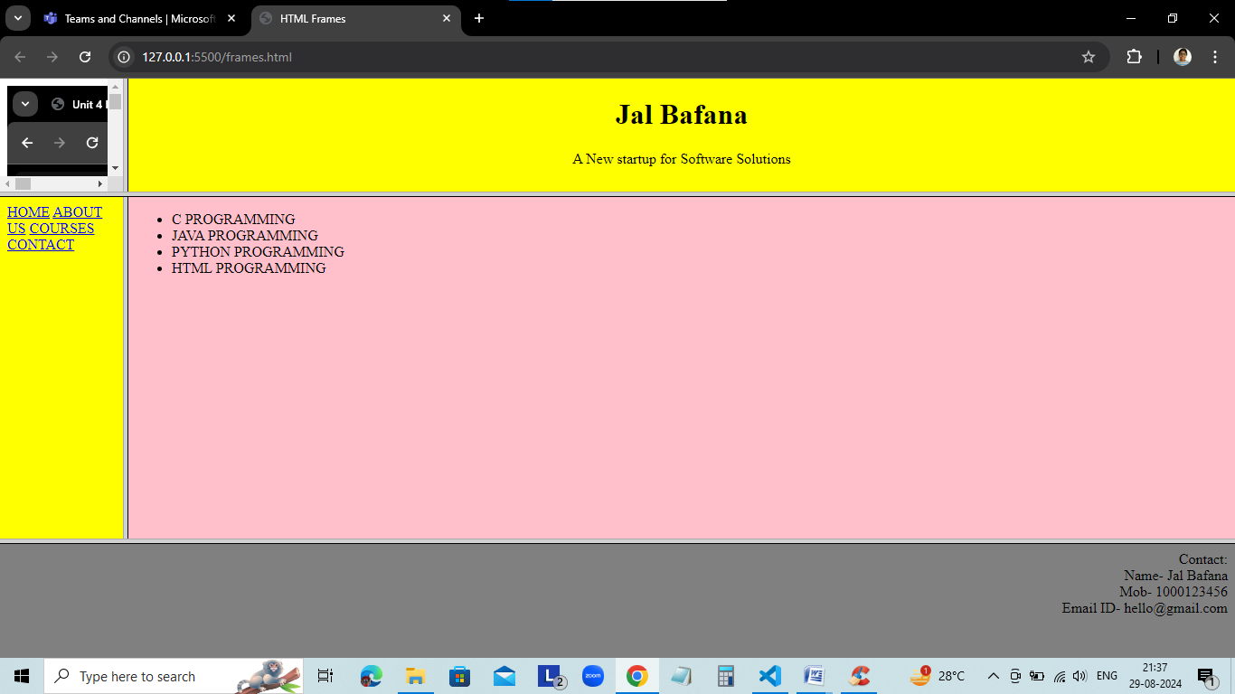

**Observation and Learning: -**

* **Learnt how to make forms in html and how to make pages more attractive and easy to edit via frames.**

**Answer the Questions: -**

1. What is hyperlink in HTML? Which tag is used? What are various attributes of <a>? explain.

In HTML, the tag defines a hyperlink, which is used to link from one page to another. The most important attribute of the element is the href attribute, which indicates the link's destination.

1. List out various form elements and their associated tags.

• **<form>**: Encapsulates the form elements and specifies how data should be submitted.

• **<input>**: Used for a variety of input types, including text, passwords, checkboxes, and submit buttons.

• **<textarea>**: Provides a multi-line text input area for longer user input.

• **<select>**: Creates a dropdown menu from which users can select an option.

• **<option>**: Defines individual options within a <select> dropdown.

• **<button>**: Represents a clickable button for form submission or other actions.

• **<label>**: Associates a text label with a form control, improving accessibility and user experience.

• **<input type="file">**: Lets users select files from their device for upload.

**Conclusion:**