|  |  |
| --- | --- |
| **Name: Jal Bafana** | **Roll no: K005** |
| **Program/Branch: Btech. Cyber Security** | **Batch: K1** |

## Aim:

1. Apply styling technique Using Inline CSS
2. Apply styling technique Using External CSS

## Prerequisites:-

- Basic Tags of HTML.

**Theory:-**

# Cascading Style Sheets (CSS)

**Syntax**

selector { property: value }

* A CSS rule-set consists of a selector and a declaration block:
* Declaration part is further divided into property and values.

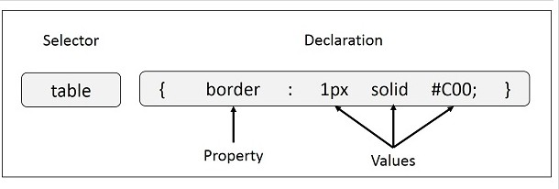

* **Selector** − A selector is an HTML tag at which a style will be applied. This could be any tag like <h1> or <table> etc.
* **Property** - A property is a type of attribute of HTML tag. Put simply, all the HTML attributes are converted into CSS properties. They could be *color*, *border* etc.
* **Value** - Values are assigned to properties. For example, *color* property can have value either *red* or any other color.

The selector points to the HTML element you want to style.

The declaration block contains one or more declarations separated by semicolons. Each declaration includes a property name and a value, separated by a colon.

|  |  |
| --- | --- |
| **Properties** | **Values** |
| background-attachment | scroll, fixed |
| background-color | (color), transparent |
| background-image | none, (location) |
| background-position | (percent), (length), top, center, bottom, left, center, right |
| background-repeat | repeat, repeat-x, repeat-y, no-repeat |
| Background | Any of the above background values separated by spaces. |
| Color | (color) |

|  |  |
| --- | --- |
| **Properties** | **Values** |
| margin-bottom | (length), (percent), auto |
| margin-left | (length), (percent), auto |
| margin-right | (length), (percent), auto |
| margin-top | (length), (percent), auto |
| margin | Any of the above margin values in top, right, bottom, left order separated by spaces. |
| padding-bottom | (length), (percent) |
| padding-left | (length), (percent) |
| padding-right | (length), (percent) |
| padding-top | (length), (percent) |

|  |  |
| --- | --- |
| padding | Any of the above padding values in top, right, bottom, left order separated by spaces. |
| border-bottom-width | medium, thin, thick, (length) |
| border-bottom | Any of the border-top-bottom, border-color and border-style values. |
| border-color | (color) |
| border-left-width | medium, thin, thick, (length) |
| border-left | Any of the border-top-left, border-color and border-style values. |
| border-right-width | medium, thin, thick, (length) |
| border-right | Any of the border-right-width, border-color and border-style values. |
| border-style | none, dotted, dashed, solid, double, groove, ridge, inset, outset |
| border-top-width | medium, thin, thick, (length) |
| border-top | Any of the border-top-width, border-color and border-style values. |
| border | Any of the border values. Applies to all borders. |
| height | auto, (length), (percent) |
| width | auto, (length), (percent) |
| list-style-type | disc, circle, square, decimal, lower-roman, upper-roman, lower-alpha, upper-alpha, upper-latin, hebrew, armenian, georgian, cjk-ideographic, hiragana, katakana, hiragana-iroha, katakana-iroh, none |
| list-style-image | none, (url) |
| list-style-position | outside, inside |
| **Properties** | **Values** |
| list-style | Any of the above list-style values separated by spaces. |
| white-space | normal, pre, nowrap |
| border-collapse | collapse, separate, inherit |
| border-spacing | (length)(length), inherit |
| caption-side | top, bottom, left, right, inherit |
| empty-cells | show, hide, inherit |

|  |  |
| --- | --- |
| speak-header | once, always, inherit |
| table-layout | auto, fixed, inherit |

### Three Ways to Insert CSS

There are three ways of inserting a style sheet:

* Internal style sheet
* Inline style
* External style sheet

### Internal Style Sheet

An internal style sheet should be used when a single document has a unique style. You define internal styles in the head section of an HTML page, inside the <style> tag, like this:

<head>

<style> hr{color:sienna;} p{margin-left:20px;}

body{background-image:url("images/background.gif");}

</style>

</head>

### Inline Styles

An inline style loses many of the advantages of a style sheet (by mixing content with presentation). Use this method sparingly!

To use inline styles, add the style attribute to the relevant tag. The style attribute can contain any CSS property. The example shows how to change the color and the left margin of a paragraph:

<p style="color:sienna;margin-left:20px;">This is a paragraph.</p>

nth-child Property: The :nth-child(n) selector matches every element that is the nth child of its parent. n can be a number, a keyword (odd or even), or a formula (like an + b).

For example:

<!DOCTYPE html>

<html>

<head>

<style>

p:nth-child(odd) {

background: red;

}

p:nth-child(even) {

background: lightgreen;

}

</style>

</head>

<body>

<p>The first paragraph.</p>

<p>The second paragraph.</p>

<p>The third paragraph.</p>

<p>The fourth paragraph.</p>

<p>The fifth paragraph.</p>

</body>

</html>

Output:

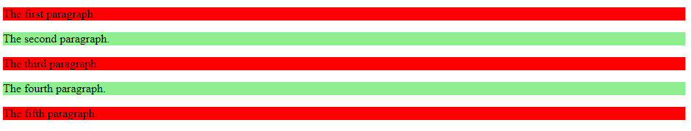

**Instructions to Students:-**

* 1. Write html code in Note Pad & save with .html extension.
  2. Execute using Web Browser.
  3. Copy and Paste code as well as output (snapshot of output) in Part B

1. Design a navigation bar in a web page using HTML and CSS using external CSS.



Also create Home, Students, faculty and contact us pages separately.

Note: overflow: hidden property that prevents the list elements from going outside of the list,

display: block property displays the links as the block elements and makes the entire link area clickable.

float: left property, which uses float for getting the block elements to slide them next to each other.

<!DOCTYPE html>

<html lang="en">

<head>

    <meta charset="UTF-8">

    <meta name="viewport" content="width=device-width, initial-scale=1.0">

    <title>Document</title>

    <link rel="stylesheet" href="Q1-lab5.1.css">

</head>

<body>

    <ul>

        <li><a href="home.com">Home</a></li>

        <li><a href="students.com">Students</a></li>

        <li><a href="faculty.com">Faculty</a></li>

        <li><a href="contact.com">Contact Us</a></li>

    </ul>

</body>

</html>

ul{

    list-style-type: none;

    margin: 0;

    padding: 0;

    overflow: hidden;

    background-color: #a49b9b;

}

li{

    float: left;

}

li a{

    display: block;

    text-align: center;

    padding: 16px;

    text-decoration: none;

}

li a:hover{

    background-color: rgb(79, 75, 75);

    color: white;

}

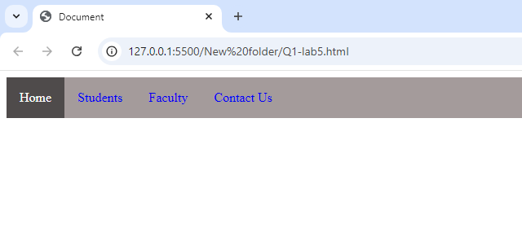

1. Design a web page using box model using external CSS

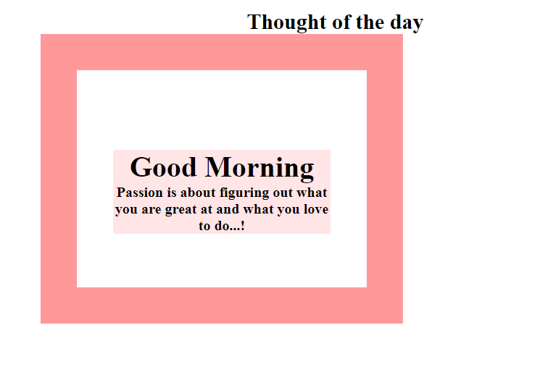

Note: Only use inline style for the text “Thought of the day”.

<!DOCTYPE html>

<html lang="en">

<head>

    <meta charset="UTF-8">

    <meta name="viewport" content="width=device-width, initial-scale=1.0">

    <title>Lab 5</title>

    <link rel="stylesheet" href="Q1-lab5.1.css">

</head>

<body>

    <p>Thought of the Day</p>

    <div class="d1">

        <div class="d2">

            <h1>Good Morning</h1>

            Passion is about figuring out what you are great at and what you love to do...!

        </div>

    </div>

</body>

</html>

p{

    text-align: center;

    font-weight: bold;

}

.d1{

    margin-left: 600px;

    width: 350px;

    height: 200px;

    border: solid;

    border-color: coral;

    border-width: 30px;

}

.d2{

    width:170px;

    align:center;

    background-color:lightpink;

    text-align:center;

    margin: auto;

}

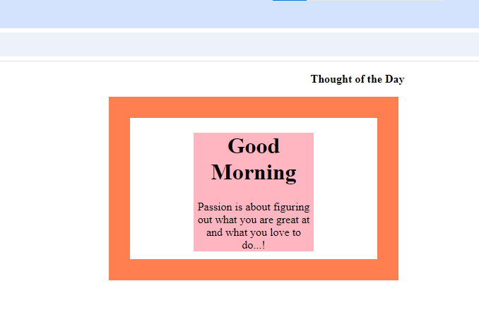

1. Design a web page to style a table using external CSS.

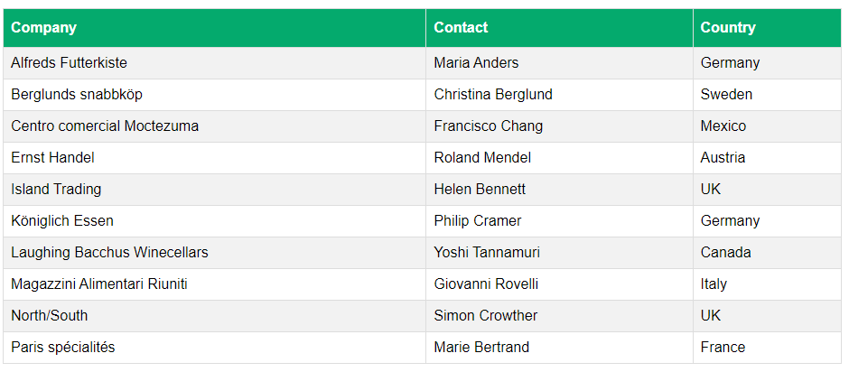

<!DOCTYPE html>

<html lang="en">

<head>

    <meta charset="UTF-8">

    <meta name="viewport" content="width=device-width, initial-scale=1.0">

    <title>Lab 5</title>

    <link rel="stylesheet" href="Q1-lab5.1.css">

</head>

<body>

    <table>

        <tr>

            <th>Company</th>

            <th>Contact</th>

            <th>Country</th>

        </tr>

        <tr>

            <td>Alfreds Futterkiste</td>

            <td>Maria Anders</td>

            <td>Germany</td>

        </tr>

        <tr>

            <td>Berglunds snabbköp</td>

            <td>Christina Berglund</td>

            <td>Sweden</td>

          </tr>

          <tr>

            <td>Centro comercial Moctezuma</td>

            <td>Francisco Chang</td>

            <td>Mexico</td>

          </tr>

          <tr>

            <td>Ernst Handel</td>

            <td>Roland Mendel</td>

            <td>Austria</td>

          </tr>

          <tr>

            <td>Island Trading</td>

            <td>Helen Bennett</td>

            <td>UK</td>

          </tr>

          <tr>

            <td>Königlich Essen</td>

            <td>Philip Cramer</td>

            <td>Germany</td>

          </tr>

          <tr>

            <td>Laughing Bacchus Winecellars</td>

            <td>Yoshi Tannamuri</td>

            <td>Canada</td>

          </tr>

          <tr>

            <td>Magazzini Alimentari Riuniti</td>

            <td>Giovanni Rovelli</td>

            <td>Italy</td>

          </tr>

          <tr>

            <td>North/South</td>

            <td>Simon Crowther</td>

            <td>UK</td>

          </tr>

          <tr>

            <td>Paris spécialités</td>

            <td>Marie Bertrand</td>

            <td>France</td>

          </tr>

    </table>

</body>

</html>

table{

    width: 100%;

    border-collapse: collapse;

}

th, td{

    padding: 8px;

    text-align: left;

}

th{

    background-color: green;

    color: white;

}

tr:nth-child(even){

    background-color: rgb(202, 199, 199);

}

# 

# Conclusion: - In this Experiment we learnt about external css in much detail.