**Part A (To be referred by students)**

**SAVE THE FILE AND UPLOAD AS (RollNo_Name_Exp2)**

**Topic covered:** Basic Tags of HTML5(Tables, List, image)

**Learning Objective: Learner would be able to**

1. To present an introduction to Web Programming, with an emphasis on the Web Programming languages like HTML.
2. Describe different architectural components used in web development.

**Prerequisites:-**

* PPS

**Outcomes:-**

* Student will know about web browser & how it interprets web pages.
* Students will know about how to execute HTML file
* Students will get idea about basic tags of HTML.
* Students will get idea about how to work with HTML list, table and images.

**Theory:-**

**What is HTML?**

HTML is a language for describing web pages. HTML stands for Hyper Text Markup Language. HTML is a markup language. A markup language is a set of markup tags. The tags describe document content. HTML documents contain HTML tags and plain text. HTML documents are also called web pages.

**HTML Tags**

HTML markup tags are usually called HTML tags. HTML tags are keywords (tag names) surrounded by angle brackets like <html>. HTML tags normally come in pairs like <p> and </p>. The first tag in a pair is the start tag, the second tag is the end tag. The end tag is written like the start tag, with a slash before the tag name. Start and end tags are also called opening tags and closing tags

**HTML Element Syntax**

An HTML element starts with a start tag / opening tag. An HTML element ends with an end tag / closing tag. The element content is everything between the start and the end tag. Some HTML elements have empty content. Empty elements are closed in the start tag. Most HTML elements can have attributes.

**HTML Attributes**

HTML elements can have attributes. Attributes provide additional information about an element. Attributes are always specified in the start tag. Attributes come in name/value pairs like: name="value".

Its good practice to follow following html format: -

<!DOCTYPE html>  
<html lang="en-us">  
<head>

<meta charset="utf-8">  
  <title> Title</title>  
</head>  
<body>  
  
</body>  
</html>

**HTML Tags:-**

Structure of HTML

<!DOCTYPE html>  
<html lang="en-us">  
<head>

<meta charset="utf-8">  
  <title> Title</title>  
</head>  
<body>

</body>  
</html>

1. Formatting Tags (Heading, Font, Size, Color and all characteristics of font)
2. Lists

Unordered List

An unordered list starts with the **<ul>** tag. Each list item starts with the **<li>** tag.

**Example:**

<ul>  
  <li>Cricket</li>  
  <li>Tennis</li>  
  <li>Hockey</li>  
</ul>

Ordered List

An ordered list starts with the **<ol>** tag. Each list item starts with the **<li>** tag.

**Example:**

<ol>  
  <li>Cricket</li>  
  <li>Tennis</li>  
  <li>Hockey</li>  
</ol>

1. Tables

* An HTML table is defined with the **<table>** tag.
* Each table row is defined with the **<tr>** tag.
* A table header is defined with the **<th>** tag.
* By default, table headings are bold and centered.
* A table data/cell is defined with the **<td>** tag.

**Example:**

<table >  
  <tr>  
    <th>Firstname</th>  
    <th>Lastname</th>   
    <th>Age</th>  
  </tr>  
  <tr>  
    <td>Sachin</td>  
    <td>Tendulkar</td>   
    <td>40</td>  
  </tr>  
  <tr>  
    <td>Rahul</td>  
    <td>Dravid</td>   
    <td>42</td>  
  </tr>  
</table>

**Cell that Span Many rows (Rowspan)**

<table style="width:100%">  
  <tr>  
    <th>Name:</th>  
    <td>RAM Rao</td>  
  </tr>  
  <tr>  
    <th rowspan="2">Mobile:</th>  
    <td>123456</td>  
  </tr>  
  <tr>  
    <td>654321</td>  
  </tr>  
</table>

1. Image

* Images help to make web page look attractive.
* We should always use images in jpg, gif or png, as browser supports these format.
* HTML images are defined with the **<img>** tag.

Example

<img src="flower.jpg" alt="W3Schools.com" width="104" height="142">

The compulsory attribute for <img> tag is **src** to specify URL of the image

* 1. **alt** stands for Alternate Text – If the browser is not supporting Images it display the value of ALT .
  2. **height** and **width** specify the height and width of the image.

Img also has following attributes

* 1. Hspace – specifies the amount of space to left and right of image.
  2. Vspace – Specifies the amount of space to top and bottom of an image.
  3. Border – Specifies border around an image.
  4. Align – Defines the alignment of image.

**Example:-**

<img src="home.jpg" alt="Hill Climbing" hspace=250 vspace=250 border=10 align="right">

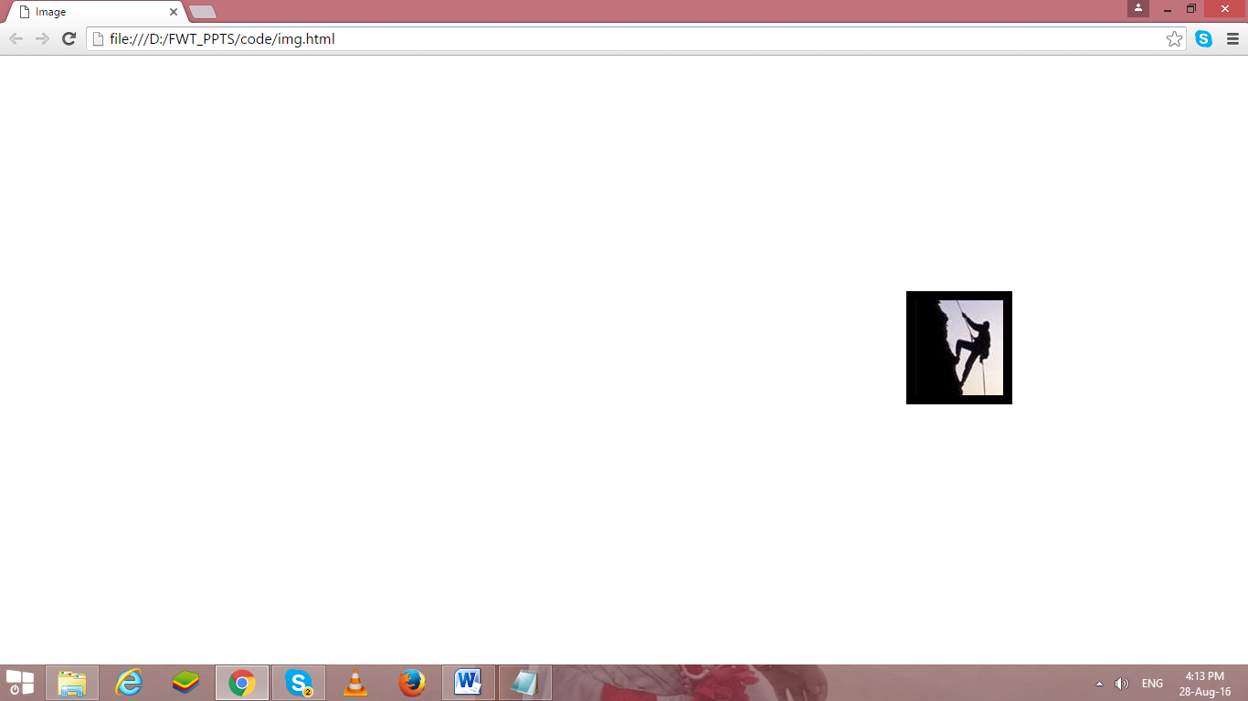

**Problem Statement:**

Create a static web page using HTML that has

1. Registration page (Without using form)

2. Contact Us page (To display any firm address, dummy mobile, dummy email id etc.)

3. Home Page (Your CV)

**Note: - Don’t use any type of CSS in your code…**

**Part B (to be completed by students)**

(Students must submit the soft copy as per the following segments. A soft copy containing Part A and Part B must be uploaded on the platform specified by the Practical Teacher. The filename should be **RollNo_Name_Exp1**)

|  |  |
| --- | --- |
| **Roll No.: K005** | **Name: Jal Bafana** |
| **Prog/Yr/Sem:Cyber Sec (Sem3)** | **Batch: K1** |
| **Date of Experiment:01.08.2024** | **Date of Submission: 01.08.2024** |

**Create a static web page using HTML that has**

**1**. Registration page (Without using form)

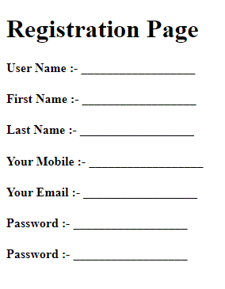

2. Contact Us page (To display any firm address, dummy mobile, dummy email id etc.)

3. Web page of Your CV

**Note: - Don’t use any type of CSS in your code…**

Note: - Do all entries with your personal details in following format…

**Create a webpage to display your Curriculum vitae (CV) as per following format.**



**B. TECH. COMPUTER ENGINEERING**

**Name: - Your Name**

**OBJECTIVE:**

Write single line objective

**EDUCATION:**

|  |  |  |  |  |
| --- | --- | --- | --- | --- |
| **Degree** | **Institute** | **Board/University** | **CGPA/Percentage** | **Year** |
| B. Tech |  |  |  | Currently Pursuing |
| XII |  |  |  | 2018 |
| X |  |  |  | 2016 |

**Note: - if X & XII from same institute then use row span in institute column and If board is same for X & XII use row span in Board/University Column.**

**TECHNICAL SKILLS:**

|  |  |
| --- | --- |
| **Domain** | **Details** |
| Languages |  |
| Web Designing |  |
| Software |  |
| Database |  |
| Analytics |  |
| Operating Systems |  |

**KEY PROJECTS:**

|  |  |  |  |
| --- | --- | --- | --- |
| **Project Title** | **Duration** | **Platform Used** | **Brief Description** |
|  |  |  |  |
|  |  |  |  |
|  |  |  |  |

**TECHNICAL –PRESENTATION/WORKSHOPS/CERTIFICATION**

* Program 1
* Program 2

**TECHNICAL –WORK EXPERIENCE / INTERNSHIPS:**

1. Internship 1
2. Internship 2

**HTML Code 1 : -**

<!DOCTYPE html>

<html lang="en">

<head>

    <meta charset="UTF-8">

    <meta name="viewport" content="width=device-width, initial-scale=1.0">

    <title>Document</title>

</head>

<body>

    <table align="center" width="100%" style="display:flex;justify-content: center;">

        <tr colspan="2" style="display:flex;justify-content: center;">

            <td>

                <h2>Registration Page</h2>

            </td>

        </tr>

        <tr>

            <td>User Name :-</td>

            <td>Jal Bafana</td>

        </tr>

        <tr>

            <td>First Name :-</td>

            <td>Jal</td>

        </tr>

        <tr>

            <td>Last Name :-</td>

            <td>Bafana</td>

        </tr>

        <tr>

            <td>Your Mobile :-</td>

            <td>9898986565</td>

        </tr>

        <tr>

            <td>Your Email :-</td>

            <td>mynameisjal@gmail.com</td>

        </tr>

        <tr>

            <td>Password :-</td>

            <td>12345</td>

        </tr>

        <tr>

            <td>Password :-</td>

            <td>12345</td>

        </tr>

    </table>

</body>

</html>

**Output (only in print screen format) Code -1**

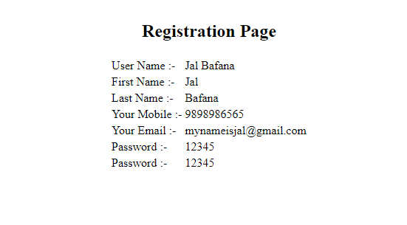

**HTML Code 2: -**

<!DOCTYPE html>

<html lang="en">

<head>

    <meta charset="UTF-8">

    <meta name="viewport" content="width=device-width, initial-scale=1.0">

    <title>Document</title>

</head>

<body>

    <h1>Contact Us</h1>

    <h2>Get in touch with us at :</h2>

    <p><b>Address:</b> Mukesh Patel School Technology Management and Engineering</p>

    <p><b>Phone no.:</b> 1234567890 /9873467231 /10002432</p>

    <p><b>Email:</b> mpstme@gmail.com/ mpadmin@gmail.com</p>

    <p><b>Monday - Friday: </b> 9:00 AM - 6:00 PM</p>

    <p><b>Saturday:</b> 10:00 AM - 4:00 PM</p>

    <p><b>Sunday:</b> Closed</p>

    <h2>Follow Us:</h2>

    <p>

        <a href="facebook.com">Facebook</a> |

        <a href="twitter.com">Twitter</a> |

        <a href="linkden.com">LinkedIn</a> |

        <a href="instagram.com">Instagram</a>

    </p>

</body>

</html>

**Output (only in print screen format) Code -2**

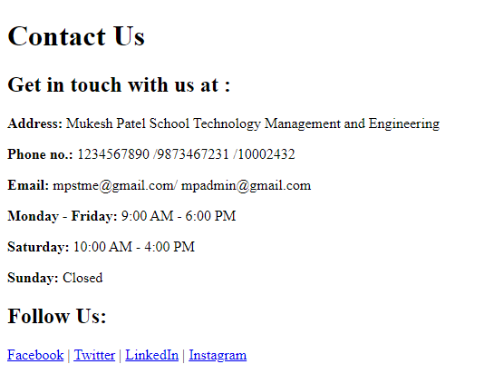

**HTML Code 3 : -**

<!DOCTYPE html>

<html lang="en">

<head>

    <meta charset="UTF-8">

    <meta name="viewport" content="width=device-width, initial-scale=1.0">

    <title>Document</title>

</head>

<body>

    <div style="text-align: center;">

        <img src="nmimslogo.jpg" alt="">

    </div>

    <h2>Btech. Computer Engineering</h2>

    <b>Name:- Jal Bafana</b>

    <br>

    <h2><u>OBJECTIVE:</u></h2>

    To leverage my skills in Cyber Security field

    <br>

    <h2><u>EDUCATION:</u></h2>

    <table border="1">

        <tr>

            <th><b>Degree</b></th>

            <th><b>Institute</b></th>

            <th><b>Board/University</b></th>

            <th><b>CGPA/Percentage</b></th>

            <th><b>Year</b></th>

        </tr>

        <tr>

            <td><b>B.tech</b></td>

            <td><b>MPSTME</b></td>

            <td><b>MU</b></td>

            <td><b>9.1</b></td>

            <td><b>Currently Pursuing</b></td>

        </tr>

        <tr>

            <td><b>XII</b></td>

            <td><b>TSEC</b></td>

            <td><b>HSC</b></td>

            <td><b>77%</b></td>

            <td><b>2023</b></td>

        </tr>

        <tr>

            <td><b>X</b></td>

            <td><b>Cambridge School</b></td>

            <td><b>ICSE</b></td>

            <td><b>92%</b></td>

            <td><b>2021</b></td>

        </tr>

    </table>

    <br>

    <h2><u>TECHNICAL SKILLS:</u></h2>

    <table border="1">

        <tr>

            <th><b>Domain</b></th>

            <th><b>Details</b></th>

        </tr>

        <tr>

            <td>Languages</td>

            <td>C++, Java, HTML5, Python</td>

        </tr>

        <tr>

            <td>Web Designing</td>

            <td>HTML, CSS, Basic JavaScript</td>

        </tr>

        <tr>

            <td>Software</td>

            <td>Autocad, </td>

        </tr>

        <tr>

            <td>Datbase</td>

            <td>Oracle</td>

        </tr>

        <tr>

            <td>Analytics</td>

            <td>Research, Creative, Decision-making</td>

        </tr>

        <tr>

            <td>Operating Systems</td>

            <td>Windows, MacOS</td>

        </tr>

    </table>

    <br>

    <h2><u>KEY PROJECTS:</u></h2>

    <table border="1">

        <tr>

            <th><b>Project Title</b></th>

            <th><b>Duration</b></th>

            <th><b>Platform Used</b></th>

            <th><b>Brief Description</b></th>

        </tr>

        <tr>

            <td>Spider Robot</td>

            <td>15 days</td>

            <td>Arduino ide</td>

            <td>A physical 4-leged spider robot made with components and 3D printed parts</td>

        </tr>

        <tr>

            <td>Calculator</td>

            <td>5 days</td>

            <td>Html, C++</td>

            <td>A complete functional calculator with most everyday functions</td>

        </tr>

    </table>

    <br>

    <h2><u>TECHNICAL-PRESENTATION/WORKSHOPS/CERTIFICATIONS:</u></h2>

    <ul>

        <li>Conducted a workshop in college for freshers</li>

        <li>2nd place in coding competition in junior college</li>

    </ul>

    <br>

    <h2><u>TECHNICAL –WORK EXPERIENCE / INTERNSHIPS::</u></h2>

    <ol>

        <li>Community Service of 1 month at Vatsalya</li>

        <li>Three months study + internship at codecamp</li>

    </ol>

</body>

</html>

**Output (only in print screen format) Code -2**

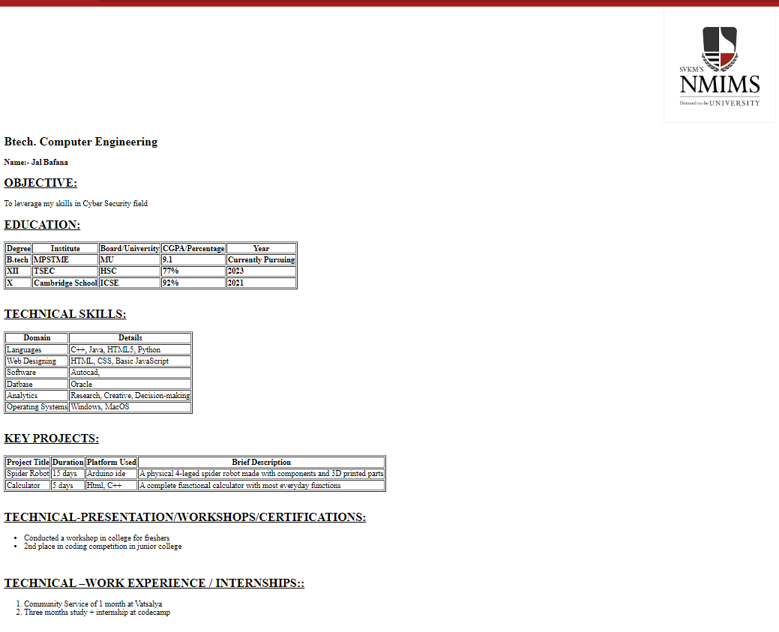

**Observation and Learning: -**

Learned how to make 3 web pages very basic without applying css in the code.

The first was an about page, the second was a contact page and the 3*rd* was a CV page

**Conclusion:**

Have made three pages using HTML without much css and successfully made them without errors.