|  |  |  |  |  |  |
| --- | --- | --- | --- | --- | --- |
| Description: nmims-new-logo | **SVKM’s NMIMS**  **Mukesh Patel School of Technology Management & Engineering Shirpur Campus** | | | | |
| **Deparment of IT** | | | | |
| **Instructor Manual** | | **Lab Manual (Part-A)** | | | **Academic Year-** |
| **Year:-Second** | | **Subject:- Web Programming** | | | **Semester:- III** |
|  | | | **Experiment # 3** |  | |
|  | | |  | **Date of Conduction:- / /** | |
| **Class:- BTECH** | | | | **Division:-** | |

**Aim:**

1. Apply styling technique Using Inline CSS
2. Apply styling technique Using Internal CSS

**Prerequisites:-**

* Basic Tags of HTML.

**Theory:-**

**Cascading Style Sheets (CSS)**

**Syntax**

selector { property: value }

* A CSS rule-set consists of a selector and a declaration block:
* Declaration part is further divided into property and values.

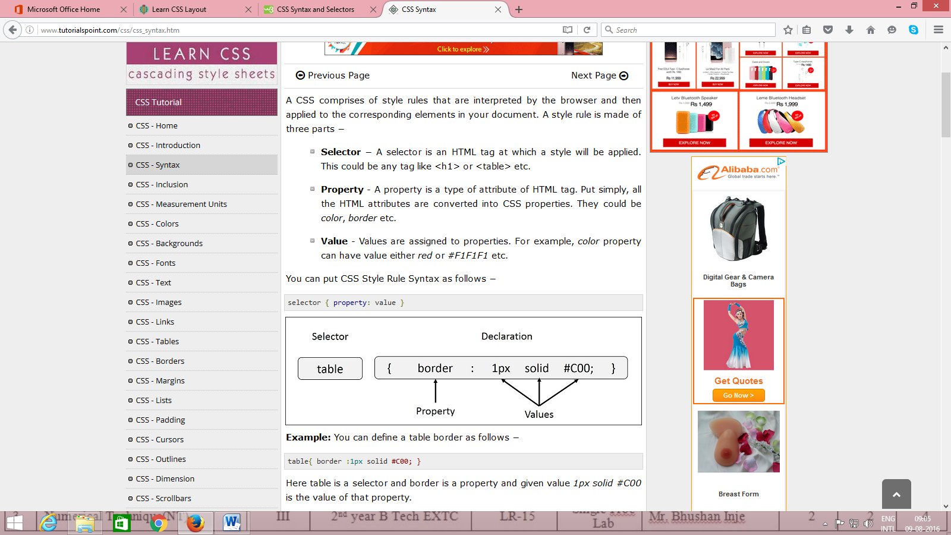

* **Selector** − A selector is an HTML tag at which a style will be applied. This could be any tag like <h1> or <table> etc.
* **Property** - A property is a type of attribute of HTML tag. Put simply, all the HTML attributes are converted into CSS properties. They could be *color*, *border* etc.
* **Value** - Values are assigned to properties. For example, *color* property can have value either *red* or any other color.

The selector points to the HTML element you want to style.

The declaration block contains one or more declarations separated by semicolons.

Each declaration includes a property name and a value, separated by a colon.

|  |  |
| --- | --- |
| **Properties** | **Values** |
| background-attachment | scroll, fixed |
| background-color | (color), transparent |
| background-image | none, (location) |
| background-position | (percent), (length), top, center, bottom, left, center, right |
| background-repeat | repeat, repeat-x, repeat-y, no-repeat |
| Background | Any of the above background values separated by spaces. |
| Color | (color) |

|  |  |
| --- | --- |
| **Properties** | **Values** |
| margin-bottom | (length), (percent), auto |
| margin-left | (length), (percent), auto |
| margin-right | (length), (percent), auto |
| margin-top | (length), (percent), auto |
| margin | Any of the above margin values in top, right, bottom, left order separated by spaces. |
| padding-bottom | (length), (percent) |
| padding-left | (length), (percent) |
| padding-right | (length), (percent) |
| padding-top | (length), (percent) |
| padding | Any of the above padding values in top, right, bottom, left order separated by spaces. |
| border-bottom-width | medium, thin, thick, (length) |
| border-bottom | Any of the border-top-bottom, border-color and border-style values. |
| border-color | (color) |
| border-left-width | medium, thin, thick, (length) |
| border-left | Any of the border-top-left, border-color and border-style values. |
| border-right-width | medium, thin, thick, (length) |
| border-right | Any of the border-right-width, border-color and border-style values. |
| border-style | none, dotted, dashed, solid, double, groove, ridge, inset, outset |
| border-top-width | medium, thin, thick, (length) |
| border-top | Any of the border-top-width, border-color and border-style values. |
| border | Any of the border values. Applies to all borders. |
| height | auto, (length), (percent) |
| width | auto, (length), (percent) |
| list-style-type | disc, circle, square, decimal, lower-roman, upper-roman, lower-alpha, upper-alpha, upper-latin, hebrew, armenian, georgian, cjk-ideographic, hiragana, katakana, hiragana-iroha, katakana-iroh, none |
| list-style-image | none, (url) |
| list-style-position | outside, inside |
| **Properties** | **Values** |
| list-style | Any of the above list-style values separated by spaces. |
| white-space | normal, pre, nowrap |
| border-collapse | collapse, separate, inherit |
| border-spacing | (length)(length), inherit |
| caption-side | top, bottom, left, right, inherit |
| empty-cells | show, hide, inherit |
| speak-header | once, always, inherit |
| table-layout | auto, fixed, inherit |

**Three Ways to Insert CSS**

There are three ways of inserting a style sheet:

* Internal style sheet
* Inline style
* External style sheet

**Internal Style Sheet**

An internal style sheet should be used when a single document has a unique style. You define internal styles in the head section of an HTML page, inside the <style> tag, like this:

<head>  
<style>  
hr{color:sienna;}

p{margin-left:20px;}

body{background-image:url("images/background.gif");}   
</style>  
</head>

**Inline Styles**

An inline style loses many of the advantages of a style sheet (by mixing content with presentation). Use this method sparingly!

To use inline styles, add the style attribute to the relevant tag. The style attribute can contain any CSS property. The example shows how to change the color and the left margin of a paragraph:

<p style="color:sienna;margin-left:20px;">This is a paragraph.</p>

**Instructions to Students:-**

1. Write html code in Note Pad & save with .html extension.
2. Execute using Web Browser.
3. Copy and Paste code as well as output (snapshot of output) in Part B

|  |  |  |  |  |  |
| --- | --- | --- | --- | --- | --- |
| Description: nmims-new-logo | **SVKM’s NMIMS**  **Mukesh Patel School of Technology Management & Engineering Shirpur Campus** | | | | |
| **Deparment of IT** | | | | |
| **Instructor Manual** | | **Lab Manual (Part-B)** | | | **Academic Year- 2019-20** |
| **Year:-Second** | | **Subject:- WP** | | | **Semester:- III** |
|  | | | **Experiment # 3** |  | |
|  | | |  | **Date of Conduction:- / /2019** | |
| **Class:-** | | | | **Division:-** | |

1. Design a web page using CSS which includes the following:

1) Use different font styles

2) Control the repetition of image with background-repeat and no-repeat property

3) Define style for links as a: link, a: active, a: hover, a: visited

**Note: You can referee the following page**

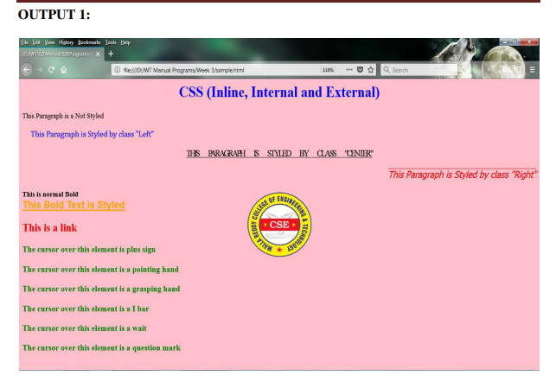

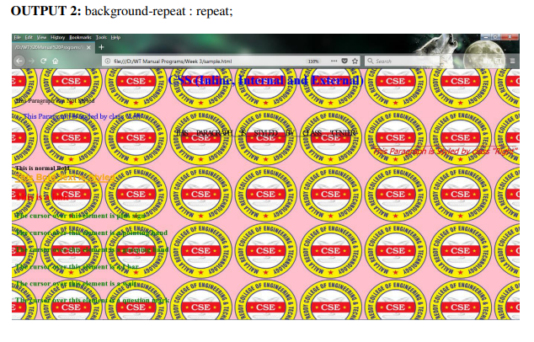

**Code:-**

1st Program

<!DOCTYPE html>

<html>

<head><title>NMIMS</title></head>

<link rel="stylesheet" href="style.css">

<body bgcolor="pink">

    <center>

        <h1><p class="head">CSS(INLINE,INTERNAL AND EXTARNAL)</h1></p>

    </center>

    <p class="n">This paragrapgh is not styled</p>

    <p class="left"> &nbsp; This paragraph is styled by class"left"</p>

    <center>

    <br>

        <h2><u>This paragraph is styled by class"center"</u></h2>

        </br>

    </center>

    <p class="right"> This paragraph is styled by class"right"</p>

    <p><b>This is normal BOLD</b></p>

    <p class="bold"><b>THIS BOLD TEXT IS STYLED</b></p>

    <a href="#" class="link"><b>This is a link</b></a>

    <div class="hver">

        <p class="plus">The cursor over this element is plus sign</p>

        <p class="pointing">The cursor over this element is pointing hand </p>

        <p class="grasping">The cursor over this element is grasping hand</p>

        <p class="I">The cursor over this element is I bar</p>

        <p class="wait">The cursor over this element is wait</p>

        <p class="question">The cursor over this element is question mark</p>

    </div>

</body>

</html>

body {

    background-image: url('img1.png');

    background-repeat: no-repeat;

    background-position: center 300px;

}

.head{

    color:blue;

    }

.left{

    color:blue;

    text-align:left;

    }

.right{

    color:red;

    text-align:right;

    text-decoration: overline;

    }

.bold{

    color:orange;

    text-align:bold;

    text-decoration: underline;

    }

.link{

    color:red;

    text-align:link;

    }

.hver{

    color:green;

    }

.plus:hover{

    cursor: crosshair;

    }

    .pointing:hover{

    cursor: pointer;

    }

.grasping:hover{

    cursor: grab;

    }

.wait:hover{

    cursor: wait;

    }

.question:hover{

    cursor: help;

    }

2nd Program

<!DOCTYPE html>

<html>

<head><title>NMIMS</title></head>

<link rel="stylesheet" href="style.css">

<body bgcolor="pink">

    <center>

        <h1><p class="head">CSS(INLINE,INTERNAL AND EXTARNAL)</h1></p>

    </center>

    <p class="n">This paragrapgh is not styled</p>

    <p class="left"> &nbsp; This paragraph is styled by class"left"</p>

    <center>

    <br>

        <h2><u>This paragraph is styled by class"center"</u></h2>

        </br>

    </center>

    <p class="right"> This paragraph is styled by class"right"</p>

    <p><b>This is normal BOLD</b></p>

    <p class="bold"><b>THIS BOLD TEXT IS STYLED</b></p>

    <a href="#" class="link"><b>This is a link</b></a>

    <div class="hver">

        <p class="plus">The cursor over this element is plus sign</p>

        <p class="pointing">The cursor over this element is pointing hand </p>

        <p class="grasping">The cursor over this element is grasping hand</p>

        <p class="I">The cursor over this element is I bar</p>

        <p class="wait">The cursor over this element is wait</p>

        <p class="question">The cursor over this element is question mark</p>

    </div>

</body>

</html>

body {

    background-image: url('img2.png');

    background-repeat: repeat;

    background-position: center 300px;

}

.head{

    color:blue;

    }

.left{

    color:blue;

    text-align:left;

    }

.right{

    color:red;

    text-align:right;

    text-decoration: overline;

    }

.bold{

    color:orange;

    text-align:bold;

    text-decoration: underline;

    }

.link{

    color:red;

    text-align:link;

    }

.hver{

    color:green;

    }

.plus:hover{

    cursor: crosshair;

    }

    .pointing:hover{

    cursor: pointer;

    }

.grasping:hover{

    cursor: grab;

    }

.wait:hover{

    cursor: wait;

    }

.question:hover{

    cursor: help;

    }

**Input and Output:-**

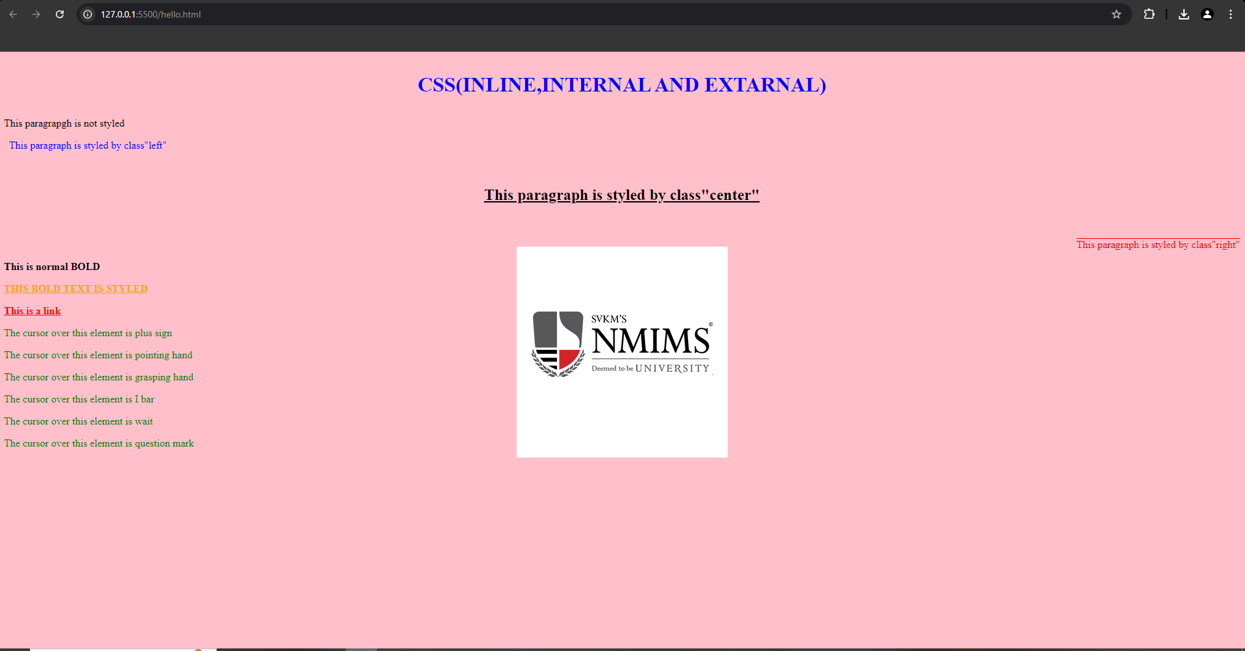

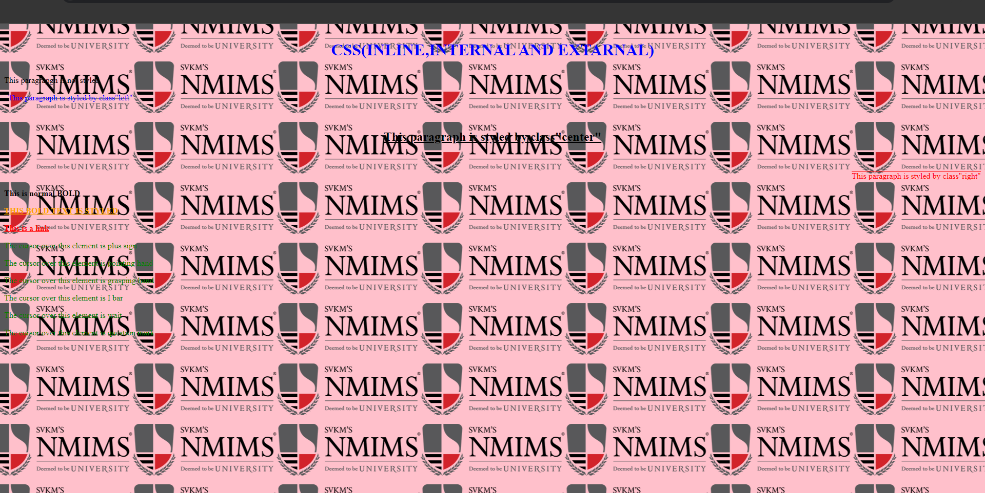

**Observation and Learning: -**

We’ve covered how to style an HTML webpage using CSS, including things like class selectors, cursor styles, text decoration, and text alignment.

**Conclusion: -**

HTML and CSS is a very powerful tool for making any type of attractive website.

**Questions: -**

1. What is CSS?

CSS, which stands for Cascading Style Sheets, is a stylesheet language used to describe the presentation of a document written in HTML or XML. It allows you to control the visual appearance of web pages, such as layout, colors, fonts, and spacing.

1. What are advantages of CSS?

**• Separation of Content and Presentation:** CSS allows you to separate the structure of your HTML content from its presentation. This makes your HTML cleaner and more semantic, and it allows for easier maintenance and updates.

• **Consistency**: By defining styles in one place (a CSS file), you can ensure that your website's appearance is consistent across different pages. This avoids the need to repeat styling rules and makes updates easier.

• **Flexibility and Control**: CSS provides fine-grained control over the visual presentation of web pages. You can adjust layout, colors, fonts, and other design elements with precision. Features like Flexbox and Grid offer powerful tools for creating complex layouts.

• **Responsiveness**: CSS supports responsive design techniques, allowing you to create web pages that adapt to various screen sizes and devices. Media queries enable you to apply different styles based on screen width, resolution, or other factors.

1. What are selector, property and value?

In CSS, you use **selectors** to choose which HTML elements you want to apply styles to. **Properties** define which characteristics of those elements you want to modify, such as their color or size. **Values** are the specific settings you assign to these properties to achieve your desired look. When combined, selectors, properties, and values create **declarations** that dictate the appearance of the selected elements.

1. What are various ways to embedded CSS in HTML?

CSS can be incorporated into an HTML document in three main ways:

1. InlineCSS: This method involves using the style attribute directly within an HTML element to apply styles to that specific element. It’s useful for styling individual elements but can become unwieldy for larger projects.
2. InternalCSS: You can include CSS rules within the <style> tag in the <head> section of your HTML document. This approach is suitable for styling elements across a single HTML page and keeps the CSS organized in one place within the document.
3. ExternalCSS: For larger websites, it’s often better to use an external stylesheet. This involves linking to a separate .css file from the HTML document using the <link> tag in the <head> section. This method helps keep your CSS and HTML files separate, making the code more manageable and reusable across multiple pages.