|  |  |  |
| --- | --- | --- |
|  | Experiment # 6 |  |
|  |  | Date of Conduction:- / / |
| Class:-B.Tech IT/MBA.Tech IT/B.Tech (CS) | | Division:- |

ET_{\text{dir}} = K ×ET_{\text{x}} + K ×E_{\text{fs}} ×D_{\text{sn\_to\_BS}}^2

Aim:

1. Basic Java script
2. Functions

Prerequisites:-

- OOPS concept and HTMLS basic tags Theory:-

//defining a function function <function-name>()

{

// code to be executed

};

//calling a function

<function-name>();

Function Declaration

* Function Function_Name(value1,value2)
* {
* return value1;
* Return value 2;
* }
  1. Example 1

<html>

<script type=“javascript”> Function add(a,b)

{

Return a+b;

}

Alert(add(1,2));

</script>

</body>

</html>

* 1. Example: Define and Call a Function function ShowMessage() { alert("Hello World!");

}

ShowMessage();

* 1. Example: Function Parameters function ShowMessage(firstName, lastName) {

alert("Hello " + firstName + " " + lastName);

}

ShowMessage("Steve", "Jobs"); ShowMessage("Bill", "Gates"); ShowMessage(100, 200);

* 1. Example :Iterate all Arguments function ShowMessage() {

for(var i = 0; i < arguments.length; i++){ alert(arguments[i]);

}

}

ShowMessage("Steve", "Jobs");

* [Dynamic HTML](http://en.wikipedia.org/wiki/Dynamic_HTML) (DHTML), functionality

In 1997, Netscape and Microsoft released version 4.0 of Netscape Navigator and Internet Explorer respectively, adding support for [Dynamic HTML](http://en.wikipedia.org/wiki/Dynamic_HTML) (DHTML), functionality enabling changes to a loaded HTML document.

getElementById()

The getElementById() method accesses the first element with the specified id

* **Syntax:-** document.getElementById("*id*")
* **Id:-** The id of the element you want to access/manipulate.
  1. Example 5

<html>

<head>

<script>

function getValue()

{

var x=document.getElementById("myHeader");

}

</script>

</head>

<body>

<h1 id="myHeader“ >Click me!</h1>

</body>

</html>

Try and catch

try

{

// code that may throw an error

}

catch(ex)

{

// code to be executed if an error occurs

}

finally{

// code to be executed regardless of an error occurs or not

}

*Error Handling in JS*

try

{

var result = Sum(10, 20); // Sum is not defined yet

}

catch(ex)

{

document.getElementById("errorMessage").innerHTML = ex;

}

Regular Expressions

* + A regular expression is an object that describes a pattern of characters.
  + The JavaScript **RegExp** class represents regular expressions.
  + **RegExp** define methods that use regular expressions to perform
  + powerful pattern-matching
  + search-and-replace functions on text.

var pattern = new RegExp(pattern, attributes);

**pattern:** A string that specifies the pattern of the regular expression.

**attributes:** An optional string containing any of the attributes that specify

* "g“ =global
* "i“ =case-insensitive
* "m" = multiline matches.
* Brackets ([]) have a special meaning.
* They are used to find a range of characters.

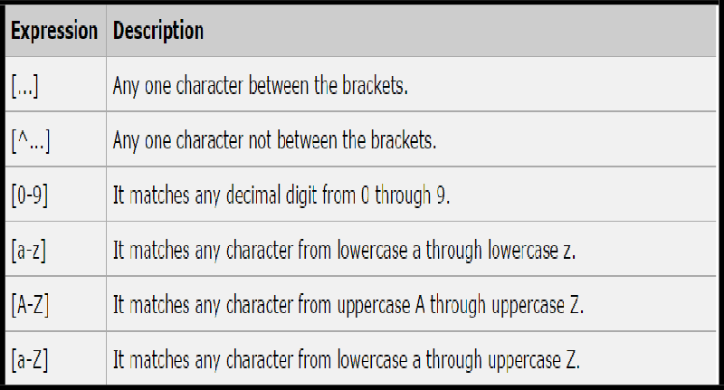

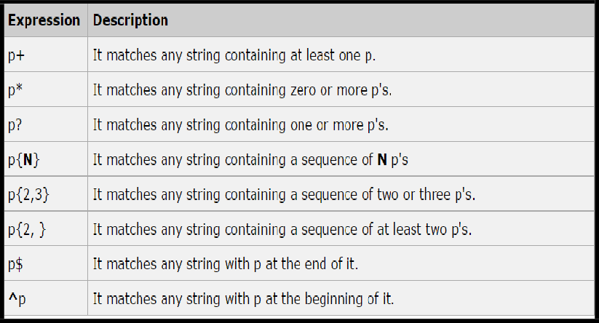

*Example 6*

<script type="javascript"> function hello(name)

{

alert("Hello" +name.value+ ".Nice to meet you"); return true;

}

</script>

<form>

Enter your name: <input type="text" name="fname" id="1">

<input type="button" onclick ="hello(document.getElementById('1'))" value="Submit">

</form> innerHTML

* The innerHTML property sets or returns the HTML content (inner HTML) of an element.
* Syntax
* Return the innerHTML property:
* *HTMLElementObject*.innerHTML
* Set the innerHTML property:
* *HTMLElementObject*.innerHTML=*text*

*Example* 8

<html>

<body>

<h1>My Web Page</h1>

<p id="myP">This is a p element.</p>

<div id="myDIV">This is a div element.</div>

<script>

document.getElementById("myP").innerHTML = "Hello Dolly."; document.getElementById("myDIV").innerHTML = "How are you?";

</script>

</body>

</html>

Use String replace() With a Regular Expression

* var str = "Visit Microsoft!";

var res = str.replace(/microsoft/i, "MPSTME");

* 1. Example 9

<html>

<body>

<h2>JavaScript Functions</h2>

<p>This example calls a function to convert from Fahrenheit to Celsius:</p>

<p id="demo"></p>

<script>

function toCelsius(f) { return (5/9) * (f-32);

}

**document.getElementById("demo").innerHTML = toCelsius(77);**

</script>

</body>

</html>

* 1. Example 10

<html>

<body>

<p>Click the button to display the date.</p>

<button onclick="displayDate()">The time is?</button>

<script>

function displayDate() { document.getElementById("demo").innerHTML = Date();

}

</script>

<p id="demo"></p>

</body>

</html>

PART B

Java script and Functions

1. Write a Program using Java script with mouse over alerts

* My Name :- display your name.
* College Name :- display your college name.
* College site :- display college site.

1. WAP to identify whether a visited user is eligible for e-voting. criteria are as follows.

* Visited user should be more than 25 years
* If he is male ,print hello Mr.(name) else print Miss(name).
* Else you are not entitled to visit this page.
  + (Note:-prompt)

1. WAP to find average of marks of n subjects entered by user using “for loop” with java script.
2. Write a Program to display Exponent of a two numbers using a JavaScript functions.
3. Write a Program to display a Moon weight and input will be actual earth weight on button click events.
4. Write a Program to display todays date on mouseover event using document Object Model.

.

Code:-

**Question 1**

<!DOCTYPE *html*>

<html *lang*="en">

<head>

    <meta *charset*="UTF-8">

    <meta *name*="viewport" *content*="width=device-width, initial-scale=1.0">

    <title>Alert Page</title>

</head>

<body>

    <p>

        <h1 *onmouseover*="window.alert('Jal');"> My Name </h1>

    </p>

    <p>

        <h2 *onmouseover*="window.alert('NMIMS');"> College Name </h2>

    </p>

    <p>

        <a *href*="https://www.nmims.edu" *onmouseover*="window.alert('NMIMS Page')"> College Site</a>

    </p>

</body>

</html>

**Question 2**

<!DOCTYPE *html*>

<html *lang*="en">

<head>

    <meta *charset*="UTF-8">

    <meta *name*="viewport" *content*="width=device-width, initial-scale=1.0">

    <title>E-Voting Eligibility</title>

</head>

<body>

    <script>

        var age = parseInt(prompt("Please enter your age:"));

        if (age > 25)

        {

            var name = prompt("Please enter your name:");

            var gender = prompt("Please enter your gender (male/female):").toLowerCase();

            if (gender === "male")

            {

                document.write("Hello Mr. " + name);

            }

            else if (gender === "female")

            {

                document.write("Hello Miss " + name);

            }

            else

            {

                document.write("Invalid gender input.");

            }

        }

        else

        {

            document.write("You are not entitled to visit this page.");

        }

    </script>

</body>

</html>

**Question 3**

<!DOCTYPE *html*>

<html *lang*="en">

<head>

    <meta *charset*="UTF-8">

    <meta *name*="viewport" *content*="width=device-width, initial-scale=1.0">

    <title>Average Marks</title>

</head>

<body>

    <script>

        var numSubjects = parseInt(prompt("Enter the number of subjects:"));

        var totalMarks = 0;

        for (var i = 1; i <= numSubjects; i++)

        {

            var marks = parseFloat(prompt("Enter marks for subject " + i + ":"));

            totalMarks += marks;

        }

        var averageMarks = totalMarks / numSubjects;

        document.write("The average marks of " + numSubjects + " subjects is: " + averageMarks);

    </script>

</body>

</html>

**QUESTION 4**

<!DOCTYPE *html*>

<html *lang*="en">

<head>

    <meta *charset*="UTF-8">

    <meta *name*="viewport" *content*="width=device-width, initial-scale=1.0">

    <title>Exponent</title>

</head>

<body>

    <script>

        function ex(*b*, *e*)

        {

            return Math.pow(*b*, *e*);

        }

        var b = parseFloat(prompt("Enter the base number:"));

        var e = parseFloat(prompt("Enter the exponent number:"));

        var rslt = ex(b, e);

        document.write("The result of " + b + " raised to the power of " + e + " is: " + rslt);

    </script>

</body>

</html>

**Question 5**

<!DOCTYPE *html*>

<html *lang*="en">

<head>

    <meta *charset*="UTF-8">

    <meta *name*="viewport" *content*="width=device-width, initial-scale=1.0">

    <title>Moonwt</title>

</head>

<body>

    <script>

        function moonwt(*ewt*)

        {

            return ((*ewt*\*1.622)/9.8);

        }

        var ewt = parseFloat(prompt("Enter the Earth Weight:"));

        var rslt = moonwt(ewt);

        document.write("The Moon Weight is: " + rslt);

        </script>

</body>

</html>

**Question 6**

<!DOCTYPE *html*>

<html *lang*="en">

<head>

    <meta *charset*="UTF-8">

    <meta *name*="viewport" *content*="width=device-width, initial-scale=1.0">

    <title>Mouseover Date Display</title>

</head>

<body>

    <div *id*="hoverElement">Hover over me to see today's date</div>

    <div *id*="dateDisplay"></div>

    <script>

        function displayDate()

        {

            const today = new Date();

            const formattedDate = today.toLocaleDateString();

            document.getElementById('dateDisplay').textContent = `Today's date is: ${formattedDate}`;

        }

        document.getElementById('hoverElement').addEventListener('mouseover', displayDate);

    </script>

</body>

</html>

**Output 1:**

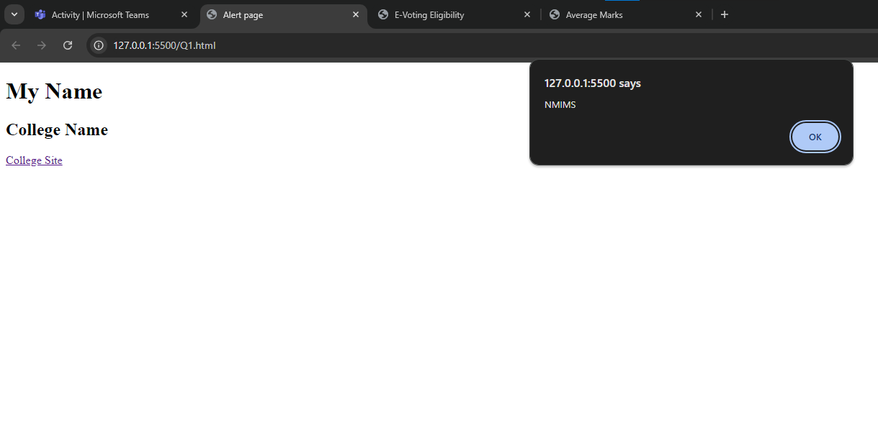

**Output 2:**

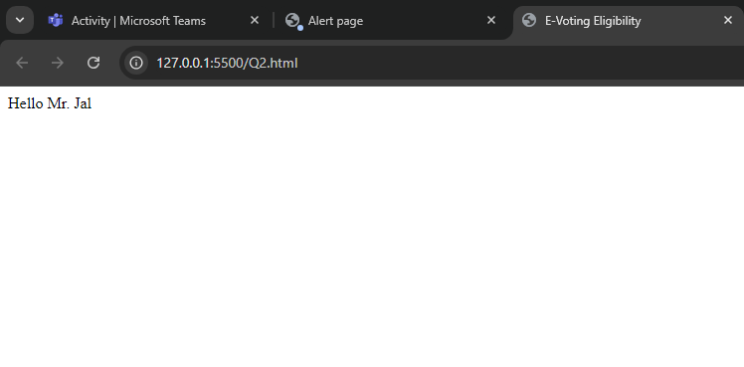

**Output 3:**

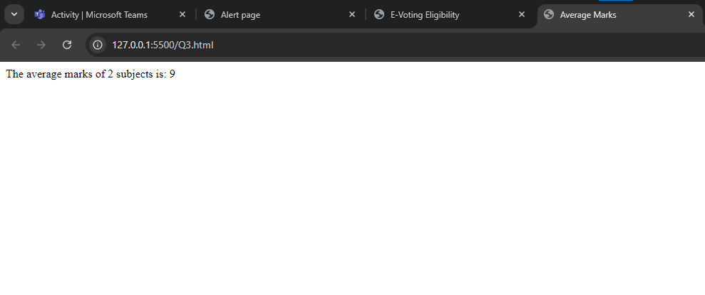

**Output 4:**

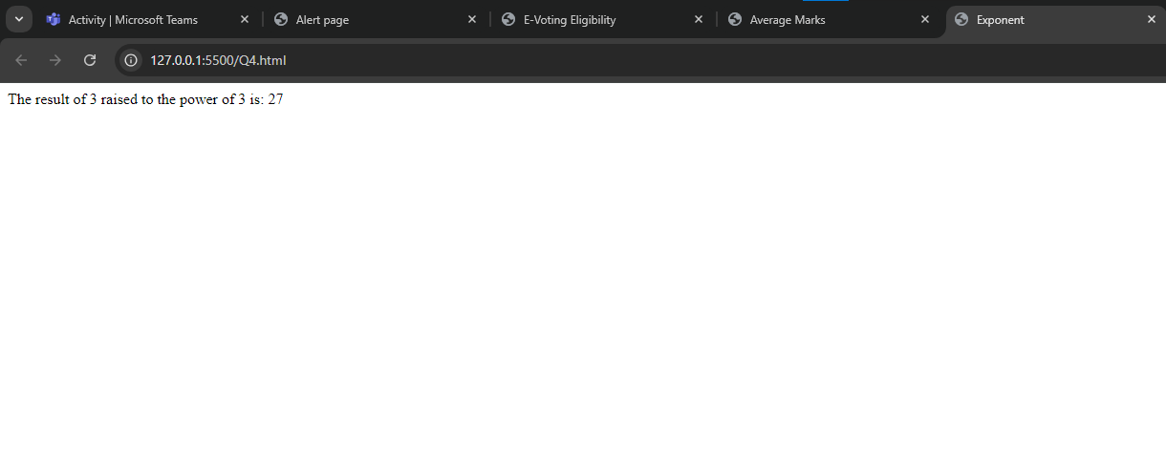

**Output 5:**

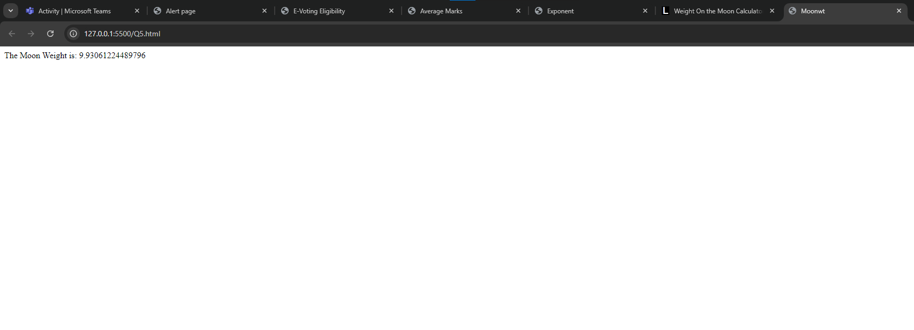

**Output 6:**

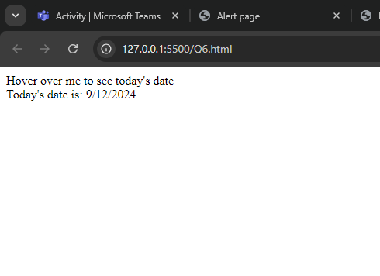

observation and Learning:-

We learnt how to to basic javascript functions like alert , input and output

Conclusion:-

Java script is a very useful language and helps to make more interactive webpages.

And learned about how to write js.