|  |  |
| --- | --- |
| **Name: Jal Bafana** | **Roll no: K005** |
| **Btech. Cyber Security (Sem-4)** | **Batch: K1** |
| **Date of Experiment: 07/01/2025** | **Date of Submission: 07/01/2025** |

**Data Warehousing and Mining Lab 1**

**Aim: Fundamentals of Data Warehousing and Mining.**

**To analyse the Following Concepts:**

1. **Database**

* **Focus: Data storage and retrieval**
* **Main Goal: Store, manage, and retrieve real-time data**
* **Key Techniques/Technologies: SQL, NoSQL, Relational/Non-relational DBMS**

1. **Data Warehouse**

* **Focus: Centralized data storage**
* **Main Goal: Aggregate and store data for analysis and reporting**
* **Key Techniques/Technologies: ETL, OLAP, Star/Snowflake Schema**

1. **Data Analytics**

* **Focus: Extracting insights from data**
* **Main Goal: Analyze data to identify patterns, trends, and predictions**
* **Key Techniques/Technologies: Descriptive, Diagnostic, Predictive, and Prescriptive Analytics**

1. **Data Science**

* **Focus: Advanced analysis using statistical and computational models**
* **Main Goal: Build models to predict outcomes and automate decisions**
* **Key Techniques/Technologies: Statistical modeling, Machine Learning (ML), Big Data, Visualization**

1. **Machine Learning**

* **Focus: Algorithmic learning from data**
* **Main Goal: Enable systems to learn from data and make decisions**
* **Key Techniques/Technologies: Supervised/Unsupervised Learning, Neural Networks, Clustering**

1. **Artificial Intelligence**

* **Focus: Simulating human intelligence**
* **Main Goal: Create systems that can perform tasks requiring human-like intelligence**
* **Key Techniques/Technologies: Machine Learning (ML), Natural Language Processing (NLP), Computer Vision, Robotics**

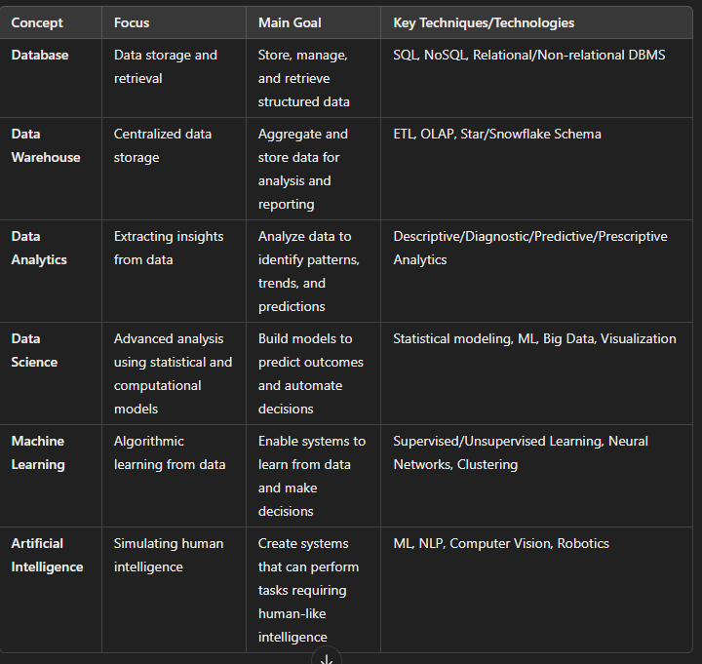

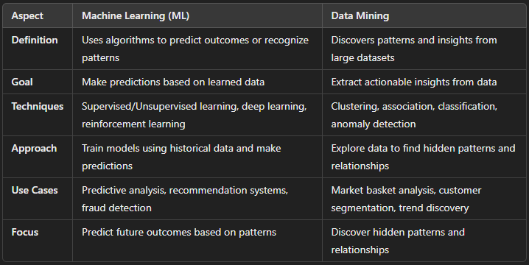

Walmart implemented **Data Warehousing** and **Data Mining** to optimize operations and improve customer experience. They integrated data from various systems into a central warehouse, applying ETL (*Extract, Transform and Load*) processes to clean and organize it. Using **OLAP** (*Online Analytical Processing*)tools, Walmart analysed sales, inventory, and trends.

**Data Mining** techniques like **Market Basket Analysis** and **Customer Segmentation** helped Walmart improve promotions, inventory management, and targeted marketing. **Demand Forecasting** and **Churn Prediction** optimized stock levels and retained customers.

The result was **improved inventory management**, **personalized marketing**, and **better customer experience**, giving Walmart a competitive edge and increasing profitability.