MBATech IT
DWM Practical
(2024-25 Batch)

KNN Algorithm

Aim:
To implement KNN algorithm

Theory:
The k-nearest neighbors algorithm uses a very simple approach to perform classification.
When tested with a new example, it looks through the training data and finds the k training examples that are closest to the new example. It then assigns the most common class label (among those k-training examples) to the test example.
The k-Nearest Neighbors (KNN) family of classification algorithms and regression algorithms is often referred to as memory-based learning or instance-based learning. Sometimes, it is also called lazy learning.
These terms correspond to the main concept of KNN. The concept is to replace model creation by memorizing the training data set and then use this data to make predictions.
The KNN algorithm uses a majority voting mechanism. It collects data from a training data set, and uses this data later to make predictions for new records.
For each new record, the k-closest records of the training data set are determined. Based on the value of the target attribute of the closest records, a prediction is made for the new record.
The basic nearest neighbor (NN) algorithm makes classification predictions or regression predictions for an arbitrary instance. To this purpose, the NN algorithm identifies a training instance that is closest to the arbitrary instance. Then, the NN algorithm returns the class label or target function value of the training instance as the predicted class label or target function value for the arbitrary instance.
The KNN algorithm expands this process by using a specified number k≥1 of the closest training instances instead of using only one instance. Typical values range from 1 to several dozen.
The output depends on whether you use the KNN algorithm for classification or regression.
In KNN classification, the predicted class label is determined by the voting for the nearest neighbors, that is, the majority class label in the set of the selected k instances is returned.
In KNN regression, the average value of the target function values of the nearest neighbors is returned as the predicted value.
By using a specified number k≥1, you can control the tradeoff between overfitting prevention and resolution. Overfitting prevention might be important for noisy data. Resolution might be important to get different predictions for similar instances
The k-nearest neighbor classifier fundamentally relies on a distance metric. The better that metric reflects label similarity, the better the classification will be. The most common choice is the Minkowski distance
$$dist\left(x,z\right)=\frac{\left(∑r=1d\left|xr-zr\right|p\right)1}{p}.dist\left(x,z\right)=\frac{\left(∑r=1d\left|xr-zr\right|p\right)1}{p}.$$
The KNN classifier makes the assumption that similar points share similar labels. Unfortunately, in high dimensional spaces, points that are drawn from a probability distribution, tend to never be close together.

Steps:
Assumption: Similar Inputs have similar outputs
Classification rule: For a test input xx, assign the most common label amongst its k most similar training inputs

Step 1: Select the value of K neighbors(say k=5)
Step 2: Find the K (5) nearest data point for our new data point based on euclidean distance(which we discuss later)
Step 3: Among these K data points count the data points in each category
Step 4: Assign the new data point to the category that has the most neighbors of the new datapoint

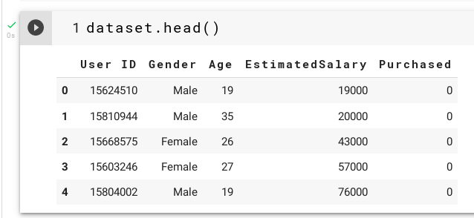

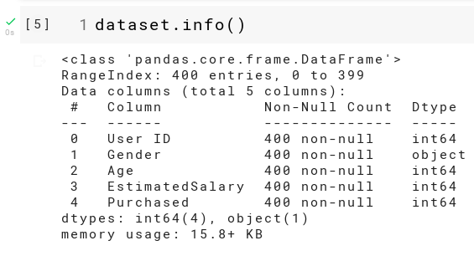

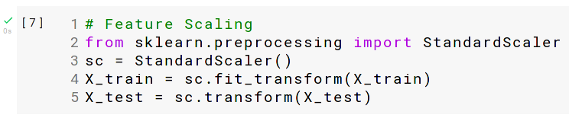

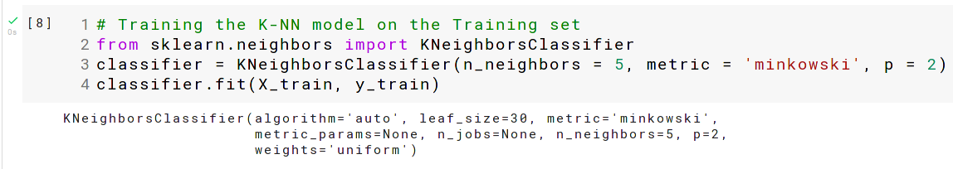

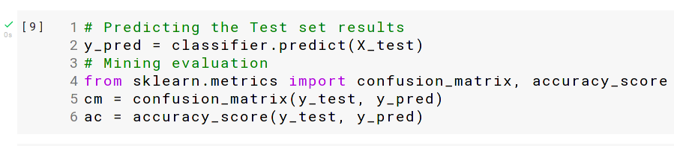

Roll no: K005 | Name: Jal Bafana
Class: Btech. Cyber Security Sem-4 | Batch: K1
Date of Experiment: 04.03.2025 | Date of Submission: 25.03.2025
Grade: | Faculty-in-charge: Prof Ruchi S

Part B
import numpy as np
import matplotlib.pyplot as plt
from sklearn.model_selection import train_test_split
from sklearn.neighbors import KNeighborsClassifier
from sklearn.datasets import load_iris
from sklearn.metrics import accuracy_score
from sklearn.preprocessing import StandardScaler

data = load_iris()
X = data.data[:, :2] # Using only the first two features for visualization
y = data.target

X_train, X_test, y_train, y_test = train_test_split(X, y, test_size=0.3, random_state=42)

scaler = StandardScaler()
X_train = scaler.fit_transform(X_train)
X_test = scaler.transform(X_test)

knn = KNeighborsClassifier(n_neighbors=3)

knn.fit(X_train, y_train)

y_pred_knn = knn.predict(X_test)

accuracy_knn = accuracy_score(y_test, y_pred_knn)
print(f'KNN Accuracy: {accuracy_knn * 100:.2f}%')

def plot_decision_boundary(clf, X, y, ax, title):
h = .02 # Step size in the mesh
x_min, x_max = X[:, 0].min() - 1, X[:, 0].max() + 1
y_min, y_max = X[:, 1].min() - 1, X[:, 1].max() + 1
xx, yy = np.meshgrid(np.arange(x_min, x_max, h),
np.arange(y_min, y_max, h))

Z = clf.predict(np.c_[xx.ravel(), yy.ravel()])
Z = Z.reshape(xx.shape)

ax.contourf(xx, yy, Z, alpha=0.8)
scatter = ax.scatter(X[:, 0], X[:, 1], c=y, edgecolors='k', marker='o', s=30)
ax.set_title(title)
ax.set_xticks(())
ax.set_yticks(())
return scatter

# Plot KNN decision boundary
fig, ax = plt.subplots(figsize=(7, 6))
plot_decision_boundary(knn, X_train, y_train, ax, f'KNN (Accuracy: {accuracy_knn * 100:.2f}%)')

# Show the plot
plt.colorbar(ax.scatter(X[:, 0], X[:, 1], c=y, edgecolors='k', marker='o', s=30), ax=ax, shrink=0.8)
plt.tight_layout()
plt.show()

import numpy as np
import matplotlib.pyplot as plt
from sklearn.model_selection import train_test_split
from sklearn.neighbors import KNeighborsClassifier
from sklearn.datasets import load_iris
from sklearn.metrics import accuracy_score
from sklearn.preprocessing import StandardScaler

data = load_iris()
X = data.data[:, :2] # Using only the first two features for visualization
y = data.target

X_train, X_test, y_train, y_test = train_test_split(X, y, test_size=0.3, random_state=42)

scaler = StandardScaler()
X_train = scaler.fit_transform(X_train)
X_test = scaler.transform(X_test)

knn = KNeighborsClassifier(n_neighbors=9)

knn.fit(X_train, y_train)

y_pred_knn = knn.predict(X_test)

accuracy_knn = accuracy_score(y_test, y_pred_knn)
print(f'KNN Accuracy: {accuracy_knn * 100:.2f}%')

def plot_decision_boundary(clf, X, y, ax, title):
h = .02 # Step size in the mesh
x_min, x_max = X[:, 0].min() - 1, X[:, 0].max() + 1
y_min, y_max = X[:, 1].min() - 1, X[:, 1].max() + 1
xx, yy = np.meshgrid(np.arange(x_min, x_max, h),
np.arange(y_min, y_max, h))

Z = clf.predict(np.c_[xx.ravel(), yy.ravel()])
Z = Z.reshape(xx.shape)

ax.contourf(xx, yy, Z, alpha=0.8)
scatter = ax.scatter(X[:, 0], X[:, 1], c=y, edgecolors='k', marker='o', s=30)
ax.set_title(title)
ax.set_xticks(())
ax.set_yticks(())
return scatter

# Plot KNN decision boundary
fig, ax = plt.subplots(figsize=(7, 6))
plot_decision_boundary(knn, X_train, y_train, ax, f'KNN (Accuracy: {accuracy_knn * 100:.2f}%)')

# Show the plot
plt.colorbar(ax.scatter(X[:, 0], X[:, 1], c=y, edgecolors='k', marker='o', s=30), ax=ax, shrink=0.8)
plt.tight_layout()
plt.show()

Output Screenshot
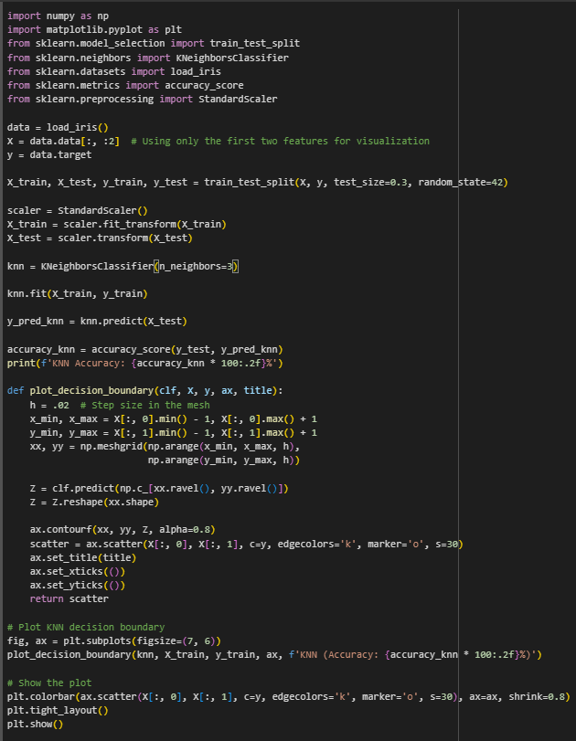

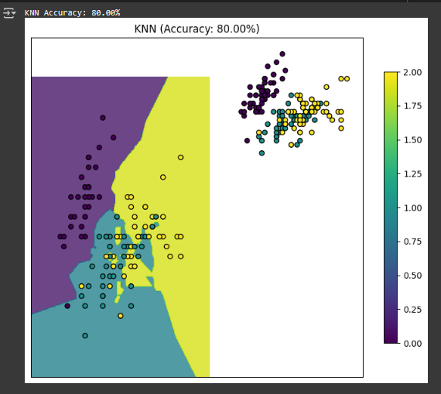

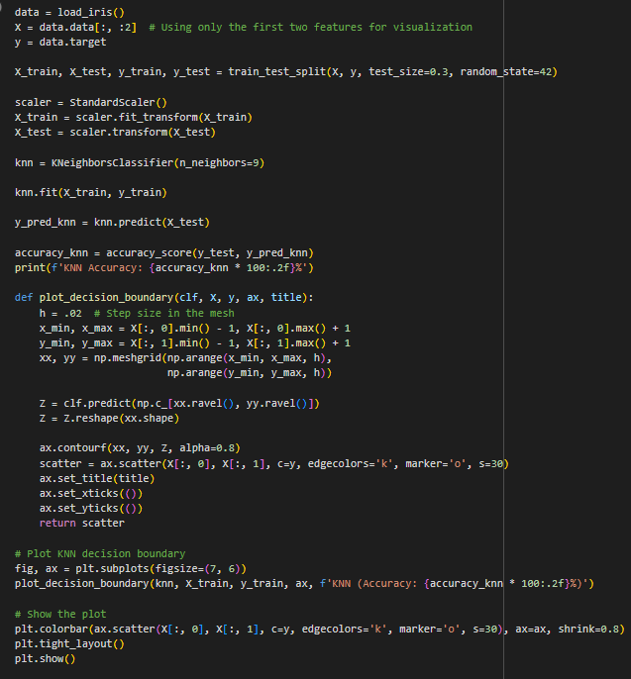

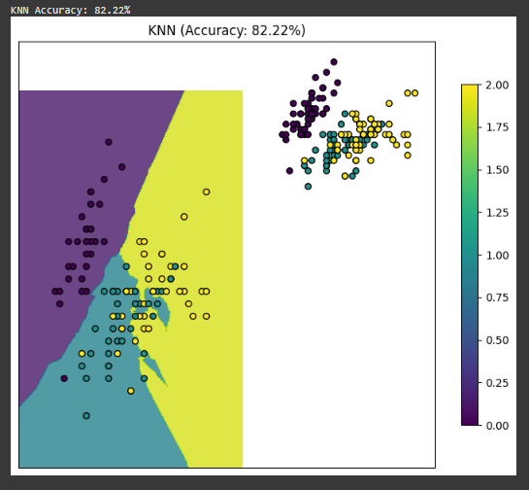

Questions

Q.1 What is the KNN principle?
The KNN (K-Nearest Neighbors) algorithm is a simple, instance-based learning algorithm used for classification and regression. It works by finding the 'k' closest data points to a new data point and assigns the most common class label (for classification) or the average value (for regression) of those k-nearest neighbors to the new point.

Q.2 Explain advantage and limitation of KNN algorithm
Advantages:
- Simple and Easy to Implement: KNN is easy to understand and implement.
- No Training Phase: KNN doesn't require a training phase, making it a "lazy" learner.
- Flexible: KNN can be used for both classification and regression tasks.

Limitations:
- Computationally Expensive: It can be slow for large datasets because it requires comparing the new data point to all training data points.
- Sensitive to Irrelevant Features: The performance of KNN can be negatively affected by irrelevant features in the data.
- Struggles with High Dimensionality: KNN doesn't perform well with high-dimensional data because of the "curse of dimensionality," where distance metrics become less meaningful.

Q.3 How does K impact the KNN algorithm?
- Small k (e.g., k=1): The model may be too sensitive to noise, leading to overfitting.

- Large k: The model becomes more generalized, potentially underfitting the data by smoothing out important distinctions between classes. The optimal 'k' value helps strike a balance between overfitting and underfitting, and it's typically chosen using techniques like cross-validation.

Conclusion:
We successfully understood the KNN algorithm and implemented it in python. The model yielded us results with an accuracy of 82.2%

