SVKM’s NMIMS University
Mukesh Patel School of Technology Management & Engineering

BA.(Tech.) CS Cybersecurity

SUBJECT: DWM
Practical Assignment

Part A (To be referred by students)

This lab maps to CO2-Course Outcome 2/ Learning Outcome 2

Aim : To implement Supervised Classification using Python programming

Outcome: After successful completion of this practical students will be able to
- Develop classification mining model using any dataset in Python

Bayesian Classification
• To implement classification using Bayes theorem.
Reference:
• Data Mining Introductory & Advanced Topic by Margaret H. Dunham
• Data Mining Concept and Technique By Han & Kamber

Theory:

The Naive Bayes classification algorithm is a probabilistic classifier. It is based on probability models that incorporate strong independence assumptions.
The independence assumptions often do not have an impact on reality. Therefore they are considered naive.
You can derive probability models by using Bayes' theorem (credited to Thomas Bayes). Depending on the nature of the probability model, you can train the Naive Bayes algorithm in a supervised learning setting.
Because naive Bayesian classifiers make such stringent assumptions about data, they will generally not perform as well as a more complicated model. That said, they have several advantages:
- They are extremely fast for both training and prediction
- They provide straightforward probabilistic prediction

- They are often very easily interpretable
- They have very few (if any) tunable parameters
These advantages mean a naive Bayesian classifier is often a good choice as an initial baseline classification. If it performs suitably, then congratulations: you have a very fast, very interpretable classifier for your problem. If it does not perform well, then you can begin exploring more sophisticated models, with some baseline knowledge of how well they should perform.
Naive Bayes classifiers tend to perform especially well in one of the following situations:
- When the naive assumptions actually match the data (very rare in practice)
- For very well-separated categories, when model complexity is less important
- For very high-dimensional data, when model complexity is less important
The last two points seem distinct, but they actually are related: as the dimension of a dataset grows, it is much less likely for any two points to be found close together (after all, they must be close in every single dimension to be close overall). This means that clusters in high dimensions tend to be more separated, on average, than clusters in low dimensions, assuming the new dimensions actually add information. For this reason, simplistic classifiers like naive Bayes tend to work as well or better than more complicated classifiers as the dimensionality grows: once you have enough data, even a simple model can be very powerful.
Bayes’ Theorem finds the probability of an event occurring given the probability of another event that has already occurred. Bayes’ theorem is stated mathematically as the following equation:

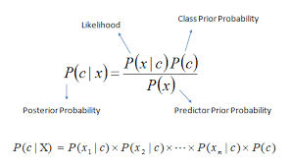

Algorithm –
1. START
2. Store the training data set
3. Specify ranges for classifying the data
4. Calculate the probability of being in one of class
5. Also, calculate the probabilities of class according to attribute ranges
6. Calculate the likelihood probability
7. Calculate P(t) by summing up of probable likelihood
8. Calculate actual probabilities
Input :
Training data set
Output
The tuple belongs to the class having the highest probability. Thus new tuples are classified.

Part B (to be completed by students)
(Students must submit the soft copy as per the following segments. The soft copy must be uploaded on the portal. The filename should be Batch_RollNo_Exp_No)

Roll no: K005 | Name: Jal Bafana
Class: Btech. Cyber Security Sem-4 | Batch: K1
Date of Experiment: 04.03.2025 | Date of Submission: 25.03.2025
Grade: | Faculty-in-charge: Prof Ruchi S

a) Python code:
i)Implementation Code in Python
ii) Output screenshot
iii) Accuracy

Description :
Gaussian Naive Bayes (GaussianNB) Can perform online updates to model parameters via partial_fit.

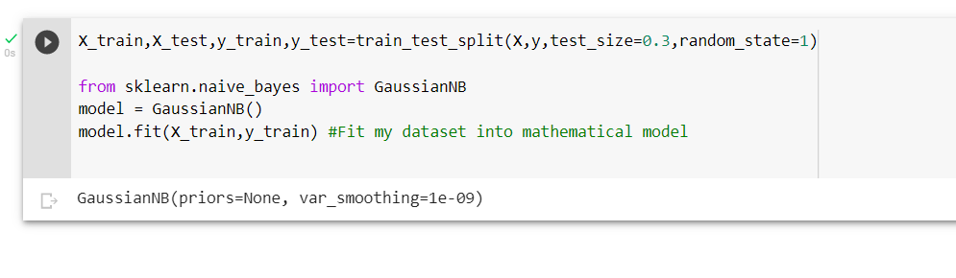
- y_pred=model.predict(X_test)
- df1=pd.DataFrame({'Actual Status':y_test,'Predicted Status':y_pred})
- df1

Description :
Two-dimensional, size-mutable, potentially heterogeneous tabular data.
Data structure also contains labeled axes (rows and columns).
Arithmetic operations align on both row and column labels. Can be
thought of as a dict-like container for Series objects. The primary
pandas data structure.

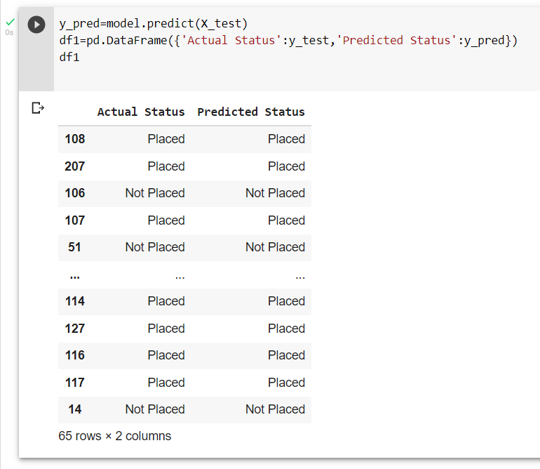

- df1.head()

Description :
Return the first n rows.

This function returns the first n rows for the object based
on position. It is useful for quickly testing if your object
has the right type of data in it.

For negative values of n, this function returns all rows except
the last n rows, equivalent to df[:-n].
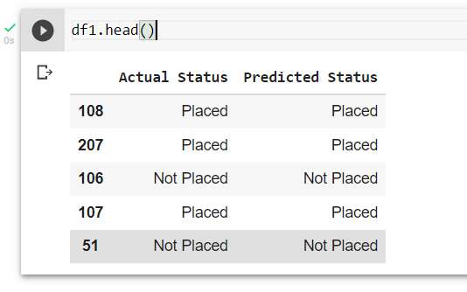

Accuracy :

- print(accuracy_score(y_test,y_pred)*10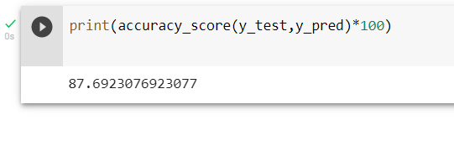
b) What is the significance of data preprocessing in classification?
Data preprocessing is required for cleaning the data and making it suitable for a machine learning model which also increases the accuracy and efficiency of a machine learning model. It is a data mining technique that transforms raw data into an understandable format. Raw data (real world data) is always incomplete and that data cannot be sent through a model. That would cause certain errors.
It involves below steps:
- Getting the dataset
- Importing libraries
- Importing datasets
- Finding Missing Data
- Encoding Categorical Data
- Splitting dataset into training and test set
- Feature scaling

Code:

import numpy as np
import matplotlib.pyplot as plt
from sklearn.model_selection import train_test_split
from sklearn.naive_bayes import GaussianNB
from sklearn.datasets import load_iris
from sklearn.metrics import accuracy_score
from sklearn.preprocessing import StandardScaler

data = load_iris()
X = data.data[:, :2]
y = data.target

X_train, X_test, y_train, y_test = train_test_split(X, y, test_size=0.3, random_state=42)

scaler = StandardScaler()
X_train = scaler.fit_transform(X_train)
X_test = scaler.transform(X_test)

nb = GaussianNB()

nb.fit(X_train, y_train)

y_pred_nb = nb.predict(X_test)

accuracy_nb = accuracy_score(y_test, y_pred_nb)
print(f'Naive Bayes Accuracy: {accuracy_nb * 100:.2f}%')

# Function to plot
def plot_decision_boundary(clf, X, y, ax, title):
h = .02 # Step size
x_min, x_max = X[:, 0].min() - 1, X[:, 0].max() + 1
y_min, y_max = X[:, 1].min() - 1, X[:, 1].max() + 1
xx, yy = np.meshgrid(np.arange(x_min, x_max, h),
np.arange(y_min, y_max, h))

Z = clf.predict(np.c_[xx.ravel(), yy.ravel()])
Z = Z.reshape(xx.shape)

ax.contourf(xx, yy, Z, alpha=0.8)
scatter = ax.scatter(X[:, 0], X[:, 1], c=y, edgecolors='k', marker='o', s=30)
ax.set_title(title)
ax.set_xticks(())
ax.set_yticks(())
return scatter

fig, ax = plt.subplots(figsize=(7, 6))
plot_decision_boundary(nb, X_train, y_train, ax, f'Naive Bayes (Accuracy: {accuracy_nb * 100:.2f}%)')

plt.colorbar(ax.scatter(X[:, 0], X[:, 1], c=y, edgecolors='k', marker='o', s=30), ax=ax, shrink=0.8)
plt.tight_layout()
plt.show()

Second Code:
import numpy as np
import matplotlib.pyplot as plt
from sklearn.model_selection import train_test_split
from sklearn.naive_bayes import MultinomialNB
from sklearn.datasets import load_iris
from sklearn.metrics import accuracy_score

data = load_iris()
X = data.data[:, :2] # Using only the first two features
y = data.target

X_train, X_test, y_train, y_test = train_test_split(X, y, test_size=0.3, random_state=42)

# No scaling, use raw features for MultinomialNB
nb = MultinomialNB()

nb.fit(X_train, y_train)

y_pred_nb = nb.predict(X_test)

accuracy_nb = accuracy_score(y_test, y_pred_nb)
print(f'Naive Bayes Accuracy: {accuracy_nb * 100:.2f}%')

# Function to plot
def plot_decision_boundary(clf, X, y, ax, title):
h = .02 # Step size
x_min, x_max = X[:, 0].min() - 1, X[:, 0].max() + 1
y_min, y_max = X[:, 1].min() - 1, X[:, 1].max() + 1
xx, yy = np.meshgrid(np.arange(x_min, x_max, h),
np.arange(y_min, y_max, h))

Z = clf.predict(np.c_[xx.ravel(), yy.ravel()])
Z = Z.reshape(xx.shape)

ax.contourf(xx, yy, Z, alpha=0.8)
scatter = ax.scatter(X[:, 0], X[:, 1], c=y, edgecolors='k', marker='o', s=30)
ax.set_title(title)
ax.set_xticks(())
ax.set_yticks(())
return scatter

fig, ax = plt.subplots(figsize=(7, 6))
scatter = plot_decision_boundary(nb, X_train, y_train, ax, f'Naive Bayes (Accuracy: {accuracy_nb * 100:.2f}%)')

# Add colorbar associated with the scatter plot of decision boundary
plt.colorbar(scatter, ax=ax, shrink=0.8)
plt.tight_layout()
plt.show()

Output:

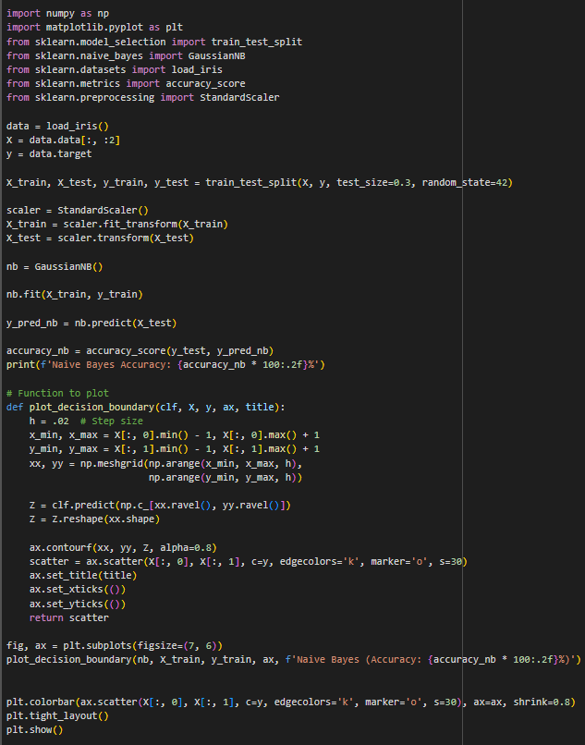
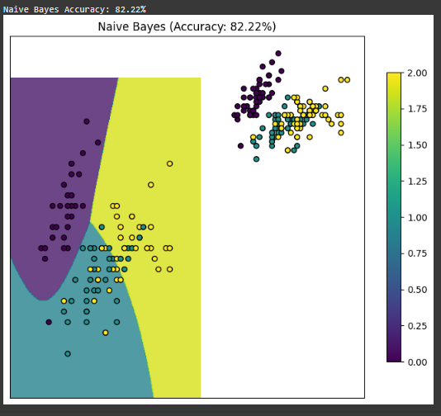

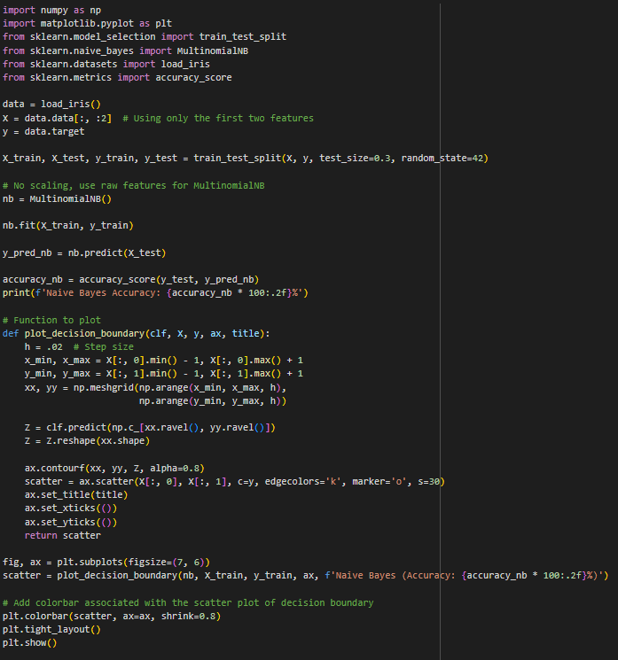
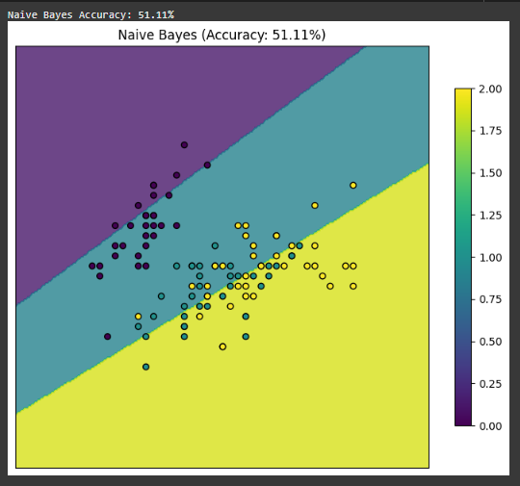

Conclusion:
We successfully applied the concept of supervised data mining and got a model with an accuracy of 87.69%. We also generated a list of actual vs predicted status through our model prediction using the Naïve Bayes classifier.

